How to automate tasks using Adobe Photoshops Batch Processing Command
This is without question one of the most useful things to know, especially for making animations where you might want to use the functionality of Photoshop on tens or hundreds of image snapshots, do it exactly the same way everytime, and do it all from the click of a button.
Step 1 – Create a new Action
There are two steps to this. First we have to create an action to be done in batch processing mode.
1.1 Window Actions This makes sure that the Actions panel is open.
1.2 Open a sample file to work with.
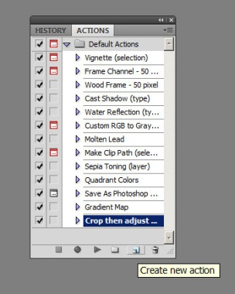
1.3 Hit the Create new action button and give it a name in the New Action popup window. Note that next to the Create New Action button (on the left) there is a Record Action (circle) and Stop Recording Action (square) button.

1.4 The Record Action circle is now red, meaning that anything you do is now being recorded.
1.5 Do all of the steps you want to do to the file. I usually like to end the action by saving the file in the format that I want and then closing the file.
1.6 When you are done hit the Stop Recording Action square.
Step 2 – Batch Processing
Now we are ready to apply the action recorded above to multiple files.
2.1 File Automate Batch… (The Batch window now pops up).
2.2 Under the Play tab select the Action you created in the above step.
2.3 Under the Source tab choose a folder with all of the files you want processed.
2.4 If you saved and closed the file in the action, then just hit the OK button. Now watch it go to work!

