Influence of the Great Salt Lake on Summer Air Quality over Nearby Urban Areas

John Horel^{1*}, Erik Crosman¹, Alexander Jacques¹, Brian Blaylock¹, Seth Arens², Ansley Long¹, Randal Martin³, John Sohl⁴
¹Department of Atmospheric Sciences, University of Utah, Salt Lake City, UT, USA 84112
² Utah Division of Air Quality, Utah Department of Environmental Quality, Salt Lake City, UT, USA, 84116
³Civil and Environmental Engineering Department, Utah State University, Logan UT, USA 84332
⁴Department of Physics, Weber State University, Ogden, UT, USA 84408
*Correspondence to: J. Horel, Department of Atmospheric Sciences, University of Utah, 135 S 1460 E, ROOM 819, Salt Lake City, UT, USA 84112
Email: john.horel@utah.edu

Abstract
Periods of reduced air quality in the urban areas of northern Utah, USA are being examined using data collected during summer 2015. The nearly 2 million residents in this region adjacent to the Great Salt Lake and referred to locally as the Wasatch Front were exposed to ozone levels exceeding the current United States National Ambient Air Quality Standard (8 h average exceeding 70 ppb) on many days during the summer. In addition to a network of 26 ozone sensors in rural and urban locations continuously monitoring ozone concentrations, extensive data were collected during scheduled and opportunistic observing periods from sensors mounted on a novel mix of vehicles, a light rail car, traffic helicopter, unmanned aerial vehicle, and tethered sonde. The temporal and spatial evolution of ozone concentrations along the Wasatch Front were compared to the prevailing regional and local meteorological conditions on the basis of gridded operational analyses, an extensive network of surface weather stations, and additional sensors deployed for the field study.

High ozone concentrations during June 2015 resulted from large-scale ridging aloft that often led to clear or partly-cloudy conditions favorable for photochemical production of ozone. Smoke from wildfires in an arc from northern California to Washington was transported into the region during August and contributed to higher ozone concentrations. The Great Salt Lake influenced ozone concentrations along the Wasatch Front through several mechanisms, most importantly its impact on local wind circulations. Thermally driven wind systems arising from the differences in Lake and surrounding land temperature modulated the transport and exchange of background ozone and ozone precursors between the Lake and urban environments. Afternoon lake breezes transported at times air with higher ozone concentrations towards the Wasatch Front while at other times the lake breezes advected cleaner air into the urban corridor.

Keywords: Great Salt Lake; ozone; air quality; lake breeze; wildfires
1. Introduction
While air quality in northern Utah, USA has improved over the past two decades, the two-million residents of the Wasatch Front (the urbanized region between the Great Salt Lake and the Wasatch Mountains to its east, see Fig. 1a) remain exposed to poor air quality during both winter and summer (Whiteman et al. 2014, Simon et al. 2015). When particulate concentrations are high during winter, the low-lying regions of the Wasatch Front are often blanketed by grey haze and clouds. Such episodes have received considerable attention during recent winters from concerned residents, the medical community, commercial enterprises, and government officials. Residents and visitors “escaping” the poor air quality by traveling from the valleys into the nearby mountains to pursue winter recreation opportunities often see the dramatic trapping of the particulate pollution at lower elevations when they travel back down into the valleys (Lareau et al 2013).
Periods of high ozone concentrations during summer along the Wasatch Front are an equal health concern to poor air quality episodes during winter. However, the public tends to pay less attention to them, except when the combination of smoke from nearby and distant wildfires leads to both higher particulate as well as higher ozone concentrations. Breathing ozone can trigger a wide range of health problems, particularly for children, the elderly, and those susceptible to asthma (Bell et al. 2004; Salvi 2007). In addition, traveling into the nearby mountains does not necessarily reduce ozone exposure as deep boundary layers in the afternoon combined with local and regional transport of ozone and its precursors can often lead to higher ozone concentrations there. While a pronounced diurnal cycle in ozone levels is common along the Wasatch Front (low in the morning and higher in the late afternoon), there are many complicating spatial and temporal variations to this general diurnal pattern resulting from the presence of the nearby mountains and the Great Salt Lake that contribute to thermally-driven circulations modulating where ozone is created and transported. The influence of warm season sea and lake breezes on the meteorology and air quality of mid-latitude coastal regions has been studied extensively both observationally and numerically (Crosman and Horel 2010). The impacts of the Great Salt Lake on atmospheric transport that affects air pollution along the Wasatch Front has been examined by Zumpfe and Horel (2007) and Crosman and Horel (2012, 2015].
The National Ambient Air Quality Standard (NAAQS) for ozone defined by the United States Environmental Protection Agency was set to a more stringent 8-hr average concentration of 70 ppb on 1 October 2015 as a result of decades of research on the health impacts of ozone exposure (Environmental Protection Agency 2015a). In order to comply with those standards, air quality agencies in western states have been and are continuing to support observational and modeling studies to understand the complex linkages between the biogenic and anthropogenic emissions of the precursor chemicals leading to ozone formation and the impacts of local, regional and global transport of ozone and other pollutants into their areas of responsibility. Critical issues for all state and local air quality agencies are to understand and determine: the background levels of ozone present in rural areas in their areas; the extent to which those levels are enhanced in nearby urban areas; and feasible steps that can be taken in the urban areas to reduce those enhanced ozone levels Environmental Protection Agency 2015b).
The Utah Division of Air Quality (DAQ) funded pilot projects in 2014-2015 to address air quality concerns facing the state. One such pilot project was the 2015 Great Salt Lake Summer Ozone Study (GSLO3S), which follows upon DAQ field work during the 2012 summer that indicated elevated ozone levels along the shores of the Great Salt Lake (Arens and Harper 2013). High ozone concentrations offshore over the Great Lakes and other coastal waters adjacent to nearby metropolitan areas have been studied for decades (Lyons and Cole 1973, Cleary et al. 2015).
The objectives of the GSLSO3S pilot study were to: (1) determine the areal and vertical extent of ozone concentrations over and surrounding the Great Salt Lake during the summer and (2) improve understanding of the physical processes that control ozone concentrations near the Great Salt Lake during the summer that might help the Utah DAQ to improve forecasts of ozone concentrations along the Wasatch Front. Due to the strong interest by many individuals involved in this project, the limited direct funding available for GSLSO3S was supplemented by other internal sources in order for DAQ, University of Utah, Utah State University, and Weber State University researchers to participate. The outcomes of this study exceeded the original goals identified at the outset of the project due to: (1) the unique mix of season-long monitoring of ozone, other pollutants, and surface and boundary layer meteorological conditions; (2) opportunistic observations from sensors onboard diverse mobile platforms; and (3) reliance on real-time communications to help position sensors and evaluate the data collected as the season progressed. While real-time communication approaches are commonplace during field experiments intended to observe severe weather, such approaches are less common for air quality studies.
2. The 2015 Great Salt Lake Summer Ozone Study
This pilot project would not have been successful without the air quality and meteorological instrumentation in place year-round along the Wasatch Front. The Utah DAQ supports a network of permanent air quality monitoring sites along the Wasatch Front with an additional sensor deployed by the United State Forest Service in the nearby Wasatch Mountains (Fig. 1b). During the 2015 summer, 16 additional 2B Technology Model 202 ozone sensors operated by the DAQ or University of Utah were deployed at the locations shown in Fig. 1c. Over 200 surface meteorological stations measuring typically temperature, moisture, and wind are operated by federal, state, commercial, and educational institutions as well as the general public (Fig. 1d). Surface-based remote sensors were deployed for the summer by the University of Utah to provide boundary layer profiles of wind and aerosol concentrations at several locations to supplement the twice-daily profiles of temperature, moisture, and wind from the rawinsondes launched by the National Weather Service (Fig. 1e). Further, the United States Geological Survey maintained a buoy with near-surface meteorological sensors as well as a string of temperature sensors from the lake surface to its bottom.
Prior to the 2015 summer, weeks near the center of each of the three months was identified for more intensive observations to observe the photochemical response to peak incoming solar radiation near the summer solstice to later periods in the summer during which high ozone concentrations had been observed during past summers. During these periods, University of Utah students and researchers operated 1-4 vehicles carrying 2B Technology ozone sensors including a mobile van coined the “Nerdmobile” carrying other air quality and meteorological sensors (Fig. 1f).
A novel source of data for this project were the 2B Technology ozone sensors mounted on a light rail car operating on electrified Utah Transit Authority routes and the KSL-TV traffic helicopter. The ozone along with a number of other meteorological and air quality sensors were enclosed within a box located on the top of a light rail car that ran on the “Red”, “Green”, or “Blue” TRAX routes generally from early morning to late evening on 71 of the June-August days (Fig. 1g). While ozone concentrations tend to drop sharply due to titration when the train crosses heavily trafficked roadways, the train-borne sensor provides a wealth of information on the temporal and spatial variation in ozone during the day in the Salt Lake Valley.
The ozone sensor, data logger, and communication system onboard the KSL traffic helicopter were turned on at the discretion of the pilot during 41 days from mid-June through August (Fig. 1h). Although his primary duties were to cover afternoon traffic bottlenecks throughout the Wasatch Front, he also flew to cover many other stories, including major traffic accidents and fatalities, wildfire outbreaks, and ongoing search and rescue operations in the Uinta and Wasatch Mountains. Given the flight restrictions arising from the Salt Lake City international airport and Hill Air Force base, the KSL-TV helicopter provided invaluable information on ozone concentrations in the boundary layer and aloft over the nearby mountains.
A critical aspect of this project that contributed to its success was the ability to monitor the spatial and temporal variability in ozone concentration in both urban and rural locations as quickly as the observations could be collected by cell phone, radio, or ethernet connections. A suite of web pages were developed before and during the summer to be able to view the air quality and meteorological observations (see http://meso2.chpc.utah.edu/gslso3s/ and Table 1). Students and other researchers posted daily summaries of prior and current conditions as well as short summaries of interesting preliminary results as they transpired (Table 1).
3. Initial Findings
Figure 2 summarizes the 8-h maximum ozone concentration at the Hawthorne DAQ site in the Salt Lake Valley during summer 2015 compared to the previous 5 summers (see Fig. 3 for its location in the Valley). High ozone concentrations were observed during June, early July and mid-late August 2015 as a result of favorable meteorological conditions for ozone formation at those times (i.e., strong ridging aloft during June and regional transport of wildfire smoke during August). A deeper and well-mixed boundary layer with enhanced flow speeds tended to prevail during much of July and early August, which resulted in a reduced buildup of ozone precursors. Ozone levels exceeded the 8-h average 2015 NAAQS during 18 days, more often than during any other recent summer (e.g., 13 days in 2012).
The Farmington Bay site recorded the most (19) exceedances of the NAAQS 8-h average standard of 70 ppb followed by Hawthorne (18), Badger Island (17), and Saltaire (16) See Fig. 3 for locations of these sites. Those cumulative summaries highlight the multiple environments in which high ozone concentrations can occur, e.g.: western lakeshore with wide expanses of exposed Lake bed (Badger Island); urban Wasatch Front (Hawthorne); and the interface between the Lake and urban environment immediately to the north of the Salt Lake Valley (Farmington Bay and Saltaire).
The ozone “air pollution” roses in Fig. 3 summarize the ozone concentrations as a function of wind direction at selected sites during the day (local 8AM- 8 PM). The strong influence of thermally driven circulations at these locations is particularly evident in Fig. 3 when considering the prevailing wind directions during summer 2015. Winds at Badger Island tend to be most frequent from the northeast (i.e., the predominant flow across the Lake is from this direction). During those times, high ozone concentrations are most likely to occur. Winds tend to flow down valley in the morning and up valley in the afternoon at valley floor stations. At Hawthorne, Neil Armstrong, Saltaire, Farmington Bay, and Bountiful, early morning down valley flows tend to be associated with lower ozone concentrations with higher ozone concentrations in the afternoon when the winds are blowing from the Lake from the west to northeast. The University of Utah campus site near a narrow canyon exit as well as at the base of steep mountain slopes exhibits early morning down slope and afternoon upslope flows. Farnsworth Peak located 1500 m above the valley floor at the crest of the Oquirrh Mountains to the west of the Salt Lake Valley tended to have winds across the crest from the west/southwest much of the summer. Given the predominant wind directions during the afternoon when ozone concentrations tend to be their highest, then it is not too surprising that the highest ozone concentrations (in excess of 60 or 70 ppb) tend to be when the winds are from northerly directions in the valley and upslope at the University of Utah (Fig. 3). Nocturnal titration of ozone was reduced at the remote western lakeshore (Badger Island) vs. that observed at the other sites shown in Fig. 3 (not shown).
Table 2 summarizes some of the episodes during the 2015 summer that are being examined in more detail. For example, the progression of a strong lake breeze front on 18 June led to the advection of high ozone levels southward through the Salt Lake Valley (Fig. 4). The approximate positions of the front as it progressed southward are indicated by the hourly interval isochrones (heavy blue lines in Fig. 4a). Ozone concentrations in excess of 60-70 ppb are commonplace throughout much of the region between 1630-1730 MDT (Fig. 4a). Lower concentrations were observed in the central swath of the lake by a truck traversing the railroad causeway that bisects the Lake.
The data collected in the boundary layer (100-400 m AGL) from the sensor onboard the KSL traffic helicopter was invaluable as shown in Fig. 4b. In this instance the copter flew southward along the main traffic corrider in the Salt Lake Valley and then on its return flight northward intersected a narrow band of high ozone concentrations (over 110 ppb) aloft at the leading edge of the lake breeze front at 23:13 MDT. These higher ozone concentrations aloft may reflect more limited ozone titration aloft relative to that underway at the surface in this urban area.
4. Summary
The GSLO₃S pilot study was the most extensive field study ever undertaken related to summer air quality along the Wasatch Front adjacent to the Great Salt Lake. Considerable data are available to the projects participants for further analysis, but all of this information is openly accessible as well to other prospective researchers (see Table 1 for links to nearly all of the data). Such research is relevant not only to improve understanding and forecasting of poor air quality episodes locally but provides insight into the interactions between air chemistry and boundary-layer meteorology wherever thermally driven circulations are present.
The observations obtained continuously from over two-dozen fixed sites as well as intermittently from mobile sensors onboard vehicles, a light rail car, and the KSL helicopter highlight the complexity of the spatial and temporal variations in ozone near the Great Salt Lake. While the typical diurnal cycle of lower ozone during the night and early morning relative to late afternoon was most common at all the urban locations, less nocturnal titration and greater dependence on local and regional wind circulations were evident at rural sites on the western shore of the Great Salt Lake or at high elevation to the west (Farnsworth Peak) and east (Snowbird) of the Salt Lake Valley. Thermally-driven circulations (whether up/down slope, mountain/valley, or land/lake breezes) clearly affected ozone levels throughout the region.
It was beyond the scope of this study to estimate emissions of precursor chemicals (e.g., nitrogen oxides and volatile organic compounds) from the urban environment or those arising from other sources (e.g., biogenic emissions or regional transport of wildfire smoke). Thus, research is ongoing to assess the impacts of such emission sources by evaluating and comparing episodes during the summer that were more likely affected by urban emissions (e.g., during June and early July) relative to periods when wildfire smoke may have had a larger impact (e.g., mid-late August).
Many factors influencing ozone concentrations over the lake and along the Wasatch Front became apparent or were at least hypothesized to be relevant as the study evolved:
- generation of ozone during an early June thunderstorm
- impacts of a wet spring on hillside vegetation potentially leading to generation of biogenic precursors for later ozone production
- early season shallow lake thermocline potentially leading to a shallow boundary layer over the lake
- limited evidence for abnormally high ozone concentrations in the central portions of the Lake
- Potential influence of enhanced albedo from the exposed salt flats on ozone formation
- enhanced ozone in the Farmington Bay region relative to other areas
- the direct and secondary roles of the Great Salt Lake on ozone production including chlorine chemistry affecting ozone formation
- variations in the intensity and duration of nocturnal titration along the shores of the Great Salt Lake due to the presence of ozone precursor pollutants
- higher ozone concentrations in the upper portions of the boundary layer during the afternoon over urban areas due to titration closer to the surface
- multiple layers with differing ozone concentrations observed in vertical profiles of the boundary-layer resulting from interactions between the urban environment and complex terrain meteorology
- the relative strength, intensity, and timing of land and lake breezes compared to those of concurrent mesoscale and synoptic-scale circulations
- the impact of canyon flows and other terrain-circulations on ozone and precursor transport along the Wasatch Front
- regional transport of wildfire smoke and its impacts on particulate concentrations as well as ozone production
- regional transport of ozone produced elsewhere.
Of particular interest for improving guidance for DAQ forecasters and planners is the extent to which numerical forecasts and simulations of ozone concentrations using coupled atmospheric-air chemistry models can be improved to capture many of the aforementioned factors affecting ozone concentrations. This will require improving emission inventories of ozone precursors, developing atmospheric modeling capabilities to resolve both the local and regional circulations, and the ability to properly simulate the generation of ozone through diverse pathways.

Acknowledgments.
We greatly appreciate the assistance of our University of Utah colleagues.., The initial phases of this research were supported by a grant form the Utah Division of Air Quality.

References
Arens, S., & K. Harper, 2013. 2012 Utah Ozone Study. 46 pp. http://www.deq.utah.gov/ Pollutants/O/ozone/docs/2013/05May/2012_Utah_Ozone_Study.pdf. Accessed 12/26/15.
Bell, M., McDermott, A., Zeger, S., Samet, J., and Dominici, F., 2004: Ozone and short-term mortality in 95 US urban communities, 1987–2000, J. Am. Med. Assoc., 292, 2372–2378.
Cleary, P. A., Fuhrman, N., Schulz, L., Schafer, J., Fillingham, J., Bootsma, H., McQueen, J., Tang, Y., Langel, T., McKeen, S., Williams, E. J., and Brown, S. S., 2015. Ozone distributions over southern Lake Michigan: comparisons between ferry-based observations, shoreline-based DOAS observations and model forecasts, Atmos. Chem. Phys., 15, 5109-5122, doi:10.5194/acp-15-5109-2015.
Crosman, E., and J. Horel, 2010: Numerical sensitivity studies of sea and lake breezes: a review. Boundary Layer Meteorology. 137, 1-29.
Crosman, E. and J. Horel, 2012. Idealized Large-Eddy Simulations of Sea and Lake Breezes: Sensitivity to Lake Diameter, Heat Flux and Stability. Boundary Layer Meteorology. 144, 309-328.
Environmental Protection Agency, 2015a: National Ambient Air Quality Standards for Ozone. https://www.gpo.gov/fdsys/pkg/FR-2015-10-26/pdf/2015-26594.pdf. Accessed 12/26/2015.
Environmental Protection Agency, 2015b: Implementation of the 2015 Primary Ozone NAAQS: Issues Associated with Background Ozone White Paper for Discussion. http://www3.epa.gov/airquality/ozonepollution/pdfs/whitepaper-bgo3-final.pdf. Accessed 12/26/2015.
Horel, J., and Coauthors, 2002: Mesowest: Cooperative mesonets in the Western United States. Bull. Amer. Meteor. Soc., 83, 211-225.
Lareau, N. P., E. Crosman, C. D. Whiteman, J. D. Horel, S. W. Hoch, W. O. J. Brown, and T. W. Horst, 2013: The persistent cold-air pool study. Bulletin American Meteorological Society, 94, 51-63.
Lyons, W. A., and L. E. Olsson, 1973: Detailed mesometeorological studies of air pollution dispersion in the Chicago lake breeze. Mon. Wea. Rev., 101, 387–403.
Salvi, S., 2007: Health effects of ambient air pollution in children. Paediatric Respiratory Reviews, 8, 275–280. doi:10.1016/j.prrv.2007.08.008
Simon, H. A. Reﬀ, B. Wells, J. Xing, and N. Frank. 2014. Ozone trends across the United States over a period of decreasing NOx and VOC emissions. Environmental Science & Technology. 49.1. 186-195.
Whiteman, C. D., S. W. Hoch, J. D. Horel, A. Charland, 2014: Relationship between particulate air pollution and meteorological variables in Utah's Salt Lake Valley. Atmos. Environ., 94, 742-753.
Zhang, L., Jacob,D. J., Yue,X., Downey,N. V., Wood,D. A., and Blewitt,D.: Sources contributing to background surface ozone in the US Intermountain West, Atmos. Chem. Phys., 14, 5295-5309, doi:10.5194/acp-14-5295-2014, 2014.
Zumpfe, D., J. Horel, 2007: Lake-breeze fronts in the Salt Lake Valley. J. Appl. Meteor., 46, 196-211.

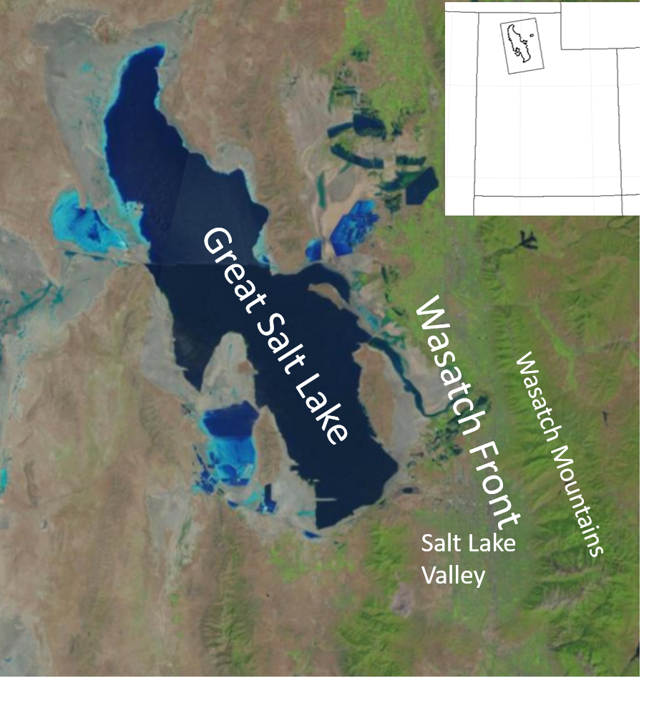
Combine all three of the figs somehow? Figure 1. The urbanized Wasatch Front in northern Utah lies between the Wasatch Mountains and the Great Salt Lake and extends southward through the Salt Lake Valley.
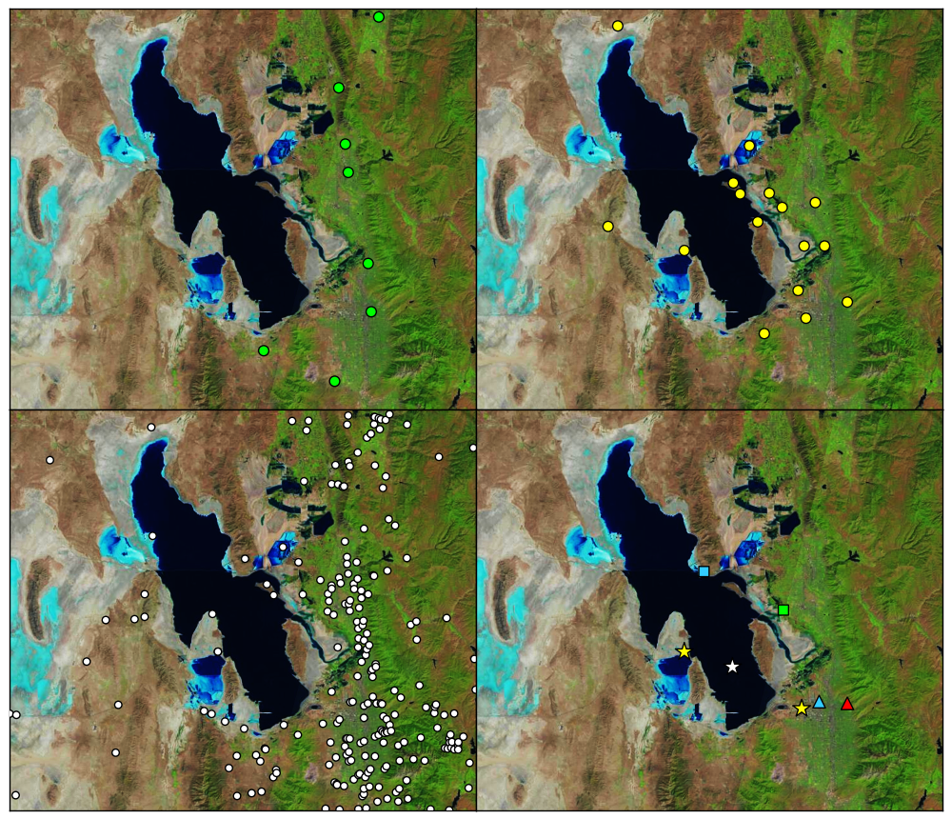
(d)
(b)
(a)

(c)
Figure 1. Location of selected instrumentation during the GSLSO₃S. a) permanent DAQ (green circles) and United States Forest Service (red circle) ozone monitoring sites. b) additional ozone monitoring sites. c) meteorological monitoring locations. d) specialized instrumentation including UAV flights (blue square); tethered sonde, sodar, lidar, ceilometer (green square); sodars (yellow stars); buoy (white star); ceilometer (red triangle); National Weather Service rawinsonde (blue triangle).

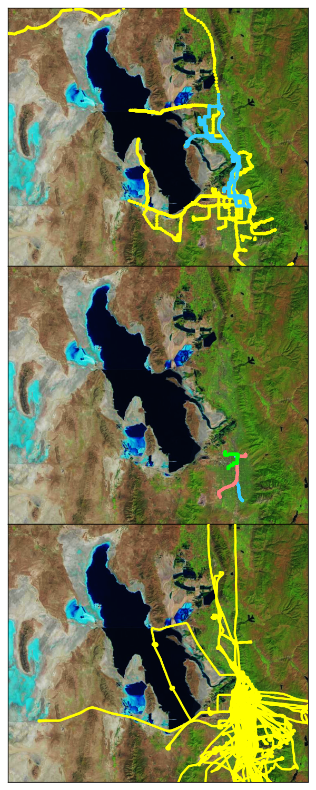
(a)

(b)

Figure 1. Data during the summer were collected on routine, planned, and opportunistic routes from ozone sensors mounted on: a) University of Utah truck, ATV, and private vehicles (yellow) and Nerdmobile (blue); b) a Utah Transit Authority light rail car on the Green, Red, and Blue routes; and c) the KSL traffic helicopter.
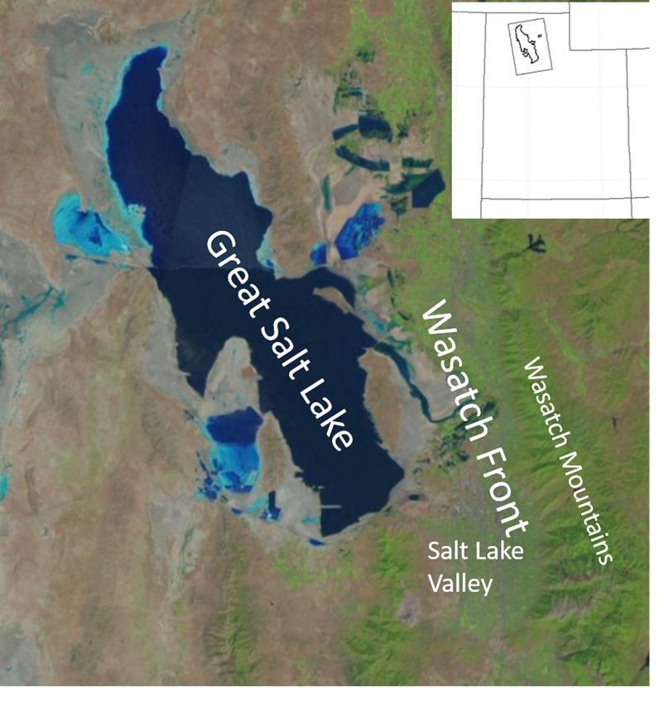

Figure 1. (a) The urbanized Wasatch Front in northern Utah lies between the Wasatch Mountains and the Great Salt Lake and extends southward through the Salt Lake Valley. Location of selected instrumentation during the GSLSO₃S. b) permanent DAQ (green circles) and United States Forest Service (red circle) ozone monitoring sites. c) additional ozone monitoring sites. d) meteorological monitoring locations. e) specialized instrumentation including UAV flights (blue square); tethered sonde, sodar, lidar, ceilometer (green square); sodars (yellow stars); buoy (white star); ceilometer (red triangle); National Weather Service rawinsonde (blue triangle). Data during the summer were also collected on routine, planned, and opportunistic routes from ozone sensors mounted on: f) University of Utah truck, ATV, and private vehicles (yellow) and Nerdmobile (blue); g) a Utah Transit Authority light rail car on the Green, Red, and Blue routes; and h) the KSL traffic helicopter.

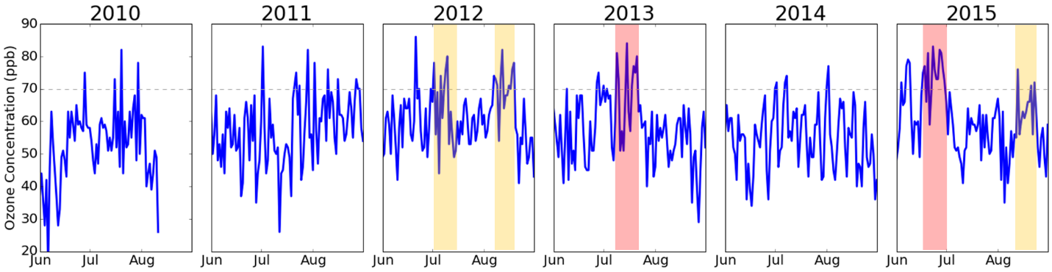

Figure 2. Daily maximum 8-h ozone concentrations at the Hawthorne site in the Salt Lake Valley for summer months from 2010- 2015. Periods dominated by extensive meteorological ridging aloft or local and regional transport of wildfire smoke are highlighted by yellow and pink shading, respectively. The NAAQS for ozone (70 ppb) is denoted by the dashed line.

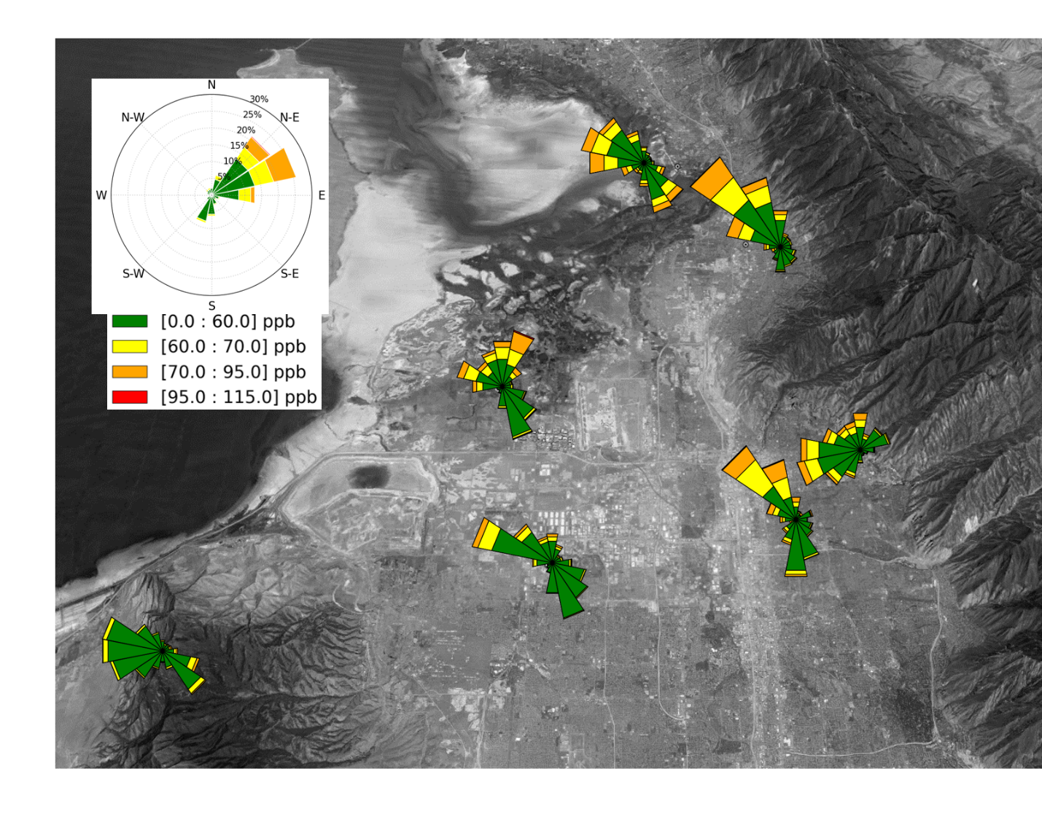
Figure 3 . Ozone wind roses at selected sites near the Salt Lake Valley metropolitan region over the entire summer from 8 AM – 8 PM local time. The inset in the upper left for Badger Island (located further to the northwest) indicates the template used for all of the ozone wind roses.
(LABEL LOCATIONS)

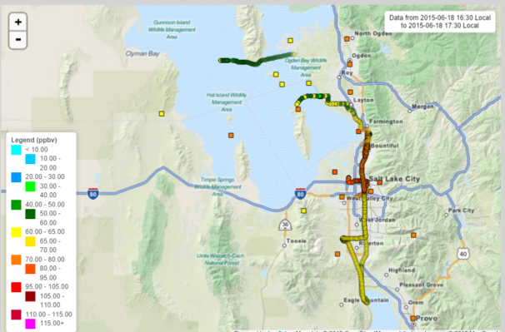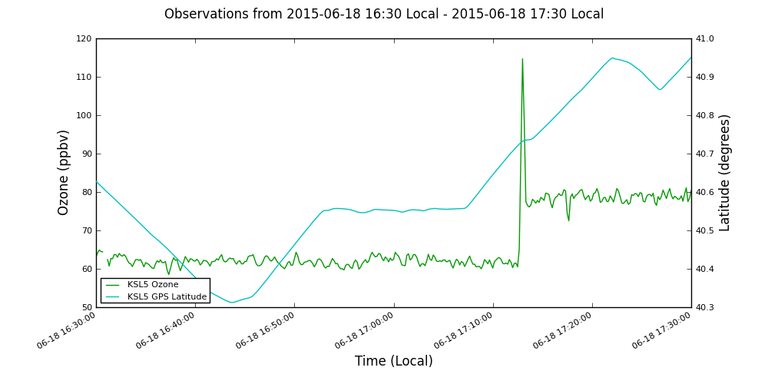
Fig. 4. a) Ozone concentrations from fixed sites (filled squares) and vehicles, light rail, and helicopter (filled circles) between 1630-1730 local time (NEED TO LABEL vehicles, etc.) according to the legend. b) Ozone concentration (green line) and latitude for (blue line) from the KSL helicopter. The approximate location from 1500-1900 MDT of the lake breeze front intersected by the helicopter at 1713 MDT are indicated by the heavy blue lines progressing southward in (a).

Figure 5. Schematic summary of the physical processes affecting ozone concentrations over and surrounding the Great Salt Lake (adapted from Crosman and Horel 2014).
Use??? Improve??

Table 1. Summary of Selected Online Resources for GSLSO₃S
Project Home page | http://meso2.chpc.utah.edu/gslso3s/
Ozone sensor sites | http://meso2.chpc.utah.edu/gslso3s/cgi-bin/site_metadata.cgi
Google earth kmz files of site locations and tracks of KSL helicopter, vehicle, and light rail | https://sites.google.com/site/gslso3skmlfiles/kml-files
Field notes and daily summaries | https://gslso3s.wordpress.com/
Statistical summaries | http://meso2.chpc.utah.edu/gslso3s/cgi-bin/statistic_summary.cgi
Time series | http://meso2.chpc.utah.edu/gslso3s/cgi-bin/time_series.cgi
Ozone pollution and wind roses | http://meso2.chpc.utah.edu/gslso3s/cgi-bin/ozone_rose.cgi
Links to data sources from surface-based in-situ and remote sensors, numerical model analyses | http://meso2.chpc.utah.edu/gslso3s/external_links.html
Hourly analysis soundings from the High Resolution Rapid Refresh | http://meso2.chpc.utah.edu/gslso3s/hrrr_sounding_viewer.php
Satellite images from MODIS | http://meso2.chpc.utah.edu/gslso3s/satellite_image_viewer.php
Ozone, wind, and temperature analyses | http://meso1.chpc.utah.edu/uu2dvar/webGL/so3s_sens.html
Ozone analysis animations and images | http://home.chpc.utah.edu/~u0035056/summer_ozone/
MesoWest API to download ozone data | http://mesowest.org/api

Table 2. Summary of poor air quality episodes during summer 2015
Period | Conditions | Ozone (ppb)
3 June | Evening Thunderstorm | Over 70 ppb at Salt Lake Valley stations
17 June - 3 July | Ridging & hotter than normal | Peak ozone over 70 ppb somewhere every day
Intensive Observing Period 1:  17 - 18 June | Strong lake breeze front on 18th | Ozone concentrated along frontal boundary  aloft
Intensive Observing Period 2:  15 - 16 July | Well mixed, deep boundary layer up to 550 mb with afternoon convection | Peak concentrations barely exceeding 70 ppb
Intensive Observing Period 3:  10 -12 August | Monsoonal conditions | 8 h avg over 70 ppb in Salt Lake Valley
16 - 24 August | Regional smoke transport | Elevated ozone and PM2.5 concentrations

