IMERG ANIMATION TOOL

DATA:
IMERG Precipitation rate - Version 5 - 0.1 x 0.1, half hourly, Final run
Data: https://pmm.nasa.gov/data-access/downloads/gpm
Technical document: https://pmm.nasa.gov/sites/default/files/document_files/IMERG_doc_180207.pdf
Theoretical basis document:
https://pmm.nasa.gov/sites/default/files/document_files/IMERG_ATBD_V5.2.pdf
Skew-T diagram- from YANKEE – Email from Steve Greco – July 18th 2018.
Wind Profiles – Dropsonde Version 2 from YANKEE, after GPS Lat/Lon fix – Email from Steve Greco on May 25th 2018. No other quality control has been applied to these data.
Aircraft Data: From CPEX data portal.

There are two interfaces/tool that has been developed.

LARGE SCALE EVOLUTION:
For each CPEX flight day, the animation is from 00:00 Z and to next day 06:00 Z and the flight hours are approximately from 17:00 Z to 23:59 Z. The intention for creating this tool, to use the IMERG precipitation to understand the evolution of precipitation systems observed on each flight during the CPEX field campaign.
http://home.chpc.utah.edu/~u1147793/cpex/step_thru/20170601/step_thru_2img.html
Change the CPEX date
Change the animation speed

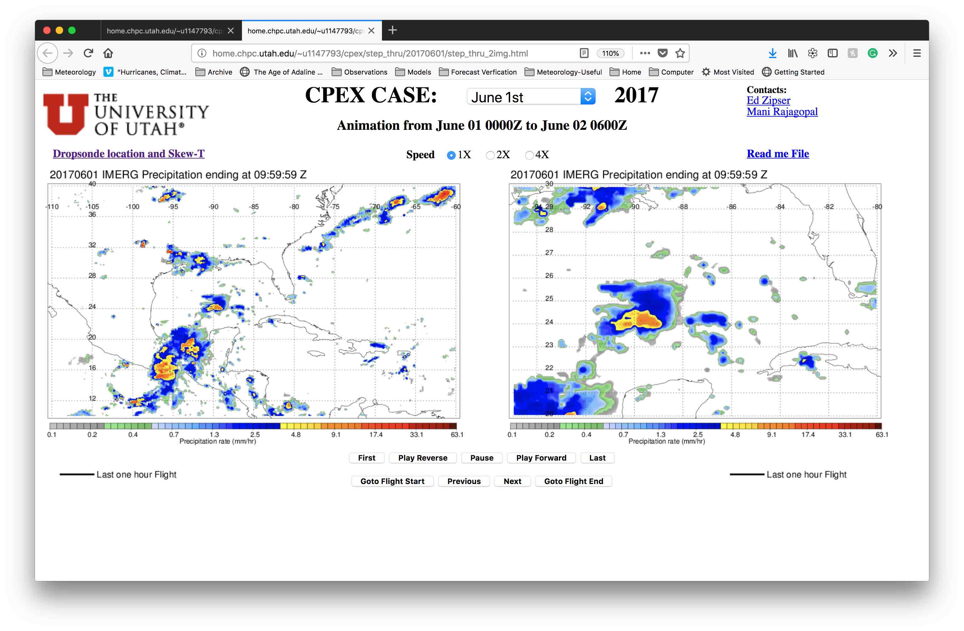
Link to Dropsonde location and sounding plots.
Controls to step through the animation
The screen can be printed using the print option from the browser under the file menu. Also, there is a URL below the “University of Utah” logo that will take you to the next interface that displays the location of the dropsonde and the vertical profiles of T, Td, and Wind.

PRECIPITATION SYSTEM, DROPSONDE LOCATION, AND SOUNDINGS

The purpose of this tool is to know the location of the dropsonde with respect to the precipitation as it evolves and to see the sounding in the same screen. The animation is available only during the flight hours. Some of the flights were over a long distance, so the animation frame has to move from one latitude/longitude box to a different box. It is difficult to capture small flight pattern, dropsonde and the precipitation system at the same resolution. Hence, we have “LARGE SCALE EVOLUTION” tool (described above) to look at the evolution of the precipitation system from a larger perspective in space and time.

Options like choosing a CPEX date, animation speed and controls to step through the animation are same as the first interface. In addition, there are options to choose a different dropsonde and profiles like Skew-T, Wind, and Wind in the boundary layer.

http://home.chpc.utah.edu/~u1147793/cpex/mcs_dropsonde_v2/20170601/mcs.html
Change the Dropsonde#
Click to see the legend and click again to hide it.

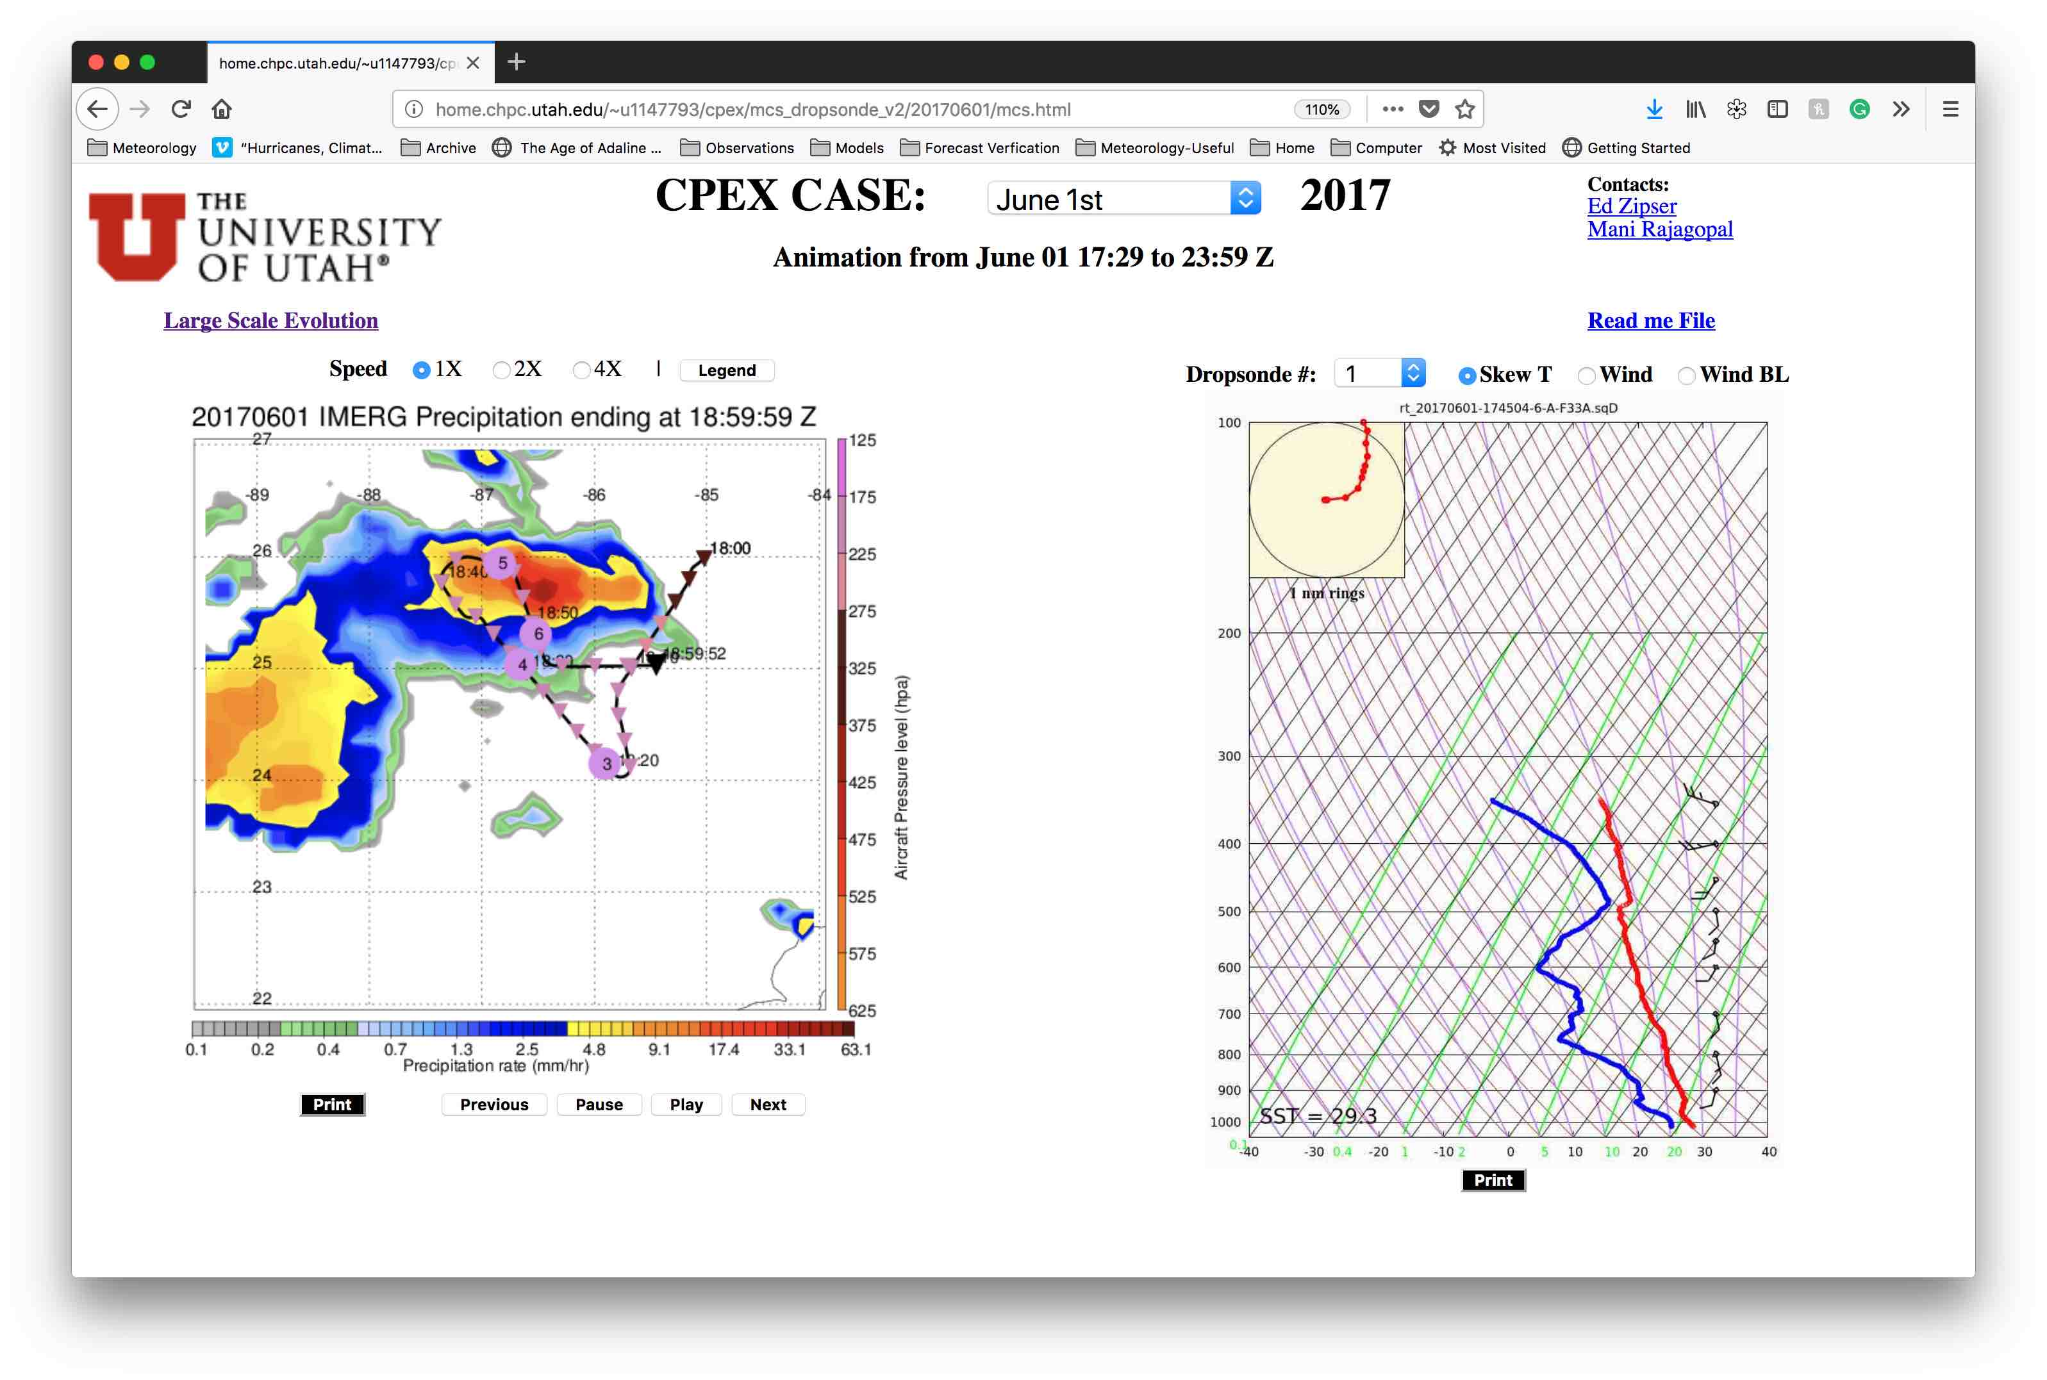
Click to print the respective image.

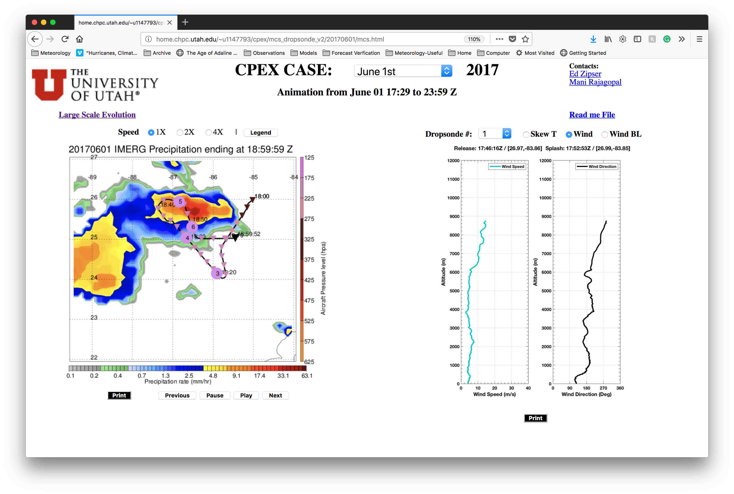
Click here to see the large evolution of this convection.
Change to a different sounding plot.

Hope this tool is useful in your research!

Contact: ed.zipser@utah.edu, mani.rajagopal@utah.edu

