L20 – MPI Example, Numerical Integration

1. Numerical Integration

Let’s now consider a real problem to write a parallel code for. Let’s take the case of numerical integration.

In 1-dimension the definite integral is defined as:

$$E=\int_{a}^{b}{f\left(x\right)dx}$$

And we can use the mean value theorem to approximate this integral by:

$$E_{N}=\frac{\left(b-a\right)}{N}\sum_{i=1}^{N}{f\left(x_{i}\right)}$$

Where the points x_{i} should cover the entire interval of integration. In the limit of large N, E_{N} should approach the exact value of E. But, this is crude.

Instead let’s consider how to do this as a Monte Carlo simulation. Monte Carlo methods typically use random sampling to investigate the problem. Hence, the term Monte Carlo comes from the Monte Carlo casino located in Monaco.

For illustration let’s calculate the integral of:

$$f\left(x\right)= \cos^{2}{x}$$

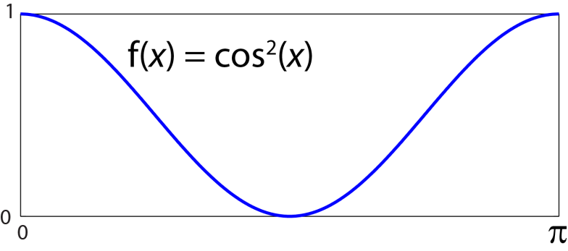

Let’s just consider the interval from 0 to π. We can determine the value of this integral analytically as E = π/2 ~ 1.5708.

If we let f_{max} be the maximum value of the function, and x_{max} be the maximum range to calculate the integral over, we can define a rectangle with area x_{max} × f_{max}.

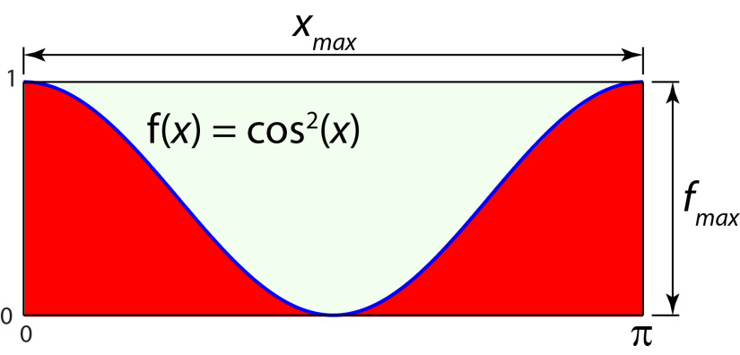

The integral of our function would just be the area of this rectangle that occurs under the curve. That is the red area in the figure above. To use a Monte-Carlo estimate we basically just hang a picture of this function up on the wall and randomly throw darts at it. Then we tabulate the number of darts that fall above the curve and the number of darts that fall below the curve. For example, let’s assume we threw the following 5 darts, marked by circles.

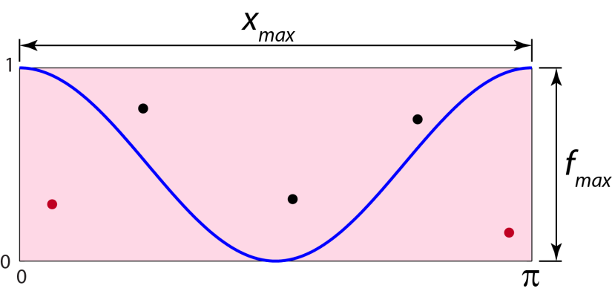

Here the two red darts fell below the curve, and the three black darts fell above the curve. We would estimate the integral as:

$$E_{N}= \frac{\# below curve}{Total \# darts}\left(f_{max}×x_{max}\right)$$

$$⟹E_{N}= \frac{2}{5}\left(1×π\right)=1.657$$

Not a great first guess. But, let’s keep throwing darts. Let’s do this a bit more automatically, and write a Fortran90 code to do it for us.

PROGRAM monte
IMPLICIT NONE

REAL(KIND=8), DIMENSION(:), ALLOCATABLE :: xrand, yrand
REAL(KIND=8) :: xmax, fmax, fr, En
INTEGER(KIND=4) :: N, Kseed, J, Nbelow

N = 1000
xmax = 3.141592654
fmax = 1.0

ALLOCATE(xrand(N))
ALLOCATE(yrand(N))

Kseed = 1
CALL RANDOM_SEED(SIZE=Kseed)
CALL RANDOM_NUMBER(xrand(:))
CALL RANDOM_NUMBER(yrand(:))

xrand(:) = xrand(:)*xmax
yrand(:) = yrand(:)*fmax

Nbelow = 0
DO J=1,N
fr = (cos(xrand(J)))**2
IF (yrand(J) <= fr) THEN
Nbelow = Nbelow + 1
ENDIF
ENDDO

!estimate integral
En = (float(Nbelow)/float(N))*(fmax*xmax)
write(*,*) En
write(*,*) Nbelow

OPEN(UNIT=1,FILE='darts.xy')
DO J=1,N
write(1,*) xrand(J), yrand(J)
ENDDO
CLOSE(1)

END PROGRAM monte

Here are the actual positions using 1,000 darts from the above code:

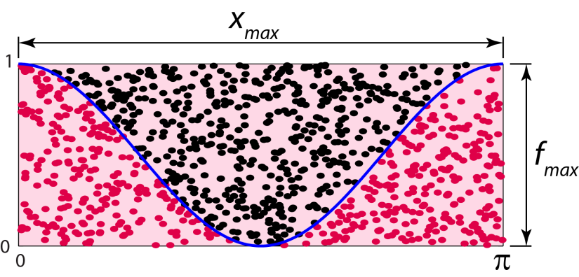

In this case, I got 483 darts below the curve (red darts), and an estimate of the integral as:

$$⟹E_{N}= \frac{483}{1000}\left(1×π\right)=1.5174$$

Which is a much better estimate, but not quite good enough yet.

Now, try running the code more times and fill in the following table. Be sure to add to the code an estimate of the error.

N | E_{N} | Error (%)
1,000
10,000
100,000
1,000,000

Where the error is defined as:

$$Error=\frac{\left|E_{actual}-E_{estimated}\right|}{E_{actual}}×100\%$$

Obviously, to improve on our estimate we need to throw more darts. So how can we do this efficiently? Well let’s let multiple processors work on the problem simultaneously.

2. Parallel Monte Carlo Approach

So, to write this as a parallel application one needs to think about how to go about the problem. In this case, it seems quite simple. We just let each processor throw the same number of darts at the dartboard, making sure that each processor is throwing a different set of darts, and tabulate all of the darts thrown that lie under the curve.

First, let’s consider for a brief moment a thing or two about random numbers. How are they generated? Are they really random? Well, the answer is in general no, because you need to have a program generate the numbers, i.e., an algorithm, and thus the numbers are pseudorandom. For, example check out the cellular automaton RULE 30 from Wolfram (just Wikipedia Rule 30), which is a pretty simple way of generating random numbers.

If we call the random number generator in Fortran as we did above,

CALL RANDOM_NUMBER(xrand(:))

This will return the same numbers every time. But, calling it again and again, will produce new sets of numbers. Hence, for our parallel application we will try multiple random number calls.

OK, so let’s set up the problem. If we were doing this on four processors we might think about this as follows:

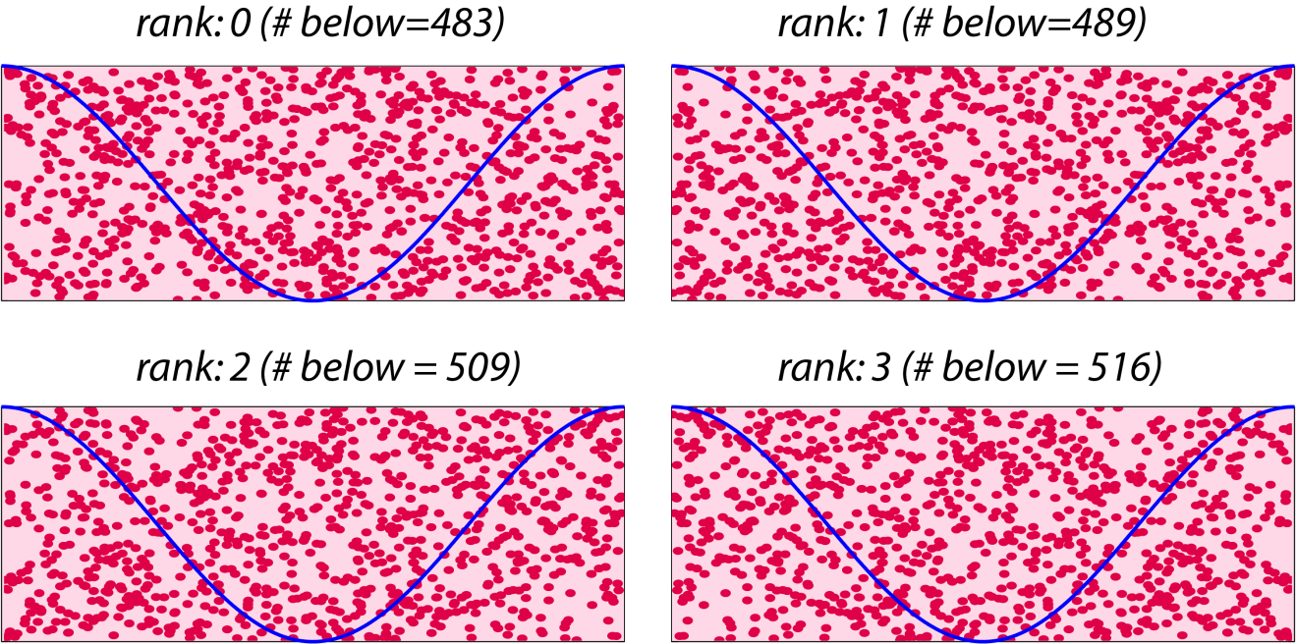

I did this as above for 4 cases, each with 1,000 dart throws with a different random seed in each case and got the # of darts below the curve as indicated.

Then, the integral estimate would be:

$$⟹E_{N}= \frac{\left(483+489+509+516\right)}{\left(1000+1000+1000+1000\right)}\left(1×π\right)=1.5684$$

Which is a minor improvement. So, let’s pursue this in a more generalized sense, and write a code that allows us to use a variable number of processors. We will just modify the code above to achieve this.

PROGRAM monte
USE mpi
IMPLICIT NONE

REAL(KIND=8), DIMENSION(:), ALLOCATABLE :: xrand, yrand
REAL(KIND=8) :: xmax, fmax, fr, En
INTEGER(KIND=4) :: N, Kseed, J, Nbelow, Ntotal, Nbtemp
INTEGER(KIND=4) :: mpi_ierr, nprocs, myrank
INTEGER(KIND=4) :: mstatus(MPI_STATUS_SIZE)

! Initialize the MPI environment
!---------------------------------------------------------------------!
CALL MPI_Init(mpi_ierr)
CALL MPI_Comm_size(MPI_COMM_WORLD,nprocs,mpi_ierr)
CALL MPI_Comm_rank(MPI_COMM_WORLD,myrank,mpi_ierr)
!---------------------------------------------------------------------!

! Initialize parameters
!---------------------------------------------------------------------!
N = 1000
xmax = 3.141592654
fmax = 1.0
!---------------------------------------------------------------------!

!Allocate memory
!---------------------------------------------------------------------!
ALLOCATE(xrand(N))
ALLOCATE(yrand(N))
!---------------------------------------------------------------------!

! Populate random numbers differently for each rank
!---------------------------------------------------------------------!
Kseed = 1
DO J=1,(myrank+1)
CALL RANDOM_SEED(SIZE=Kseed)
CALL RANDOM_NUMBER(xrand(:))
CALL RANDOM_NUMBER(yrand(:))
ENDDO

xrand(:) = xrand(:)*xmax
yrand(:) = yrand(:)*fmax
!---------------------------------------------------------------------!

!Now calculate Nbelow on each processor
!---------------------------------------------------------------------!
Nbelow = 0
DO J=1,N
fr = (cos(xrand(J)))**2
IF (yrand(J) <= fr) THEN
Nbelow = Nbelow + 1
ENDIF
ENDDO

!write out value of Nbelow for each rank
write(*,*) "myrank= ", myrank, "Nbelow= ", Nbelow
!---------------------------------------------------------------------!

! Now tabulate all of the Nbelows and total throws onto rank 0
!---------------------------------------------------------------------!
! First send the messages
IF (myrank > 0) THEN
CALL MPI_Send(Nbelow,1,MPI_INTEGER,0,myrank,MPI_COMM_WORLD,mpi_ierr)
ENDIF

! Now receive them on rank 0
IF (myrank == 0) THEN
Ntotal = N
DO J=1,(nprocs-1)
CALL MPI_Recv(Nbtemp,1,MPI_INTEGER,J,J,MPI_COMM_WORLD,mstatus,mpi_ierr)
Ntotal = Ntotal + N
Nbelow = Nbelow + Nbtemp
ENDDO
write(*,*) "Ntotal= ", Ntotal, "Nbelow= ", Nbelow
ENDIF
!---------------------------------------------------------------------!

!estimate integral
!---------------------------------------------------------------------!
IF (myrank == 0) THEN
En = (float(Nbelow)/float(Ntotal))*(fmax*xmax)
write(*,*) "En= ", En
ENDIF
!---------------------------------------------------------------------!

CALL MPI_Finalize(mpi_ierr)

END PROGRAM monte

3. Homework

Calculate the following integrals:

- $\int_{0}^{π}{\sin^{2}\left(π\cos{3θ}\right)}\cos^{2}{θdθ}$

- $\int_{0}^{10}{\frac{x^{3}}{x^{4}+16}dx}$

- $\int_{0}^{π}{\sin^{4}\left(3x\right)}dx$

