Large-eddy simulations of a Salt Lake Valley cold-air pool
Erik Crosman^{a*}, John Horelª
ªUniversity of Utah Deparment of Atmospheric Sciences, 135 S 1460 E Rm 819 WBB, Salt Lake City, Utah 84112, USA
*corresponding author, e-mail address: erik.crosman@utah.edu (E. Crosman)
Abstract
Persistent cold-air pools are often poorly forecast by mesoscale numerical weather prediction models, in part due to inadequate parameterization of planetary boundary-layer physics in stable atmospheric conditions, and also because of errors in the initialization and treatment of the model surface state. In this study, an improved numerical simulation of the 27-30 January 2011 cold-air pool in Utah’s Great Salt Lake Basin is obtained using a large-eddy simulation with more realistic surface state characterization. Compared to a Weather Research and Forecasting model configuration run as a mesoscale model with a planetary boundary-layer scheme where turbulence is highly parameterized, the large-eddy simulation more accurately captured turbulent interactions between the stable boundary-layer and flow aloft. The simulations were also found to be sensitive to variations in the Great Salt Lake temperature and Salt Lake Valley snow cover, illustrating the importance of land surface state in modelling cold-air pools.
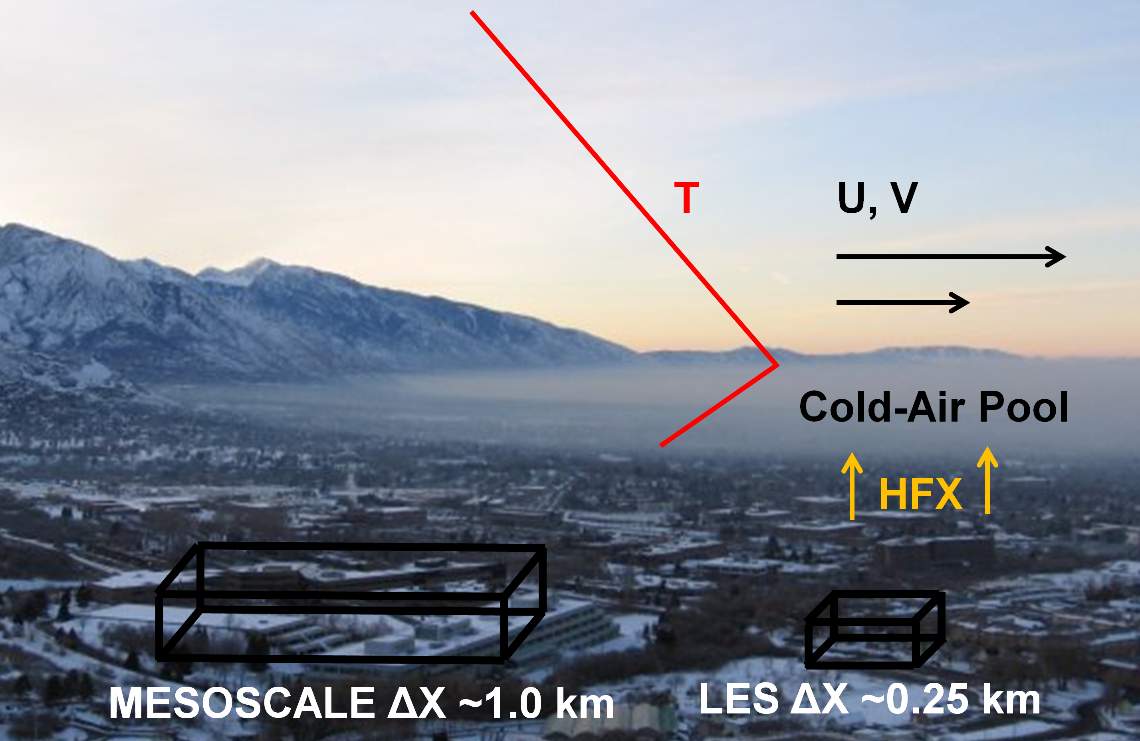

Keywords: Cold-air pool; air pollution; Large-eddy simulation; Weather Research and Forecasting Model; Numerical modelling.
- Introduction
Stable and persistent cold-air pools in the atmospheric boundary-layer are observed in many topographic basins throughout the world (e.g., Western United States (Whiteman et al. 2001, Reeves et al. 2011), United Kingdom (Sheridan et al. 2014) and Austrian Alps (Dorninger et al. 2011). Utah’s Salt Lake Valley is frequented in winter by cold air pools that last between 2 days and a week (Lareau et al. 2013), resulting in poor air quality as pollutants accumulate within the boundary-layer (Silcox et al. 2012, Whiteman et al. 2014, Crosman et al. 2017). The need for improved understanding of the meteorological forcing mechanisms that impact cold-air pools was the goal of the Persistent Cold Air Pool Study (PCAPS, 1 December 2010-7 February 2011, Lareau et al. 2013). The PCAPS research effort has resulted in a number of observational and modelling studies on cold-air pools (Silcox et al. 2012, Hall et al. 2014, Lu and Zhong 2014, Whiteman et al. 2014, Whiteman and Hoch 2014, Lareau and Horel 2015a, b, Young and Whiteman 2015, Crosman and Horel 2016, Foster et al. 2017). This study represents the first simulation of a PCAPS cold-air pool using a large-eddy simulation (LES).

A number of recent numerical studies have discussed the inadequacy of numerical weather prediction (NWP) models to simulate aspects of the cold-air pool lifecycle, resulting in poor temperature and air quality forecasts in some situations (Reeves and Stensrud 2009, Baklanov et al. 2011, Price et al. 2011, Reeves et al. 2011, Ahmadov et al. 2015, Neemann et al. 2015, Lareau and Horel 2015b). The following meteorological aspects of cold-air pools are particularly difficult to model: vertical temperature and humidity structure, cloudiness, turbulent mixing and boundary-layer flows (Holtslag et al. 2013, Neemann et al. 2015, Lareau and Horel 2015b, Foster et al. 2017). Consequently, weather and air quality forecasters have difficulty providing timely and accurate guidance regarding cold-air pool metrics such as their intensity, duration and decay.

The planetary boundary layer (PBL) parameterizations used in mesoscale NWP models are typically over-dispersive in the presence of synoptic flow aloft and result in too much vertical mixing and inaccurate moisture and temperature profiles within the stable boundary layer (Teixeira et al. 2008, Fernando and Weil 2010, Baklanov et al. 2011, Baker et al. 2011, Shin and Hong 2011, Jiménez et al. 2012, Huang et al. 2013, Reeves et al. 2011, Holtslag et al. 2013). In contrast, during periods of calm winds, these same PBL schemes may be under-dispersive, leading to limited vertical mixing at night (Foster et al. 2017). Improving understanding of cold-air pool turbulent erosion and momentum transport in the presence of variations in stability and other meteorological parameters has been the topic of several recent observational and idealized modelling investigations during PCAPS (Lareau 2014, Lareau and Horel 2015a, b). These studies found that complex terrain features such as those found in the Salt Lake Valley interact with large-scale pressure gradients and associated synoptic flows to enhance the downward movement of strong winds toward the surface. The wind shear between the relatively calm low-level cold-air pool and the higher winds at the top of the cold-air pool result in wind shear-driven mixing, or ‘turbulent erosion’ processes that act to remove the cold-air pool from the top down over time (Lareau and Horel 2015a, b). Modelling studies of several persistent Salt Lake Valley cold-air pools during PCAPS were also conducted by Wei et al. (2013), Lu and Zhong (2014), and Foster et al. (2017), but these simulations were run at typical mesoscale model resolutions (1-3 km Δx) and did not occur during a prolonged period of turbulent erosion on the upper boundary of the cold-air pool such as occurred during the last two days of the cold-air pool simulated in this study.

As discussed by Teixeria et al. (2008), LES can provide improved representation of stable boundary-layer physics. Despite their advantages, however, LES are computationally expensive and can suffer from numerical instabilities (Moeng et al. 2007; Talbot et al. 2012). Advances in computational speed and parallelization have allowed for recent increases in LES studies (e.g,, Crosman and Horel 2012, Mirocha et al. 2013, Joe et al. 2014, Zhang et al. 2014, Matheou and Chung 2015, Schalkwijk et al. 2015, Falasca et al. 2016). Zhou and Chow (2013) used LES to accurately simulate nighttime flow dynamics during stable conditions during the Terrain-Induced Rotor Experiment in California’s Owens Valley while Zhou and Chow (2014) analyzed the formation of shallow nocturnal cold pools and turbulent interactions in shallow topography in Kansas. Hughes et al. (2015) used LES to illustrate the importance of sub-grid scale humidity variations on diurnal cold pools in the United Kingdom. Research is also currently underway to simulate stable slope flows with LES over complex terrain on the Dugway Proving Grounds in Utah (Fernando et al. 2015).

In addition to modelling turbulent erosion processes, the initialization of the land surface and atmospheric state is an important parameter for numerical simulations in northern Utah (Massey et al. 2014, 2016, Neemann et al. 2015, Blaylock et al. 2017; Foster et al. 2017). For example, Neemann et al. (2015) and Foster et al. (2017) found that cold-air pool simulations in Utah’s Uintah and Salt Lake Basins were sensitive to initial snow depth and albedo, while Blaylock et al. (2017) found that summertime Great Salt Lake breezes were impacted by lake temperature. Within the Great Salt Lake Basin, both land surface state (e.g., snow cover, soil moisture, land use typology) and Great Salt Lake surface state (lake temperature and salinity) influence the surface energy balance and hence cold-air pool characteristics. In this study, we conduct several LES sensitivity studies to understand the impact on numerical simulations of variations in snow cover and Great Salt Lake surface temperature.

This is the first LES study to our knowledge to simulate the evolution of a long-duration multi-day stable wintertime cold pool in a large mountain valley. The primary goals of this study are to 1) demonstrate the increase in model skill obtained by running the Weather Research and Forecasting (WRF) model in ‘LES mode’ and to 2) quantify the sensitivity of cold-air pools to variations in Great Salt Lake temperature and snow cover. This paper is organized as follows: In Section 2 the WRF model setup, numerical simulations and PCAPS observations are described. In Section 3 a meteorological overview of the 27-30 January 2011 persistent cold-air pool is followed by a comparison between mesoscale and LES simulations. The sensitivity of cold-air pools to variations in Great Salt Lake lake temperature and snow cover are also presented. A summary and discussion of future work are given in Section 4.
- WRF Model Setup, Sensitivity Experiments, and PCAPs Observations
2.1 WRF Model Setup

The WRF model is nonhydrostatic and uses a pressure-based, terrain-following vertical coordinate system (Skamarock and Klemp 2008). Table 1 (Figure 1) summarizes the model set-up and physics options (model domains) used for this study. The WRF model version 3.4.1 was configured as both a large-eddy simulation (hereafter referred to as WRF-LES) and as a mesoscale model (herafter referred to as WRF-MESO). The simulations evaluated the core period of PCAPS intensive observational period 9 (IOP9; Lareau et al. 2013). The WRF model was initialized at 0000 UTC 27 January 2011 (1700 Mountain Standard Time (MST) 26 January) and simulations ended at 0000 UTC 31 January 2011 (1700 MST 30 January).

Both the WRF-LES and WRF-MESO simulations were prescribed with full physics. The United States Geological Survey (USGS) land use data set was used in concert with the Noah land surface model (Chen and Dudhia 2001). All simulations used the Rapid Radiative Transfer Model longwave and shortwave radiation schemes (Iacono et al. 2008) and Thompson et al. (2008) microphysics scheme. No cumulus pararameterization was used except in the 12-km WRF-MESO domain which employed the Kain-Fritsch 2 parameterization (Kain 2004). The surface layer scheme used was recently updated by Jimenez et al. (2012) for stable conditions. The operational North American Mesoscale Model (NAM) analyses at 12 km resolution were used to initialize atmospheric and land surface variables as well as provide lateral boundary conditions for the outer domain at 6-hour intervals. The NAM lateral boundary-conditions were interpolated both spatially and temporally to provide needed input for the outer WRF-LES domain. The boundaries of nests in LES are known to result in some numerical errors (Moeng et al. 2007, Goodfriend et al. 2015), but discussing or quantifying these errors was not attempted in this study. All simulations used 50 vertical levels with standard default stretching of the WRF model. The lowest 10 levels were located within approximately 1 km of the terrain surface with the first model level located around 50 m above the land surface, with a steady increase in the vertical grid spacing to ~300 m at an elevation of 2000 m above ground level (Table 1).

The WRF-LES differed from the WRF-MESO simulation in that the WRF-LES configuration is run at a small enough horizontal grid spacing that no PBL scheme is required. The major advantage of using LES is that most of the boundary-layer turbulence is resolved, compared to the parameterization of turbulent eddies and vertical motions required in PBL schemes. For the subgrid-scale (SGS) model, The WRF-LES simulation used a turbulent kinetic energy (TKE) 1.5 order closure, and all default coefficients for the SGS were used following Talbot et al. (2012), except for the time-off centering for vertical sound waves which was increased from 0.1 to 0.2 to assist filtering instabilities by the terrain. The diffusion option chosen in the WRF-LES configuration evaluates mixing in term of physical space (instead of on coordinate surfaces as done in WRF-MESO) (Table 1). The model terrain surface in the WRF-LES simulations was also smoothed to limit the Courant–Friedrichs–Lewy (CFL) condition being unmet and errors growing along terrain slopes. A horizontal grid spacing of 750 m was used in the outer WRF-LES domain, with a 250 m grid spacing in the inner WRF-LES domain. The 750 m horizontal grid spacing used for the outer WRF-LES domain occurs in the transition zone (known as “grey zone” or “terra incognita”) between coarser resolution simulations that require the use of PBL schemes and LES (Zhou et al. 2014). The inner WRF-LES domain (with a finer grid spacing of 250 m) covers the Salt Lake Valley and adjacent lake, mountain, and valley surfaces (Figure 1). The locations of the inner and outer WRF-LES simulations are shown in Figure 1b.

The WRF-MESO simulation used the Yonsei University (YSU) PBL scheme (Hong et al. 2006) following Alcott and Steenburgh (2013). The nonlocal turbulence closure scheme of the YSU was found to perform better in testing than several other PBL schemes tested (not shown), despite Lu and Zhong (2014) finding that local turbulence closure PBL schemes simulated a different cold-air pool episode somewhat better. The locations of the 3 nested domains in the WRF-MESO simulation are shown in Figure 1a. The WRF-MESO horizontal grid spacing for the outer, middle, and inner domains were 12, 4, and 1.33 km, respectively.

The following modifications were made to the WRF model for this study: the saturation vapour pressure over the Great Salt Lake was decreased (separately for the northern and southern portions of the lake) following Alcott and Steenburgh (2013) to account for the high salinity of the lake brine. The soil type in the Salt Lake Valley was modified from sand to silty clay and soil moisture was fractionally increased to ~0.4 kg m⁻³ to represent the muddy soils observed. In addition, the NAM analysis snow cover was found to overestimate the coverage of snow in the Salt Lake Valley versus observations.

Table 1 Large-eddy simulation (WRF-LES) mode and mesoscale (WRF-MESO) model configuration.

Model Parameter | WRF-LES Setup | WRF-MESO Setup
Boundary conditions | NAM Analysis |  | NAM Analysis
Vertical levels | 50 stretched |  | 50 stretched
Approximate eight above ground level (m) of lowest levels | 0, 50, 75, 100, 125, 150, 175,  200, 220, 240, 260, 280, 300 |  | 0, 50, 75, 100, 125, 150, 175,  200, 220, 240, 260, 280, 300
Model top | 50 hPa (default) |  | 50 hPa (default)
Domains | 2 one-way nests |  | 3 one-way nests
Resolution (km) | 0.750 (outer), 0.250 (inner) |  | 12 (outer), 4 (middle), 1.33 (inner)
Number of grid cells | (outer: 300 x 300);  (inner: 421 x 451) |  | (outer: 200 x 190); (middle: 250 x 250); (inner: 475 x 499)
Timestep (s) | 10, 1 |  | 36, 12, 3
Planetary boundary layer | None |  | YSU
Surface layer | Jimenez |  | Jimenez
Land surface | NOAH |  | NOAH
Land Use | USGS |  | USGS
Radiation | RRTMG |  | RRTMG
Microphysics | Thompson |  | Thompson
Cumulus | None |  | None in inner 2 domains; Kain-Fritsch in outer domain
Diffusion | Diff_opt =2; Km_opt=2 |  | Diff_opt=1:Km_opt=4
Subgrid-scale turbulence | 1.5 order TKE |  | None
CTL simulation | Lake Temperature 274.9 K;  no snow below 1450 m |  | Lake Temperature 274.9 K;  no snow below 1450 m
LK+3 | Lake Temperature 277.9 K;  no snow below 1450 m |  | NA
LK-3 | Lake Temperature 271.9 K;  no snow below 1450 m |  | NA

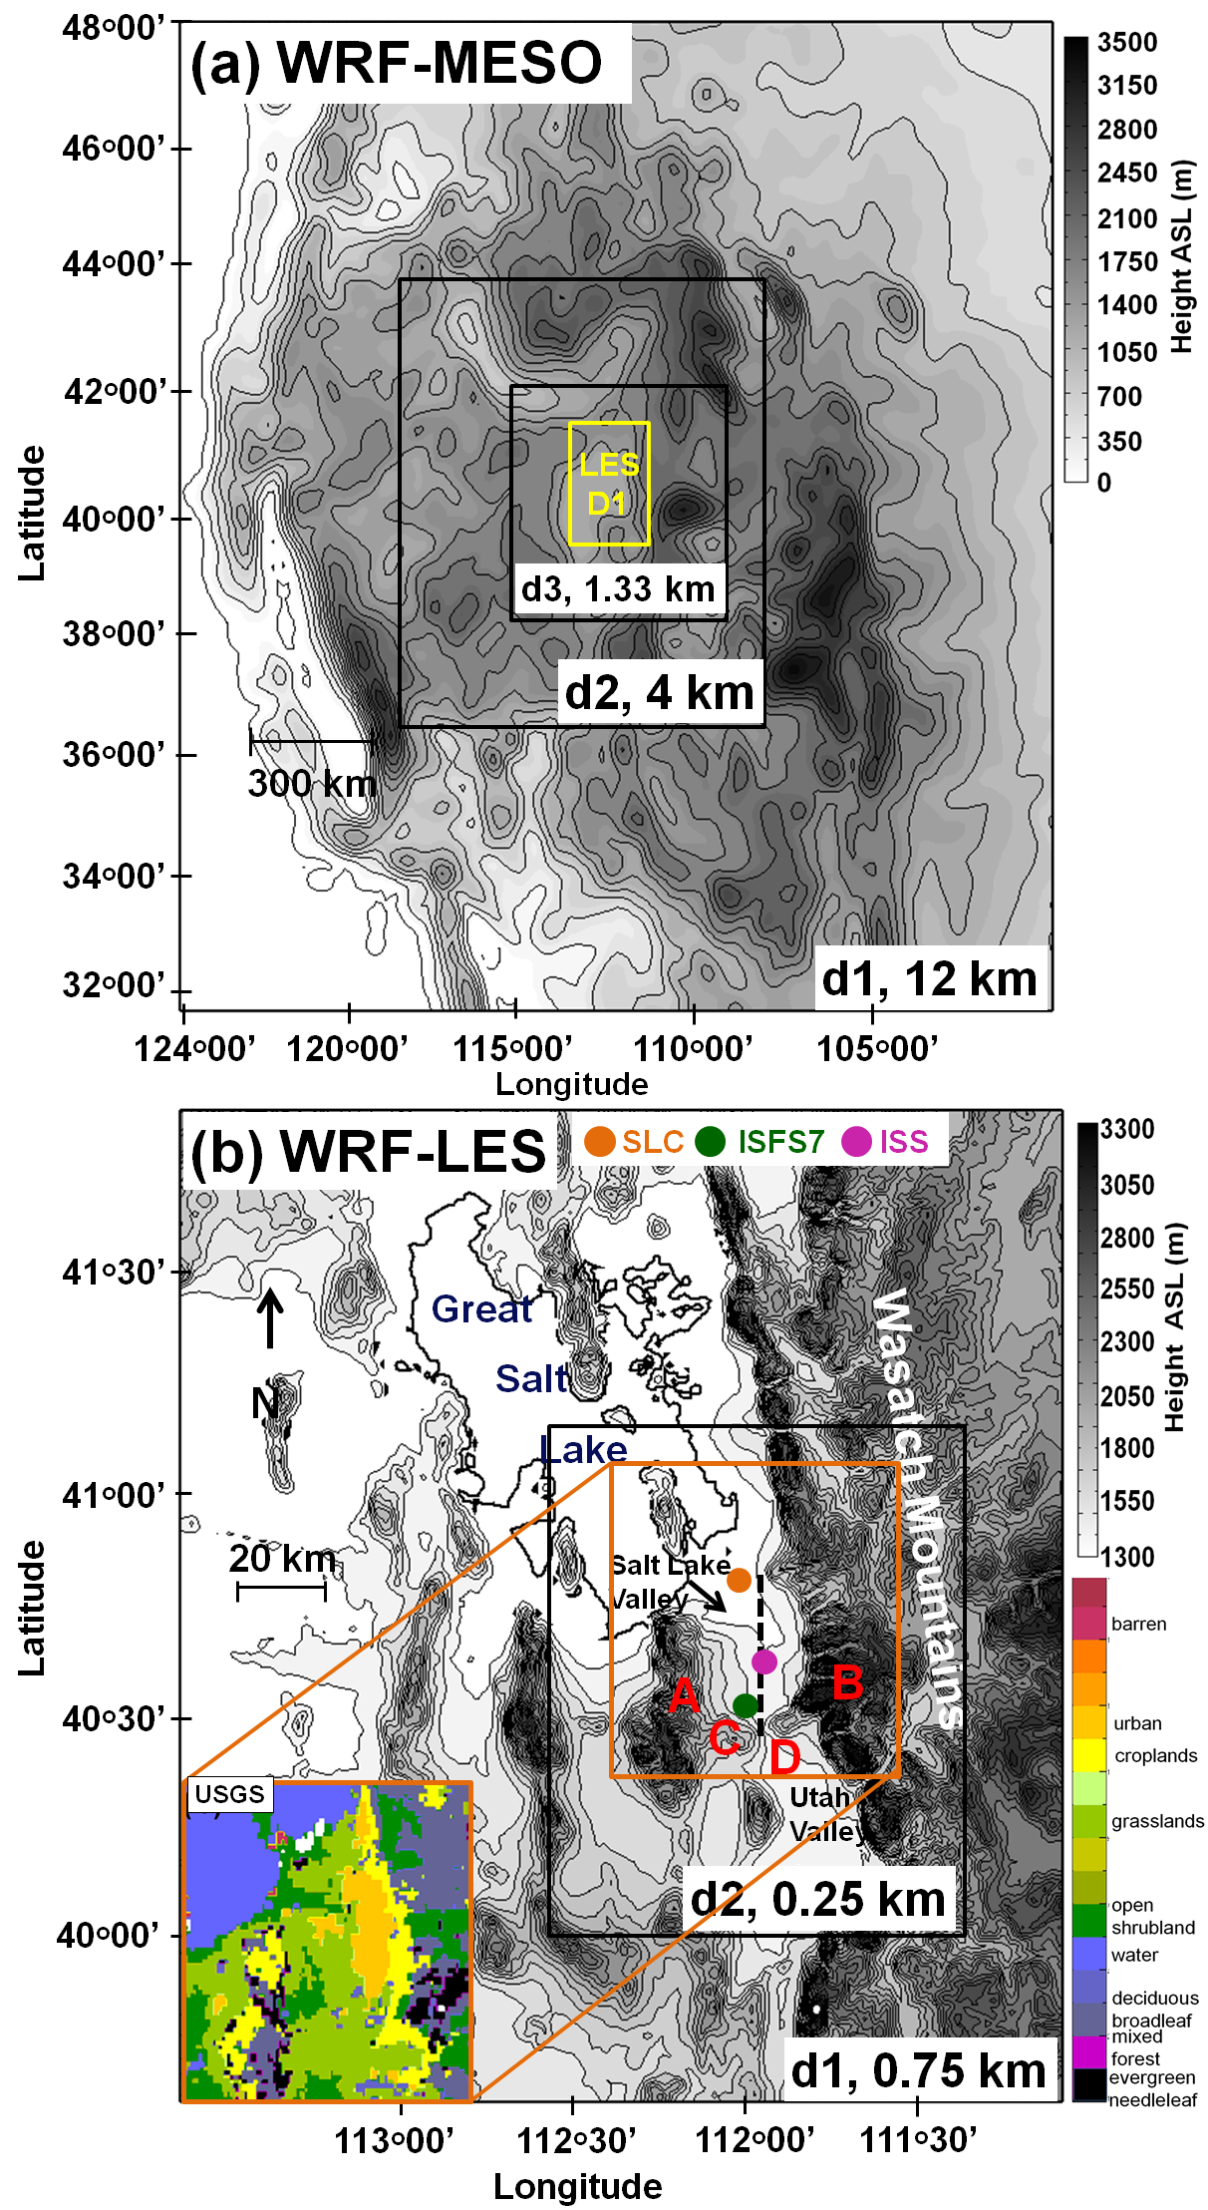
Figure 1. Domains for the (a) WRF-MESO and (b) WRF-LES simulations. The orange box in (b) outlines the Salt Lake Valley subdomain discussed in the figures and text with the corresponding surface vegetation characterization of the Salt Lake Valley in the WRF USGS land use (inset lower left according to color scale at lower right). The locations of meteorological observations used for model verification--Salt Lake City International Airport (SLC), Riverton (ISFS7) and the NCAR Integrated Sounding System and other nearby wind profiler data (ISS) are denoted by orange, green, and purple dots, respectively. The black dashed line in the Salt Lake Valley depicts the location of the vertical cross-sections plotted in subsequent figures. Terrain features that impact the cold-air pools are labelled with red letters, including the Oquirrh Mountains (A), the Traverse Mountains (C), the high Wasatch Mountains (B) and the Jordan Narrows gap (D).

For this study, the snow cover in the lower elevations below 1450 m of the Salt Lake Valley was removed based on visual and satellite observations (except for the SNW sensitivity simulation, where snow cover was increased in a depth to 10 cm below 1450 m in the Salt Lake Valley) (Table 1).

The complex topography and land use within and surrounding the Salt Lake Valley is illustrated in Figure 1b. The Salt Lake Valley is bounded by the Oquirrh Mountains to the west, the Wasatch Mountains to the east, the Traverse Range to the south, and the Great Salt Lake to the northeast. The Salt Lake Valley slopes gently upward from north to south. The Jordan Narrows gap in the Traverse Range allows for north-south exchange between the Utah Valley and Salt Lake Valley. A transition to steeper slopes is noted along the periphery of the Salt Lake Valley. The default WRF United States Geological Survey (USGS) land use option was chosen (Figure 1 lower left inset). The gentler eastern slopes of the Oquirrh Mountains retain regions of scrub and grassland, while needleleaf and broadleaf forests cover much of the Wasatch Mountains.

2.2 WRF Simulations

One WRF-MESO and four WRF-LES simulations were conducted. The CTL simulations were conducted to provide a baseline comparison of the LES and MESO model configurations. Three additional WRF-LES simulations were also conducted: A simulation with complete snow cover in the Salt Lake Valley and Utah Valley (SNW), and simulations with warm (CTL+3) and cold (CTL-3) Great Salt Lake temperature anomalies relative to the CTL simulation (Table 1). In the CTL simulation, the snow cover below 1450 m in the Salt Lake Valley was specified to be zero, and the Great Salt Lake lake temperature was specified to be 1.75 ᵒC from satellite data (Crosman and Horel 2009, Grim et al. 2013). In the SNW simulation, a uniform snow cover of 10.0 cm was placed in the Salt Lake Valley at elevations below 1450 m. In the CTL+3 simulation, the Great Salt Lake lake temperature was specified to be 4.75ᵒC, or 3 ⁰C higher than in the CTL, whereas in the CTL-3 case the lake temperature was specified to be -1.25ᵒC, or 3 ⁰C less than in the CTL (Note that the Great Salt Lake regularly observes sub-zero temperatures during wintertime due to the high salinity of the water, which prevents freezing). No modifications were made to the initial model atmospheric state prescribed from the NAM analyses in the various sensitivity simulations. Thus, the initial state is insensitive to the prescribed variations, and only the impact of changes starting from a common initial state is quantified in this study.

  - PCAPS Observations
The model simulations are compared against observations collected as part of the PCAPS field study (Lareau et al. 2013). Hourly simulated profiles of temperature, wind speed and direction, and relative humidity at the National Center For Atmospheric Research (NCAR) Integrated Sounding Site (ISS in Figure 1) were compared against hourly vertical profiles of the same parameters created using PCAPS observations, including data from a surface weather station, radio acoustic sounding system (RASS), a 915 MHz wind profiler, and 253 radiosondes (Lareau and Horel 2015a). Numerical output was also compared against meteorological data from an NCAR Integrated Surface Flux System station (ISFS7 in Figure 1). In addition, model cloud water was compared against satellite imagery showing the spatial extent of clouds within the basin during the cold-air pool (not shown).

- Results
3.1 27-30 January 2011 Persistent Cold-Air Pool
The persistent cold-air pool strengthened beneath an amplifying 500 hPa shortwave ridge on 27 and 28 January, with 500 hPa heights rising to 575 dm (Figure 2a). A descending temperature inversion between 2000 and 2500 m ASL, a common characteristic of cold-air pools during their intensification stage, was noted during the first half of the episode (Figures 3a, c and 4a). Beneath the shortwave ridge, 500 hPa wind speeds below 5-10 m s⁻¹ were observed over the intermountain west (Figure 2c), while very weak wind speeds between 1-4 m s⁻¹ were observed within the boundary-layer at 1700 MST 27 January (Figure 3b). Rapid strengthening of the cold pool stable layer occurred due to a combination of strong nocturnal cooling at the surface combined with the warm air advection and a descending subsidence inversion aloft by 1100 MST 28 January, with an increase in potential temperature of 15 K between the surface and 700 m above ground level (Figure 3c). At the same time, westerly winds began to increase above 700 hPa after 1100 MST 28 January (not shown). In response to the modest increase in westerly flow, a channelled southerly jet with wind speeds of 4-7 m s⁻¹ developed within and just above the elevated capping inversion at an altitude of 2000 m ASL (Figure 3d).

As discussed by Lareau and Horel (2015a), increasing westerly flow above 700 hPa in the Salt Lake Valley is typically associated with pressure-driven ageostrophic flow between 1700 and 2400 m ASL in the Salt Lake Valley. The complex terrain surrounding the Salt Lake Valley is hypothesized to contribute to the southerly ageostrophic flow through three mechanisms: 1) the Wasatch Mountains mechanically block the westerly geostrophic flow and turn the winds to southerly, 2) a narrowing of the east-west gap between the Wasatch and Oquirrh mountains at the south end of the Salt Lake Valley channels and accelerates the pre-existing southerly ageostrophic flow through the gap (Lareau and Horel 2015a), and 3) flow interactions with the lower Traverse Mountains at the southern end of the Salt Lake Valley result in mountain-wave interactions and downward transport of momentum.

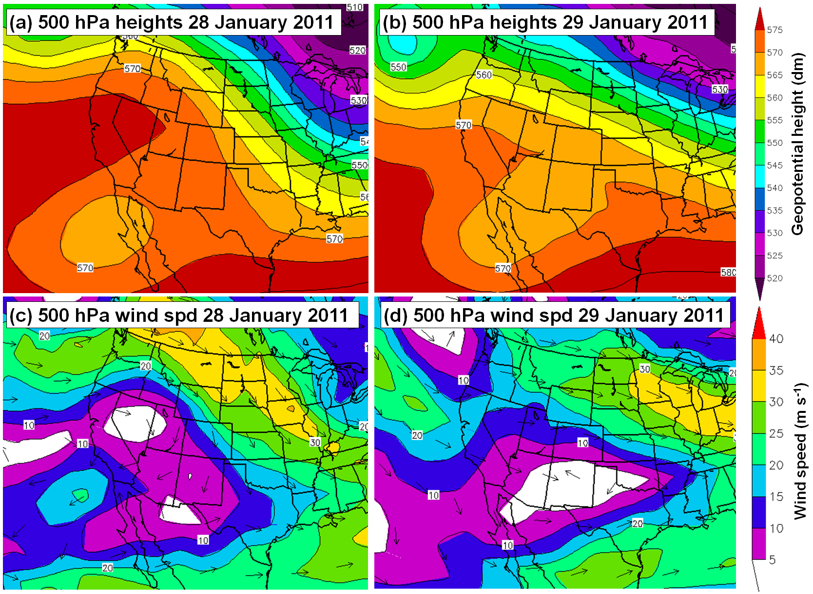
Figure 2. National Centers for Environmental Prediction Daily Analyses of 500-hPa geopotential heights for (a) 28 January 2011 and (b) 29 January 2011 and 500-hPa wind vectors for (c) 28 January 2011 and (d) 29 January 2011. Images provided by the NOAA ESRL from their web site at http://www.esrl/noaa/psd.

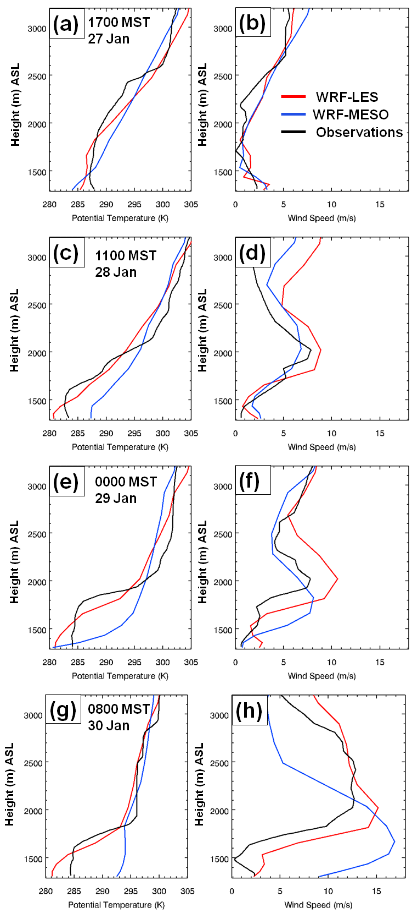

Figure 3. Observed and simulated vertical profiles of potential temperature (K, left panels) and wind speed (m s⁻¹, right panels) at the ISS site for (a-b) 1700 MST 27 January 2011, (c-d) 1100 MST 28 January 2011, (e-f) 0000 MST 29 January 2011, and (g-h) 0800 MST 30 January 2011.
The channelled ageostrophic flow and the resulting mountain waves are two important factors that are critical for turbulent erosion at top of the Salt Lake Valley cold air pools (Lareau and Horel 2015a, b). In addition, southerly gap drainage flows into the Salt Lake Valley from the adjoining Utah Valley are often enhanced by enhanced cooling and colder temperatures in the Utah Valley. These southerly katabatic flows, most common at night, can persist during both night and daytime hours during favorable conditions (Crosman and Horel 2016).
On 29 January 2011, the shortwave ridge over the intermountain west began to weaken with 500 hPa heights lowering around 10 dm and westerly wind speeds increasing to 15-20 m s⁻¹ (Figure 2b and d). The ageostrophic jet at the top of the inversion resulted in a contraction and slight lowering of the capping inversion to around 400 m above the surface as the southerly jet strengthened and deepened between 0000 MST 29 January and 1500 UTC 30 January 2011 (Figure 3e-h). The relative humidity within the cold-air pool increased during the 28 January into the 29 January 2011 (Figure 4a), with low clouds becoming relatively widespread throughout the Great Salt Lake Basin during 29 and 30 January (not shown).
3.2 27-30 Comparison of WRF-LES and WRF-MESO Simulations
The modeled and observed spatiotemporal evolution of the vertical profiles of potential temperature, wind speed, and relative humidity are shown in Figures 3 and 4. Overall, the WRF-LES CTL simulation of these variables agreed with observations better than the WRF-MESO simulation.

The overall depth and vertical temperature gradient of the cold-air pool is more realistically modeled by WRF-LES than the WRF-MESO simulation, particularly during the second half of the episode (Figures. 3 and 4). The potential temperature gradient of 0.01 K m⁻¹ noted between 1800 and 2500 m above sea level (ASL) between 28 and 30 January in the WRF-LES run is around twice the magnitude noted in the WRF-MESO simulation (Figure 4b-c). However, the WRF-LES is unable to replicate the very sharp vertical potential temperature gradients of up to 0.03 K m⁻¹ observed (Figure 4a). The depth of the low-level cold pool during the entire 4-day simulation was also greater in the WRF-LES CTL simulation than in the WRF-MESO simulation.

During the first 36-hr of the cold-air pool evolution, the vertical temperature and wind speed profiles were relatively similar between the WRF-LES and WRF-MESO simulations, although the cold-air pool was somewhat deeper in the WRF-LES simulation (Figures. 3a-b, 4b-c). However, as the large-scale synoptic flow above 750 hPa increased between 29-30
January (Figure 3f and h), the WRF-LES CTL simulation retained a realistic cold-air pool structure with cold air remaining trapped below 2000 m ASL, whereas in the WRF-MESO
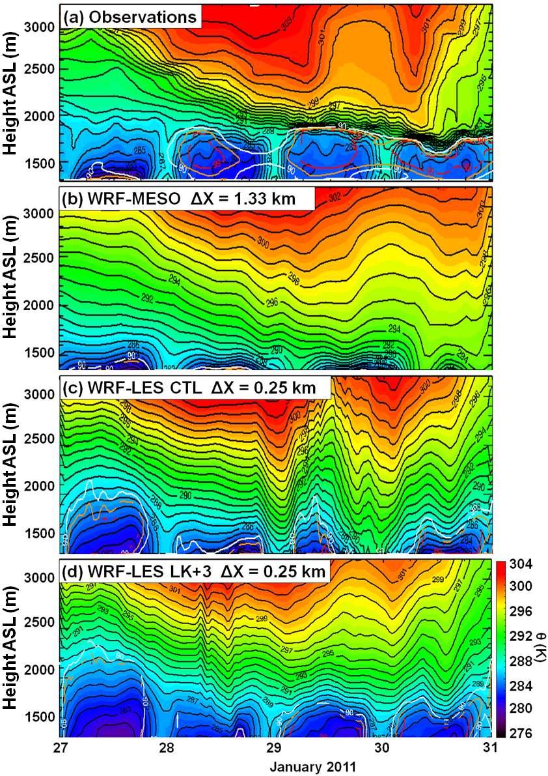
Figure 4. Time-height of potential temperature (K) and relative humidity (%) at ISS from (a) PCAPS observations, (b) WRF-MESO simulation,(c) WRF-LES CTL simulation and (d) WRF-LK+3 simulation. Relative humidity coutours of 90%, 95%, and 99 % are denoted by white, orange, and red lines, respectively. 24-h periods begin and end at 0000 UTC (1700 MST).
in the WRF-MESO simulation, although still not as deep as the observations during the last 48-h of the simulation (Figures 3 and 4a-c).

the vertical profile of potential temperature in the boundary-layer below an elevation of 1700 ASL became unrealistically warm as the cold pool was prematurely mixed out (Figures. 3 and 4).
This premature mix-out of the cold pool and the resulting warm low-level temperature bias in the WRF-MESO simulation is hypothesized to be the result of the inaccurate treatment of turbulence in the stable boundary-layer by the YSU PBL scheme, given that the WRF-MESO and WRF-LES configurations use am nearly identical configuration other than the different grid resolutions and the YSU PBL scheme turned on (off) in the WRF-MESO (WRF-LES) simulations. The differences in the evolution of the cold-air pool in these two simulations are thus likely the result of increased downward momentum transport associated with the
over-dispersive PBL scheme in the WRF-MESO simulation compared to the WRF-LES, although other factors such as differences in low clouds, model grid spacing and terrain resolution between the two simulations could also be important. An increase in the horizontal resolution of WRF-MESO to ~750 m was tested in other simulations and did not improve results considerably in those cases (not shown).

By 1100 UTC 28 January, the temperature profile in the WRF-MESO simulation had developed a warm bias of 3-6 ºC (Figure 3c). By 0000 MST 29 January 2011, the continued mechanical mixing of the top of the cold-air pool by the lowering ageostrophic jet in the WRF-MESO simulation resulted in an unrealistically shallow cold-air pool (Figures 3e-f and 4b). The differences in the vertical and spatial evolution of potential temperature and wind speeds in the Salt Lake Valley between the WRF-LES and WRF-MESO cases were maximized (Figure 3g-h) by 0900 MST on 30 January 2011 after an approximately 30-hr period of increasing wind speeds at 700 hPa.

As shown in Figure 3h, the ageostrophic jet in the WRF-MESO simulation is approximately of similar depth (800 m) as in the WRF-LES and observations, but the wind speeds are too high and ~500 m lower in the WRF-MESO. In contrast, the WRF-LES simulation of the ageostrophic southerly jet located within the stable layer at elevation 1700-2300 m ASL in the Salt Lake Valley agrees relatively well with observations (Figure 3h). The WRF-LES CTL simulations of potential temperature and relative humidity also agree more with observations for most of the cold-air pool evolution than the WRF-MESO simulations, with higher relative humidities noted within the cloudy low-level cold pool below 1800 m ASL with lower relative humidities associated with the windy more turbulent air aloft (Figure 4).

More detailed analysis of the spatial structure and dynamics of the modeled cold-air pools during the period of increasing ageostrophic channelled flow are shown in Figure 5. At 1600 UTC 30 January 2011 in the WRF-MESO simulation, a jet maximum is located over the central Salt Lake Valley in both the WRF-MESO and WRF-LES CTL simulations (Figure 5a-b). The overall location and intensity of the jet maximum within the Salt Lake Valley is consistent with PCAPS observations at that time (not shown). However, the jet is located too close to the surface in the WRF-MESO simulation and the corresponding vertical temperature profile is unrealistically warm and weakly stratified (Figure 4b and 5a). In contrast, the WRF-LES simulation retains the strongly stratified cold pool in the lowest 700 m of the boundary-layer, with the ageostrophic jet more realistically situated between 1700 and 2100 m ASL (Figure 4c and 5b). In addition, the WRF-LES CTL simulation captures the observed slope of the cold-air pool in the presence of the southerly ageostrophic jet, with cold-air pool depth around 150 m shallower near the Traverse Ridge where mountain wave activity occurs, than further north in the Salt Lake Valley toward the Great Salt Lake (Figure 5b). Along the top of the cold-air pool, wave patterns in the simulated potential temperature field likely arise from gravity waves resulting from southerly winds impinging on the top of the cold-air pool. The wave structures and slope of the cold-air pool in the WRF-LES CTL simulation shown in Figure 5b are consistent with PCAPS observations and idealized LES of Lareau and Horel (2015a, b). A plan view of 10-m wind speed across the Salt Lake Valley and surrounding mountains shows that the WRF-LES near-surface wind speeds remained below 5 m s⁻¹ except over the Wasatch Mountains and through the Jordan Narrows (Figure 5d). In contrast, the excessive vertical mixing and downward momentum transport associated with the premature erosion of the cold-air pool resulted in an anomalously warm and windy boundary-layer in the Salt Lake Valley compared to observations in WRF-MESO simulation (Figure 5c). The 2-m wind speed across the Salt Lake Valley and surrounding mountains shows that the WRF-MESO near-surface wind speeds remained between 5-10 m s⁻¹ over much of the Salt Lake Valley (Figure 5c). In addition, the turbulent mixing and stronger winds noted in WRF-MESO also mixed out the low clouds and higher humidity at this time over the Salt Lake Valley (Figures. 3g and 4b). Somewhat cooler and more humid conditions were simulated in WRF-MESO over the surface of the Great Salt Lake, although conditions remained warmer and drier than both observations and the WRF-LES simulation (Figures 4a-c and 5a).

The temporal evolution of 2-m air temperature and 10-m wind speed in the Salt Lake Valley between 27-31 January 2011 is shown in Figure 6. Despite the differences in depth of the simulated cold-air pool during the entirely of the simulation between WRF-LES and WRF-MESO (Figures 3-5), the surface time series of temperature and wind fields during these two simulations are similar for the first 48 hr before diverging after that time. The increased turbulent mixing aloft in the WRF-MESO simulation eroded the cold-air pool to the surface by 1700 MST 29 January and resulted in 2-6 ᵒC higher 2-m temperature and 3-5 m s⁻¹ higher 10 m wind speeds in WRF-MESO compared to WRF-LES for the remainder of the simulation (Figure 6).
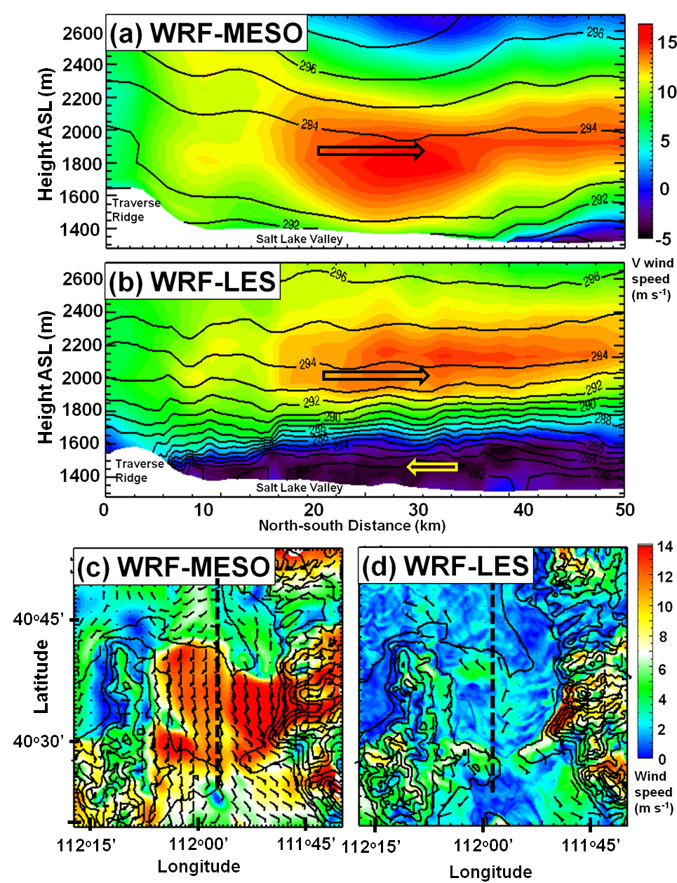

Figure 5. (a-b) North-south cross-section (shown in c and d) of the V wind component (color scale according to legend, m s⁻¹) and potential temperature (contoured every 1 K) at 0900 MST 30 January 2015 for (a) WRF-MESO simulation and (b) WRF-LES CTL simulation. (c-d) Plan-view of 10-m wind speed (color scale according to legend) and direction in the Salt Lake Valley and surroundings at 0900 MST for (c) WRF-MESO simulation and (d) WRF-LES CTL simulation. 1 wind barb = 5 m s−1, 1/2 barb = 2.5 m s⁻¹.

While the large-scale interactions between channeled winds above the low-level stable layer were simulated more realistically in WRF-LES, all simulations struggled with thermally-driven near-surface flows. The WRF-LES (WRF-MESO) run captured the down-valley katabatic jet speed and timing well on 27 (28) January but not at several other times (Figure 6b). The substantial overestimation of near-surface wind speeds in the WRF-LES simulations during two periods (overnight on 27-28 January and the daytime period on 29 January are associated with overestimation of the extent of the Jordan Narrows gap jet penetrating into the Salt Lake Valley. The WRF-LES overestimated the jet duration during the 28 January and both the jet duration and speed on 29 January, which resulted in mixing and some weakening of the thermodynamic vertical cold-air pool profile as evident by the wavy time-height pattern in potential temperature shown in Figure 4c. For example, the low-level cold pool remains less disturbed and closer to the observed structure for the WRF-LES LK+3 simulation (Figure 4a and d). As will be discussed in section 3.3, the simulated low-level jet flows in the LES are very sensitive to the near-surface vertical stability profile and the amount of near-surface cooling in the upstream Utah Valley.
3.3 WRF-LES Sensitivity to Surface State
Three WRF LES sensitivity simulations were conducted and their evolution was compared to the CTL run: warm lake (LK+3), cold lake (LK-3), and valley snow (SNW) (Section 2.2; Table 1). The simulated spatiotemporal cold-air pool boundary-layer characteristics below 500-800 m above ground level (temperature, vertical stability, wind, humidity, and cloud cover) are sensitive to changes in the surface radiation balance associated with variations in the Great Salt Lake temperature and Salt Lake Valley snow cover. A recent study by Foster et al. (2017) found that the land use and snow albedo properties are also important for cold-air pool evolution, however, in that study the impacts of changes in Great Salt Lake temperature and the differences between bare ground and snow cover in the Salt Lake Valley were not analyzed. For this study, we only crudely analyze the impact of the snow versus no snow case (similar to Neemann et al. 2015) to compare the differences between a simulation with and without snow cover.
3.3.1 Spatiotemporal Cold-Air Pool Sensitivity
At the surface, the LK-3 and SNW simulations resulted in a 1-3 ᵒC cool anomaly in the mean 2-m temperature (compared to the CTL simulation) for the aggregated 27-30 January 2011 period over the Great Salt Lake and Salt Lake and Tooele Valleys (Figure 7). The decreased surface sensible heat fluxes in the SNW simulation over the Salt Lake Valley and in the LK-3 simulation over the Great Salt Lake (Figure 8) resulted in lower temperatures and higher relative humidity compared to the CTL and LK+3 simulations, and consequently extensive low cloud and fog formation and persistence over the Salt Lake Valley at night and over the Great Salt Lake during both day and night during 27-30 January period (Figure 9). Despite the ‘insulating’ impact of the low clouds on increasing the mean surface sensible heat flux in the Salt Lake Valley and surrounding land surfaces in the LK-3 case (Figure 8f), these flux increases were unable to overcome the net sensible cooling of the cold lake on the cold-air pool in the Salt Lake Valley through advection of colder air from the Great Salt Lake into the Salt Lake Valley during the afternoon in the LK-3 simulation (Figure 7e-f). The reduced incoming daytime shortwave radiation associated with the increased cloud cover in LK-3 also resulted in less ground heat flux (not shown) during the daytime. On 28 January the extensive and persistent low clouds over the Great Salt Lake and Salt Lake Valley during the daytime heating cycle in the SNW and LK-3 cases resulted in reflection of incoming solar radiation and further net cooling of the cold-air pool compared to the LK+3 and CTL case where the low clouds had dissipated during the daytime (Figure 10). These low clouds over the lake persisted for the remainder of the cold-air pool in the SNW and LK-3 simulations. Afternoon onshore lake breeze and upslope flows were able to transport colder air into the Salt Lake Valley in the LK-3 case, helping to cool the Salt Lake Valley boundary-layer (Figures 7e and 10c).

Spatiotemporal variations in the sensitivity to prescribed land surface variations were also noted (Figures 7-9). The largest surface cool anomalies in LK-3 and SNW compared to the CTL case were observed during the daytime (Figure 7a, e). In the LK-3 simulation, sensible heat fluxes from the colder water surface combined with cloud radiative feedbacks and transport of cold lake air inland by afternoon thermally-driven flows resulted in 2-3 ᵒC

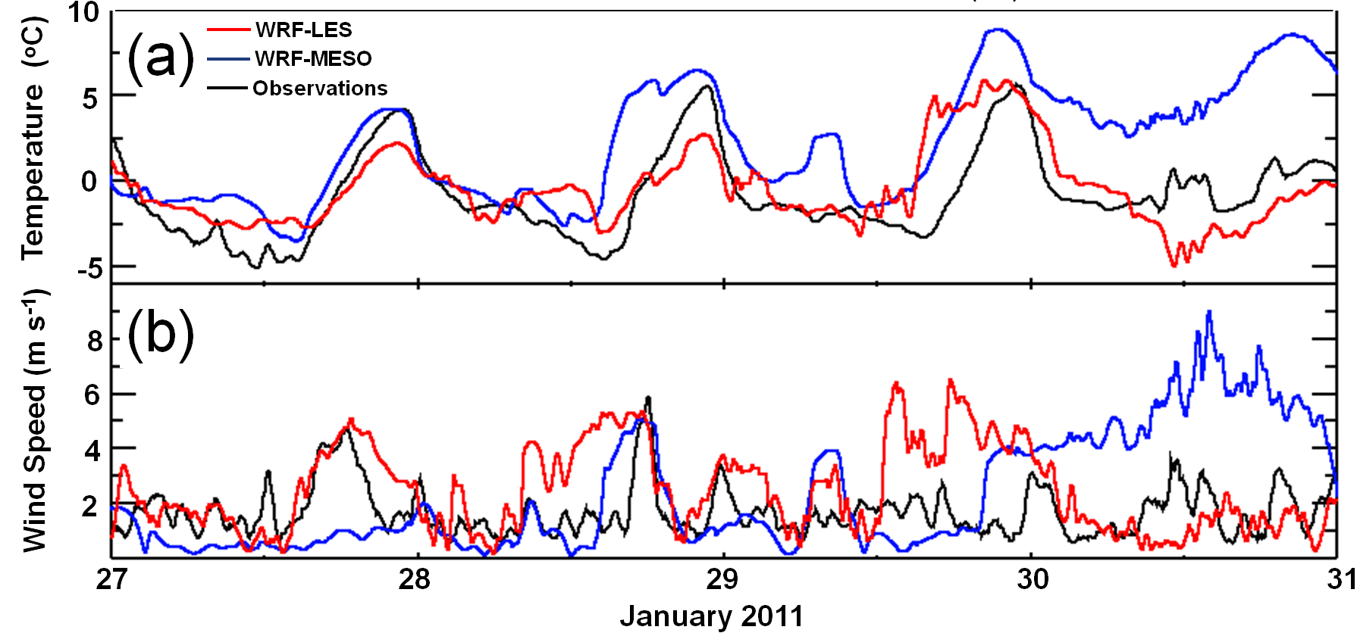
Figure 6. Simulated and observed meteograms of (a) temperature (ᵒC) and (b) 10-m wind speed (m s⁻¹) at ISFS7 between 27-30 January 2011. 24-hr periods begin and end at 0000 UTC (1700 MST).

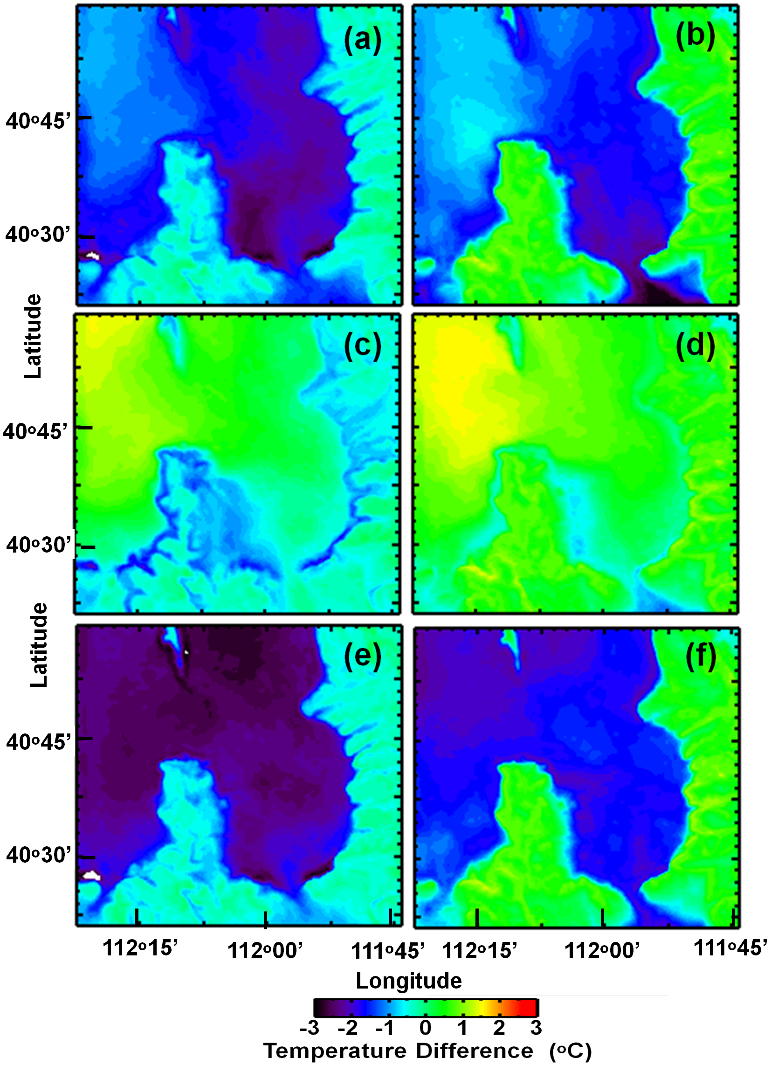
Figure 7. 2-m temperature difference (ᵒC, case - control) in the Salt Lake Valley and surroundings over the simulation period for (a, c, e) daytime and (b, d, f) nighttime. (a-b) for SNW-CTL, (c-d) LK+3-CTL, (e-f) LK-3-CTL. Daytime is defined as the period between 0900 – 1659 MST and nighttime is defined as the period between 1900 and 0400 MST .
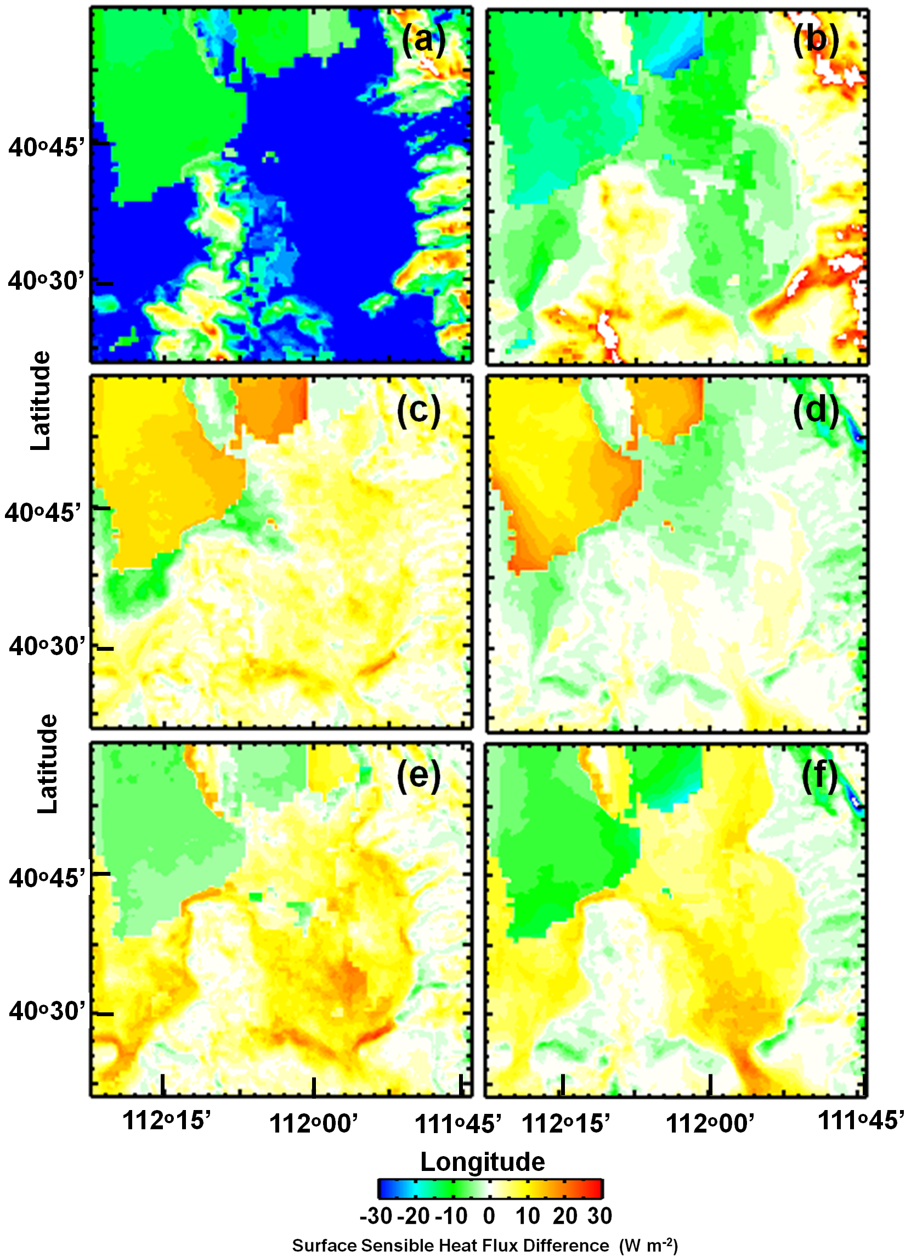

Figure 8. Difference in the land surface sensible heat flux (W m⁻²) over the simulation period for daytime (a, c, e) and nighttime (b, d, f). (a-b) for SNW-CTL, (c-d) LK+3-CTL, (e-f) LK-3-CTL. Daytime is defined as the period between 0900 – 1659 MST and nighttime is defined as the period between 1900 and 0400 MST .

decrease in mean air temperature over much of the Great Salt Lake basin, and an increase in cloud water compared to the CTL simulation (Figures 7-9). In the SNW simulation, a similar anomaly pattern in daytime cloud water was observed, but the largest decrease in daytime air temperature was found over snow-covered valley surfaces rather than the lake surface due to local snow albedo effects, decreased sensible heat fluxes, and increased daytime low cloud cover over those areas (Figures 7a, 8a, 9a.). In contrast, in the simulation with high Great Salt Lake temperatures (LK+3), warm thermal anomalies are observed over the Great Salt Lake surface, particularly at night (Figure 7c-d). These warm anomalies are also associated with a decrease in nocturnal fog formation over the lake surface as the sensible heat fluxes from the lake prevented the near-surface air from cooling to its dew point temperature (Figures 8d and 9d). The positive temperature anomalies and nocturnal decreases in low cloud cover in the LK+3 case, however, remain mostly fixed to the Great Salt Lake and do not extend into the Salt Lake or Tooele Valleys to the extent that the cool and cloudy anomalies do in the LK-3 and SNW simulations (Figures 7 and 9). A reason for this may be that the cooler and cloudier boundary-layer air over the Great Salt Lake in the LK-3 and SNW cases is advected inland by thermally-driven up-valley flows and lake breezes during the daytime, thus the cooling at the lake surface is redistributed inland during the afternoon. However, no parallel flow mechanism exists to transport the warm anomalies noted over the Great Salt Lake into the surrounding land surfaces, although in the warm lake case, the daytime lake breeze circulation is weakened. The weakened lake breeze circulation decreases the magnitude of the afternoon cold air advection and results in a 100-200 m deepening of afternoon mixed layers in the LK+3 simulation relative to the CTL, SNW, and LK-3 simulations. Consequently, cool anomalies are noted during daytime on the valley slopes in the LK+3 simulation since greater convective daytime mixing results in the development of a deeper daytime mixed layer beneath the capping temperature inversion in the LK+3 simulation. This results in a lifting in elevation of the cold-air pool capping temperature inversion in the LK+3 simulation relative to the CTL, SNW, and LK-3 simulations (Figures 7 and 10).

The cooling effect of the cold Great Salt Lake (LK-3) resulted in dense fog in the lowest 200 m above the lake surface on Jan 29 and 30 (Figure 10d). Increased cloud cover was noted during both the daytime and nighttime over the Great Salt Lake and surroundings valleys in the SNW and LK-3 simulations relative to the CTL simulation, which likely contributed to net cooling of the cold-air pool. In the SNW case, colder air draining over the lake from the surrounding land at night resulted in a colder and thus higher humidity resident air mass over the lake during the night. That air mass persisted into the following day due to the more extensive cloud cover throughout the basin and snow albedo feedbacks over the land surface which inhibited mixing and dissipation of the clouds (Figure 10b). In the LK-3 case, a colder lake surface resulted in sensible cooling of the overlying air (primarily during the daytime), similarly contributing to a higher average relative humidity

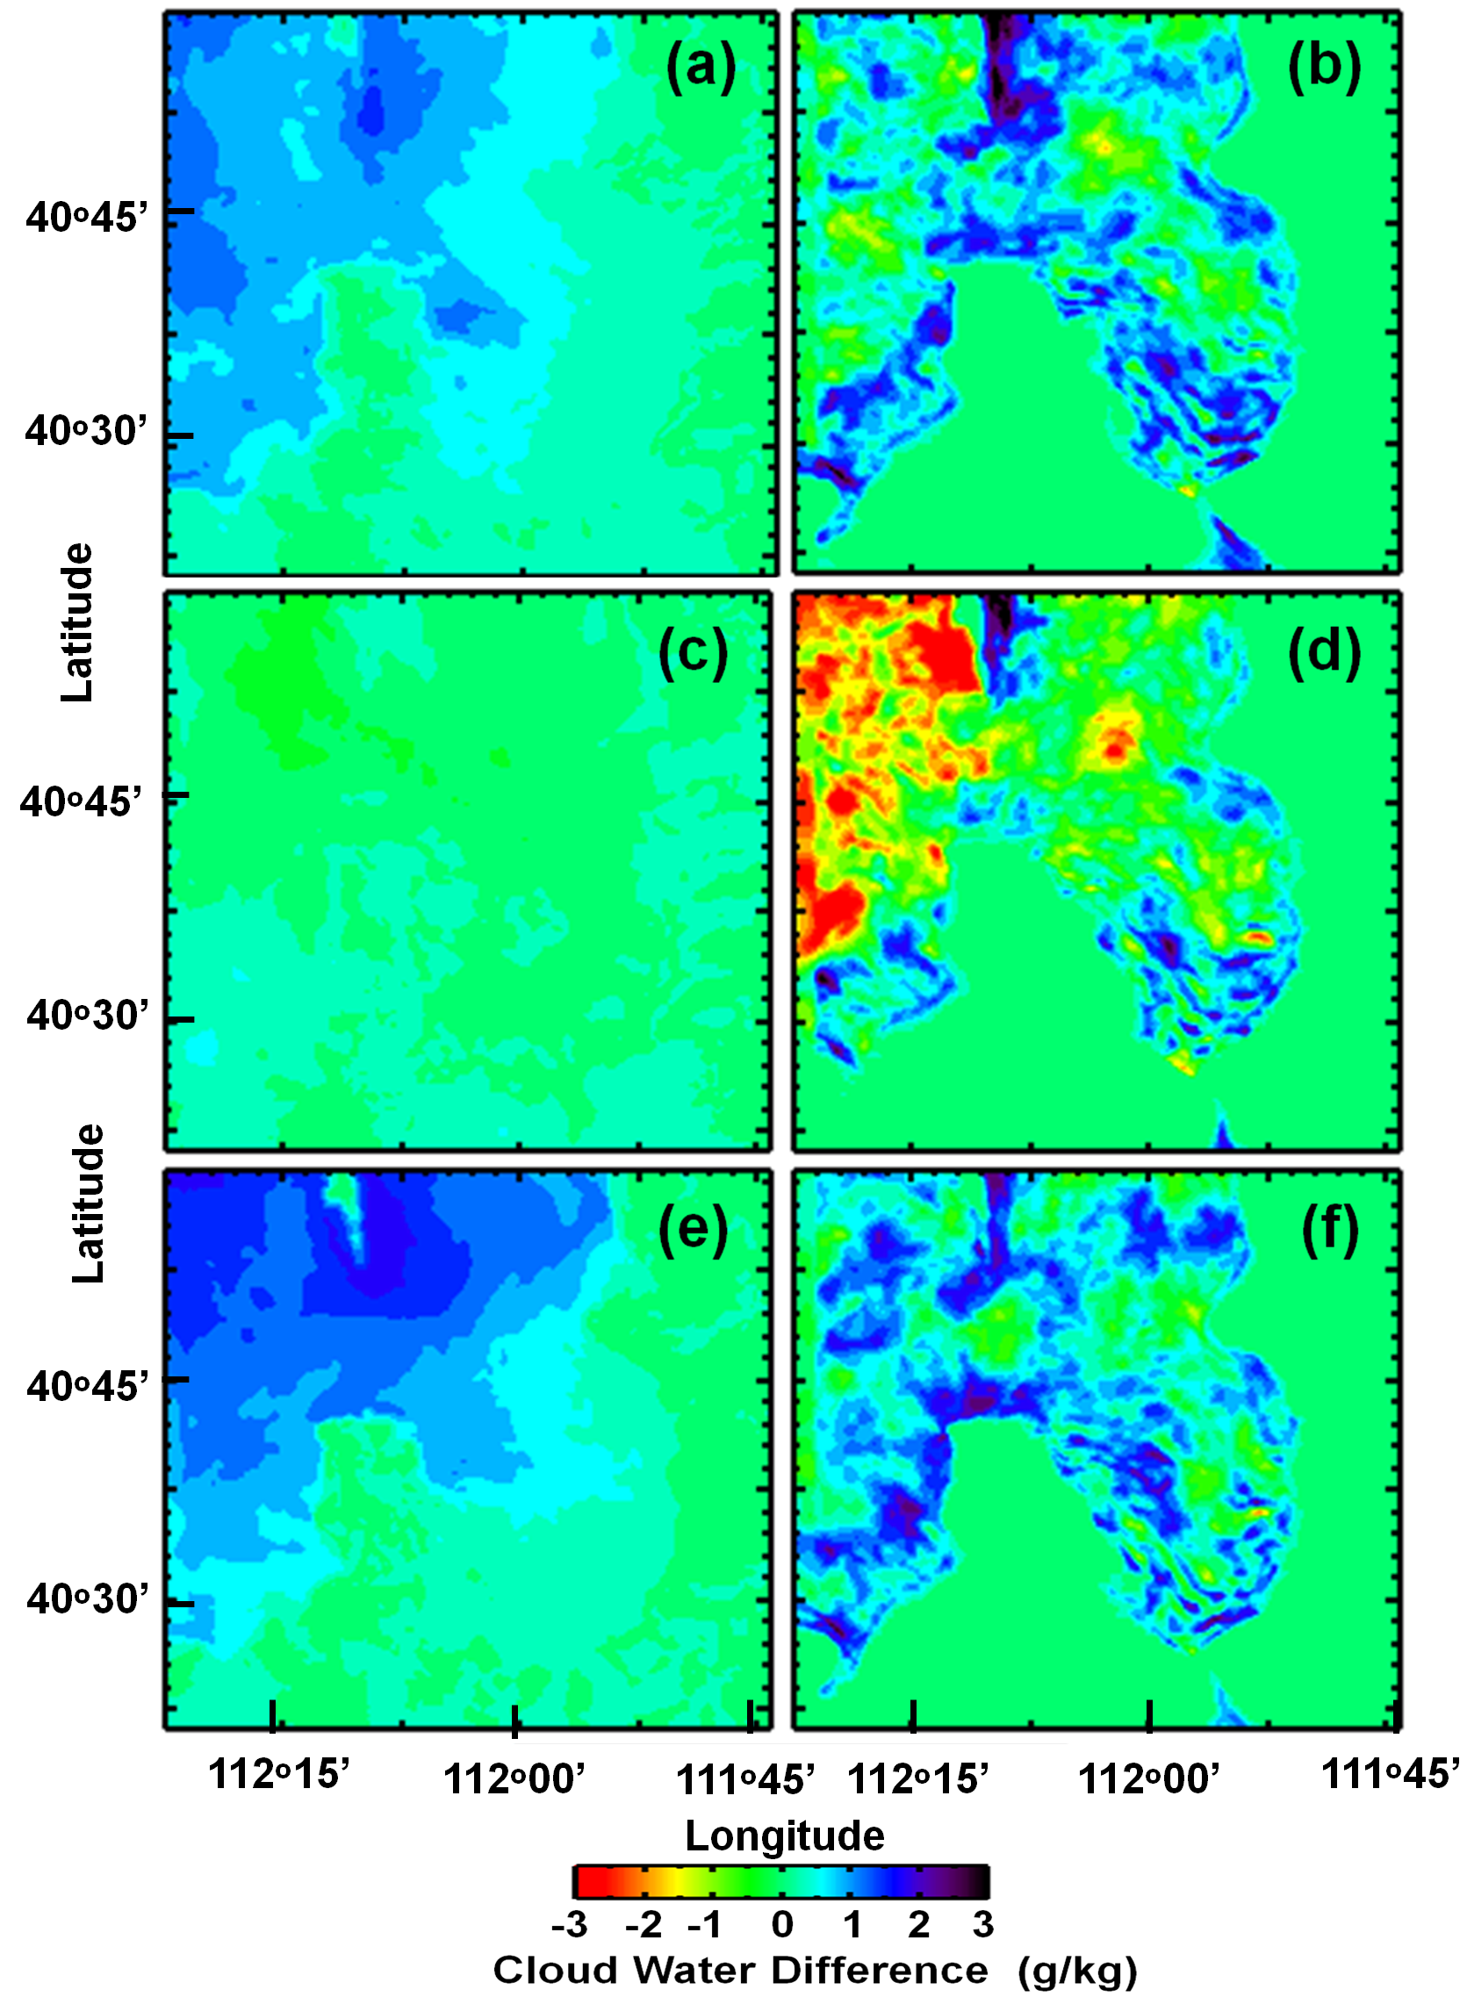

Figure 9. Difference in integrated cloud water (g kg⁻¹) in lowest 10 model levels over the simulation period for daytime (a, c, e) and nighttime (b, d, f). (a-b) for SNW-CTL, (c-d) LK+3-CTL, (e-f) LK-3-CTL. Daytime is defined as the period between 0900 – 1659 MST and nighttime is defined as the period between 1900 and 0400 MST .

resident air mass and more persistent clouds over the Great Salt Lake compared to the CTL simulation. During the nighttime, the enhanced clouds in LK-3 and SNW are most apparent along the edge of the terrain slopes, where saturation of the cooler boundary layer occurred earlier in the evening, yielding longer periods of nocturnal fog and low clouds than in the CTL case (Figure 9b, f). In the SNW simulation, nighttime surface fog was also enhanced over the foothills where surface radiative cooling associated with snow cover overlaps with a near-saturated stable layer (Figures 7b and 9b). In the LK-3 simulation, the overall cooler and higher relative humidity boundary-layer over the lake is transported into the surrounding valleys regions during the afternoon by upvalley thermally-driven flows, resulting in earlier nocturnal fog formation in those areas (Figure 9f).

3.3.2 Vertical Cold-Air Pool Evolution
Variations in surface heating and cooling modulate the vertical profiles of stability in the Salt Lake Valley and over the Great Salt Lake in each case. The cumulative effects of variations in surface fluxes on the vertical temperature profiles in the lowest 100-350 m of the boundary layer in the Salt Lake Valley are apparent in Figure 10. In the SNW simulation, afternoon mixed layers in the Salt Lake Valley are very shallow (~150-200 m deep) due to the higher albedo and reduced solar heating associated with the snow cover (Figure 10a). In contrast, in the LK+3 simulation (Figure 10e), afternoon mixed layers in the Salt Lake Valley are ~300-400 m deep due to a lack of snow and less cloud cover and weaker onshore cool lake breeze flow. During the nighttime, the greatest nocturnal cooling and highest stability in the lowest 200 m in the Salt Lake Valley was simulated with snow cover on the ground (SNW), with similar evolution noted for the LK-3 case (Figure 10c). The nighttime low-level boundary-layer temperatures in the Salt Lake Valley were somewhat warmer in the warm lake case (LK+3) (Figure 10f).

Over the Great Salt Lake, the reduced amplitude of daytime surface heating and nocturnal cooling over the water surface also result in quasi-uniform vertical temperature profiles during both day and night, with slightly thicker cloud layers providing enhanced sub-cloud turbulence and a slight elevation of the low-level stable layer at night (Figure 10). The cumulative effects of surface fluxes from the cool lake (LK-3) and warm lake (LK+3) on the vertical temperature and cloud water profiles in the lowest 100-300 m of the Great Salt Lake boundary layer are apparent, with a shallower, colder, and cloudier vertical temperature profile noted over the lake surface in the LK-3 simulation (Figure 10c), and a consistently warmer and less stable near-surface boundary-layer in the lowest 300 m of the boundary-layer above the warm lake (Figure 10e) associated with increased sensible heat

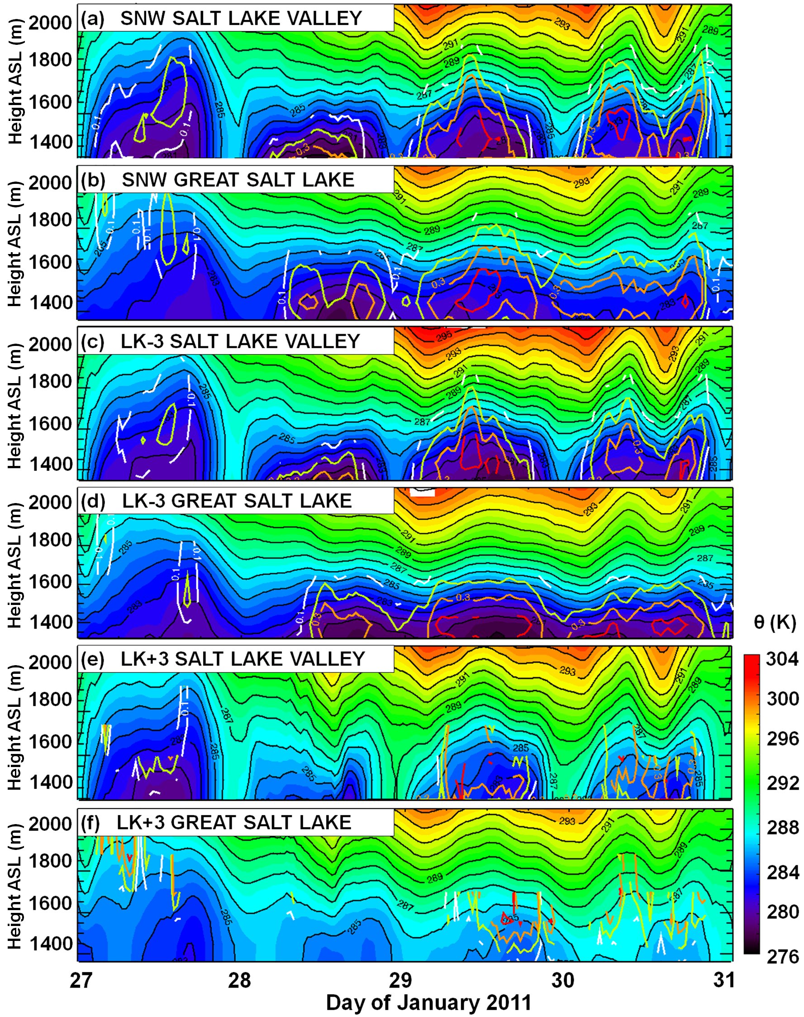
Figure 10. WRF LES simulated time-height of potential temperature (K) and cloud water (g kg-¹) between 27-30 January 2011 at ISS for (a) SNW, (c) LK-3, and (e) LK+3 simulations and over the southeastern corner of the Great Salt Lake for (b) SNW, (d) LK-3, and (f) LK+3 simulations. Cloud water amounts of 0.1, 0.2, 0.3, and 0.4 g kg−1 are denoted by white, green, orange, and red lines, respectively. 24-hr periods begin and end at 0000 UTC (1700 MST).

fluxes (Figure 8c-d). In the SNW case, nocturnal cold air drainage from surrounding land surfaces toward the Great Salt Lake (not shown) results in a similar vertical stability profile as that observed in the cold lake case (Figure 10b).

3.3.3 Boundary-Layer Flows
The high ambient vertical stability noted during the 27-31 January 2011 cold-air pool enhanced not only the sensitivity of boundary-layer temperature, relative humidity, and clouds to prescribed land surface variations, but also the sensitivity of boundary-layer flows to these variations. An example of the variability of near-surface meteorological variables during a nighttime (0500 MST 28 January 2011) period are shown in Figure 11. The thermally-driven flows that occur during Salt Lake Valley cold-air pools are crucial for transporting pollutants within otherwise largely stagnant cold-air pools (Lareau et al. 2013). During afternoon heating, northwesterly up-valley thermally-driven flows typically occur in the Salt Lake Valley, with south-southeasterly down-valley drainage flows observed at night. Multiple forcing mechanisms influence the evolution of the up- and down-valley flows. During the daytime, the up-valley circulation includes contributions from lake breeze, urban, and upslope circulations. At night, katabatic drainage flows are observed in both the Salt Lake and Utah Valleys, flowing roughly south to north, with acceleration of the katabatic exchange often noted due to channeling through the Jordan Narrow gap (Figure 1). Locally-forced downslope flows and tributary drainage flows also may contribute to the downvalley flow, but these flows have not been extensively studied or observed (Lareau et al. 2013).

The intensity and depth of the 10-m katabatic drainage flows through the Jordan Narrows was noted to vary between the four LES (not shown). For example, when the vertical stability was higher (lower) or the temperature differences between the Utah and Salt Lake Valley were lower (higher), the katabatic drainage wind speeds were typically higher (lower). During the night in the LK+3 simulation, the modeled katabatic flow between the Utah Valley and Salt Lake Valley through the Jordan Narrows was simulated with higher winds than in the other simulations, for example the LK-3 simulation (Figure 11). The lack of low-level cold air over the Great Salt Lake and Salt Lake Valley (due to warmer lake water and weaker cold advection of lake air into the Salt Lake Valley by lake breezes the prior afternoon) resulted in 5ᵒC temperature differences between the Utah and Salt Lake Valleys, resulting in katabatic pressure-driven flows into the Salt Lake Valley from the Utah Valley (Figures 11a and c). The warmer lake temperature in the LK+3 run also resulted in a deeper mixed-layer and lower stability in the lowest 250 m above the the surface than observed in the other simulations (Figures 10f and 11a), which allowed the katabatic flow to penetrate at the base of the stable layer down slope into the Great Salt Lake basin.

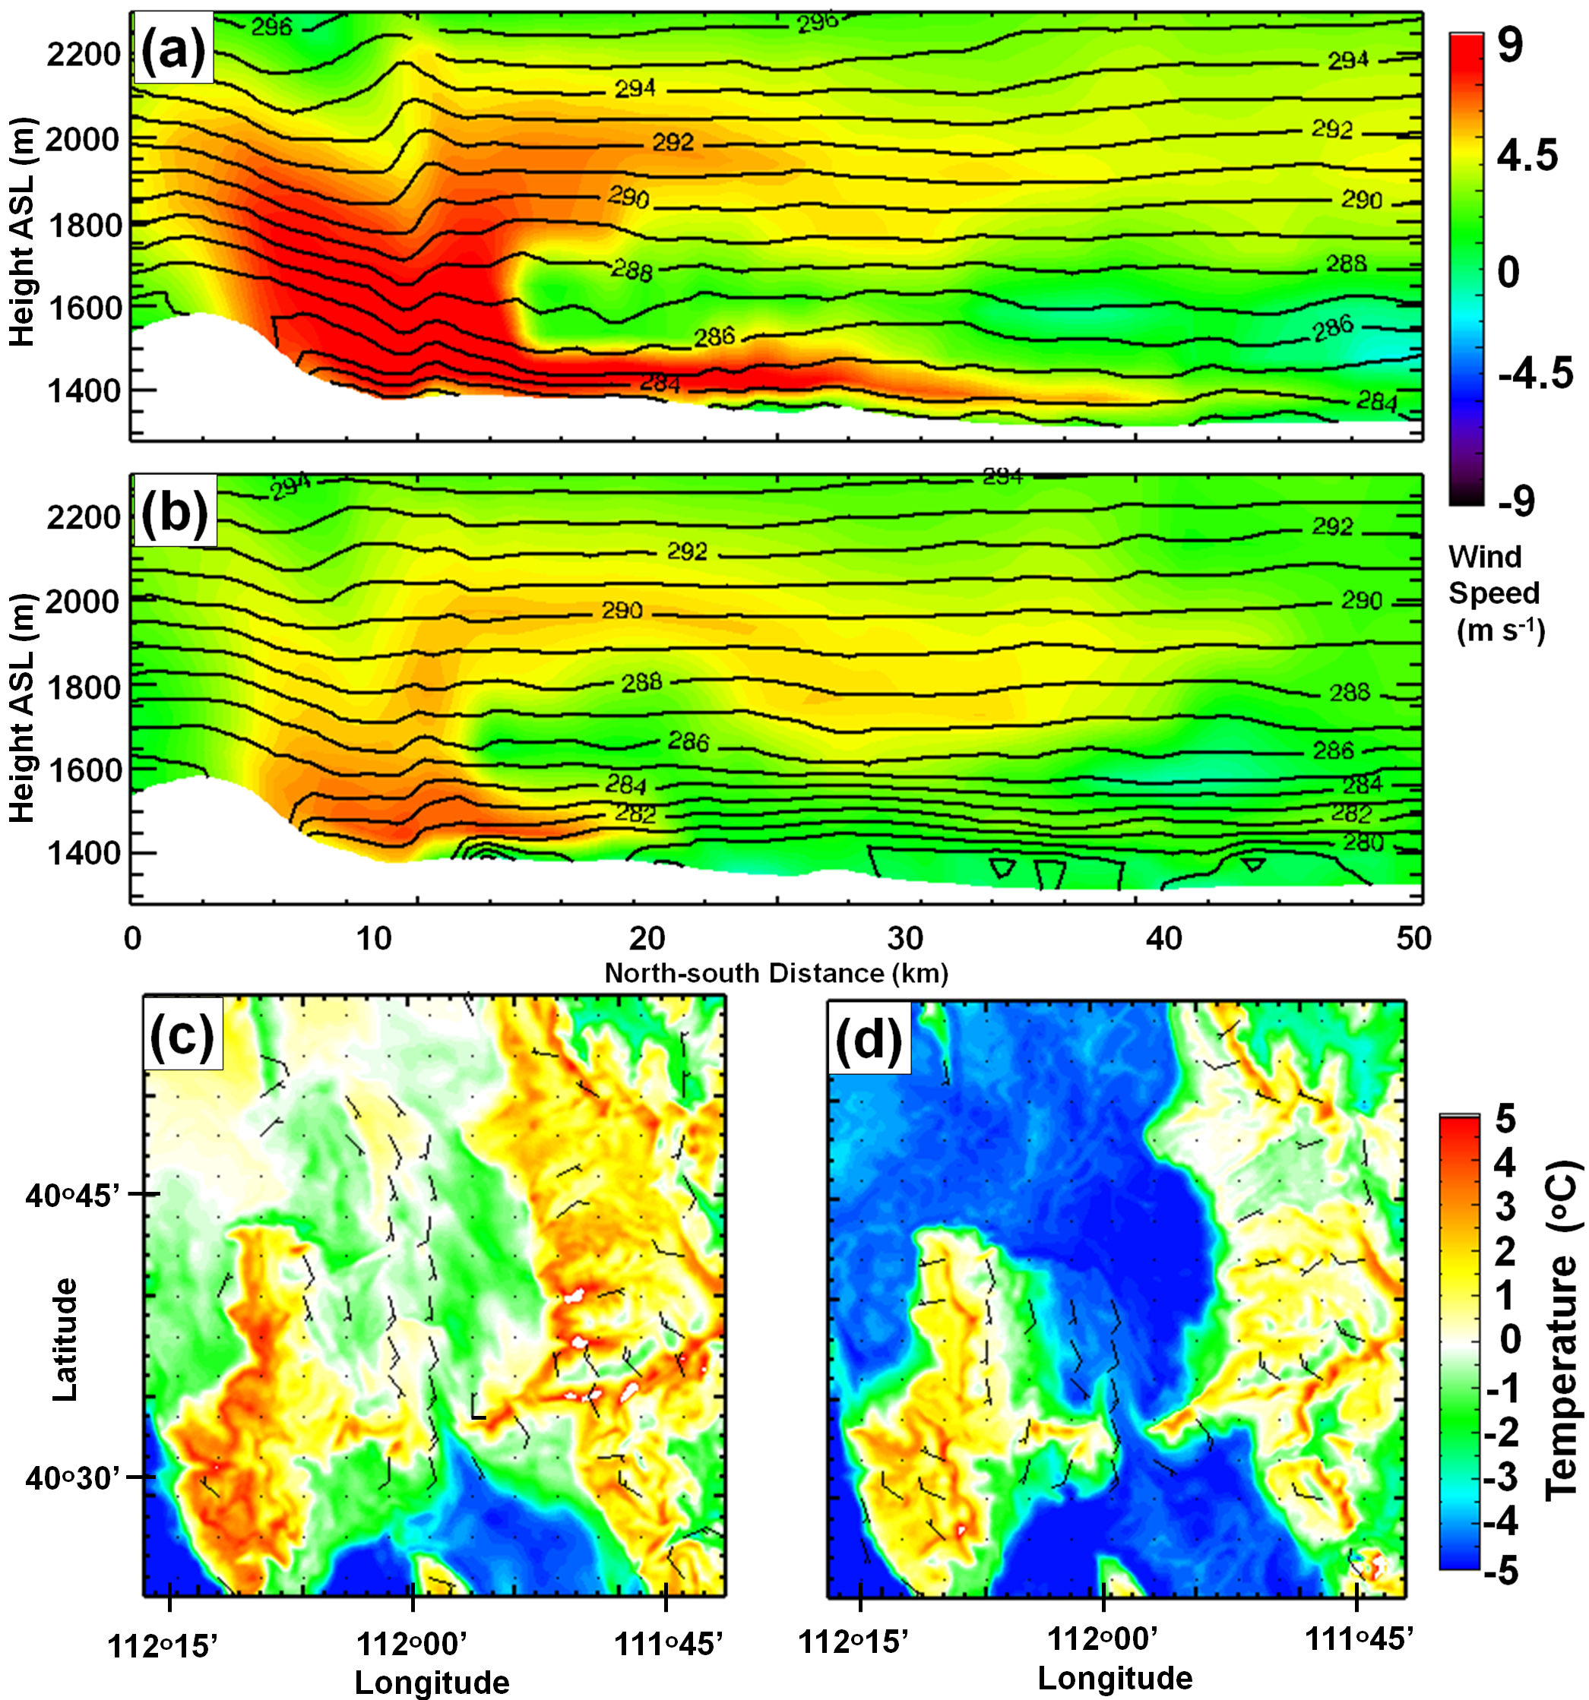
Figure 11. North-south cross-section (see Figure 1) of the V component wind (color scale according to legend, m s⁻¹) and potential temperature (contoured every 1 K) at 0500 MST 28 January 2011 for (a) LK+3 and (b) LK-3 simulation. Positive wind speeds represent southerly winds (vector pointing toward the right) and negative wind speeds represent norhterly winds (vector pointing to the left). (c-d) Plan-view of 2-m temperature (color scale according to legend) and wind speed and direction at 0500 MST 28 January 2011 for (c) LK+3 and (d) LK-3 simulation. 1 wind barb = 5 m s−1, 1/2 barb = 2.5 m s⁻¹.

In more stable situations, such as observed when the lake is cold (LK-3), the drainage katabatic flow is unable to penetrate to the surface into the Salt Lake Valley, instead remaining trapped within an elevated stable layer outside of the gap flow that occurs immediately downstream of the Jordan Narrows (Figure 11b). Enhanced katabatic gap flows through the Jordan Narrows were frequently observed during snow-covered cold-air pools during PCAPS (Lareau et al. 2013).

During the daytime, the same factors listed for nighttime flows remain important, but the modulating effects of cloud cover and land use variations (e.g., urban vs non-urban) on the surface fluxes and thermally-driven flows are more pronounced than at night (not shown). During the afternoon, horizontal gradients in diurnal surface heating were modulated by low cloud, snow cover, lake temperature, and land use variations. On 1700 MST 28 January 2011, widespread clouds remained during the afternoon over the Great Salt Lake and northern Salt Lake Valley in the SNW simulation, with minimal clouds simulated in the LK+3 simulation (Figure 10b, f). This resulted in a stronger low-level horizontal temperature gradient and thermally-driven upvalley circulation in the SNW simulation that extended 250 m above the surface (not shown).
- Discussion and Future Work
In this study we have demonstrated that the WRF model run in a coarse LES mode (ΔX=250 m) was able to better simulate the evolution and turbulent erosion of a persistent cold-air pool compared to a mesoscale WRF model configured with a standard PBL scheme (ΔX=1333 m). It is well-known that PBL schemes struggle to correctly represent the turbulent erosion of cold-air pools, although more testing of the various PBL schemes in stable conditions is needed (Banks et al. 2016). For the cold-air pool modeled here, the YSU PBL scheme used in the WRF-MESO simulation was likely over-dispersive and accelerated top-down turbulent erosion processes.

The importance of properly characterizing the model surface state in cold-pool simulations has also been demonstrated. During shallow cold-air pools, there is a heightened sensitivity of clouds, vertical temperature profiles, and thermally-driven flows in the lowest 500 m of the atmosphere to variations in the model surface state (e.g., Great Salt Lake temperature and snow cover). This heightened sensitivity is due in part to the high ambient stability and long cold-air pool duration, both factors that act to allow the effects of surface flux errors to aggregate in the boundary-layer over time.
This sensitivity highlights the uncertainty introduced by typical errors associated with prescribing Great Salt Lake surface temperature and fractional snow cover for operational numerical weather prediction models in northern Utah.

This study highlights the importance of correctly representing both land use, lake temperature, and snow cover during cold-air pools. An unexpected finding is that Great Salt Lake temperature variations consistent with climatological variability or errors in the prescribed lake surface temperature in operational weather models (Crosman and Horel 2009) results in relatively large changes in basin cold-air pool evolution. Equally surprising is that adding snow cover to the simulation did not have a notably larger impact on the Salt Lake Valley cold-air pool than a climatologically cold lake surface. In the Uintah Basin, Neemann et al. (2015) found that surface temperatures during a cold-air pool were 8 ºC colder when snow cover was prescribed. In this simulation, however, the addition of snow only decreased the mean 2-m temperatures by 2-3 ºCover the Salt Lake Valley. These differences illustrate the impact of urban land use and the adjacent snow-free Great Salt Lake on limiting the additional radiative cooling over the snow surface in the Salt Lake Valley compared to the barren Uintah Basin. In this study, for the most part default WRF option are used, which have obvious known limitations. For example, the urban core in the WRF USGS land use specification (Figure 1) is primarily in the central and eastern Salt Lake Valley. However, the urbanized region extends over a larger portion of the Salt Lake Valley than that (Foster et al. 2017).

This study illustrates the utility of running a targeted LES domain for boundary-layer simulations in complex terrain. Additional rigorous testing of the WRF-LES configuration in complex terrain is needed. While the WRF-LES performed better than the WRF-MESO configuration for this particular simulation, more work is needed to better understand the WRF-LES and WRF-MESO model limitations and weaknesses in simulating cold-air pools. Improving our understanding of when and how much improvement is gained through LES will be the topic of future work. Future work is needed to address other issues such as: nest boundary errors, model sensitivity to domain size and grid resolution, sub-grid scale model choice, and boundary conditions. Unfortunately, numerical constraints make testing LES a computationally expensive exercise. For instance, a 24 hour LES simulation configured as in Table 1 takes 5-7 days running in parallel on several hundred processors. Much work also remains to better understand how to optimize these simulations (e.g., how many embedded nests, vertical and horizontal resolution, what resolution of terrain and land use, etc.). For these simulations, obtaining a stable simulation required smoothing the topography (Figure 2c) and vertical grid spacing > 50 m. In the future, the smoothing required for these simulations may not be needed with the use of the currently under-development WRF immersed boundary method (IBM) (Lundquist et al. 2010) and other improvements to LES being tested in complex terrain (e.g., Marjanovic et al. 2014, Daniels et al. 2016). A larger domain to ensure noisy boundary conditions do not propagate into the region of interest would be preferred if computational capabilities allowed. The horizontal resolution was not decreased to order 100 m typically recommended for LES simulations because such a small grid would be computationally unfeasible at this time over such a large domain. To run such a simulation, a very small inner domain would have been required, and it was critical to this study that the boundary-layer evolution in the entire Salt Lake Valley and surrounding regions that interact through local flows with the Salt Lake Valley (Great Salt Lake, Utah Valley, and surrounding mountains) be resolved. Finally, a comparison of LES simulations with lower-resolution mesoscale models may help further understanding of the types of cold pool situations where mesoscale models struggle the most, and what aspects of those models require the most improvements (e.g., microphysics, PBL, or surface layer schemes). In addition more rigorous testing of the potential impacts of increasing both the number of vertical levels and horizontal resolution of the WRF-MESO compared to the WRF-LES simulations is needed. For example, a WRF-MESO simulation at higher resolution than 1.33 km may be able to capture terrain-flow interactions, gap flows, and vertical stable layers better than the simulation undertaken here.

The sensitivity of cold-air pool mixing height and thermally-driven flows to variations in Great Salt Lake temperature and low elevation snow cover is substantive. While no chemical or pollutant tracer model was coupled to the simulations described herein, the differences in simulated boundary-layer small particulate (PM_{2.5}) pollutant concentration and transport would likely co-vary with variations in the simulated boundary-layer flows. Future work will use recently added tracer capabilities in WRF to look at the overall movement of particles within the cold-air pool. Coupling the output from numerical simulations with Utah Division of Air Quality photochemical modelling may also help improve the understanding of linkages between cold-air pool characteristics and pollutant build-up.

The level of the Great Salt Lake has decreased from recent drought to near historic lows. At these levels, the surface area of the lake is decreased more than 30% relative to average water levels (Crosman and Horel 2009), and the heat capacity of the shallower Lake is decreased as well. In this study, the default UGSG Great Salt Lake elevation from 2001 USGS data set was used, which overestimates the size of the Lake. Future work will be conducted to better understand the impact of changes in the Great Salt Lake surface area and heat capacity on cold-air pools. (e.g., using a coupled lake model, or simple slab model representation of the Lake temperature rather than treating it as a constant (Strong et al. 2014).

Finally, the population of Utah is expected to roughly double in the next 25 years (Utah Governor's Office of Planning and Budget Report: Demographic and Economic Analysis). Consequently, the Salt Lake Valley will become increasingly urbanized over the next several decades. Since urban areas tend to retain less snowpack and melt snowfall sooner than rural areas, the Salt Lake Valley is likely to have decreasing snow albedo impacts on cold-air pools in the future. In addition, anthropogenic climate effects may increase the frequency of wintertime rain events, further decreasing the mean wintertime snow cover in the Salt Lake Valley (Ashfaq et al. 2013). Since urban areas also tend to be warmer than surrounding non-urban areas in wintertime, that would also further decrease the intensity of cold-air pools in the Salt Lake Valley (Malevich and Klink 2011). Thus, the results from this study suggest that future Salt Lake Valley cold-air pool frequency and intensity and attendant pollutant concentrations will likely be affected by both urban sprawl in the Salt Lake Valley, the level of the Great Salt Lake, and changes in the frequency of snow-covered wintertime days resulting from anthropogenic climate change.
Acknowledgements
An allocation of computer time from the Center for High Performance Computing at the University of Utah is gratefully acknowledged. We would like to acknowledge Neil Lareau for the Great Salt Lake time-height data and C. David Whiteman for leading the PCAPS field campaign. This research was supported by the National Science Foundation [grant # ATM-0938397].
References
Ahmadov, R., McKeen, S., Trainer, M., Banta, R., Brewer, A., Brown, S., Edwards, P. M., de Gouw, J. A.,
Frost, G. J.,Gilman, J., Helmig, D., Johnson, B., Karion, A., Koss, A., Langford, A., Lerner, B.,
Olson, J.,Oltmans, S., Peischl, J., Pétron, G., Pichugina, Y., Roberts, J. M., Ryerson, T., Schnell, R.,
Senff, C.,Sweeney, C., Thompson, C., Veres, P., Warneke, C., Wild, R., Williams, E. J., Yuan, B.,
Zamora, R. 2015. Understanding high wintertime ozone pollution events in an oil and natural gas
producing region of the western US. Atmos. Chem. Phys. 15, 411-429, doi:10.5194/acp-15-411-2015.

Alcott, T. I., Steenburgh, W. J., 2013. Orographic influences on a Great Salt Lake-effect snow-storm.
Mon.Weather Rev. 141, 2432–2450. doi:10.1175/MWR-D-12-00328.1.

Ashfaq, M., Ghosh, S., Kao, S.C., Bowling, L.C., Mote, P., Touma, D., Rauscher, S.A., Diffenbaugh, N.S.,
2013. Near-term acceleration of hydroclimatic change in the western U.S. J. Geophys. Res. Atmos.
118, 10676–10693, doi:10.1002/jgrd.5081.6

Baker, K. R., Simon, H., Kelly, J.T., 2011. Challenges to modelling “cold pool” meteorology associated
with high pollution episodes. Environ. Sci. Technol. 45, 7118–7119.

Baklanov, A. , Grisogono, B., Bornstein, R., Mahrt, L., Zilitinkevich, S.,Taylor, P., Larsen, S.
E., Rotach, W. M., Fernando, H. J. S., 2011. The nature, theory, and modeling of atmospheric
planetary boundary layers, B. Am. Meteorol. Soc. 92, 123–128, doi:10.1175/2010BAMS2797.1.

Banks, R.F., Tiana-Alsina, J., Baldasano, J.M., Rocadenbosch, F., Papayannis, A., Solomos, S., Tzanis C.G.,
2016. Sensitivity of boundary layer variables to PBL schemes in the WRF model based on surface
meteorological observations, lidar, and radiosondes during the HygrA-CD campaign. Atmos. Res.
http://dx.doi.org/10.1016/j.atmosres.2016.02.024

Blaylock, B., Horel, J., Crosman, E., 2017. Impact of lake breezes on summer ozone concentrations in the Salt
Lake Valley, J. Appl. Meteor. Climatol. 56, 353–370, doi: 10.1175/JAMC-D-16-0216.1.

Chen, F., Dudhia, J., 2001. Coupling an advanced land surface–hydrology model with the Penn State–
NCAR MM5 modeling system. Part I: Model implementation and sensitivity. Mon. Wea. Rev. 129,
569–585.

Crosman, E., Horel, J., 2009. Remote sensing of the surface temperature of the Great Salt Lake. Remote
Sens. Environ. 113, 73-81.

Crosman, E., Horel, J., 2012. Idealized large-eddy simulations of sea and lake breezes: sensitivity to lake
diameter, heat flux, and stability. Boundary-Layer Meteorol. 144, 309-328.

Crosman, E, Horel, J., 2016. Winter lake breezes near the Great Salt Lake. Boundary-Layer Meteorol. 159,
439-464, doi:10.1007/s10546-015-0117-6.

Crosman, ET.,Jacques, A.A, Horel, J.D., 2017. A novel approach for monitoring vertical profiles of
boundary-layer pollutants: Utilizing routine news helicopter flights. In press, Atmospheric
Pollution Research .

Daniels, M.H., Lundquist, K.A., Mirocha, J.D., Wiersema, J.D., Chow, F.K., 2016. A new vertical grid
nesting capability in the Weather Research and Forecasting (WRF) model. Mon. Weather Rev.,
144, 3725–3747, doi: 10.1175/MWR-D-16-0049.1.,

Dorninger, M., Whiteman, C.D., Bica, B., Eisenbach, S., Pospichal, B., Steinacker, R., 2011. Meteorological
events affecting cold-air pools in a small basin J. Appl. Meteor. Climatol., 50, 2223–2234, doi:
10.1175/2011JAMC2681.1.

Falasca, S., Catalano, F., Moroni, M., 2016. Numerical study of the daytime planetary boundary layer over an
idealized urban area: Influence of surface properties, anthropogenic heat flux, and geostrophic wind
intensity. J. Appl. Meteor. Climatol. 55, 1021–1039, doi: 10.1175/JAMC-D-15-0135.1

Fernando, H. J. S., Weil, J.C., 2010. Whither the Stable Boundary Layer?. Bull. Amer. Meteor. Soc. 91,
1475–1484. doi: http://dx.doi.org/10.1175/2010BAMS2770.1, 2010

Fernando, H.J.S., Pardyjak, E.R., Di Sabatino, S., Chow, F.K., De Wekker, S.F.J., Hoch, S.W., Hacker, J.,
Pace, J.C., Pratt, T., Pu, Z., Steenburgh, W.J., Whiteman, C.D., Wang, Y., Zajic, D., Balsley, B.,
Dimitrova, R., Emmitt, G.D., Higgins C.W., ,Hunt, J.C.R., Knievel, J.C., Lawrence, D., Liu, Y.,
Nadeau, D.F., Kit, E., Blomquist, B.W., Conry, P., Coppersmith, P.R., Creegan, E., Felton, M.,
Grachev, A., Gunawardena, N., Hang, C., Hocut, C.M., Huynh, G., Jeglum, M.E., Jensen, D.,
Kulandaivelu, V., Lehner, M., Leo, L.S., Liberzon, D., Massey, J.D., McEnerney, K., Pal, S., Price, T.,
Sghiatti, M., Silver, Z., Thompson, M., Zhang, H., Zsedrovits, T., 2015. The MATERHORN:
Unraveling the Intricacies of Mountain Weather. Bull. Amer. Meteorol. Soc. 96, 1945–1967, doi:
10.1175/BAMS-D-13-00131.1.

Foster, C., Crosman, E., Horel, J., 2017. Simulations of a cold-air pool in Utah’s Salt Lake Valley: Sensitivity
to land use and snow cover. In press, Boundary-Layer Meteorol.. doi:10.1007/s10546-
017-0240-7

Goodfriend, E., Chow, F.K.,Vanella, M., Balaras, E., 2015.Improving Large-eddy simulation or neutral
boundary layer flow across grid interfaces. Mon. Wea. Rev. 143, 3310–3326.
doi: 10.1175/MWR-D-14-00392.1.

Grim, J.A., Knievel, J.C., Crosman, E.T., 2013. Techniques for Using MODIS Data to Remotely Sense Lake
Water Surface Temperatures. J. Atmos. Ocean. Technol. 30, 2434–2451, doi:
http://dx.doi.org/10.1175/JTECH-D-13-00003.1.

Hall, S. J., Maurer, G., Hoch, S.W., Taylor, R., Bowling, D.R., 2014. Impacts of anthropogenic emissions and
cold air pools on urban to montane gradients of snowpack ion concentrations in the Wasatch , Utah.
Atmos. Environ. 98, 231-241.

Holtslag, A. A. M., Svensson, G., Baas, P., Basu, S., Beare, B., Beljaars, A. C. M., Bosveld, F. C., Cuxart, J.,
Lindvall, J., Steenveld, G. J., Tjernstrom, M., Van De Wiel, B. J. H., 2013. Stable atmospheric
boundary layers and diurnal cycles: challenges for weather and climate models, B. Am. Meteorol.
Soc. 94, 1691–1706, doi:10.1175/BAMS-D-11-00187.1.

Hong, S.-Y., Noh, Y., Dudhia, J. (2006), A new vertical diffusion package with explicit treatment
of entrainment processes. Mon. Weather Rev. 134, 2318–2341.

Huang, H.Y., Hall, A., Teixeira, J., 2013. Evaluation of the WRF PBL Parameterizations for marine
boundary layer clouds: Cumulus and stratocumulus. Mon. Weather Rev. 141, 2265-2271.

Hughes, J. K., Ross, A. N., Vosper, S. B., Lock, A. P., Jemmett-Smith, B. C., 2015. Assessment of valley
cold pools and clouds in a very high-resolution numerical weather prediction model, Geosci. Model
Dev. 8, 3105-3117, doi:10.5194/gmd-8-3105-2015.

Iacono, M. J., Delamere, J.S., Mlawer, E.J., Shephard, M.W., Clough, S.A., Collins, W.D., 2008.
Radiative forcing by long-lived greenhouse gases: Calculations with the AER radiative transfer
models. J. Geophys. Res. 113, D13103, doi:10.1029/2008JD009944.

Jiménez, P. A., Dudhia, J., González-Rouco, J. F., Navarro, J., Montávez, J. P., García- Bustamante, E.,
2012. A revised scheme for the WRF surface layer formulation. Mon. Weather Rev. 140, 898–918,
doi:10.1175/MWR-D-11-00056.1.

Joe, D.K., Zhang, H., DeNero, S.P., Lee, H.H., Chen, S.H., McDonald, B.C., Harley, R.A., Kleeman, M.J.,
2014. Implementation of a high-resolution Source-Oriented WRF/Chem model at the Port of
Oakland. Atmos. Environment. 82, 351-363.

Kain, J. S., 2004. The Kain–Fritsch convective parameterization: An update. J. Appl. Meteor. 43, 170–181.

Lareau, N. P., 2014. The Dynamics of persistent cold-air pool breakup, Ph.D. thesis, University of Utah, Salt
Lake City, Utah, 138 pp..

Lareau, N.P., Horel, J.D., 2015a: Dynamically Induced Displacements of a Persistent Cold-Air Pool.
Boundary-Layer Meteorol.154, 291-316. DOI 10.1007/s10546-014-9968-5.

Lareau, N.P., Horel, J.D., 2015b. Turbulent Erosion of Persistent Cold-Air Pools: Numerical Simulations. J.
Atmos. Sci. 72, 1409–1427doi: http://dx.doi.org/10.1175/JAS-D-14-0173.1, 2015.

Lareau, N. P., Crosman, E. T., Whiteman, C. D., Horel, J. D., Hoch, S. W., Brown, W. O. J., and Horst, T.
W., 2013. The persistent cold-air pool study, B. Am. Meteorol. Soc. 94, 51–63,
doi:10.1175/BAMS-D-11-00255.1.

Lu, W., Zhong, S., 2014. A numerical study of a persistent cold air pool episode in the Salt Lake Valley,
Utah. J. Geophys. Res. Atmos. 119, 1733-1752, doi:10.1002/2013JD020410.

Lundquist, K.A., Chow, F.K.,, Lundquist J.K., 2010. An immersed boundary method for The Weather
Research and Forecasting model. Mon Weather Rev. 138, 796-817.

Malevich SB and K Klink, 2011. Relationships between Snow and the Wintertime Minneapolis Urban Heat
Island. J. Appl. Meteor. Climatol., 50, 1884–1894. doi: http://dx.doi.org/10.1175/JAMC-D-11-05.1.

Marjanovic, N., Wharton, S. Chow. F.K., 2014. Investigation of model parameters for high-resolution wind
energy forecasting: case studies over simple and complex terrain. Journal of Wind Engineering and
Industrial Aerodynamics 134(11), 10-24. DOI 10.1016/j.jweia.2014.08.007

Massey, J.D., Steenburgh, W.J., Hoch, S.W., Knievel, J.C., 2014. Sensitivity of Near-Surface Temperature
Forecasts to Soil Properties over a Sparsely Vegetated Dryland Region. J. Appl. Meteor. Climatol. 53,
1976–1995. doi: http://dx.doi.org/10.1175/JAMC-D-13-0362.1.

Massey, J.D., Steenburgh, W.J., Knievel, J.C., Cheng, W.Y.Y., 2016. Regional soil moisture biases and their
influence on WRF model temperature forecasts over the Intermountain West. Wea. Forecasting, 31,
197–216, doi: 10.1175/WAF-D-15-0073.1.

Matheou, G Chung. D., 2014. Large-Eddy Simulation of Stratified Turbulence. Part II: Application of the
Stretched-Vortex Model to the Atmospheric Boundary-Layer. J. Atmos. Sci. 71, 4439–4460. doi:
http://dx.doi.org/10.1175/JAS-D-13-0306.1.

Mirocha, J., Kirkil, G., Bou-Zeid, E., Chow, F.K., Kosović, B., 2013. Transition and equilibration of neutral
atmospheric boundary layer flow in one-way nested large-eddy simulations using the Weather
Research and Forecasting model. Mon. Wea. Rev. 141, 918–940.

Moeng, C.H.,, Dudhia, J., Klemp, J., Sullivan, P., 2007. Examining Two-Way Grid Nesting for Large Eddy
Simulation of the PBL Using the WRF Model. Mon. Wea. Rev. 135, 2295–2311. doi:
http://dx.doi.org/10.1175/MWR3406.1.

Neemann, E. M., Crosman, E. T., Horel, J. D., Avey, L, 2015. Simulations of a cold-air pool associated
with elevated wintertime ozone in the Uintah Basin, Utah. Atmos. Chem. Phys. 15, 135-151.
doi:10.5194/acp-15-135-2015

Price, J.D., Vosper, S., Brown, A., Ross, A., Clark, P., Davies, F., Horlacher, V., Claxton, B., McGregor,
J.R., Hoare, J.S., Jemmett-Smith, B., Sheridan, P., 2011. COLPEX: Field and Numerical Studies over a
Region of Small Hills. Bull. Amer. Meteor. Soc. 92, 1636–1650.
doi: http://dx.doi.org/10.1175/2011BAMS3032.1

Reeves, H. D. Stensrud, D. J., 2009. Synoptic-scale flow and valley cold pool evolution in the western
United States. Wea. Forecasting. 24, 1625-1643. doi:10.1175/2009WAF2222234.1.

Reeves, H. D., Elmore, K. L., Manikin, G. S., Stensrud, D. J., 2011. Assessment of forecasts during
persistent valley cold pools in the Bonneville Basin by the North American Mesoscale Model. Wea.
Forecasting, 26, 447–467, doi:10.1175/WAF-D-10-05014.1.

Schalkwijk, J., Harmen J. J. Jonker, A. Pier Siebesma, and Erik Van Meijgaard, 2015. Weather forecasting
using GPU-based large-eddy simulations. Bull. Amer. Meteorol. Soc. 96, 715–723, doi:
10.1175/BAMS-D-14-00114.1.

Sheridan, P. F., Vosper, S. B., Brown, A. R., 2014.Characteristics of cold pools observed in narrow valleys
and dependence on external conditions, Q. J. Roy. Meteorol. Soc.. 140, 715– 728, doi:10.1002/qj.2159.

Shin, H. H., Hong, S., 2011. Intercomparison of planetaryboundary-layer parametrizations in the WRF
model for a single day from CASES-99. Bound.-Layer Meteorol. 139,1–21.

Silcox, G. D., Kelly, K. E., Crosman, E. T., Whiteman, C. D., Allen, B. L., 2012. Wintertime PM2.5
concentrations in Utah’s Salt Lake Valley during persistent multi-day cold-air pools, Atmos. Environ.
46, 17–24, doi:10.1016/j.atmosenv.2011.10.041.

Skamarock, WC, Klemp JB, 2008. A time-split nonhydrostatic atmospheric model for weather research and
forecasting applications. J. Comput. Phys. 227,3465-3485.

Strong, C., A. K. Kochanski, Crosman, E.T., 2014: A slab model of the Great Salt Lake for regional climate
simulations, J. Adv. Model. Earth Syst., 6, 602–615.

Talbot C., Bou-Zeid, E., Smith, J., 2012. Nested mesoscale large-eddy simulations with WRF: Performance in
real test cases. J. Hydrometeorol. 13, 1421–1441. doi: http://dx.doi.org/10.1175/JHM-D-11-048.1

Teixeira, J., and Coauthors, 2008. Parameterization of the Atmospheric Boundary Layer: A view from just
above the inversion. Bull. Amer. Meteorol. Soc., 89, 453–458.
doi: http://dx.doi.org/10.1175/BAMS-89-4-453

Thompson, G., Field, P.R., Rasmussen, R.M., Hall, W.D., 2008. Explicit forecasts of winter precipitation
using an improved bulk microphysics scheme. Part II: Implementation of a new snow
parameterization. Mon. Wea. Rev. 136, 5095–5114.

Wei, L., Pu, Z., Wang, S., 2013. Numerical Simulation of the Life Cycle of a Persistent Wintertime Inversion
over Salt Lake City. Boundary-Layer Meteorol. 148, 399-418.

Whiteman, C.D., S. Zhong, W. J. Shaw, J. M. Hubbe, X. Bian, and J. Mittelstadt, 2001. Cold
pools in the Columbia basin. Wea. Forecasting, 16, 432-447.

Whiteman, C.D., Hoch, S.W., 2014. Pseudovertical temperature profiles in a broad valley from lines of
Temperature sensors on sidewalls. J. Appl. Meteor. Climatol. 53, 2430–2437, doi: 10.1175/JAMC-D-
14-0177.1.

Whiteman, C. D., Hoch,S.W., Horel, J.D., Charland, A., 2014. Relationship between particulate air
pollution and meteorological variables in Utah's Salt Lake Valley. Atmos. Environ. 94, 742-753.

Young, J.S., and C. D. Whiteman, 2015. Laser Ceilometer Investigation of Persistent Wintertime Cold-Air
Pools in Utah’s Salt Lake Valley. J. Appl. Meteor. Climatol., 54, 752–765. doi:
http://dx.doi.org/10.1175/JAMC-D-14-0115.1

Zhang, N., X.Wang, Z. Peng, 2014. Large-eddy simulation of mesoscale circulations forced by
inhomogeneous urban heat island. Boundary-Layer Meteorol. 151, 179-194.

Zhou, B., Chow, F.K., 2013. Nighttime Turbulent Events in a Steep Valley: A Nested Large-Eddy Simulation
Study. J. Atmos. Sci., 70, 3262–3276. doi: http://dx.doi.org/10.1175/JAS-D-13-02.1.

Zhou, B., Chow, F.K., 2014. Nested Large-Eddy Simulations of the Intermittently Turbulent
Stable Atmospheric Boundary Layer over Real Terrain. J. Atmos. Sci. 71, 1021–1039. doi:
http://dx.doi.org/10.1175/JAS-D-13-0168.1.

Zhou, B., Simon, J.S., Chow, F.K., 2014. The convective boundary layer in the Terra Incognita. J. Atmos
Sci. 71, 2545-2563. doi: 10.1175/JAS-D-13-0356.1.

