Assessment of 2011 Spring and Summer Mesoscale Pressure Perturbations
Detected by the USArray

Alexander A. Jacques¹, John D. Horel¹, Erik T. Crosman¹, and Frank L. Vernon²
¹Department of Atmospheric Sciences, University of Utah, Salt Lake City, UT
²Scripps Institution of Oceanography, University of California San Diego, La Jolla, CA

Submitted to
Monthly Weather Review
DATE HERE

Corresponding author address: Alexander A. Jacques, Department of Atmospheric Sciences,
University of Utah, 135 South 1460 East Room 819, Salt Lake City, UT, 84112.
E-mail: alexander.jacques@utah.edu
Abstract
Mesoscale convective phenomena induce pressure perturbations that can alter the strength and magnitude of surface winds, precipitation, and other sensible weather and in some cases inflict injuries and damage to property. This work extends prior research to identify and characterize mesoscale pressure features using a unique resource of 1-Hz pressure observations available from the USArray Transportable Array seismic field campaign.
A two-dimensional variational technique is used to obtain 5 km surface pressure analysis grids every 5 min from 1 March – 31 August 2011 from the USArray observations and gridded surface pressure from the Real Time Mesoscale Analysis over a swath of the central United States. Band-pass filtering and feature tracking algorithms are employed to identify prominent mesoscale pressure perturbations and their properties. Two case studies, the first involving mesoscale convective systems and second a solitary gravity wave, are shown. Summary statistics for all tracked features indicate a majority of perturbations last less than 3 h, produce maximum perturbation magnitudes between 2-5 hPa, and move at speeds ranging from 15-35 m s⁻¹. The results of this study combined with improvements nationwide in real-time access to pressure observations at sub-hourly reporting intervals highlight the potential for improved detection and nowcasting of high-impact mesoscale weather features.

1. Introduction
Many prominent mesoscale phenomena, whether present at the surface or aloft within the troposphere, lead to pressure perturbations that can be sensed by surface-based sensors and extracted by temporally removing diurnal, synoptic, and seasonal-scale fluctuations in the measured time series (e.g., Jacques et al. 2015). Mesoscale processes, such as large-amplitude gravity waves and convective systems, can result in very large pressure perturbations coupled with other sensible weather impacts. Mesoscale convective systems (MCSs), in particular bow echoes and derechos, are often associated with very strong positive mesoscale perturbations induced by the development and maintenance of a local mesohigh within the system such that the leading edge of the perturbation is often associated with strong damaging winds (Przybylinski 1995; Evans and Doswell 2001; Engerer et al. 2008; Metz and Bosart 2010). Following the mesohigh, larger MCSs often have a wake low feature typically characterized by a large negative mesoscale pressure perturbation. While typically less potent, occasionally severe winds are generated towards the back of these wake lows as well (Loehrer and Johnson 1995; Coleman and Knupp 2009).
Large-amplitude mesoscale gravity waves have also been extensively studied and remain difficult to forecast using currently available conventional surface weather observations and numerical guidance. The movement, amplification, and decay of such features through generally stable environments has often been a focus for research (Bosart and Seimon 1988; Crook 1988; Ramamurthy et al. 1993; Zhang et al. 2001; Plougonven and Zhang 2014). Additionally, their impacts on precipitation generation or suppression (Bosart et al. 1998), wind field amplification or modification (Bosart and Seimon 1988; Schneider 1990), and convection initiation (Ruppert and Bosart 2014) have also been examined, mainly through analysis of case events that had large impacts.
A suite of observational and numerical resources have been used to identify and categorize mesoscale weather features that produce large pressure fluctuations. In many cases, detailed analyses of perturbation pressure fields have focused on specific cases. Several studies have used time series analysis techniques including frequency filtering (Koch and O’Handley 1997; Koch and Saleeby 2001; Jacques et al. 2015) and wavelet analysis (Grivet-Talocia and Einaudi 1998; Grivet-Talocia et al. 1999) to isolate the specific pressure perturbation features. Other studies have taken more holistic approaches to produce regional climatologies of prominent mesoscale feature occurrences (e.g., Koppel et al. 2000; Bentley et al. 2000; Guastini and Bosart 2016). Phase speeds for features such as MCS and inertial gravity waves have been assessed within 15-35 m s⁻¹ (Koppel et al. 2000). However, cases have also been documented involving gravity waves that have moved near or above the upper bound of 35 m s⁻¹ (Bosart et al. 1998; Adams-Selin and Johnson 2013).
Several existing mesoscale feature climatologies have relied upon subjective analysis to identify unique characteristics that describe the particular feature of interest. However, objective feature identification and tracking has also been utilized to identify and track synoptic-scale features (König et al. 1993; Hodges 1994; Hoskins and Hodges 2002; Hodges et al. 2003; Raible et al. 2008; Kravtsov et al. 2015). Techniques such as the Storm Cell Identification and Tracking (SCIT, Johnson et al. 1998), Tornado Vortex Signature (TVS, Brown and Wood 2012), and cloud-tracking algorithms (e.g., Liu et al. 2014) have been employed to identify smaller features. The Method for Object-Based Diagnostic Evaluation (MODE) has been a prominent tool for numerical weather prediction forecast verification (Davis et al. 2006; Davis et al. 2009). An extension known as MODE Time Domain (MODE-TD) incorporates the ability to follow a detected feature over time and assess properties such as speed and direction, in addition to nontemporal properties such as areal extent (Bullock 2011). Both have been utilized for verification of mesoscale features in many studies (Bullock 2011; Mittermaier and Bullock 2013; Clark et al. 2014; McMillen and Steenburgh 2015).
Pressure observations have been a prominent resource to initialize global and mesoscale forecast models (Anderson et al. 2005; Ingleby 2014; Lei and Anderson 2014; Madaus et al. 2014). Numerical reanalysis projects, including the 20th Century Reanalysis Project, have also utilized archived pressure observations to provide more accurate representation of prior high-impact events (Whitaker et al. 2004; Compo et al. 2006; Compo et al. 2011). Lacking potential representativeness errors of many other state variables, pressure data from diverse resources such as mesonets (Horel et al. 2002) and mobile phones (Mass and Madaus 2014) are more amenable for operational data assimilation.
A unique resource of high temporal resolution pressure observations from the EarthScope USArray Transportable Array (TA) is used in this study. The TA, described further by Tytell et al. (2016), is part of a National Science Foundation geoscience field campaign and involved over 400 surface-based instrument platforms deployed in a Cartesian-type fashion across a section of the continental United States (CONUS). The design and deployment strategy of the TA provided geoscientists with a detailed dataset of the North American continent subsurface (Tytell et al. 2016). Atmospheric pressure sensors, reporting at 1 and 40 Hz, were installed in late 2009 while the TA was located over the central CONUS to aid in identifying signals in seismic observations induced by non-seismic phenomena (de Groot-Hedlin et al. 2008; Hedlin et al. 2010; Hedlin et al. 2012; de Groot-Hedlin et al. 2014).
Jacques et al. (2016) describe the TA pressure data in greater detail and its ongoing archival for the CONUS and Alaska in the Research Data Archive at the National Center for Atmospheric Research.
Time series for every available station were analyzed during the period between 1 Jan 2010 – 28 Feb 2014 by Jacques et al. (2015) to assess mesoscale (10 min - 4 h), subsynoptic (4 - 30 h), and synoptic (30 h - 5 day) pressure fluctuations as a function of geographic location and season. A prominent region of mesoscale pressure perturbations was noted across the central portion of the CONUS during the spring (MAM) and summer (JJA) months, consistent with past climatologies of MCSs and gravity wave case studies. However, since each time series was analyzed independently, it was not possible to characterize the size, speed, direction, or other characteristics of pressure features rippling across the TA domain.
This study extends the analyses conducted by Jacques et al. (2015) to identify, track, and characterize mesoscale pressure features, focusing on the geographical region and period, 1 Mar – 31 Aug 2011, when mesoscale activity was ubiquitous. Figure 1 illustrates the TA deployment during this period in a north-south swath within the central CONUS, stretching from the Canadian border south to the western Gulf of Mexico coastline. Section 2 details the datasets and methods used to isolate and detect prominent mesoscale pressure perturbations. Our experimental design focuses on features that can be tracked for at least an hour and have areal extents greater than 10000 km² (radial dimension ~100 km). Section 3 presents two contrasting cases during the period of interest. Section 4 summarizes all of the detected mesoscale features in terms of their location, size, magnitude, phase speed, and direction. Section 5 summarizes the results and discusses how this work might be extended operationally to detect and nowcast high-impact mesoscale weather features .

2. Data and Methods
a. Pressure Data Resources
1) TA Observations
As described by Tytell et al. (2016), pressure sensors such as the Setra-278 pressure transducer were installed within a sub-surface USArray vault with tubing extending above the surface to identify and filter out atmospheric influences on seismic observations. Data from the Setra-278 sensors were recorded and available at interval rates of 1 and 40 Hz. Jacques et al. (2016) describe the methods used to collect the data from the Incorporated Research Institutions for Seismology (IRIS) systems and archive them in an efficient format for atmospheric applications. The data are archived from 1 Jan 2010 – 31 Dec 2015 in the Research Data Archive at the National Center for Atmospheric Research with the intent to continue updating the archive annually until the completion of the USArray campaign. The pressure observations can also be visualized via the web (http://meso1.chpc.utah.edu/usarray, Jacques et al. 2015).
The relatively short-term (~2-y) deployment strategy for most USArray sites inhibits their use for ongoing studies for many locales. However, advantages for using TA observations for this retrospective study include their temporal resolution and sensor uniformity, deployment approach, and data quality. The 1 Hz observations from the Setra-278 sensors were sampled at 5 min intervals here. The roughly Cartesian deployment of the 400 sensors at spacing of ~70 km is unique compared to conventional and other observation networks that tend to be clustered in urban areas (Tyndall and Horel 2013). Jacques et al. (2015) summarize the objective rate-of-change checks of 2 hPa s⁻¹ (2 hPa min⁻¹) used to indicate suspect (or potentially suspect) periods of data for each TA site. Sensor performance for the TA in general from 1 Jan 2010 – 31 Dec 2015 is very high, with a median 99.79% uptime per site (Jacques et al. 2016).

2) Background Grids

The Real Time Mesoscale Analysis (RTMA) product of the National Centers for Environmental Prediction (NCEP) is used to provide surface pressure data on a regular grid with 5 km horizontal resolution and 1 h temporal resolution during 2011 (de Pondeca et al. 2011). The RTMA used at that time downscaled 1-h surface pressure forecasts from the Rapid Update Cycle (RUC) model as its background and then performed a univariate two-dimensional variational analysis to incorporate thousands of pressure observations over the CONUS. Since TA observations were made available in real time to NCEP beginning in March 2012 as part of our project, TA observations from 2011 were not incorporated into the RTMA analyses and hence represent an independent dataset. To visualize the pressure fields in the presence of topography, surface elevation for each RTMA 5 km grid square is used to convert surface pressure to sea level pressure (equivalent here to altimeter).

For our pressure analyses, we needed background fields at 5 km resolution every 5 min. However, visual inspection of the hourly RTMA sea level pressure fields in our region of interest indicated many non-physical “mesoscale”-appearing pressure features that likely arose due to the combined effects of errors or poorly resolved features in the RUC background grids, errors in the pressure observations, or inaccurate station elevation metadata leading to errors in the reduction to sea level pressure. It was determined that no simple bias corrections were practical. Following Jacques et al. (2015), a Butterworth low-pass (12 h) filter was applied to the hourly surface pressure grids to reduce the impact of these potential error sources, yet retain the temporal and spatial evolution of large-scale weather features within which the mesoscale features observable by the TA observations exist. Then, they were interpolated from hourly to 5-min intervals using cubic splines over the entire 6-month period at each grid point.
b. Pressure Tendency Analyses
The enhanced temporal resolution of the TA observations is not sufficient to overcome the inherent limits of the relatively coarse distance (~70 km) between sensors to detect and track mesoscale pressure features, unless the features are travelling in a quasi-linear fashion from one site to another. Similarly, even if the RTMA pressure fields at 5 km resolution did not suffer during 2011 from apparent errors, the hourly temporal resolution of those grids inhibits establishing temporal continuity for individual pressure features as many often develop, grow, and decay in close proximity to one another. Hence, as an approach to attempt to take full advantage of the resources available, we adjust the relatively high spatial resolution of the RTMA background grids with the high temporal resolution of the TA observations. As a further precaution to reduce errors arising from mismatches between the gridded elevations and those of the TA sites, our analyses are derived from gridded values and observations converted from surface pressure to 5 min pressure tendency, a step common to other similar studies (Mass reference??).
The University of Utah Two Dimensional Variational Analysis (UU2DVAR, Tyndall and Horel (2013) is used to generate pressure tendency analyses every 5 min on the 5 km grid of the RTMA background fields. The background to observation error variance ratio was specified a priori to be 1.0, which implies that the two data sources are assumed to be equally credible. After initial testing, the background error covariances are assumed as well to decay isotropically as a function of the distance between the gridpoints with a decorrelation length scale of 80 km. Since the average spacing between TA sites is roughly similar, that implies that innovations (differences between the observations and background values)
at multiple nearby locations will influence the analysis at any particular gridpoint.

Pressure tendency analysis grids are then converted back to surface pressure and sea level pressure grids. The sea level pressure analysis in Figure 2a highlights the smaller mesoscale features, particularly on the northern and eastern flanks of the surface low, superposed on synoptic-scale troughing (ridging) in the western (eastern) half of the domain.

c. Feature Identification and Tracking
To isolate mesoscale pressure features, a Butterworth band-pass filter with period bounds corresponding to 10 min and 12 h is applied to surface pressure time series at every analysis grid point to produce grids of mesoscale pressure perturbations at 5-min intervals. Figure 2b illustrates that the types of mesoscale features resolved by our analysis approach tend to align with portions of MCS complexes.
Mesoscale features are defined here as those with an absolute perturbation magnitude of at least 1 hPa, detected for at least 1 h, and with an areal extent of at least 10,000 km² (radial dimension of ~100 km) at some point during their existence. The temporal and spatial thresholds are defined to help isolate instances of large magnitude events that could be accurately assessed and tracked as described here. Mesoscale features are first identified for each analysis gridpoint independently. Beginning with procedures often used to verify features embedded within numerical forecasts (e.g., Clark et al. 2014), regions of mesoscale activity are identified as areas of conjoined grid cells where a pressure perturbation larger than 1 hPa in absolute magnitude was detected. Attributes, including the areal extent of the 1-hPa absolute magnitude region, are calculated for each region and time.

An iterative approach is used to track detected features over successive analysis grids that allows features to form, merge, and decay over extended periods. Given the sizes of interest here (> 10,000 km² ) and propagation speeds (15-35 m s⁻¹) of pressure perturbations often associated with high-impact weather, it is to be expected that a propagating feature overlaps within a relatively large region on the 5 km grid within a 20 min window. Hence, temporal matching is first conducted using analysis grids separated by 5 min and then overlapping features over longer temporal ranges (10, 15, and 20 min apart) are matched in a fashion similar to the spatiotemporal overlap approaches that have been used in feature detection algorithms for both radar (e.g., Johnson et al. 1998; Jung and Lee 2015) and MODE-TD (e.g., Bullock 2011; Clark et al. 2014).
To manage as best as possible splitting and merging of features, the centroid distance to the location of maximum magnitude of a feature is utilized as a means to determine those features that continue, form, or dissipate as well as allow for features that occasionally fall below the 1-hPa threshold for a short period within their lifetime but are clearly the same feature previously discovered. Subjective reviews with ancillary datasets were conducted to address occasional situations where merging and splitting features appeared to be unphysical.
Metrics, including geographic centroid position, maximum absolute magnitude position, maximum absolute pressure perturbation magnitude, and other statistics, are saved for every feature at each 5-min interval of its existence.
An adaptation of the methodology used by MODE-TD is applied to determine feature speed and direction at each timestep within its lifetime. The MODE-TD tool derives the components of zonal (u) meridional (v) velocity over a feature’s lifetime through linear regression using all x and y coordinate locations, respectively (Bullock 2011). We perform a similar linear regression but restrict the sample to the positions of the feature within a moving 30 min window to determine its speed and direction at each time. This allows us to assess changes in direction and speed of features, which is often seen with mesoscale systems that move large distances and through varying environments.

3. Case Studies
a. Event Overviews
To demonstrate our approach to identify and track large mesoscale pressure perturbation features, two cases are chosen within the 1 Mar – 31 Aug 2011 period. Due to the north-south orientation of the TA deployment, the two cases have phenomena with a substantive meridional propagation component so they can be assessed across the TA domain for longer periods of time. The first case involves the development and movement of two successive MCS complexes that formed overnight on 11 Aug 2011 over the northern and central Great Plains. The second case involves a mesoscale gravity wave that formed in association with the synoptic system responsible for a deadly tornado outbreak across the southeastern CONUS on 27 Apr 2011, when the negative perturbation associated with the gravity wave propagated northward away from the primary synoptic system and across much of the Great Plains region.

b. 11-12 August 2011 Successive Northern Plains MCS Events
1) Synopsis
The analysis for this case focuses on two semi-linear convective complexes that initially formed over South Dakota and moved to the southeast over several hours into Nebraska and western Iowa before continuing southeast at varying intensities into northeast Kansas and northwest Missouri. NARR analysis at 1800 UTC 11 Aug 2011, a few hours prior to the organization of the first MCS, shows mid-level geostrophic flow at 500 (Fig. 3a) and 700 (Fig. 3b) hPa from west to northwest across the central to northern Great Plains. A digging shortwave trough was propagating into Montana at this time (Fig. 3a), serving as a potential source to organize convection upstream of the trough location. Figure 4 depicts air temperature, dewpoint, and wind observations from surface-based National Weather Service (NWS) Automated Surface and Weather Observing System (ASOS/AWOS) and Bureau of Land Management Remote Automated Weather Station (RAWS) platforms at 1800 UTC 11 Aug 2011 obtained from MesoWest (Horel et al. 2002). A warm, moist low-level environment is evident with southerly surface flow across much of eastern and central Nebraska and South Dakota with temperatures ≥ 25 ºC and high dewpoints ≥ 16 ºC.
The 0000 UTC 12 Aug 2011 atmospheric soundings from Aberdeen, South Dakota (Fig. 5a) and North Platte, Nebraska (Fig. 5b) show elevated Convective Available Potential Energy (CAPE) values. Both soundings also exhibit the presence of low-mid-level wind shear supporting the development of organized multicellular structures as well as drier mid-levels (600-700 hPa) that support enhanced downdrafts (e.g., Coniglio et al. 2011). Perhaps most noticeable is the presence of a strong low-level capping inversion in Figure 5b, which likely prevented any surface-based convective development upstream of the first complex.

2) Feature Analysis
The first MCS initially forms over central South Dakota and then organizes and moves southeastward into the western periphery of the deployed TA. By 0100 UTC 12 Aug 2011, the complex forms a classic bow echo structure (Fig. 6a). A region of positive mesoscale pressure perturbations lies near the apex of the bow echo, where the expected mesohigh would reside, and several TA stations, including J32A (Parkston, SD), experience large positive mesoscale pressure perturbations (Fig. 7a).
By 0400 UTC (Fig. 6b), the first MCS expands, with the detected mesohigh expanding as well. The dashed red line shows the general movement of the feature during its lifetime based on the approach described in Section 2. The median speed for this assessed mesohigh feature is 22.4 m s⁻¹ in a generally southeast direction. The wake low feature is detected initially at 0400 UTC associated with the northern mesovortex that developed as a part of this MCS (Fig. 6b). Large negative pressure perturbations are recorded at TA stations such as H33A near Clear Lake, South Dakota (Fig. 7b). Initial generation of the second MCS can also begin to be detected at 0400 UTC in South Dakota west of the TA deployment.
The first MCS continues moving south-southeastward and by 0900 UTC lies over northeastern Kansas and northwest Missouri, with a large positive mesoscale pressure perturbation still in place. The eastern edge of the bow echo has significantly weakened while the southern and southwestern edges of the complex continued to maintain strength and move south. The weakened portion of the MCS can still be seen in the radar reflectivity over southern Minnesota at 0900 UTC (Fig. 6c), though the region of positive mesoscale pressure perturbations has weakened, as shown by the TA observations. The remaining prominent mesohigh region instead shifted southwest to accompany the stronger convection associated with the western portion of the original complex. The western edges of the complex have begun to weaken as well, but the positive mesoscale pressure perturbation remains intact along the general outflow boundary of the complex as seen in Figure 6c. Further, a wake low feature is well established behind the first MCS, as indicated by a collocated track (blue dashed line) behind the mesohigh track (red dashed line) with a similar median speed of 22.1 m s⁻¹. The second MCS has also formed and is beginning to move into the bounds of the TA domain.
The large mesohigh region with the first MCS dissipates and is no longer detected by 1200 UTC (Fig. 6d). The negative pressure perturbation associated with the trailing wake low region remains. The positive perturbation associated with the second complex expands in coverage as the system propagates farther into the TA domain with a median speed of 20.8 m s⁻¹. This complex remains less organized than the first, with a smaller leading line of convection and larger stratiform region remaining further back over much of eastern Nebraska. Stations K32A and M33A in northeast and east-central Nebraska, respectively, show the passage of the first MCS mesohigh, wake low, and second complex mesohigh structures quite well via time series of pressure perturbation observations (Fig. 7).
NWS and RAWS surface wind observations report wind gusts for both complexes that were approaching, if not surpassing, NWS severe wind criteria of 25.9 m s⁻¹. Figure 8 shows wind observations at 0415 UTC during the first complex passage. Wind direction observations are as expected along the boundaries of the leading convective line, with a peak wind gust of 24 m s⁻¹ recorded at ASOS station KODX (Ord, NE) along the southwestern edge. However, winds backing from southerly to easterly with time can be seen behind the initial convective line in association with the wake low region, with an equally intense 24 m s⁻¹ wind gust recorded by ASOS station KBKX (Brookings Municipal Airport, SD) on the back edge of the precipitation associated with the first MCS. The second complex produced near-severe wind speeds as well with ASOS site KLNK (Lincoln Municipal Airport, NE) recording a 24 m s⁻¹ peak wind gust (not shown).

c. 26-27 April 2011 Propagating Mesoscale Gravity Wave
1) Synopsis
The second case involves the development of a mesoscale gravity wave across the south-central CONUS that propagated northward through a large swath of the TA domain early (0000-0600 UTC) 27 Apr 2011. The wave originated as a strong negative pressure perturbation across southeast Oklahoma. The feature moved northward through the central Great Plains as a fairly intense negative pressure perturbation, where it was detected well by the TA stations. The wave maintained amplitude until reaching the northern portion of the Great Plains, where it then began to dissipate.
The general synoptic environment that was present during the generation of this feature has been reviewed extensively, as the feature occurred just prior to an extremely devastating and deadly tornado outbreak across Alabama and surrounding states later on 27 Apr 2011 (Knupp et al. 2014; Yussouf et al. 2015). The generation point of the mesoscale feature was to the northeast of a developing surface cyclone over northeastern Texas, placing the feature in a synoptic environment that was likely favorable for gravity wave amplification and maintenance. Knupp et al. (2014) provide an in-depth sounding analysis of the upper level environment associated with the warm sector of the synoptic system, including reviews of instability and shear parameters that supported the development of supercells associated with the tornadic outbreak. The soundings provided here (Fig. 9) focus on the environment upstream of the mesoscale gravity wave generation region. The 0000 UTC 27 Apr 2011 sounding at Springfield, Missouri indicates an inversion layer between 900-800 hPa, with weaker stability aloft from 800-600 hPa (Fig. 9a). Winds within the inversion layer were generally light, while above the inversion layer strong south-southwesterly flow can be seen. Further north at Topeka, Kansas (Fig. 9b) the inversion layer is higher (based just below 800 hPa) and sharper but remained surmounted by a layer of weaker stability above. Winds within the thin inversion layer are relatively light, with west-southwesterly flow observed in the above layer of weaker stability. The Omaha, Nebraska sounding (Fig. 9c) depicts an inversion layer beginning just below 750 hPa with a layer of weaker stability above the inversion. Winds were northwest backing to westerly through the inversion layer and the layer above. Finally, the 0000 UTC sounding recorded at Chanhassen, Minnesota does not have a sharp inversion layer present, with northeasterly flow backing to northwesterly dominating the lower and mid-levels (Fig. 9d).
Previous authors (Lindzen and Tung 1976; Bosart et al. 1998; Ruppert and Bosart 2014) have described how the combination of a strong stable inversion layer with a critical level above it in a layer of weaker stability can lead to the trapping and ducting of vertically propagating gravity waves, allowing for the feature to maintain strength and in some cases amplify. As shown in Figure 10, the general movement of the negative pressure perturbation associated with the gravity wave (blue contoured region and blue dashed feature track) is northerly. Reviewing the upper-air sounding winds, flow within the layer above the inversion has a large zonal component as opposed to meridional at Topeka and Omaha (Figs. 9b-c), resulting in very low magnitudes of flow component in the direction of wave propagation. This may have aided in the development of a critical level that could maintain wave amplitude as the feature moved northward. Since the Chanhassen sounding (Fig. 9d) has opposing flow without a strong inversion layer , the wave likely dissipated as it continued to move north into Minnesota.

2) Perturbation Feature Analysis
Convective initiation within the warm sector of the synoptic system begins around 2000 UTC 26 Apr 2011 in southern Arkansas, as seen on radar imagery (Fig. 10a). By 2200 UTC (Fig. 10b) convection continues to develop near a surface boundary structure located near Arkansas, southeastern Oklahoma, and northeastern Texas. Coincident with the convective initiation was the generation of a large negative mesoscale pressure perturbation in southeastern Oklahoma, signifying the birth of the mesoscale gravity wave. It is unclear whether this perturbation was responsible for the convective initiation or vice versa, as described in previous cases (e.g., Bosart et al. 1998). The gravity wave expands and moves north through much of the TA across eastern Kansas, Missouri, and into Iowa from 0000-0400 UTC 27 Apr 2011 (Figs. 10c-e). Precipitation is not associated with this northward-moving feature compared to other stronger gravity wave cases that have modified precipitation distributions (e.g., Ruppert and Bosart 2014; Jacques et al. 2015). This feature moves rather quickly, with a median speed of 36.6 m s⁻¹. By 0600 UTC, the feature begins to dissipate as it moves into Minnesota (Fig. 10f).
Pressure perturbation time series at several TA sites along the path of the gravity wave depict the negative mesoscale perturbation experienced as the wave passes (Fig. 11). TA station P36A northwest of Atchison, Kansas depicts the sharpest pressure decrease associated with the wave (Fig. 11a), with subsequent TA stations further north (Figs. 11b-d) showing the sharpness of the pressure fall and overall wave amplitude decreasing, implying weakening of the feature over time.
The gravity wave was not intense enough to produce any wind damage impacts, although surface winds were modified as the wave propagated northward (not shown). For this event, wave passage is coincident with an enhancement of north-northwesterly winds as it translated north, followed by a relaxing of wind speeds behind the gravity wave. In some cases the winds relaxed from gusting 5-8 m s⁻¹ during the gravity wave passage to near calm conditions one hour later. The wave did move through a region of the CONUS where wind turbines are abundant, thus identification and tracking of these features have potential applications within the wind energy industry for identification of potential wind ramp events.

4. Summary Statistics
a. Feature Occurrences
As mentioned in Section 2, mesoscale pressure perturbation features are defined to last at least 1 h and encompass an area exceeding 10,000 km² at one point during their lifetime. Table 1 provides a monthly summary of the 627 detected features identified during 1 Mar – 31 Aug 2011. June is the most active month for mesoscale features over the TA domain, with 156 features detected (24.9%). April, May, and August are also active, with July (12.0%) and March (5.4%) exhibiting the fewest features across the TA domain. Roughly equal numbers of positive and negative pressure perturbations are identified.
Figure 12 provides a monthly distribution of propagating feature tracks for positive (red) and negative (blue) events. Distinct patterns and seasonal shifts can be assessed. For example, during April and May (Figs. 12b-c) most features are generated in the south-central to central CONUS and then move in a general southwest to northeast direction. This is not uncommon for mid-to-late-spring convective episodes often tied to developing synoptic systems over the Great Plains, where convection initiates in the warm sector and moves east to northeast along or near established baroclinic zones under general southwest flow. Mesoscale and inertial gravity wave events also typically have similar propagation patterns given their preferred area of genesis relative to synoptic systems (e.g., Koppel et al. 2000). In contrast, a shift to the north and change in orientation of the tracks is evident from July to August (Figs. 12e-f). Clear northwest to southeast patterns are seen in August, providing evidence that events similar to the 11-12 Aug 2011 MCS cases dominate this portion of the study period.

b. Feature Characteristics
Figure 13a summarizes the lifetime of detected features during the 1 Mar – 31 Aug 2011 period within our analysis domain. Most of the features last less than 3 h (72.9%), with 21.4% of them lasting from 3-6 h. Long-lived MCS events moving across the TA domain such as the two case studies examined earlier are relatively rare, with the gravity wave lasting 7.4 h (97th percentile) and the mesohigh of the primary MCS lasting 10.1 h (99th percentile).
Figure 13b illustrates the maximum areal extent of the detected features. As anticipated, features with smaller areal extent are more common, with 70.5% less than 40,000 km² and only 5.3% larger than 80,000 km² during their lifetime. Summarizing the total distance traveled by the features (Fig. 13c), most moved fewer than 200 km. The distance traveled is calculated by assessing the movement of the feature every 5 min. The combination of shorter lifespan (Fig. 13a) and small propagation velocity is in part responsible for the majority moving less than 200 km. Very few events (5.3%) propagate further than 500 km, many of which relate well with features with longer duration periods (not shown). An extreme case for this period was the 26-27 Apr 2011 gravity wave, which moved 1,140 km away from its generation point, the maximum distance assessed for any feature in this study. In terms of feature perturbation strength, distributions for both positive and negative features are generally similar, with many features having a maximum observed perturbation magnitude of 2-4 hPa (not shown).

c. Feature Speeds and Directions
The distributions of median speed and direction for all assessed mesoscale features are provided in Figure 14. Consistent with phase speeds noted in the literature, 76.1% of the features have a median speed between 15-35 m s⁻¹. Features with median speeds less than 15 m s⁻¹ (greater than 35 m s⁻¹) comprise 11.2% (12.7%) of the distribution, respectively. A general eastward progression of the features is also evident (Fig. 14b), with most features moving in a general eastward to southeastward direction, with northeasterly movement a secondary maximum. Few features have a median direction over their lifespan that was northwesterly during this period.
Rather than summarizing only one general speed and direction for each feature, the speeds and directions of features during their entire lifetime are also determined (Fig. 15) since they varied within their lifespan. All calculated feature speeds and directions are collected and binned into geographic sectors over the TA domain based on their geographic centroid location. Normalized feature speed and direction roses are created for each sector to quantify the distribution of speeds and directions of features within that region and time period (features that last longer or remain in a particular sector may be weighted more heavily in this analysis). As summarized overall in Figure 15, speeds of 15-35 m s⁻¹ occur the most frequently in all sectors and for all movement directions. Interesting variations in favored directions are evident as well. For example, features in the northeast sector of the TA domain appear to favor propagation directions that are northeasterly to easterly, whereas further west and south an easterly to southeasterly propagation direction is favored.
Figure 16 depicts the propagation speeds divided by season with spring (MAM) and summer (JJA) in Figures 16a and 16b, respectively. Shifts in preferred direction are seen in all sectors between the two seasons, with east-northeast movement preferred in spring and east-southeast movement during summer. These results follow the monthly distributions of feature tracks, as shown in Figure 12. Also noticeable is a decrease in speeds from spring to summer, with fewer features moving above 35 m s⁻¹ at some point in their lifetime in summer compared to spring. This result could be related to the general lack of established synoptic mid-to-upper-level flow during the summer months, with mesoscale processes instead being the more dominant phenomena under generally quiescent synoptic conditions across the Great Plains.
Slight differences between positive and negative perturbation speeds and directions are seen during the period of study. Most noticeable is the shift in preferred directions across the northern sectors, where positive perturbations favor east to southeast directions while negative perturbations favor east to northeast movement. This is likely related to phenomena type, where the prominent positive perturbations are more associated with convective systems such as the MCS events of 11-12 Aug 2011 (propagated southeast) and the negative events are more associated with gravity wave-like features such as the 26-27 Apr 2011 case (propagated north).

5. Summary and Discussion
Prominent mesoscale pressure perturbation features, some of which were associated with high-impact sensible weather phenomena, are assessed for the 1 Mar – 31 Aug 2011 period across the central CONUS through the combination of two distinct resources of surface pressure data. Observations at 1-Hz temporal resolution and ~70 km spacing are collected from sensors deployed as part of the USArray TA seismic field campaign, which was located across the central CONUS during the study period (Fig. 1). Hourly RTMA surface pressure analyses, at 5-km horizontal resolution, are incorporated as an additional resource of background surface pressure data due to the increased spatial resolution. The background grids and TA observations are combined to produce a set of surface pressure grids available every 5 min for the period of interest. Temporal band-pass filtering (10 min – 12 h) of the analysis grids isolates perturbations produced by prominent mesoscale phenomena. A perturbation feature tracking algorithm, based on principles employed by other algorithms used for various meteorological datasets (e.g., MODE-TD), is developed to isolate prominent mesoscale perturbation features over the region of interest and evaluate their characteristics over time (e.g., propagation speed and direction).
The results shown in this study highlight the advantages of using both surface observations and numerical gridded products in a cohesive manner to better evaluate the detection and propagation of such mesoscale features, which may or may not be accompanied by variations in other sensible weather fields (e.g., temperature, wind, or precipitation). Surface pressure observation networks typically have adequate temporal resolution (≤ 20 min) to provide an accurate depiction of the passage of a mesoscale feature, but often lack the spatial distribution (e.g., TA ~70 km, urban clustering, etc.) required to properly assess spatial characteristics. In contrast, numerical analysis grids provide adequate spatial resolution (≤ 5 km) but typically lack better temporal resolution (at best 1 h).
The two case studies (Section 3) provide examples of inherently different phenomena that are assessed with a filtered analysis grid dataset and adequate feature detection and tracking algorithm. The 11-12 Aug 2011 MCS features evaluated in the first case (Figs. 6 and 8) highlight the ability to detect and track mature mesohighs and wake lows. While conventional techniques have often focused on identification and tracking of feature boundaries to signify feature propagation (e.g., Ruppert and Bosart 2014), the perturbations associated with the first MCS highlight an example where the dynamically evolving nature of a large MCS leads to shifts and variations in the perturbation speed and direction, as shown in Fig. 6. The algorithm developed here considers those deviations, resulting in the nonlinear tracks that better explain the movement of such features. The 26-27 Apr 2011 gravity wave case (Fig. 10) provides an example where a coherent mesoscale feature can be tracked for long distances and time periods while still remaining collocated with fluctuations in other surface measurements (e.g., surface wind variations), despite general broadening of the feature as shown in the time series of TA stations (Fig. 11).
The aggregate statistics (Section 4) for all prominent mesoscale features detected are consistent with climatologies derived for various mesoscale phenomena types (Koppel et al. 2000; Bentley et al. 2000; Guastini and Bosart 2016) as well as specific case studies (Bosart and Seimon 1988; Schneider 1990; Bosart et al. 1998; Ruppert and Bosart 2014). The results build upon Jacques et al. (2015) by applying a more Lagrangian perspective to the mesoscale perturbations detected by each TA station when using a more Eulerian approach. Table 1 and Figure 12 provide general conclusions that mesoscale feature occurrences during the spring and summer of 2011, within the deployment region of the TA, were most frequent across the central Great Plains region of the CONUS. Feature propagation tracks (Fig. 12) show the seasonal transitions from spring convection and east-northeastward gravity wave propagation to summer easterly and southeasterly propagating MCS events as the general positioning of the jet stream shifts north and ridging dominates the southern Great Plains. Histograms of lifetime, maximum areal coverage, and distance traveled (Fig. 13) show that many of the detected features have brief lifespans (less than 3 h), small areal extent (less than 40,000 km²), and short propagation distances (less than 200 km), with the case studies of Section 3 being more extreme cases.
The calculated phase speeds and directions of the assessed features agree well with the few perturbation climatologies and multiple case studies in the literature, of which most assessed the general speeds of mesoscale features to be within 15-35 m s⁻¹. The histograms of median propagation speeds (Fig. 14a) place over 76% of the detected features within those limits. Roses computed from speeds and directions evaluated for features over their entire lifetime show the geographic (Fig. 15) and seasonal (Fig. 16) variations in speeds and directions. Those results support previous work describing general speed and direction characteristics for MCS, derecho, and large-magnitude gravity wave phenomena (Bosart et al. 1998; Koppel et al. 2000; Adams-Selin and Johnson 2013).
The algorithms and results demonstrated here highlight the potential for further research and development of additional enhanced algorithms for more accurate detection of mesoscale pressure perturbations that can, directly or indirectly, result in impacts on life, property, and industry. The location and temporal period of this study were restricted by the deployment strategy of the TA. As the TA migrated eastward after Aug 2011, the frequency of mesoscale pressure perturbations decreased as described by Jacques et al. (2015), resulting in a smaller sample size, despite large-magnitude inertial gravity waves also occurring from the Great Lakes eastward as well (Bosart et al. 1998; Koppel et al. 2000). Future research to expand geographic and temporal boundaries could involve the incorporation of additional observational resources, provided the temporal resolution of the observational data is sufficient.
Automated gravity wave detection algorithms have been explored previously in several studies (Koch and O’Handley 1997; Koch and Saleeby 2001). However, those studies highlight issues associated with acquiring real-time observations with adequate temporal resolution as well as the time required to process and detect mesoscale features. Inclusion of wind observations from trusted resources and analysis grids should be considered to better isolate high-impact events through analysis of both mesoscale wind and pressure perturbations, in addition to other resources such as radar imagery for events that modulate precipitation. Conventional real-time ASOS/AWOS observations are only presently available in an experimental state at sufficient temporal resolution (5 min). Advances in dissemination of higher temporal resolution ASOS/AWOS observations, incorporation of other observational datasets and numerical gridded products such as the RTMA or High Resolution Rapid Refresh (HRRR), and continual advancements in computing power make the automated operational detection of mesoscale features much more realistic.

6. Acknowledgements
Funding for this research was provided by National Science Foundation Grant 1252315. TA pressure data access was provided by the Incorporated Research Institutions of Seismology Web Services and the Array Network Facility at Scripps Institution of Oceanography, University of California San Diego. Access to RMTA surface pressure grids and NARR reanalysis data were courtesy of web products available via the National Centers for Environmental Prediction. Atmospheric sounding data, radar imagery, and surface observations were from web services courtesy of University of Wyoming, Iowa Environmental Mesonet, and MesoWest/SynopticLabs, respectively. The authors acknowledge the University of Utah Center for High Performance Computing (CHPC) for computational hardware and software.

References
Adams-Selin, R. D., and R. H. Johnson, 2013: Examination of gravity waves associated with the
13 March 2003 bow echo. Mon. Wea. Rev., 141, 3735-3756.
Anderson, J. L., B. Wyman, S. Zhang, and T. Hoar, 2005: Assimilation of PS observations using
an ensemble filter in an idealized global atmospheric prediction system. J. Atmos. Sci., 62, 2925-2938.
Benjamin, S. G., J. M. Brown, G. Manikin, and G. Mann, 2007: The RTMA background-Hourly
downscaling of RUC data to 5-km detail. Preprints, 22nd Conf. on Weather Analysis and Forecasting/18th Conf. on Numerical Weather Prediction, Park City, UT, Amer. Meteor. Soc., 4A.6. [Available online at http://ams.confex.com/ams/pdfpapers/124825.pdf.]
Bentley, M. L., T. L. Mote, and S. F. Byrd, 2000: A synoptic climatology of derecho producing
mesoscale convective systems in the north-central Plains. Int. J. Climatol., 20, 1329-1349.
Bosart, L. F., and A. Seimon, 1988: A case study of an unusually intense atmospheric gravity
wave. Mon. Wea. Rev., 116, 1857-1886.
——, W. E. Bracken, and A. Seimon, 1998: A study of cyclone mesoscale structure with
emphasis on a large-amplitude inertia-gravity wave. Mon. Wea. Rev., 126, 1497-1527.
Brown, R. A., and V. T. Wood, 2012: The Tornadic Vortex Signature: an update. Wea.
Forecasting, 27, 525-530.
Bullock, R., 2011: Development and implementation of MODE time domain object-based
verification. Preprints, 24th Conf. on Weather and Forecasting/20th Conf. on Numerical Weather Prediction, Seattle, WA, Amer. Meteor. Soc., 96. [Available online at https://ams.confex.com/ams/91Annual/webprogram/Paper182677.html.]
Clark, A. J., R. G. Bullock, T. L. Jensen, M. Xue, and F. Kong, 2014: Application of object-
based time-domain diagnostics for tracking precipitation systems in convection-allowing models. Wea. Forecasting, 29, 517-542.
Coleman, T. A., and K. R. Knupp, 2009: Factors affecting surface wind speeds in gravity waves
and wake lows. Wea. Forecasting, 24, 1664-1679.
Compo, G. P., J. S. Whitaker, P. D. Sardeshmukh, 2006: Feasibility of a 100-year reanalysis
using only surface pressure data. Bull. Amer. Meteor. Soc., 87, 175-190.
——, and Coauthors, 2011: The Twentieth Century Reanalysis Project. Quart. J. Roy.
Meteor. Soc., 137, 1-28.
Coniglio, M. C., S. F. Corfidi, and J. S. Kain, 2011: Environment and early evolution of the 8
May 2009 Derecho-producing convective system. Mon. Wea. Rev., 139, 1083-1102.
Crook, N. A., 1988: Trapping of low-level internal gravity waves. J. Atmos. Sci., 45, 1533-1541.
Davis, C. A., B. Brown, and R. Bullock, 2006: Object-based verification of precipitation
forecasts. Part I: Methodology and application to mesoscale rain areas. Mon. Wea. Rev., 134, 1772-1784.
——, ——, ——, and J. Halley-Gotway, 2009: The Method for Object-Based Diagnostic Evaluation
(MODE) applied to numerical forecasts from the 2005 NSSL/SPC Spring Program. Wea. Forecasting, 24, 1252-1267.
de Groot-Hedlin, C. D., M. A. H. Hedlin, K. Walker, D. P. Drob, and M. Zumberge, 2008: Study
of propagation from the shuttle Atlantis using a large seismic network. J. Acoustic Soc. Amer., 124, 1442-1451.

de Groot-Hedlin, C. D., M. A. H. Hedlin, and K. T. Walker, 2014: Detection of gravity waves
across the USArray: A case study. Earth Planet. Sci. Lett., 402, 346-352.
de Pondeca, M., and Coauthors, 2011: The Real-Time Mesoscale Analysis at NOAA's National
Centers for Environmental Prediction: Current status and development. Wea. Forecasting, 26, 593-612.
Engerer, N. A., D. J. Stensrud, and M. C. Coniglio, 2008: Surface characteristics of observed
cold pools. Mon. Wea. Rev., 136, 4839-4849.
Evans, J. S., and C. A. Doswell III, 2001: Examination of derecho environments using proximity
soundings. Wea. Forecasting, 16, 329-342.
Grivet-Talocia, S., and F. Einaudi, 1998: Wavelet analysis of a microbarograph network. IEEE
Trans. Geosci. Remote Sens., 36, 418-433.
——, ——, W. L. Clark, R. D. Dennett, G. D. Nastrom, and T. E. VanZandt, 1999: A 4-yr
climatology of pressure disturbances using a barometer network in central Illinois. Mon. Wea. Rev., 127, 1613-1629.
Guastini, C. T., and L. F. Bosart, 2016: Analysis of a Progressive Derecho Climatology and
Associated Formation Environments. Mon. Wea. Rev., 144, 1363-1382.
Hedlin, M. A. H., D. Drob, K. Walker, and C. D. de Groot-Hedlin, 2010: A study of acoustic
propagation from a large bolide in the atmosphere with a dense seismic network. J. Geophys. Res., 115, B11312.
Hedlin, M. A. H., C. D. de Groot-Hedlin, and D. P. Drob, 2012: A study of infrasound
propagation using dense seismic network recordings of surface explosions. Bull. Seismological Soc. of Amer., 102, 1927-1937.

Hodges, K. I., 1994: A general method for tracking analysis and its application to meteorological
data. Mon. Wea. Rev., 122, 2573-2586.
——, B. J. Hoskins, J. Boyle, and C. Thorncroft, 2003: A comparison of recent reanalysis datasets
using objective feature tracking: storm tracks and tropical easterly waves. Mon. Wea. Rev., 131, 2012-2037.
Horel, J., and Coauthors, 2002: Mesowest: Cooperative mesonets in the western United States.
Bull. Amer. Meteor. Soc., 83, 211-225.
Hoskins, B. J., and K. I. Hodges, 2002: New perspectives on the Northern Hemisphere winter
storm tracks. J. Atmos. Sci., 59, 1041-1061.
Ingleby, B., 2014: Global assimilation of air temperature, humidity, wind and pressure from
surface stations. Quart. J. Roy. Meteor. Soc., 141, 504-517.
Jacques A. A., J. D. Horel, E. T. Crosman, and F. L. Vernon, 2015: Central and eastern United
States surface pressure variations derived from the USArray network. Mon. Wea. Rev., 143, 1472-1493.
——, ——, ——, ——, and J. Tytell, 2016: The Earthscope US Transportable Array 1 Hz surface
pressure dataset. Geoscience Data J., 3, 29-36.
Johnson, J. T., P. L. MacKeen, A. Witt, E. D. Mitchell, G. J. Stumpf, M. D. Eilts, and K. W.
Thomas, 1998: The Storm Cell Identification and Tracking Algorithm: an enhanced WSR-88D algorithm. Wea. Forecasting, 13, 263-276.
Jung, S., and G. Lee, 2015: Radar-based cell tracking with fuzzy logic approach. Meteor.
Applications., 22, 716-730.
Knupp, K. R., and Coauthors, 2014: Meteorological Overview of the Devastating 27 April 2011
Tornado Outbreak. Bull. Amer. Meteor. Soc., 95, 1041-1062.
Koch, S. E., and C. O’Handley, 1997: Operational forecasting and detection of mesoscale gravity
waves. Wea. Forecasting, 12, 253-281.
——, and S. Saleeby, 2001: An automated system for the analysis of gravity waves and other
mesoscale phenomena. Wea. Forecasting, 16, 661-679.
König, W., R. Sausen, and F. Sielmann, 1993: Objective identification of cyclones in GCM
simulations. J. Climate, 6, 2217-2231.
Koppel, L. L., L. F. Bosart, and D. Keyser, 2000: A 25-yr climatology of large-
amplitude hourly surface pressure changes over the conterminous United States. Mon. Wea. Rev., 128, 51-68.
Kravtsov, S., I. Rudeva, and S. K. Gulev, 2015: Reconstructing sea level pressure variability via
a feature tracking approach. J. Atmos. Sci., 72, 487-506.
Lei, L., and J. L. Anderson, 2014: Impacts of frequent assimilation of surface pressure
observations on atmospheric analyses. Mon. Wea. Rev., 142, 4477-4483.
Lindzen, R. S. and K. Tung, 1976: Banded Convective Activity and Ducted Gravity Waves.
Mon. Wea. Rev., 104, 1602-1617.
Liu, Y., D. Xi, Z. Li, and C. Shi, 2014: Automatic tracking and characterization of
cumulonimbus clouds from FY-2C geostationary meteorological satellite images. Advances in Met., 2014, 1-18.
Loehrer, S. M., and R. H. Johnson, 1995: Surface pressure and precipitation life cycle
characteristics of PRE-STORM mesoscale convective systems. Mon. Wea. Rev., 123, 600-621.
Madaus, L. E., G. J. Hakim, and C. F. Mass, 2014: Utility of dense pressure observations for
improving mesoscale analyses and forecasts. Mon Wea Rev., 142, 2398-2413.
Mass, C. F., and L.E. Madaus, 2014: Surface pressure observations from smartphones: A
potential revolution for high-resolution weather prediction? Bull. Amer. Meteor. Soc., 95, 1343-1349.
McMillen, J. D., and W. J. Steenburgh, 2015: Capabilities and limitations of convection-
permitting WRF simulations of lake-effect systems over the Great Salt Lake. Wea. Forecasting, 30, 1711-1731.
Metz, N.D., and L.F. Bosart, 2010: Derecho and MCS development, evolution, and multiscale
interactions during 3-5 July 2003. Mon. Wea. Rev., 138, 3048-3070.
Mittermaier, M. P., and R. Bullock, 2013: Using MODE to explore the spatial and temporal
characteristics of cloud cover forecasts from high-resolution NWP models. Met. Applications, 20, 187-196.
Plougonven, R., and F. Zhang, 2014: Internal gravity waves from atmospheric jets and fronts,
Rev. Geophys., 52, 33-76.
Przybylinski, R. W., 1995: The bow echo: observations, numerical simulations, and severe
weather detection methods. Wea. Forecasting, 10, 203-218.
Raible, C. C., P. M. Della-Marta, C. Schwierz, H. Wernli, and R. Blender, 2008: Northern
Hemisphere extratropical cyclones: A comparison of detection and tracking methods and different reanalyses. Mon. Wea. Rev., 136, 880-897.
Ramamurthy, M. K., R. M. Rauber, B. P. Collins, and N. K. Malhotra, 1993: A comparative
study of large-amplitude gravity-wave events. Mon. Wea. Rev., 121, 2951-2974.
Ruppert, J. H., and L. F. Bosart, 2014: A case study of the interaction of a mesoscale gravity
wave with a mesoscale convective system. Mon. Wea. Rev., 142, 1403-1429.

Schneider, R. S., 1990: Large-amplitude mesoscale wave disturbances within the intense
midwest extratropical cyclone of 15 December 1987. Wea. Forecasting, 5, 533-558.
Tyndall D., and J. Horel, 2013: Impacts of mesonet observations on meteorological surface
analyses. Wea. Forecasting, 28, 254-269.
Tytell J., F. Vernon, M. Hedlin, C. de Groot Hedlin, J. Reyes, B. Busby, K. Hafner, and J.
Eakins, 2016: The USArray Transportable Array as a platform for weather observation and research. Bull. Amer. Meteor. Soc., 97, 603-619.
Whitaker, J. S., G. P. Compo, X. Wei, and T. M. Hamill, 2004: Reanalysis without radiosondes
using ensemble data assimilation. Mon. Wea. Rev., 132, 1190-1200.
Yussouf, N., D. C. Dowell, L. J. Wicker, K. H. Knopfmeier, and D. M. Wheatley, 2015: Storm-
Scale Data Assimilation and Ensemble Forecasts for the 27 April 2011 Severe Weather Outbreak in Alabama. Mon. Wea. Rev., 143, 3044-3066.
Zhang, F., S. E. Koch, C. A. Davis, and M. L. Kaplan, 2001: Wavelet analysis and the governing
dynamics of a large-amplitude mesoscale gravity-wave event along the East Coast of the United States. Quart. J. Roy. Meteor. Soc., 127, 2209-2245.
Tables

Table 1. Counts (percentages) of prominent mesoscale pressure perturbation features detected from 1 Mar – 31 Aug 2011 over the TA domain. Percentages for all features are relative to the total number (627) while percentages for positive and negative ones are relative to the total during that month.

Description | Mar | Apr | May | Jun | Jul | Aug | Total
Positive | 12 (35) | 54 (45) | 61 (52) | 78 (50) | 43 (57) | 65 (52) | 313 (50)
Negative | 22 (65) | 65 (55) | 56 (48) | 78 (50) | 32 (43) | 61 (48) | 314 (50)
All | 34 (5) | 119 (19) | 117 (19) | 156 (25) | 75 (12) | 126 (20) | 627 (100)

Figure Captions

Figure 1. Locations of TA platforms with pressure observations from 1 Mar 2011 – 31 Aug 2011.

Figure 2. (a) Gridded sea level pressure analysis centered on northern Iowa at 0200 UTC 27 Jun 2011 according to the scale at the bottom. (b) As in (a) except for radar reflectivity and mesoscale pressure perturbations contoured at 0.5 hPa in dark red (blue) for positive (negative) perturbations. Radar reflectivity image courtesy of the Iowa Environmental Mesonet web services.

Figure 3. North American Regional Reanalysis (NARR) valid 1800 UTC 11 Aug 2011. (a) 500-hPa geopotential height (solid gray contoured every 40 gpm) and absolute vorticity (shaded according to the scale at the bottom). (b) 700-hPa geopotential height (solid contoured every 30 gpm), relative humidity (shaded), and wind barbs (full barb 10 m s⁻¹).

Figure 4. Selected surface observations at 1800 UTC 11 Aug 2011 over South Dakota and Nebraska. Station plots depict surface temperature (ºC, red), dewpoint (ºC, green), wind barbs (full barb 5 m s⁻¹), and peak wind gust (m s⁻¹, blue) recorded within an hour of the valid time.

Figure 5. Skew-T, log-p diagrams from (a) Aberdeen, South Dakota and (b) North Platte, Nebraska at 0000 UTC 12 Aug 2011. Solid (dashed) black lines denote temperature (dewpoint) profiles with observed winds provided to the right of the plot (full barb 10 m s⁻¹). Hypothetical parcel trajectory annotated as red solid line with calculated CAPE in bottom-left text box. Sounding geographic location shown with blue star on inset geographic map.

Figure 6. Mesoscale features at (a) 0100, (b) 0400, (c) 0900, (d) 1200 12 Aug 2011 over the north-central CONUS. Base radar reflectivity larger than 20 dBZ shaded according to the scale at the bottom. Perturbation features shown as dark red (blue) contours for positive (negative) perturbations, with their tracks shown by dashed dark red (blue) lines. Pressure perturbations at TA sites (circle markers) are shaded according to the scale on the right.

Figure 7. Mesoscale pressure perturbation time series from 2100 UTC 11 Aug 2011 – 1500 UTC 12 Aug 2011 at TA stations (a) J32A, (b) H33A, (c) K32A, and (d) M33A. Location of stations shown as gray stars on the maps to the right of the time series.

Figure 8. As in Fig. 6 except at 0415 UTC 12 Aug 2011 over portions of Nebraska, Iowa, and South Dakota with surface winds (barbs, full barb 5 m s⁻¹) and wind gusts (black text) plotted as well.

Figure 9. As in Fig. 5 except at 0000 UTC 27 Apr 2011 at (a) Springfield, Missouri, (b) Topeka, Kansas, (c) Omaha, Nebraska, and (d) Chanhassen, Minnesota.

Figure 10. As in Figure 6, except at (a) 2000 UTC 26 Apr 2011, (b) 2200 UTC, (c) 0000 UTC 27 Apr 2011, (d) 0200 UTC, (e) 0400 UTC, and (f) 0600 UTC across the central CONUS.

Figure 11. As in Figure 7, except valid 2200 UTC 26 Apr 2011 – 1000 UTC 27 Apr 2011 at TA stations (a) P36A, (b) M36A, (c) J35A, and (d) H36A.

Figure 12. Mesoscale feature tracks for positive (red) and negative (blue) perturbations during (a) March, (b) April, (c) May, (d) June, (e) July, and (f) August 2011.

Figure 13. Mesoscale perturbation features summarized by (a) duration (h), (b) maximum 1-hPa perturbation areal extent (km²), and (c) geographic distance traveled (km).

Figure 14. As in Fig. 13 except summarized in terms of (a) median speed and (b) median direction.

Figure 15. Mesoscale feature speed and direction roses for all features detected from 1 Mar – 31 Aug 2011. Features are split into 8 geographic sectors as shown by the rose locations, with total sample counts to the lower left of each sector. Samples are derived from the speeds and directions every 5 min during every features’ lifetime.

Figure 16. As in Figure 15, except divided into features during (a) spring (MAM) and (b) summer (JJA
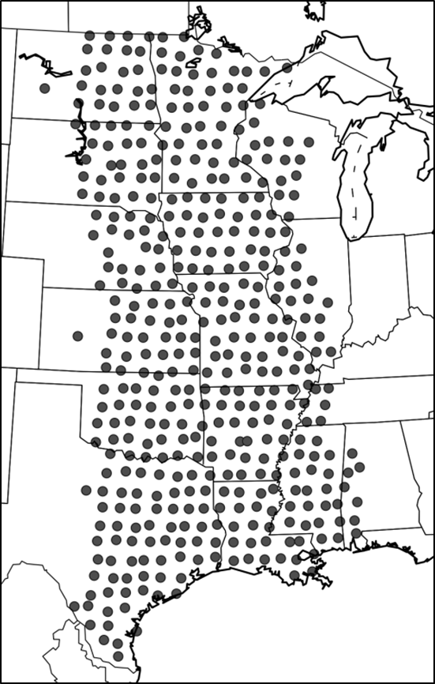

Figure 1. Locations of primary TA platforms with pressure observations from 1 Mar 2011 – 31 Aug 2011.

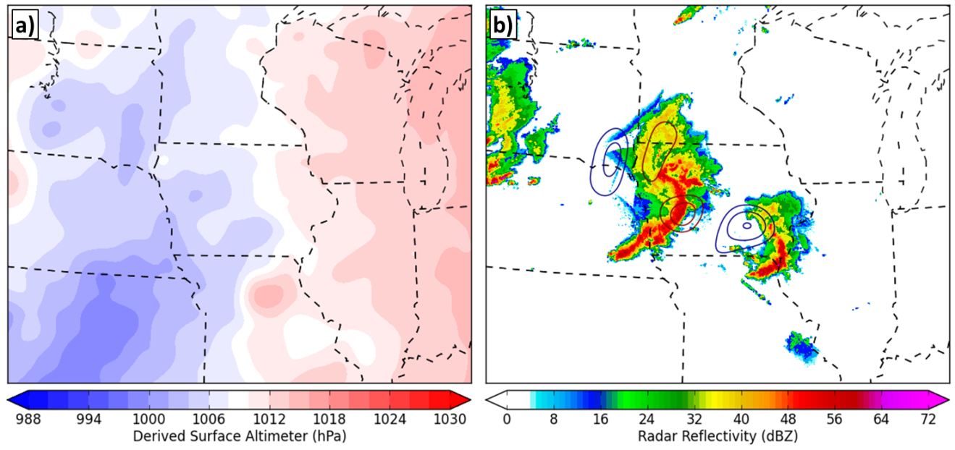

Figure 2. (a) Gridded analysis of derived surface altimeter centered on northern Iowa at 0200 UTC 27 Jun 2011. (b) Base radar reflectivity with contours of band-pass filtered (10 min - 12 h) mesoscale pressure perturbations across the same region at 0200 UTC 27 Jun 2011. Perturbation contours at 0.5 hPa are shown in dark red (blue) for positive (negative) perturbations. Radar reflectivity imagery courtesy the Iowa Environmental Mesonet web services.

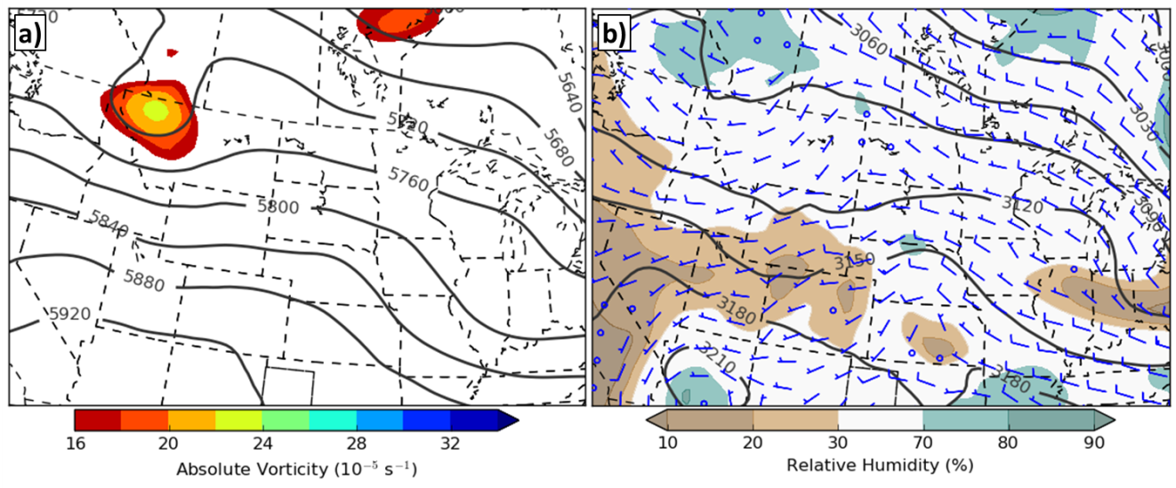

Figure 3. North American Regional Reanalysis (NARR) valid 1800 UTC 11 Aug 2011. (a) 500-hPa geopotential height (solid gray contoured every 40 gpm) and vorticity (shaded). (c) 700-hPa geopotential height (solid contoured every 30 gpm), relative humidity (shaded), and wind barbs (full barb 10 m s⁻¹).

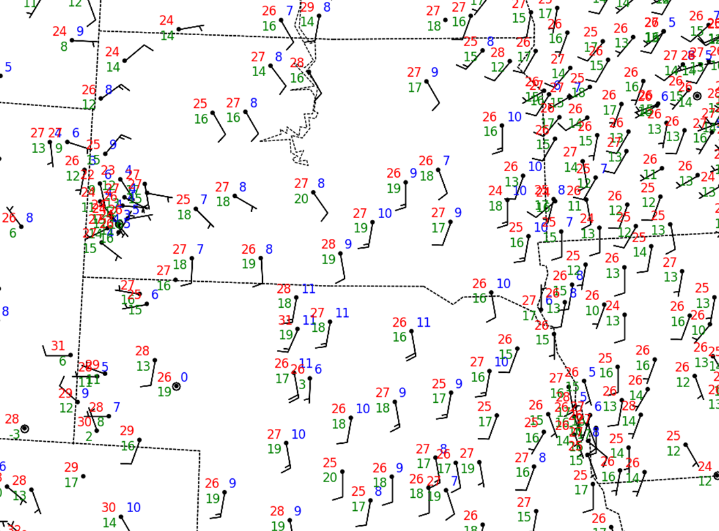

Figure 4. NWS ASOS/AWOS and BLM RAWS surface observations valid 1800 UTC 11 Aug 2011 over South Dakota and Nebraska. Station plots depict surface temperature (C, red), dewpoint (C, green), wind barbs (full barb 5 m s⁻¹), and peak wind gust (m s⁻¹, blue) recorded within an hour of the valid time.

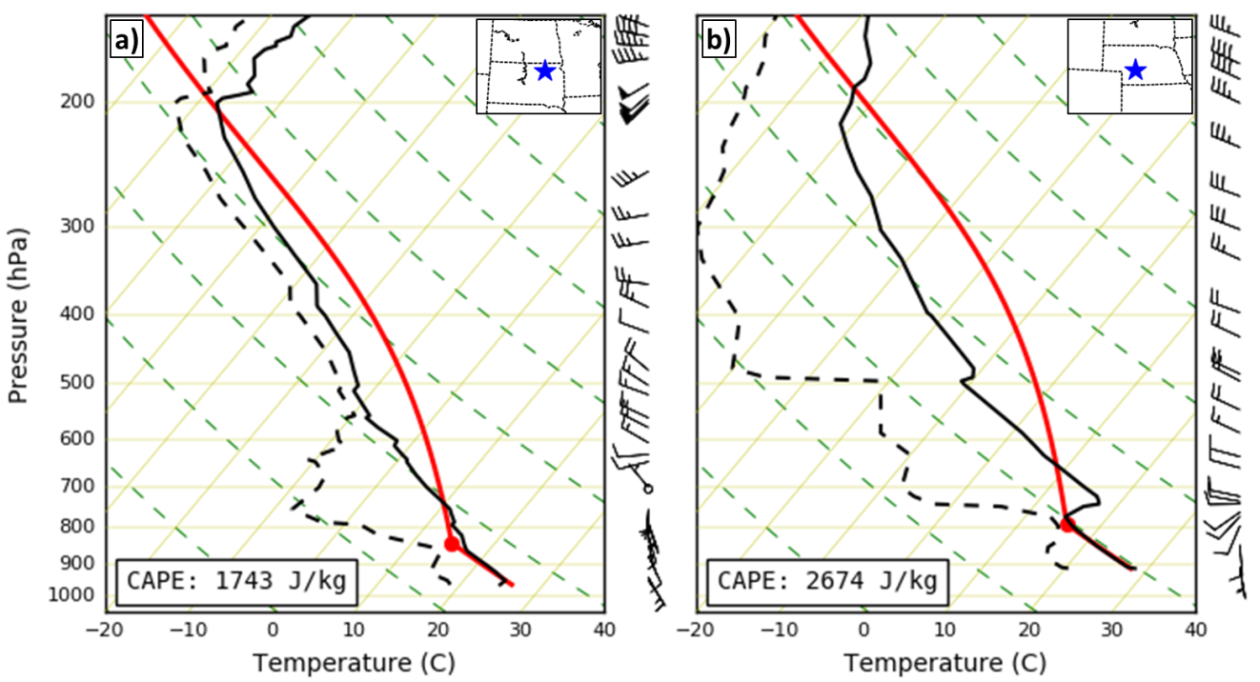

Figure 5. Skew-T, log-p diagrams from (a) Aberdeen, South Dakota and (b) North Platte, Nebraska valid 0000 UTC 12 Aug 2011. Solid (dashed) black lines denote temperature (dewpoint) profiles with observed winds provided to the right of the plot (full barb 10 m s⁻¹). Hypothetical parcel trajectory annotated as red solid line with calculate CAPE in bottom-left text box. Sounding geographic location shown with blue star on inset geographic map.
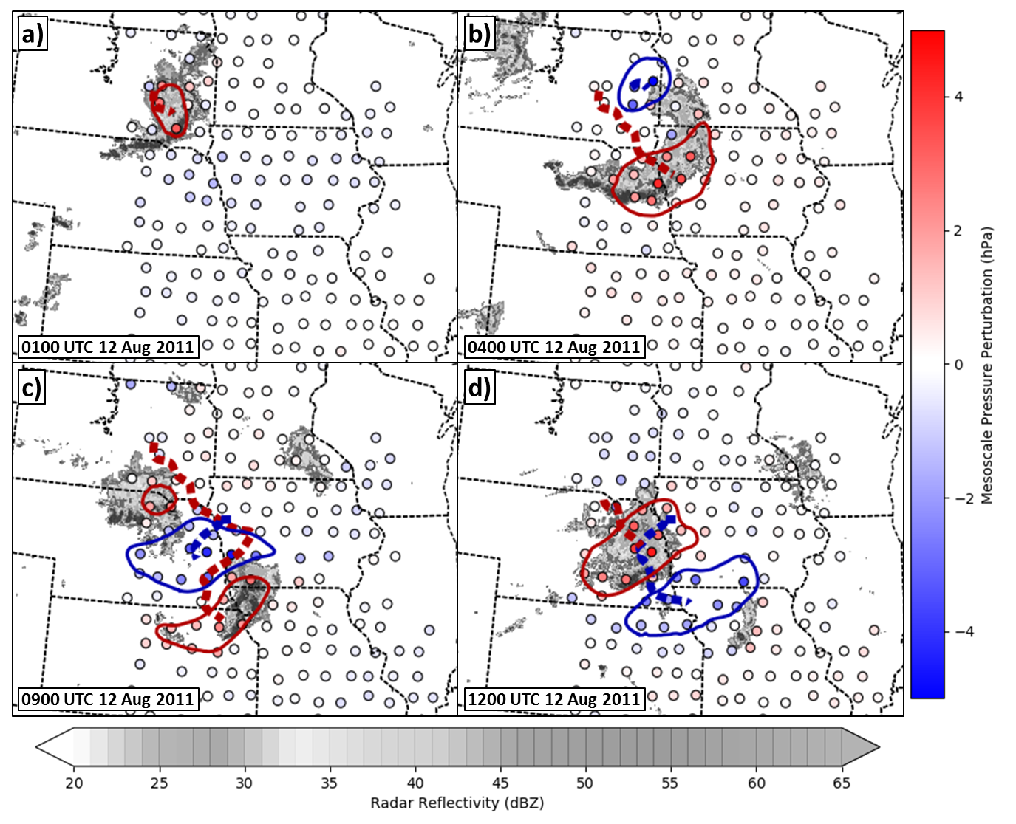

Figure 6. Mesoscale feature identification analyses valid (a) 0100, (b) 0400, (c) 0900, (d) 1200 12 Aug 2011 over the north-central CONUS. Base radar reflectivity larger than 20 dBZ given in grayscale coloring. Detected perturbation features shown as dark red (blue) contours for positive (negative) perturbations, with feature tracks shown as dashed dark red (blue) lines. TA locations plotted as circle markers with red (blue) coloring denoting magnitude of positive (negative) mesoscale perturbation recorded.
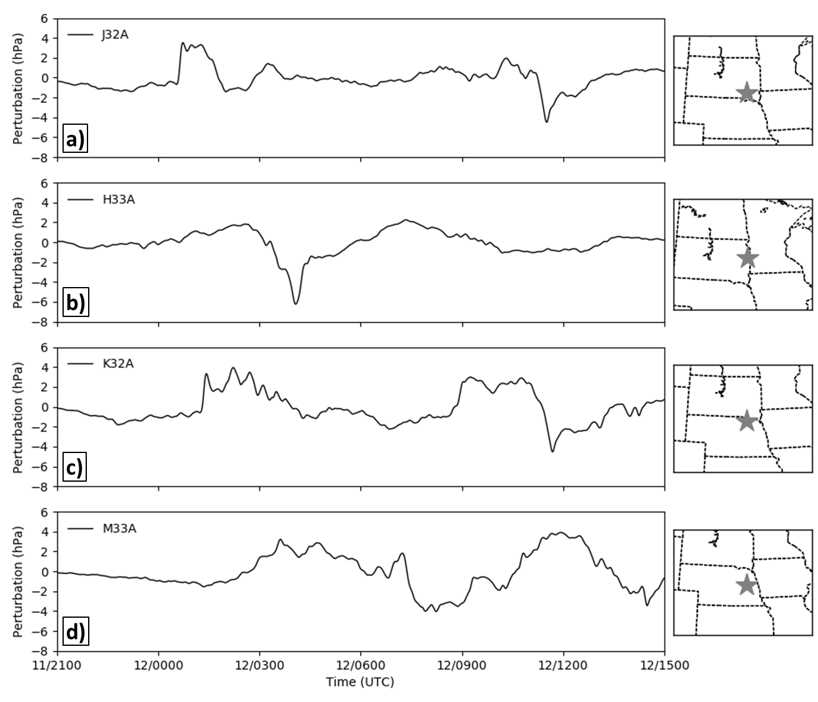

Figure 7. Band-pass filtered (10 min – 12h) mesoscale pressure perturbation time series valid 2100 UTC 11 Aug 2011 – 1500 UTC 12 Aug 2011 at TA stations (a) J32A, (b) H33A, (c) K32A, and (d) M33A. Location of stations shown as gray stars on geographic maps to the right of the time series.
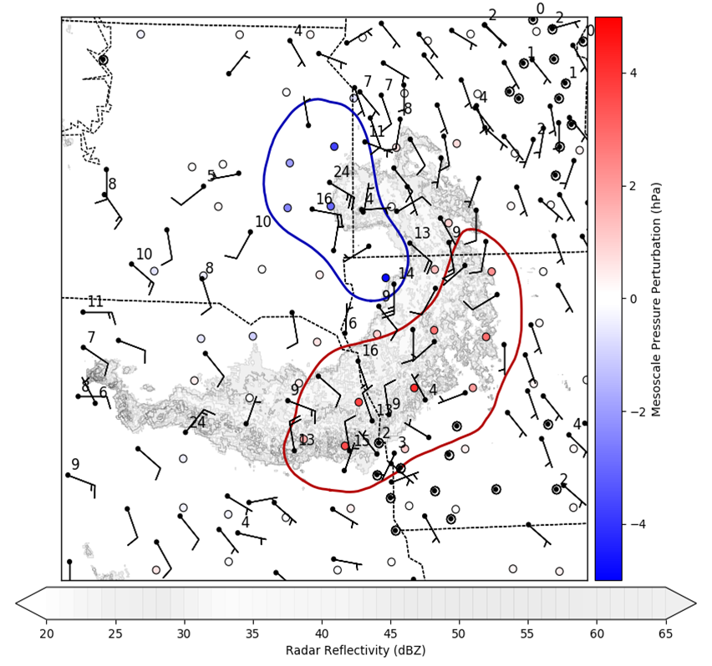

Figure 8. Detected positive (negative) mesoscale features in red (blue), radar imagery (faded grayscale), TA mesoscale pressure perturbations (colored circle markers), and NWS ASOS/AWOS and BLM RAWS surface winds (barbs, full barb 5 m s⁻¹) valid 0415 UTC 12 Aug 2011 over intersection of Nebraska, Iowa, and South Dakota. Surface station peak wind gusts provided in black text if recorded (m s⁻¹).
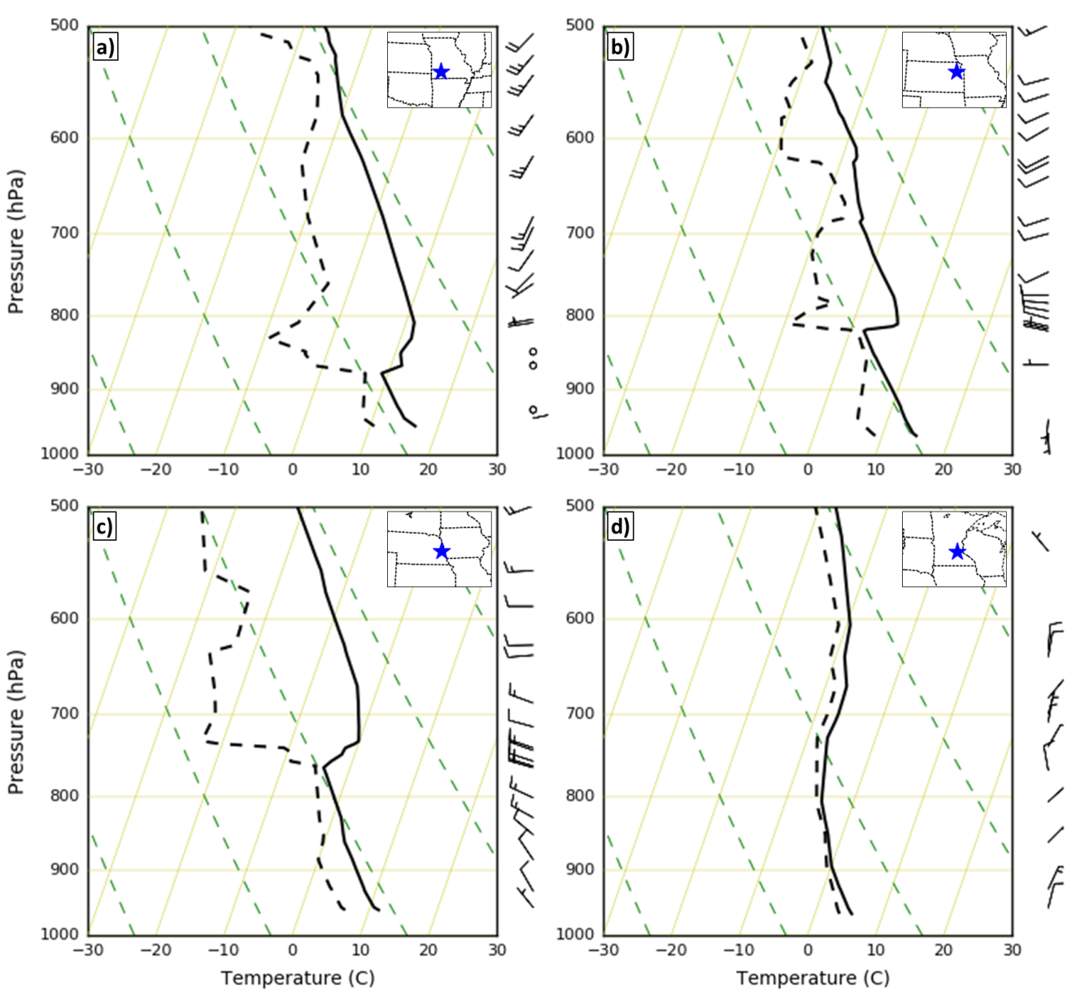

Figure 9. Skew-T, log-p diagrams from (a) Springfield, Missouri, (b) Topeka, Kansas, (c) Omaha, Nebraska, and (d) Chanhassen, Minnesota valid 0000 UTC 27 Apr 2011. Solid (dashed) black lines denote temperature (dewpoint) profiles with observed winds provided to the right of the plot (full barb 10 m s⁻¹). Sounding geographic location shown with blue star on inset geographic map.
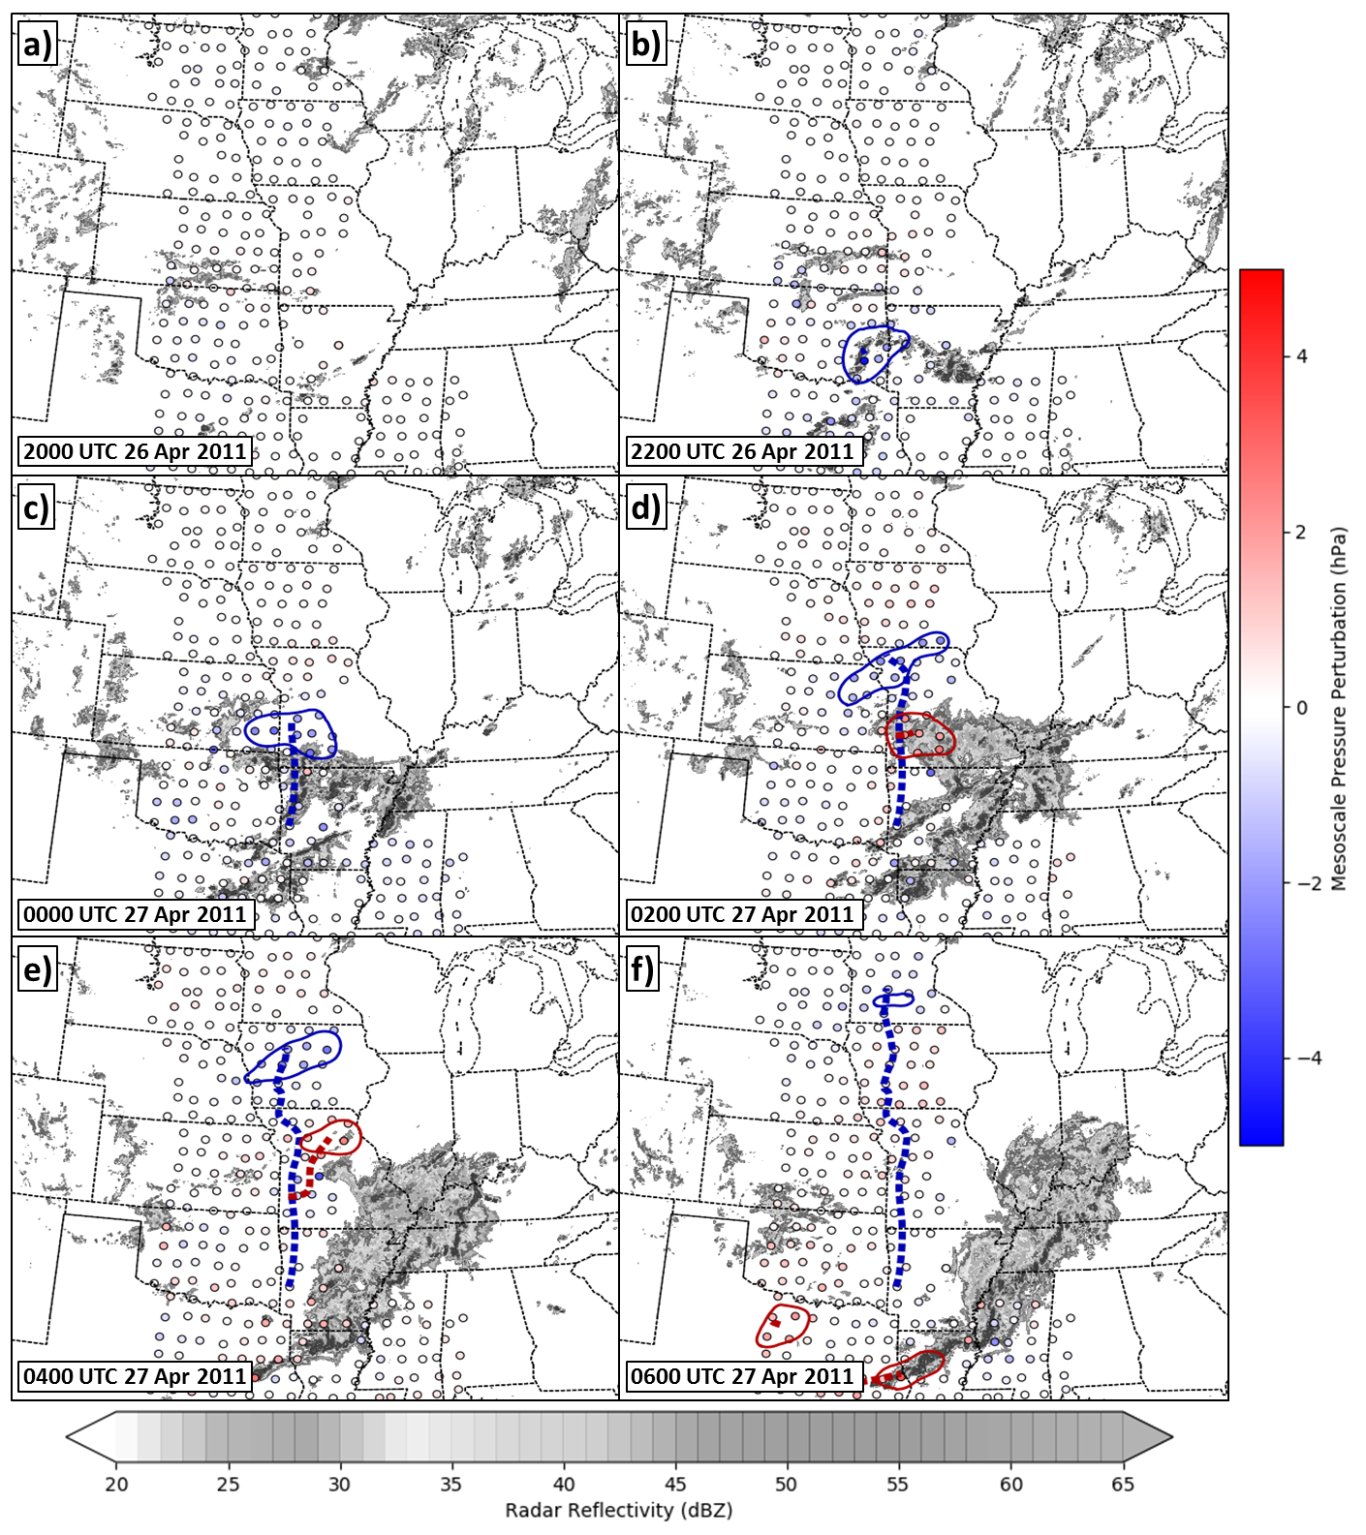

Figure 10. As in Figure 6, except at (a) 2000 UTC 26 Apr 2011, (b) 2200 UTC, (c) 0000 UTC 27 Apr 2011, (d) 0200 UTC, (e) 0400 UTC, and (f) 0600 UTC across the central CONUS.
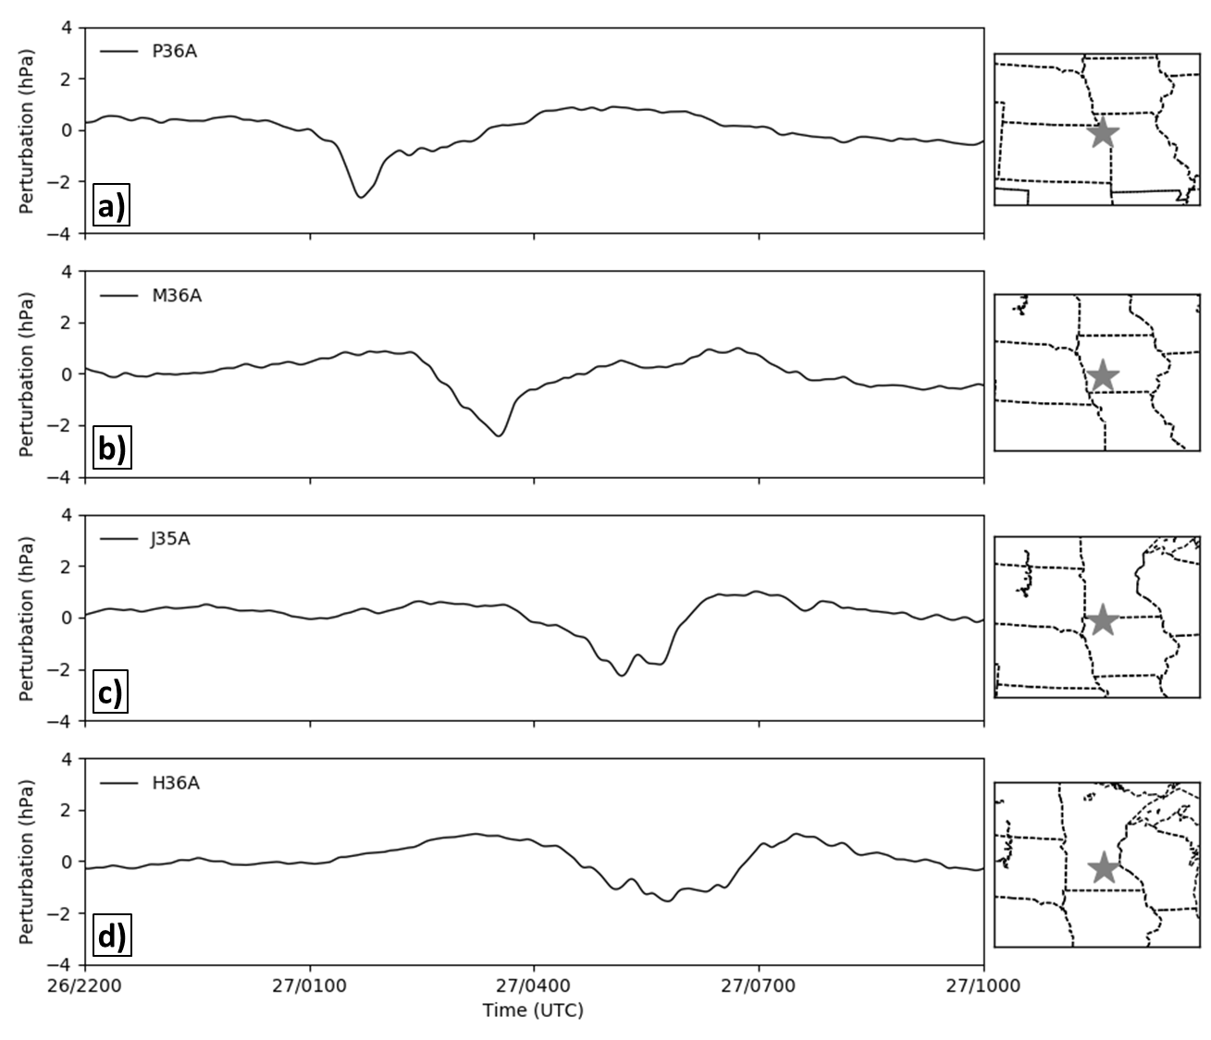

Figure 11. As in Figure 7, except valid 2200 UTC 26 Apr 2011 – 1000 UTC 27 Apr 2011 at TA stations (a) P36A, (b) M36A, (c) J35A, and (d) H36A.

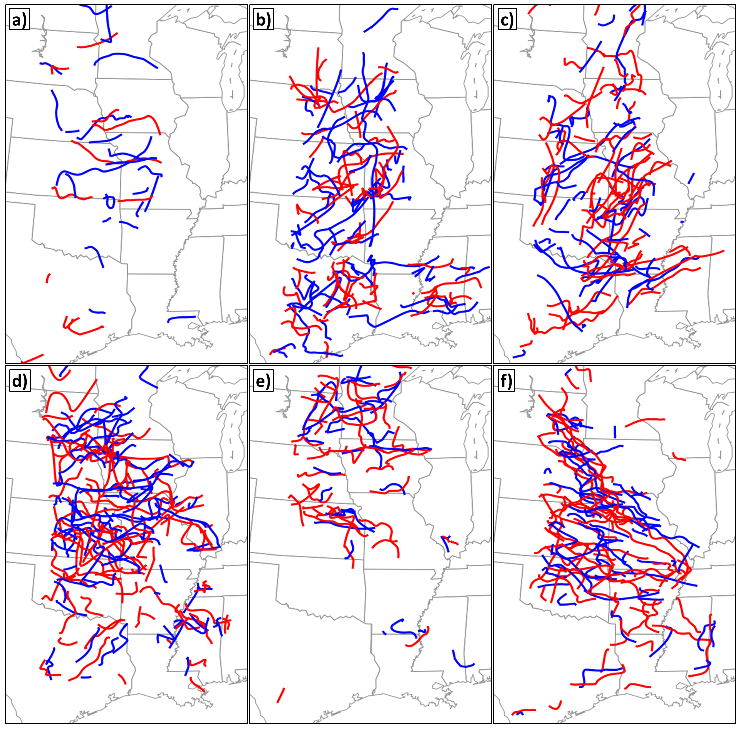

Figure 12. Mesoscale feature tracks for positive (red) and negative (blue) perturbations for (a) March, (b) April, (c) May, (d) June, (e) July, and (f) August 2011.

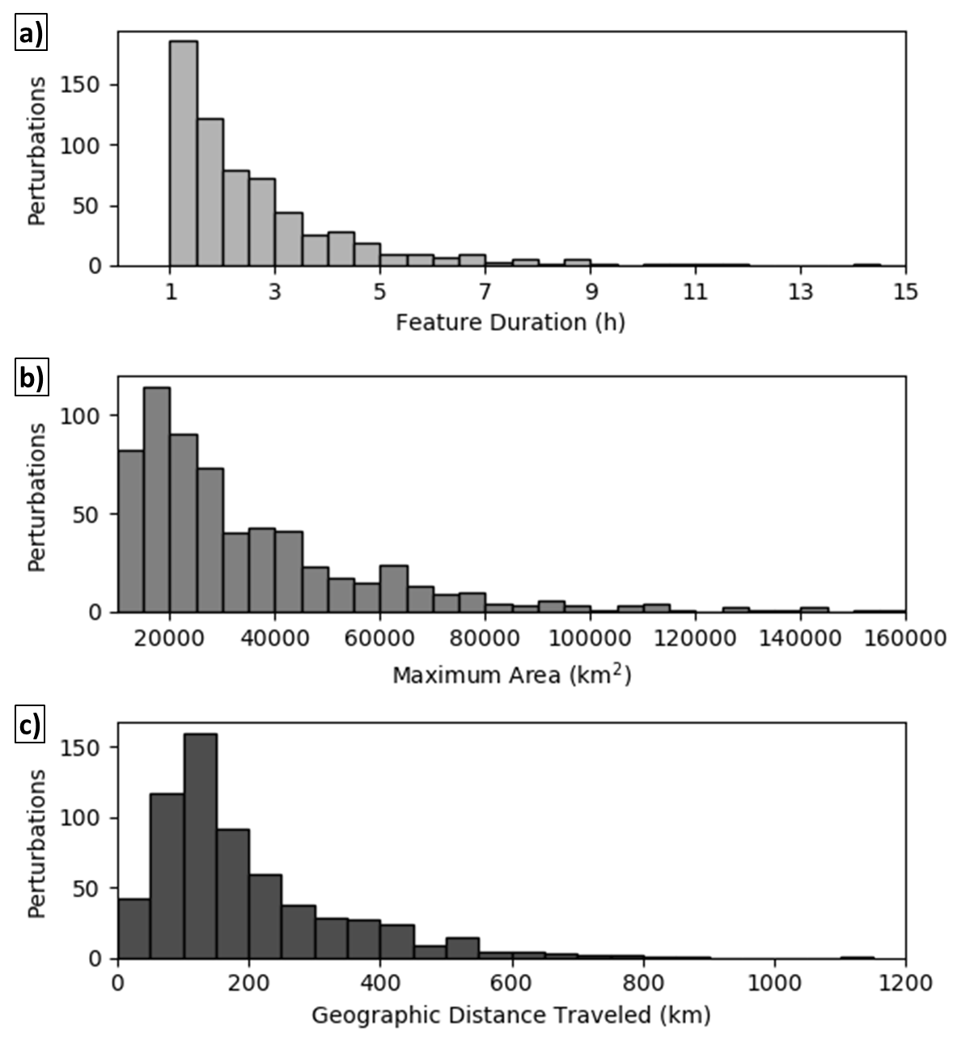

Figure 13. Histograms of detected mesoscale perturbation feature occurrences by (a) duration of feature existence (h), (b) maximum 1-hPa perturbation areal extent during feature existence (km²), and (c) geographic distance traveled (km) for the full period examined.

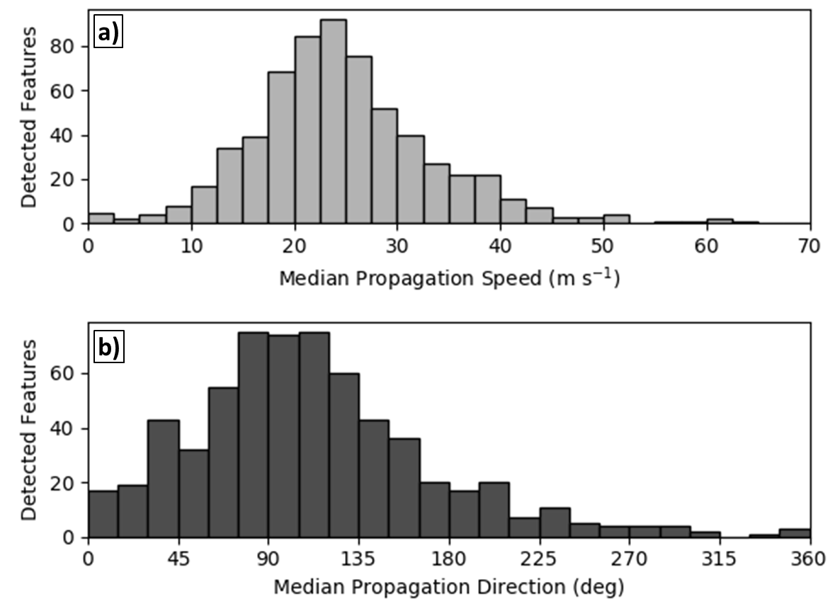

Figure 14. Histograms of detected mesoscale perturbation feature occurrences by (a) median feature speed and (b) median direction.
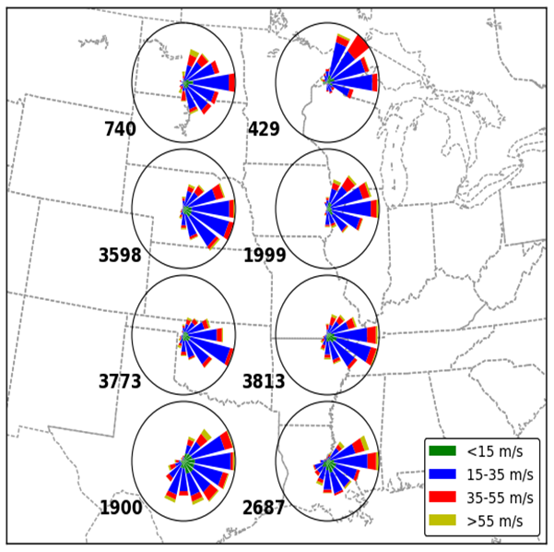

Figure 15. Mesoscale feature speed and direction roses for all features detected from 1 Mar – 31 Aug 2011. Features are split into 8 geographic sectors as shown by the general rose locations, with sample counts indicating the number of assessed feature speeds and directions per bin to the lower left of each sector. Samples are composed of speeds and directions calculated at all timestamps for a specific feature’s existence period.
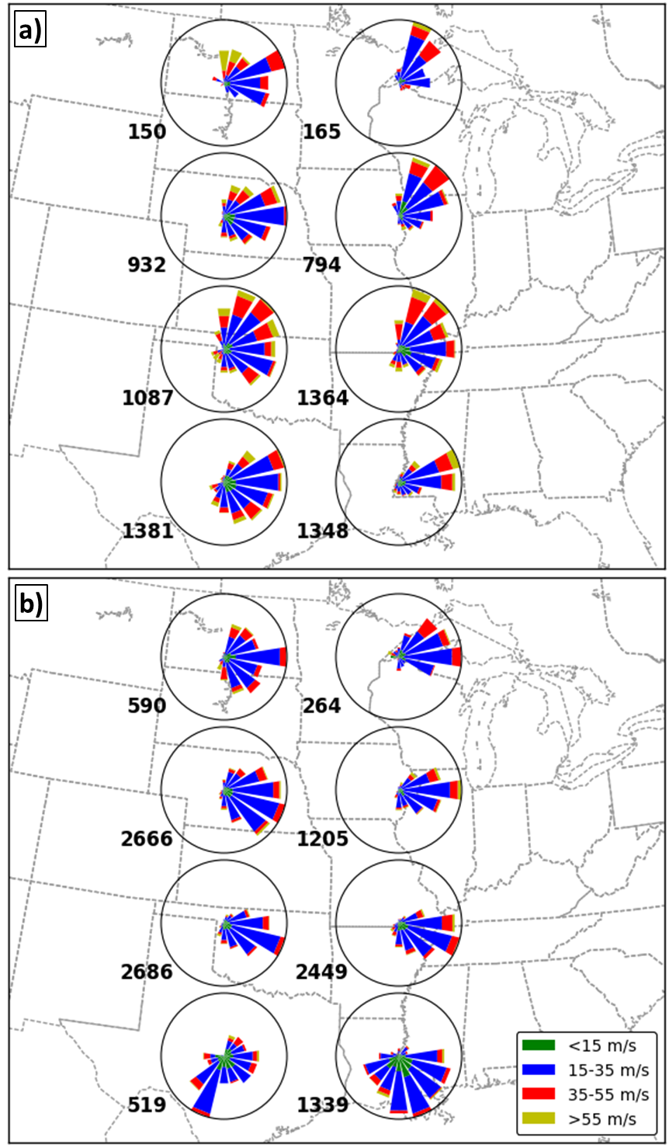

Figure 16. As in Figure 15, except divided into (a) spring (MAM) and (b) summer (JJA) mesoscale pressure features.

