Predictability of the 1 December 2011 Wasatch windstorm

by

John Lawson
Dept. of Geological and Atmospheric Science
Iowa State University
Ames, Iowa, United States of America

and

John Horel
Dept. of Atmospheric Science
University of Utah
Salt Lake City, Utah, United States of America

Submitted to Weather and Forecasting: 13 March 2015

Corresponding author address: John Lawson, Department of Geological and Atmospheric Science, Iowa State University, Ames IA 50011
Email: johnroblawson@gmail.com
Abstract
A downslope windstorm on 1 December 2011 led to considerable damage along a
narrow 50-km swath at the western base of the Wasatch Mountains in northern Utah.
Operational forecasts issued by the Salt Lake City National Weather Service Forecast
Office provided accurate guidance for the event at lead times of 1–2 days, based in part on their locally generated high-resolution numerical forecasts. Forecasters highlighted the possibility of the windstorm four days in advance. To address the apparent enhanced predictability of this windstorm, three 11-member three-domain ensemble forecasts were initialized from 0000 UTC on 25, 27, and 29 November 2011 using the Weather Research and Forecasting (WRF) model with initial and boundary conditions supplied by reforecasts from the Global Ensemble Forecast System Reanalysis version 2 dataset (GEFS/R2). Eight of the eleven ensemble members from the 29 November 2011 forecast (60 h before the windstorm) generated a strong, localized windstorm with the outliers arising from reduced cross-barrier flow. Analysis of kinetic energy error growth suggests that the apparent skill of the 60-h forecasts was not a result of underdispersion of the GEFS/R2 initial and boundary conditions, but rather related to regional reduction in error growth in the mid-tropospheric flow upstream of northern Utah. The ensemble initialized two days earlier (27 November, 108 h prior to the windstorm) contains fewer members that generate strong windstorms, while no members generate a windstorm in the ensemble initialized on 25 November (156 h prior). This reduction in skill with increasing forecast lead time results from the sensitivity of the ensemble solutions to the lateral boundary conditions imposed by the GEFS/R2 during the 0000 UTC 29 November to 0000 UTC 30 November time span.

1. Introduction
The Wasatch windstorm of 1 December 2011 (Lawson and Horel 2015, hereby LH15) led to winds that gusted to 45 m s⁻¹ (102 mph) in a narrow band along the Wasatch Front in northern Utah (Fig. 1). While the windstorm inflicted over $75 million in damage, the impact on lives and property was likely reduced by ample warning time of 1–2 days from the National Weather Service (NWS) Weather Forecast Office in Salt Lake City. Forecasters cited high-resolution numerical weather prediction (NWP) output in part as the basis for this confidence. Furthermore, Area Forecast Discussions up to 90 h before the event mentioned the enhanced risk of damaging winds along the Wasatch Front.
Strong downslope windstorms in the lee of mountain ranges extend a finite distance away from the base. In general, the smaller the phenomenon’s length-scale, the shorter the timescale before forecasts lose their predictive skill (Lorenz 1969). This asymptopic “predictability horizon” (Palmer 2005) is an intermittent property of chaotic atmospheric flow (Palmer et al. 2014). Hence, in NWP simulations of downslope windstorms, the sensitivity of damaging winds to initial conditions and model error may preclude suitable warning times. Reinecke and Durran (2009) found windstorms in the Owens Valley downstream of the Sierra Mountains to lose predictability after 12-h lead times. In light of this, the Wasatch windstorm of 1 December 2011 appeared anomalously predictable: was this an attribute of this particular atmospheric regime (a temporary reprieve from a prohibitive predictability horizon), or the result of fortuitous deterministic NWP simulations?
The synoptic-scale circulations associated with windstorms in westerly flow (e.g., downstream of the Sierra and Rocky Mountains) differ from those associated with easterly flow across the Wasatch Mountains. Westerly windstorms are often associated with a mid-level jet maximum and a short-wave vorticity maximum (e.g., Lilly and Zipser 1972; Reinecke and Durran 2009). In contrast, Wasatch windstorms are associated with a mid-tropospheric cut-off low to the south and an anticyclonic Rossby-wave breaking (ARWB) event to the north ( LH15), i.e., lifecycle 1 of baroclinic waves (Thorncroft et al. 1993). ARWB events sometimes precede a blocking pattern. Oortwijn (1998) found error growth downstream of a short-wave trough aloft is enhanced by strong winds and diffluent flow, but also found the forecasts of blocking episodes to be very sensitive to initial conditions. Tibaldi and Molteni (1990) found the European Centre for Medium Range Forecasts (ECMWF) operational model to underestimate the occurrence of blocking events, and to consistently fail to predict the events beyond 3–4-day lead times. The weakness in NWP blocking forecasts may also be related to larger errors in critical regions such as the Caribbean and the Philippines (Li et al. 1999).
Recently, Durran and Gingrich (2014) illustrated how small relative errors in the prevailing large-scale circulation may inhibit forecast skill of embedded mesoscale systems more so than large relative errors on the smallest scales. This study will address the apparent enhanced predictability of the Wasatch windstorm of 1 December 2011. We address the extent to which synoptic-scale error growth in the flow upstream of the Wasatch Mountains controlled the predictability of this mesoscale phenomenon. We first present the data and methods used to evaluate model and ensemble performance (section 2). In section 3, we discuss the results of the ensemble forecasts as a function of lead time, finishing with an evaluation of error growth for each of the ensemble forecasts. We summarize the nature and potential source of the extended predictability of this windstorm in section 4.

2. Data and Methods
All numerical simulations were performed with the Weather Research and Forecasting (WRF, Skamarock et al. 2008) model, version 3.4, and the Advanced Research WRF dynamical core (see LH15 for WRF configuration details). Each simulation used 12-, 4-, and 1.3-km nested domains, with feedback enabled between the nests (Fig. 2). For the ensemble forecasts in this study, initial and boundary conditions were provided every 6 h by the Global Ensemble Forecast System Reforecast (GEFS/R2) dataset (Hamill et al. 2013; Hamill and Kalidis 2014). The GEFS/R2 archive contains reforecasts (i.e., hindcasts initialized with reanalyses) initialized every day at 0000 UTC. Because the GEFS/R2 dataset has only one soil level, atmospheric data from the GEFS/R2 were merged with Global Forecast System soil analyses to initialize the WRF forecasts. No variations in model configuration or parameterizations were performed. As this case was dry, strongly forced by dynamical flow, and simulated at ~3–7-day lead times, it is likely that initial and boundary condition error dominates over model error (e.g., Stensrud et al., 2000).
Three GEFS/R2–WRF ensembles were created, starting at 0000 UTC on 25 November, 27 November, and 29 November, and each ending at 1800 UTC, 2 December 2011. This led to 156-h, 108-h, and 60-h forecasts, respectively, valid during the windstorm (~1200 UTC 1 December). These ensembles are named the 25Nov, 27Nov, and 29Nov runs, respectively. Each ensemble contains one control member (c00) and ten perturbation members (p01–p10). We contrasted WRF output on the synoptic scale to the ECMWF Reanalysis (ERA)-Interim dataset, downloaded at 1º-by-1º resolution.

3. Results
(a) 29 November ensemble simulation (29Nov)
The ensemble forecast with the shortest lead-time, 29Nov, provides 57–67-h forecasts at the time of maximum wind along the Wasatch Front (0900–1900 UTC, 1 December). The ensemble-mean 700-hPa geopotential-height fields for 0000, 0600, 1200, and 1800 UTC on 1 December 2011, taken from perturbation members only, are shown in Fig. 3. The ensemble mean captures the general evolution of the ARWB event, with a ridge spreading southeastward into Wyoming during the day (compare to Fig. 6 of LH15). Using ensemble-member standard deviation σ of the 700-hPa geopotential-height field as a measure of ensemble spread around the mean (Fig. 3), we note more variability between ensemble members to the west and northwest of the developing cutoff low, with the greatest spread at 1200 and 1800 UTC (σ up to 55 m). In northern Utah, the 700-hPa flow is arriving from Wyoming, where ensemble spread within the ridge is reduced (σ less than 5 m in places). Hence, the closer agreement between members upstream of the Wasatch at the synoptic scale may help explain the enhanced predictability for the downslope windstorm.
Figure 4 presents the 700-hPa geopotential height at 1200 UTC for each member of the 29Nov ensemble, and the ERA-Interim reanalysis field at that time. All members have an anticyclone centered west of Oregon and Washington, encircled by the 3270-m contour, which is 60 m higher than the ERA-Interim analysis at the same time and location. This systematic bias is persistent throughout the 700-hPa geopotential-height field, and was also seen in simulations initialized by the North American Mesoscale model (see LH15). The lowest-contoured isohypse inside the cut-off low ranges from 2850 m in p06 to 2970 m in p03. As the strength of the anticyclone is fairly similar between ensemble members, the height gradient—and the easterly gradient wind—across northern Utah is largely controlled by the depth of the cut-off low. The gradient-wind direction above the Wasatch Front at 700 hPa at 1200 UTC is roughly northeasterly for all ensemble members. In the majority of members (p00, p01–p07, and p10), this flow is more easterly than northeasterly (i.e., clockwise of 45°). The two exceptions, p08 and p09, simulate flow with a larger northerly component, while their low centers are weaker and farther eastward.
The ERA-Interim low center deepens ~60 m between 0000 and 0600 UTC, and another ~30 m over the next 6 h (Fig. 6 in LH15). It reaches its deepest height of < 2880 m at 1200 UTC, before increasing by ~30 m at 1800 UTC. However, all 29Nov members have their lowest values at 1800 UTC. This 6-h delay in all members, related to a lag of the anticyclonic wave-breaking aloft, may suggest underdispersion within the GEFS/R2 dataset, but does not fundamentally affect the structure of simulated windstorms other than delaying by ~6 h the strongest surface winds. Total height falls between 0000 UTC and 1800 UTC range from ~30 m in p03 to ~150 m in p06, which suggests why these members contain the shallowest and deepest cut-off lows, respectively.
Figure 5 shows the maximum 10-m wind speeds along the Wasatch Front between 0000 UTC 1 December and 0000 UTC 2 December (48–66 h forecasts) for each 29Nov member, as well as the NAM-Control simulation from LH15. Eight members of the 11 develop winds stronger than 15 m s⁻¹ along the Wasatch Front for this period with peak winds located approximately where they were observed. As discussed by Ancell (2013), the ensemble mean of the maximum wind speeds is not necessarily relevant for high-impact events such as this one (not shown). The synoptic-scale features evident in Fig. 4 may explain common features associated with the ensemble forecasts of the downslope windstorm. The strongest (p06) and weakest (p03) 10-m winds along the Wasatch Front occur with the deepest and shallowest 700-hPa geopotential-height lows at 1200 UTC, respectively. Furthermore, the three weakest cut-off lows at 1200 UTC (p03, p08, and p09) are associated with weak surface winds, and two of those cases have more northerly 700-hPa gradient wind and cut-off lows farther east. The rate of deepening of the cut-off low does not appear to be a critical factor, as the member with the strongest 10-m wind (p06) has only average (~90 m in 18 h) deepening compared with all members. Hence, it is more likely that the depth, location, and orientation of the cut-off low are more critical than its rate of deepening.
Based on Figure 5, we subjectively divided perturbation members into two groups around a 15 m s⁻¹ threshold: the seven members with strong surface winds (Group-W composed of p01, p02, p04, p05, p06, p07, and p10) and the three members with weak surface winds (Group-N composed of p03, p08, and p09). The results obtained from this composite are not substantially sensitive to the 15 m s⁻¹ threshold used to define the group members. Figure 6 shows the differences in potential temperature and wind speed at 1800 UTC between mean Group-W and mean Group-N across the Wasatch Front (see the cross-section path in Fig. 1). Upstream of the Wasatch Mountains, the Group-W members have stronger easterly wind roughly 1 km above the surface with no substantive differences in stability between the two Groups. Of course, downstream of the Wasatch, the differences in stability and wind are substantial.
Time series of 10-m wind speeds sampled every 5 s within each ensemble member are shown in Fig. 7 for three locations indicated in Fig. 1: Centerville (where the strongest winds were observed), Ogden Peak (at the crest of the Wasatch), and Salt Lake International Airport (away from the downslope windstorm). The strong surface winds associated with the downslope windstorm in the c00 member and the seven Group-W members are generated at Centerville (Fig. 7a). These winds start between 66 h (p06) and 76 h (p07) into the simulation, and cease between 72 h (p01) and 84 h (p06). This figure highlights the agreement in the overall temporal signature and evolution between members for this windstorm, with the exception of the three outliers of Group-N. Three ensemble members (p04, p06, and p10) begin the windstorm before or close to the time it was observed at this location (0900 UTC, or 57 h into the simulation) and continue slightly beyond the observed cessation time. Three others (c00, p01, and p02) delay onset of the windstorm until after 1200 UTC, while the remaining two Group-W members delay onset until after 1500 UTC.
The synoptic-scale flow evident in Fig. 4 for p04, p06, and p10 was favorable for crest-level easterly flow by 1200 UTC. Likewise, the simulated winds at Ogden Peak (Fig. 7b) for these three members were stronger sooner. However, differences in the magnitude of the cross-barrier flow between the ensemble members were generally small, implying less sensitivity of lee-side strong winds to crest level wind speed. This concurs with the composite differences shown in Fig. 6: crest-level differences in winds over the Wasatch Mountains (Fig. 7b) are smaller than wind differences upstream tens of kilometers. The chaotic wind-speed time series at Salt Lake City (Fig. 7c) located only 20 km from the region of strong downslope winds indicates how sensitive such mesoscale phenomena can be to local terrain features.

(b) Earlier Ensemble simulations
Next, we assess a forecast ensemble initialized at 0000 UTC 27 November, 48 h prior to that discussed in the previous subsection. Both the ensemble mean and ensemble standard deviation σ of 700-hPa geopotential height for 1200 UTC on 1 December 2011 are shown in Fig. 8. The ensemble-mean features are similar to those shown for the ensemble forecast initialized later: the ARWB to the north, development of a cut-off low to the south, and north–south height gradient across northern Utah. However, the variability between ensemble members to the west of the cutoff low has increased (σ around 75 m). The lowest spread again remains upstream of northern Utah associated with the breaking ridge.
As expected by the increased ensemble standard deviation, the geopotential-height fields at 700 hPa for each 27Nov member (Fig. 9) show reduced agreement; more variability in the location of the cut-off low leads to more variability in the orientation of the 700-hPa flow across northern Utah. Maximum 10-m wind during 1 December 2011 (Fig. 10) highlights seven ensemble members that simulate 15 m s⁻¹ (windstorm-strength) winds at the valley floor (p01, p04–p09) and three members that do not (p02, p03, p10). However, two members (p08 and p09) barely meet this criterion for designation as a windstorm. In addition, there are fewer portions of the Wasatch Front with winds in excess of 32.5 m s⁻¹ (orange colors) for the 27Nov members compared to the 29Nov ensemble members.
For the ensemble initialized at 0000 UTC 25 November, the development of the cut-off low is not captured: the ensemble mean at 1200 UTC 1 December (Fig. 11) displays a broad ridge across the western United States. Only one ensemble member develops a cut-off low in this period (not shown). No member simulates a downslope windstorm along the Wasatch Front on 1 December 2011 (not shown).

(c) Error growth and its sensitivity to initialization time
A common limitation of ensemble simulations, particularly for small numbers of perturbation members, is the potential for them to be underdispersive, and hence misrepresent the predictability of atmospheric phenomena (e.g., Buizza and Palmer 1998; Clark et al. 2011). If our ensembles are persistently underdispersive (not considering the uncaptured, but presumably small, component of spread related to model error), then the difference between members within each ensemble should remain relatively small over time, and the growth of these differences should not be slowed by reaching saturation (i.e., when members are as different from each other as two states randomly chosen from the model climatology). We evaluate the growth rate of these differences with Difference Kinetic Energy (Zhang et al. 2002):
DKE $=\frac{1}{2}\sum{({U^{'}}_{ijk}^{2}+ {V'}_{ijk}^{2})}$
where $U'$ and $V'$ are the differences in wind components between all permutations of all perturbation ensemble members, without repetition. DKE, or ‘uncertainty’, is calculated here for all model levels up to 500 hPa at each grid point on the 12 km grid to focus on error growth relevant to the windstorm in the lower and mid-troposphere. Lower DKE does not result over higher terrain simply from the shallower volume of integration, since we found that the dominant DKE signal is associated with the prevailing synoptic-scale flow.
Figure 12 shows DKE calculated from the 12 km grid, integrated only over the 4-km domain area that encompasses the Intermountain West (Fig. 2), from the lowest model level to 500 hPa for all three ensembles as a function of forecast lead time. The growth rate of errors in the first 24 h of the ensembles initialized on 27 November and 29 November are similar while that initialized on the 25th is more rapid (note the log-scale in the y-axis). However, at later forecast lead times, mean DKE is often larger in the 27Nov and 29Nov runs. Moreover, the DKE values for each of the three runs are not that dissimilar at the time of the windstorm (1200 UTC 1 December 2011). Hence, the decreasing skill to simulate the downslope windstorm with increasing lead time is not simply due to larger regional error growth with increasing lead time.
Figure 13 shows DKE superimposed onto the mean 700-hPa geopotential-height field for the 29Nov ensemble, valid at 1200 UTC on 29 November, 30 November, and 1 December (12-h, 36-h, and 60-h forecasts, respectively). At 1200 UTC 29 November (Fig. 13a), DKE over 200 m² s⁻² is confined to the vicinity of the short-wave trough in the northwest corner of the domain. A day later (Fig. 13b), the uncertainty maximum has been deformed and bifurcated into two regions associated with short-wave troughs over Montana and northern California. The local magnitude of DKE in these two lobes is smaller than the previous day, i.e., the uncertainty is being diluted, despite DKE increasing overall when computed over the entire 12-km domain (not shown). Prior to the onset of the windstorm (0000 UTC 1 December), differences between ensemble members are still small in the region of northern Utah and southwestern Wyoming (DKE values of ~200 m² s⁻²; not shown). Uncertainty grows substantially in spatial coverage and magnitude between 0000 UTC and 1200 UTC (Fig 13c) over California and Arizona, associated with deepening of the cut-off low. Uncertainty in the eastern short-wave trough has stayed confined to the trough axis over the Texas–Oklahoma panhandle and farther northeast. The broad area of lower uncertainty north of the cut-off low is punctuated by a thin ribbon of high uncertainty (greater than 200 m² s⁻²) associated with the barrier-jet feature over western Wyoming that is funneling northeasterly winds towards the Wasatch Front (see LH15), as well as over the Wasatch Front where the windstorm is underway (not shown). This suggests the smaller-scale variation of lower-tropospheric wind is still very sensitive to the more-certain larger-scale synoptic pattern. Figures 13a–c also suggest that the larger-scale region around and upstream of the windstorm is ‘protected’ from uncertainty growth via advection by the ARWB, though uncertainty grows via Eulerian changes related to the formation of the barrier-jet feature upstream of the Wasatch Mountains (Fig. 16 in LH15).
For the 60 h forecasts from the 27Nov ensemble, the area with over 600 m² s⁻² DKE near the small trough off the British Columbia coast (Fig. 14a) is larger than that found for the 12 h forecasts from the 29Nov run (Fig. 13a). However, DKE remains less than 200 m² s⁻² over the Intermountain West despite the longer forecast lead time. A day later (Fig. 14b), there is a broad zone exceeding 600 m² s⁻² DKE associated with both the developing cut-off low along the coast and the trough passing north of Utah. Over the next day (Fig. 14c), the area exceeding 1600 m² s⁻² DKE associated with the deepening low becomes substantially larger than in the 29Nov run (Fig. 13c), but DKE upstream (i.e. east) of northern Utah is generally less than 1000 m² s⁻². DKE in the vicinity of the Wasatch Front is high as expected and associated with the variability in the ensemble’s treatment of the windstorm (not shown).
Mean 700-hPa geopotential height, valid at 1200 UTC 29 November from the 25Nov ensemble, does not exhibit the small trough developing off the west coast of British Columbia at that time with considerable DKE in that region (Fig. 15a). The subsequent evolution over the next day (Fig. 15b) leads to increasing uncertainty upstream of northern Utah within the weak northwesterly flow. By the time of the windstorm (1200 UTC 1 December, Fig.15c), DKE is relatively low over the Intermountain West, with greater uncertainty over much of the region further downstream over Arizona and to the east over Wyoming and Colorado. Hence, not only has the area exceeding 2000 m² s⁻² DKE increased across the domain (associated with the longer forecast lead time), but also, as already shown, the ensemble has failed to develop the correct synoptic-scale circulation over the western United States.
Prior to 0000 UTC 29 November, no discernible differences between the 25Nov and 27Nov ensembles exist in the circulation features and error growth on the 12-km WRF domain (not shown). The degree to which the GEFS/R2 reforecast boundary conditions define the shortwave trough entering the northwest corner of the 12km domain between 0000 UTC 29 November and 0000 UTC 30 November appears to dictate the regime from which the model trajectories progress. For the 25Nov ensemble, those boundary conditions are applied at lead times of 96-120 h and result in solutions that diverge from those in the 27Nov and 29Nov ensembles at shorter lead times (48–72 h and 0–24 h, respectively). This quick expansion of the solution envelope between ensemble run times after 0000 UTC 29 November suggests forecast performance of the ARWB event was sensitive to the lateral boundary conditions imposed by the GEFS/R2, with less sensitivity to those lateral boundary conditions at lead times shorter than 90 h.

4. Summary
The downslope windstorm of 1 December 2011 described by LH15 was forecast operationally at anomalously large lead times (a general description at 90 h, with more specific details by 24–48 h) compared to many other windstorm events in other locations. Local NWS forecasters cited high-resolution NWP deterministic products as the source of their confidence in these forecasters. Using GEFS/R2 initial- and boundary-condition ensemble datasets imposed on nested WRF domains, this study suggests that global-scale models were likely able to forecast the large-scale conditions conducive for the ARWB event over the western United State at lead times of up to four days. Imposing initial and lateral boundary conditions from the GEFS/R2 at longer lead times as shown in this study led to lower skill for defining the regional circulation over the western United States.
While a predictability horizon of 4 days for the regional-scale circulation may not be considered particularly long, establishing the correct synoptic setup in this instance led to much higher predictability on the mesoscale than might be expected otherwise. Forecasters could subjectively recognize the developing conditions that were conducive to downslope windstorms along the Wasatch Front, i.e., favorable easterly cross-barrier flow upstream. Later, deterministic high-resolution model forecasts at lead times of ~48 h may have been able to supply accurate forecasts since the regional circulation may have been “dialed in” by the initial and lateral boundary conditions supplied to the high-resolution model. This study suggests that having the correct synoptic setup, combined with the diversion of the northerly airflow upstream as a result of the side barrier created by the Uinta Mountains (LH15), may result in enhanced deterministic model skill locally. We found small spread (low DKE) between ensemble members in this region, such that ensemble forecasts at 1.3-km resolution at lead times of ~60 h reproduced many spatial and temporal characteristics of the highly localized wind event along the Wasatch Front.
The characteristics of the planetary and synoptic scale circulation that led to this particular ARWB event over the western United States, and the degree to which the GEFS/R2 model forecasts resolved appropriately those circulation features, remains unanswered here. Further, subjective examination of other WRF high-resolution deterministic model forecasts for nascent downslope windstorms along the Wasatch Front suggests the model tends to overforecast their occurrence. Examining ensembles of forecasts for such events may help to explain this bias.

Acknowledgments
We thank an anonymous WRF-Help correspondent for help with creating GEFS/R2–WRF ensembles; Trevor Alcott for insightful discussions along the way; Professors Courteney Strong and Jim Steenburgh for useful suggestions on the original thesis manuscript; the Center for High-Performance Computing at the University of Utah for provision of, maintenance of, and assistance with the supercomputers. This research was supported by NOAA/NWS Collaborative Science, Technology, and Applied Research Program Grant NA10NWS4680005 and NA13NWS4680003.

References
Ancell, B. C., 2013: Nonlinear Characteristics of Ensemble Perturbation Evolution and Their Application to Forecasting High-Impact Events. Weather Forecast., 28, 1353–1365.

Clark, A. J. and coauthors, 2011: Probabilistic Precipitation Forecast Skill as a Function of Ensemble Size and Spatial Scale in a Convection-Allowing Ensemble. Mon. Weather Rev. 139, 1410–1418.
Durran, D. and M. Gingrich, 2014: Atmospheric Predictability: Why Butterflies Are Not of Practical Importance. J. Atmos. Sci., 71, 2476–2488.
Hamill, T. M., G. T. Bates, J. S. Whitaker, D. R. Murray, M. Fiorino, T. J. Galarneau, Y. Zhu, and W. Lapenta, 2013: NOAA’s second-generation global medium-range ensemble reforecast data set. Bull. Am. Meteorol. Soc., 94, 1553–1565.
Hamill, T., and G. N. Kiladis, 2014: Skill of the MJO and Northern Hemisphere Blocking in GEFS Medium-Range Reforecasts. Mon. Wea. Rev., 142, 868–885.
Lawson, J., and J. Horel, 2015: Analysis of the 1 December 2011 Wasatch downslope windstorm. Weather Forecast., 30, 115-135.
Li, Z., A. Barcilon, and I. M. Navon, 1999: Study of Block Onset Using Sensitivity Perturbations in Climatological Flows. Mon. Weather Rev., 127, 879–900.
Lilly, D. K., and E. J. Zipser, 1972: The Front Range windstorm of 11 January 1972: a meteorological narrative. Weatherwise, 25, 56–63.
Lorenz, E., 1969: The predictability of a flow which possesses many scales of motion. Tellus, 21, 289–307.
Oortwijn, J., 1998: Predictability of the onset of blocking and strong zonal flow regimes. J. Atmos. Sci., 55, 973–994.
Palmer, T., 1993: Extended-range atmospheric prediction and the Lorenz model. Bull. Am. Meteorol. Soc., 74, 49–65.
Palmer, T. N., 2005: Quantum Reality, Complex Numbers, and the Meteorological Butterfly Effect. Bull. Am. Meteorol. Soc., 86, 519–530.
Palmer, T. N., A. Döring, and G. Seregin, 2014: The real butterfly effect. Nonlinearity, 27, R123.

Reinecke, P., and D. Durran, 2009: Initial-condition sensitivities and the predictability of downslope winds. J. Atmos. Sci., 66, 3401–3418.
Stensrud, D., J. Bao, and T. Warner, 2000: Using initial condition and model physics perturbations in short-range ensemble simulations of mesoscale convective systems. Mon. Weather Rev., 128, 2077–2107.

Skamarock, W. C., J. B. Klemp, J. Dudhia, and D. O. Gill, 2008: A Description of the Advanced Research WRF Version 3, 2008. NCAR Technical Note. NCAR/TN-, 113.
Thorncroft, C. D., B. Hoskins, and M. McIntyre, 1993: Two paradigms of baroclinic-wave life-cycle behaviour. Quart. J. Roy. Meteor. Soc., 119, 17–55.
Tibaldi, S., and F. Molteni, 1990: On the operational predictability of blocking. Tellus A, 42A, 343–365.
Zhang, F., C. Snyder, and R. Rotunno, 2002: Mesoscale predictability of the “surprise” snowstorm of 24-25 January 2000. Mon. Weather Rev., 130, 1617–1632.

Figure Captions
Figure 1: Terrain elevation in northern Utah and western Wyoming (shading). Locations (Salt Lake International Airport, KSLC; Hill Air Force Base, KHIF, and Ogden Peak, OGP), mountain ranges, and cross-section paths mentioned in the text are shown. The Wasatch Front is the low-lying region paralleling the west slopes of the Wasatch Mountains. Centerville lies at the intersection of the A–B cross-section immediately to the west of the Wasatch Range. The shaded rectangular box along the Wasatch Front approximately delineates the damage swath on 1 December 2011.

Figure 2: Domain areas for the 12-, 4-, and 1.3-km domains in the Weather Research and Forecasting model. Terrain is from the 12-km domain at 10-min resolution.

Figure 3: Ensemble-mean 700-hPa geopotential height (contoured at 30 m with the heavy line denoting 3060 m), and ensemble standard deviation (shaded according to the scale), taken from the 29Nov run, valid at (a) 0000 UTC, (b) 0600 UTC, (c) 1200 UTC, and (d) 1800 UTC, 1 December 2011.

Figure 4: Geopotential height contoured at 30 m intervals (heavy line denotes 3000-m contour) at 700 hPa, valid 1200 UTC 1 December 2011, taken from (a) ECMWF ERA-Interim, (b) the control GEFS/R2–WRF run, and (c–l) the ten GEFS/R2–WRF perturbation members from the 29Nov ensemble run.
Figure 5: Maximum 10-m wind from 1.3-km WRF model domain between 0000 UTC 1 December and 0000 UTC 2 December. Terrain contoured every 400 m for reference with the Great Salt Lake outlined in the top left of each domain.

Figure 6: Group-W minus Group-N along the A–B cross-section (see Figure 1) for wind speed parallel to the cross-section (color-shaded) and potential temperature (contoured), taken from the 29Nov run valid at 1800 UTC, 1 December 2011.

Figure 7: High-temporal-resolution WRF output of 10-m wind speeds at three locations near the Wasatch Front: (a) Centerville, (b) Ogden Peak (OGP), and (c) Salt Lake International Airport (KSLC).

Figure 8: As in Fig. 3c, but taken from the 27Nov ensemble run

Figure 9: As in Fig. 4, but for the 27Nov ensemble run.

Figure 10: As in Fig. 5, but taken from the 27Nov ensemble run.

Figure 11: As in Fig. 3c, but taken from the 25Nov ensemble run.
Figure 12: Difference Kinetic Energy, vertically integrated from the surface to 500 hPa at all grid points in the 4-km domain area, as a function of forecast hour and ensemble forecast pair. Values from the 29Nov (green), 27Nov (blue), and 25Nov (black) ensemble runs are shown. Arrows and color boxes on the x-axis denote the peak time of the windstorm (1200 UTC 1 December) for the three runs.
Figure 13: Vertically-integrated Difference Kinetic Energy in the lower troposphere from the 29Nov ensemble run valid at (a) 1200 UTC 29 November, (b) 1200 UTC 30 November, and (c) 1200 UTC 1 December. Black lines indicate 700 hPa geopotential height, contoured every 90 m for reference. Thick line denotes the 3060-m isohypse.

Figure 14: As in Fig. 13, but from the 27Nov ensemble run.
Figure 15: As in Fig. 13, but from the 25Nov ensemble run.

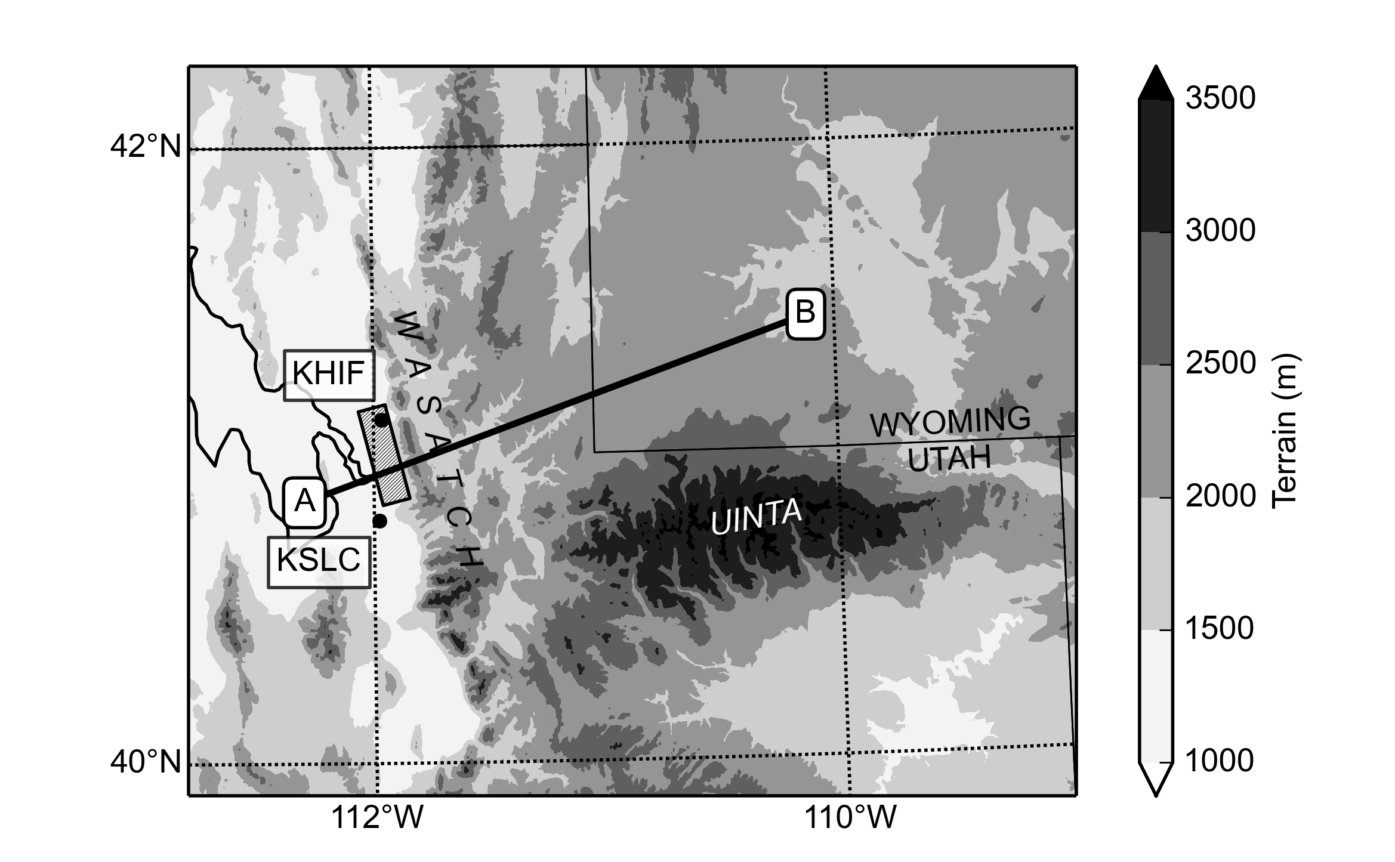
OGP

Figure 1: Terrain elevation in northern Utah and western Wyoming (shading). Locations (Salt Lake International Airport, KSLC; Hill Air Force Base, KHIF, and Ogden Peak, OGP), mountain ranges, and cross-section paths mentioned in the text are shown. The Wasatch Front is the low-lying region paralleling the west slopes of the Wasatch Mountains. Centerville lies at the intersection of the A–B cross-section immediately to the west of the Wasatch Range. The shaded rectangular box along the Wasatch Front approximately delineates the damage swath on 1 December 2011.

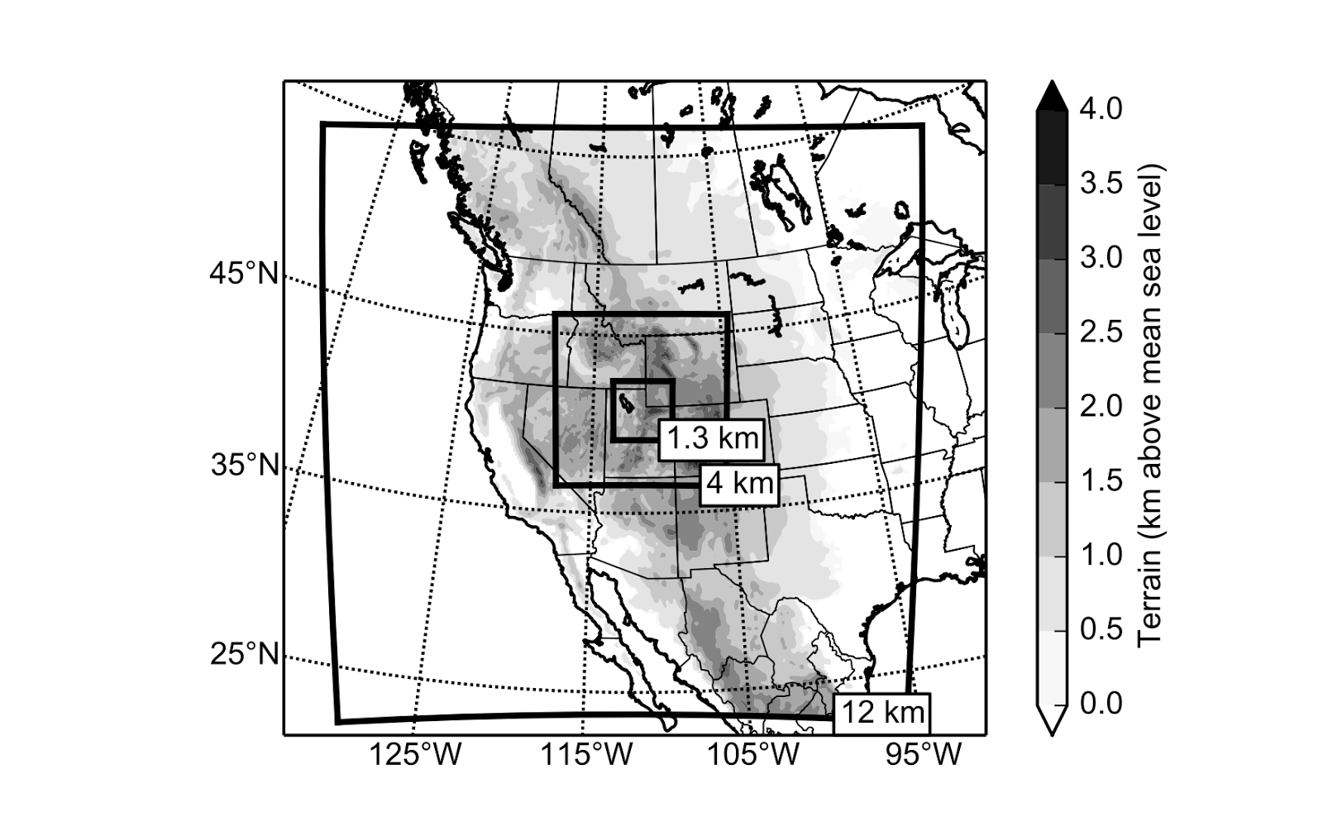Figure 2: Domain areas for the 12-, 4-, and 1.3-km domains in the Weather Research and Forecasting model. Terrain is from the 12-km domain at 10-min resolution.

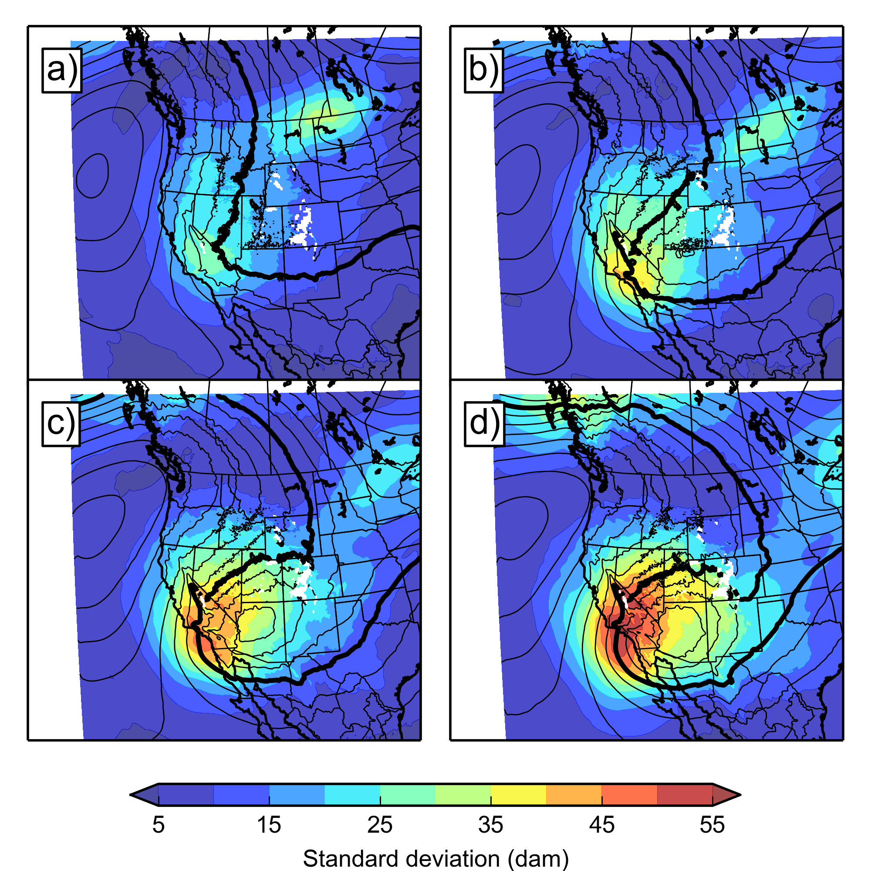

Figure 3: Ensemble-mean 700-hPa geopotential height (contoured at 30 m with the heavy line denoting 3060 m), and ensemble standard deviation (shaded according to the scale), taken from the 29Nov run, valid at (a) 0000 UTC, (b) 0600 UTC, (c) 1200 UTC, and (d) 1800 UTC, 1 December 2011.

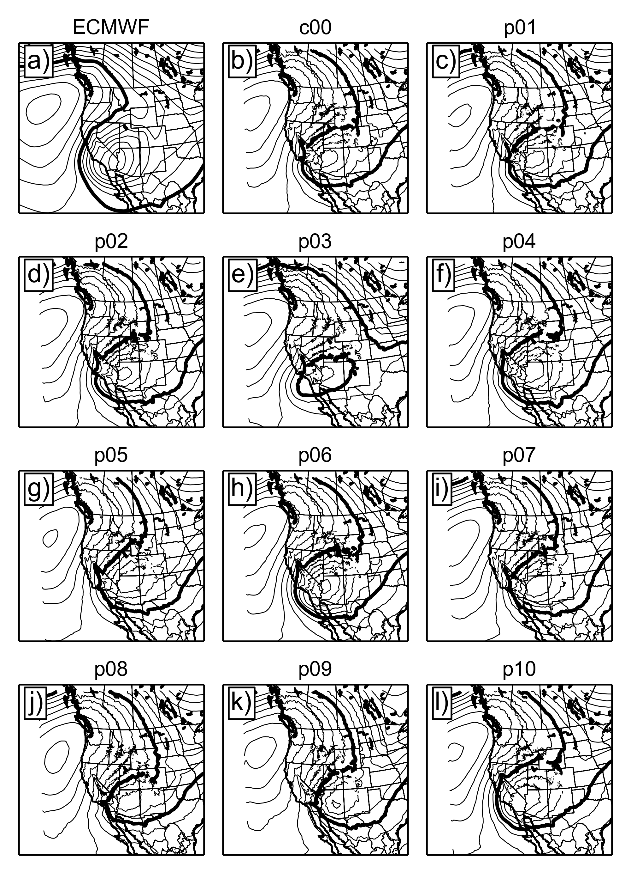

Figure 4: Geopotential height contoured at 30 m intervals (heavy line denotes 3000-m contour) at 700 hPa, valid 1200 UTC 1 December 2011, taken from (a) ECMWF ERA-Interim, (b) the control GEFS/R2–WRF run, and (c–l) the ten GEFS/R2–WRF perturbation members from the 29Nov ensemble run.

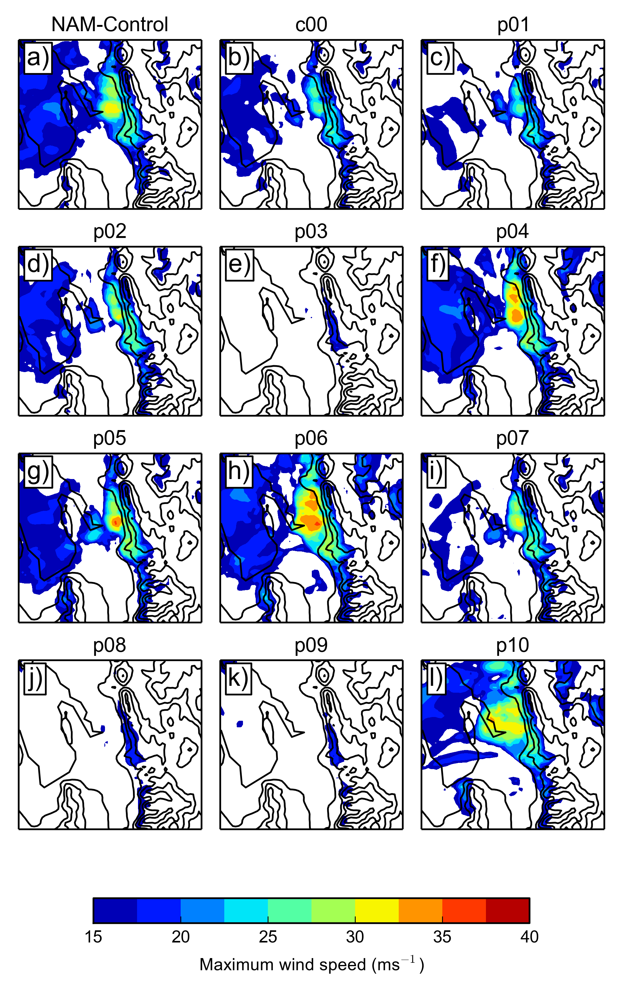

Figure 5: Maximum 10-m wind from 1.3-km WRF model domain between 0000 UTC 1 December and 0000 UTC 2 December. Terrain contoured every 400 m for reference with the Great Salt Lake outlined in the top left of each domain.

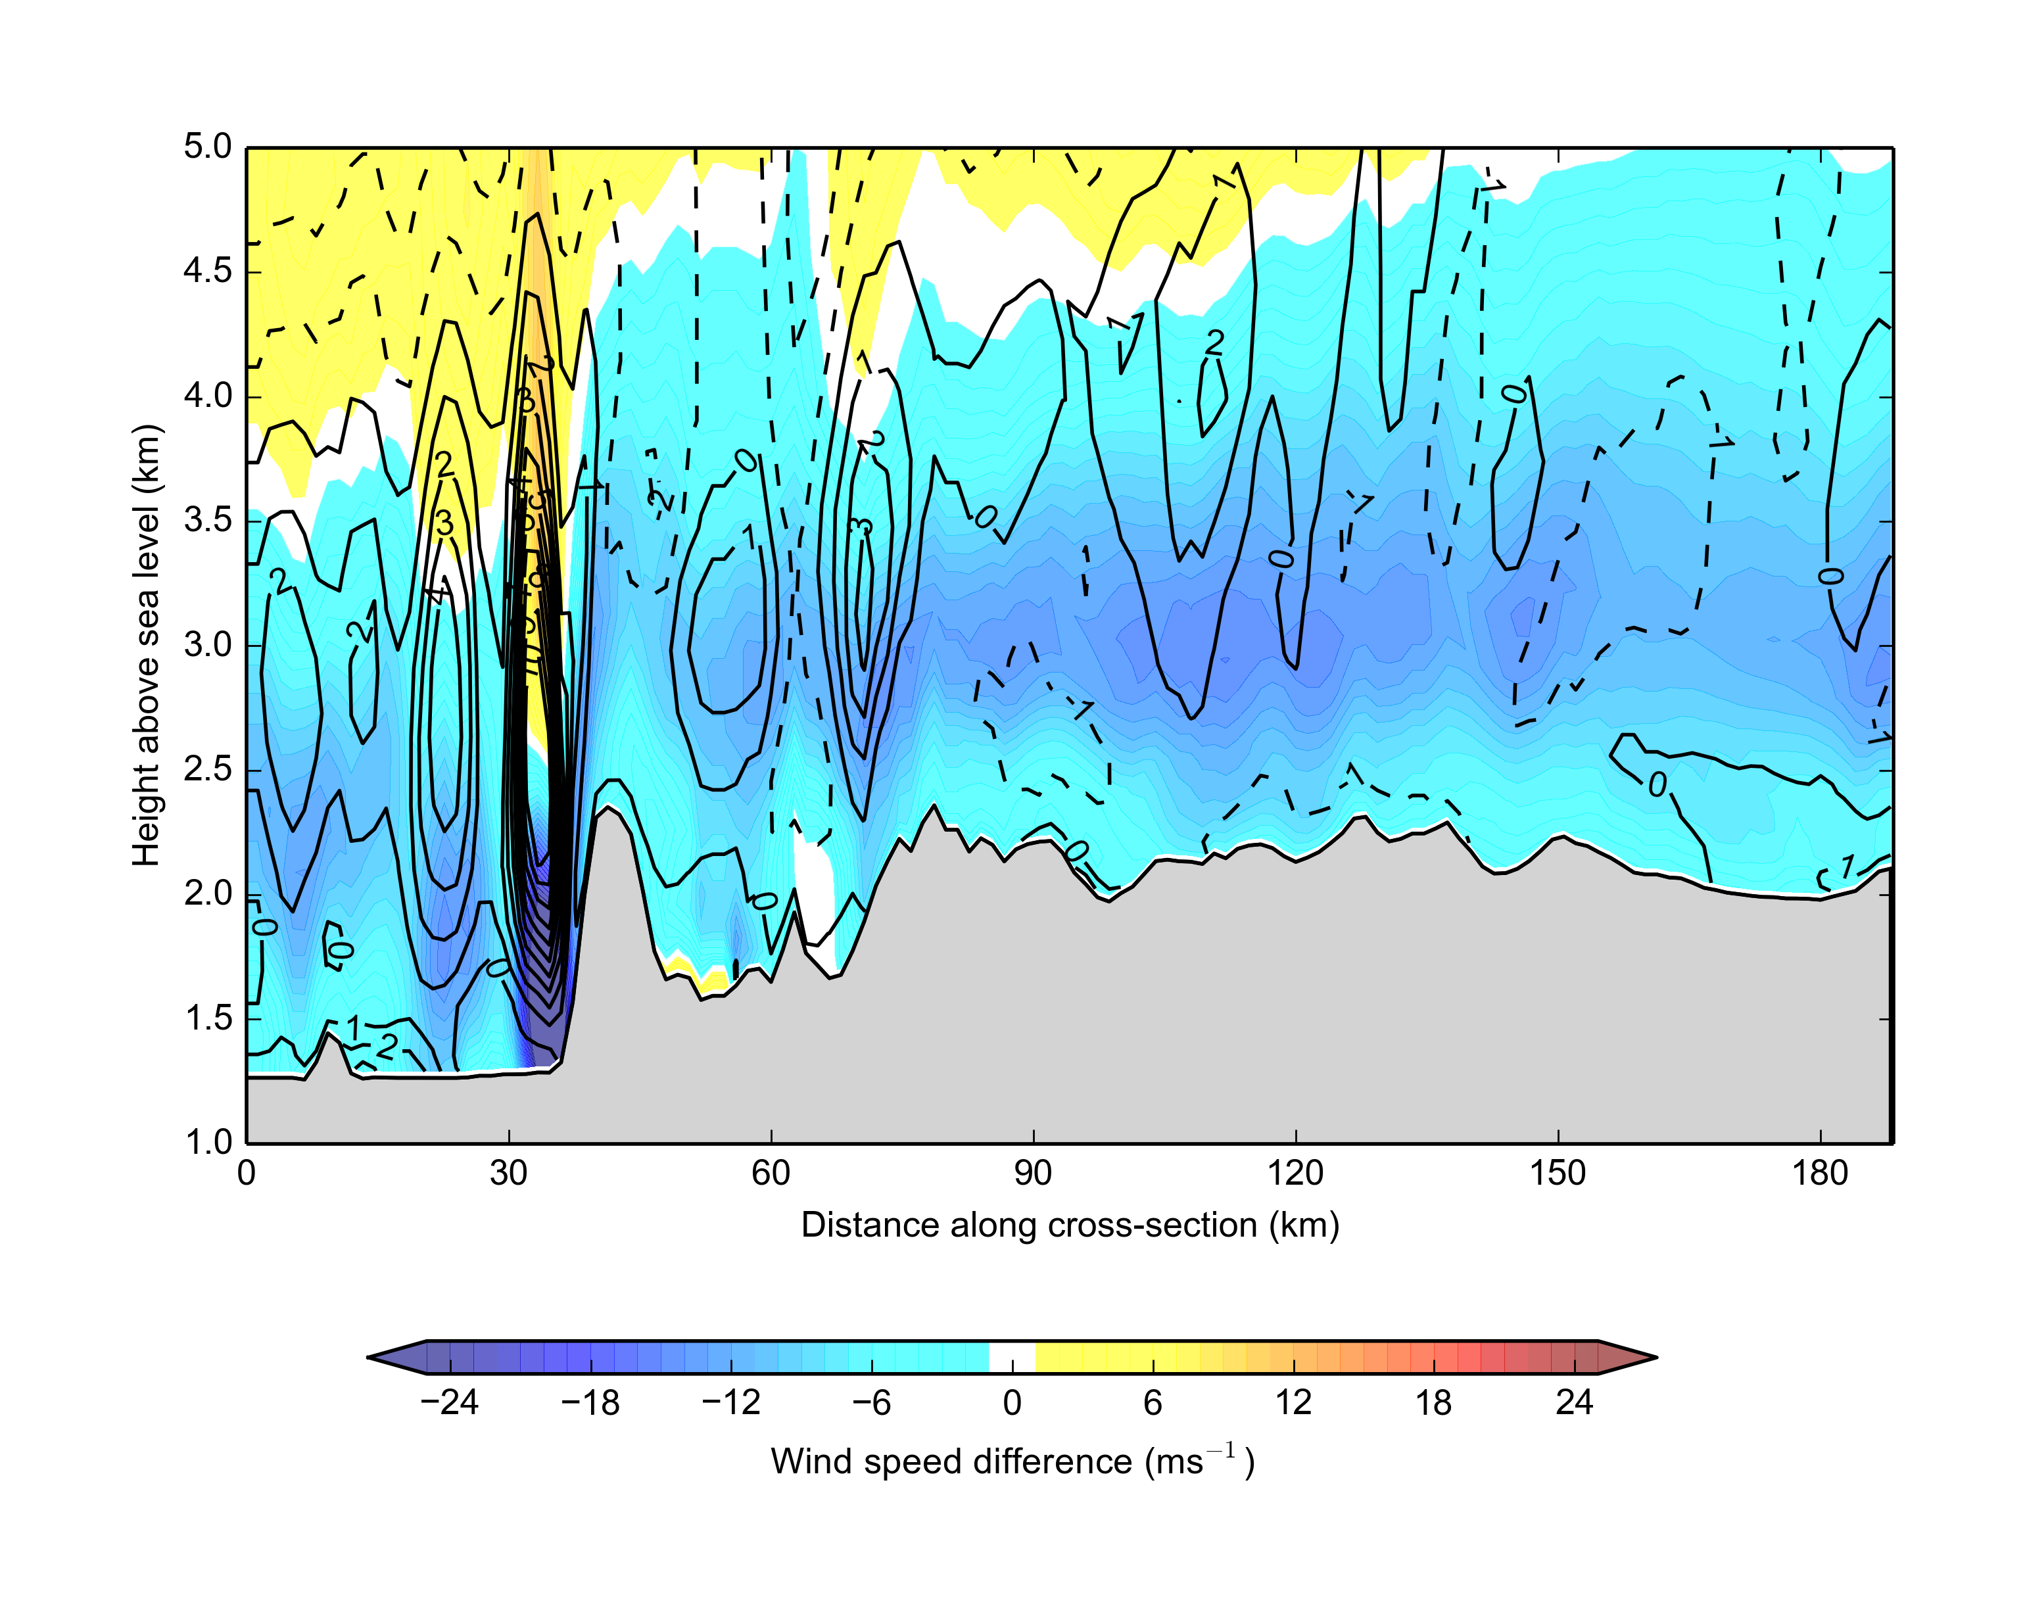

Figure 6: Group-W minus Group-N along the A–B cross-section (see Figure 1) for wind speed parallel to the cross-section (color-shaded) and potential temperature (contoured), taken from the 29Nov run valid at 1800 UTC, 1 December 2011.

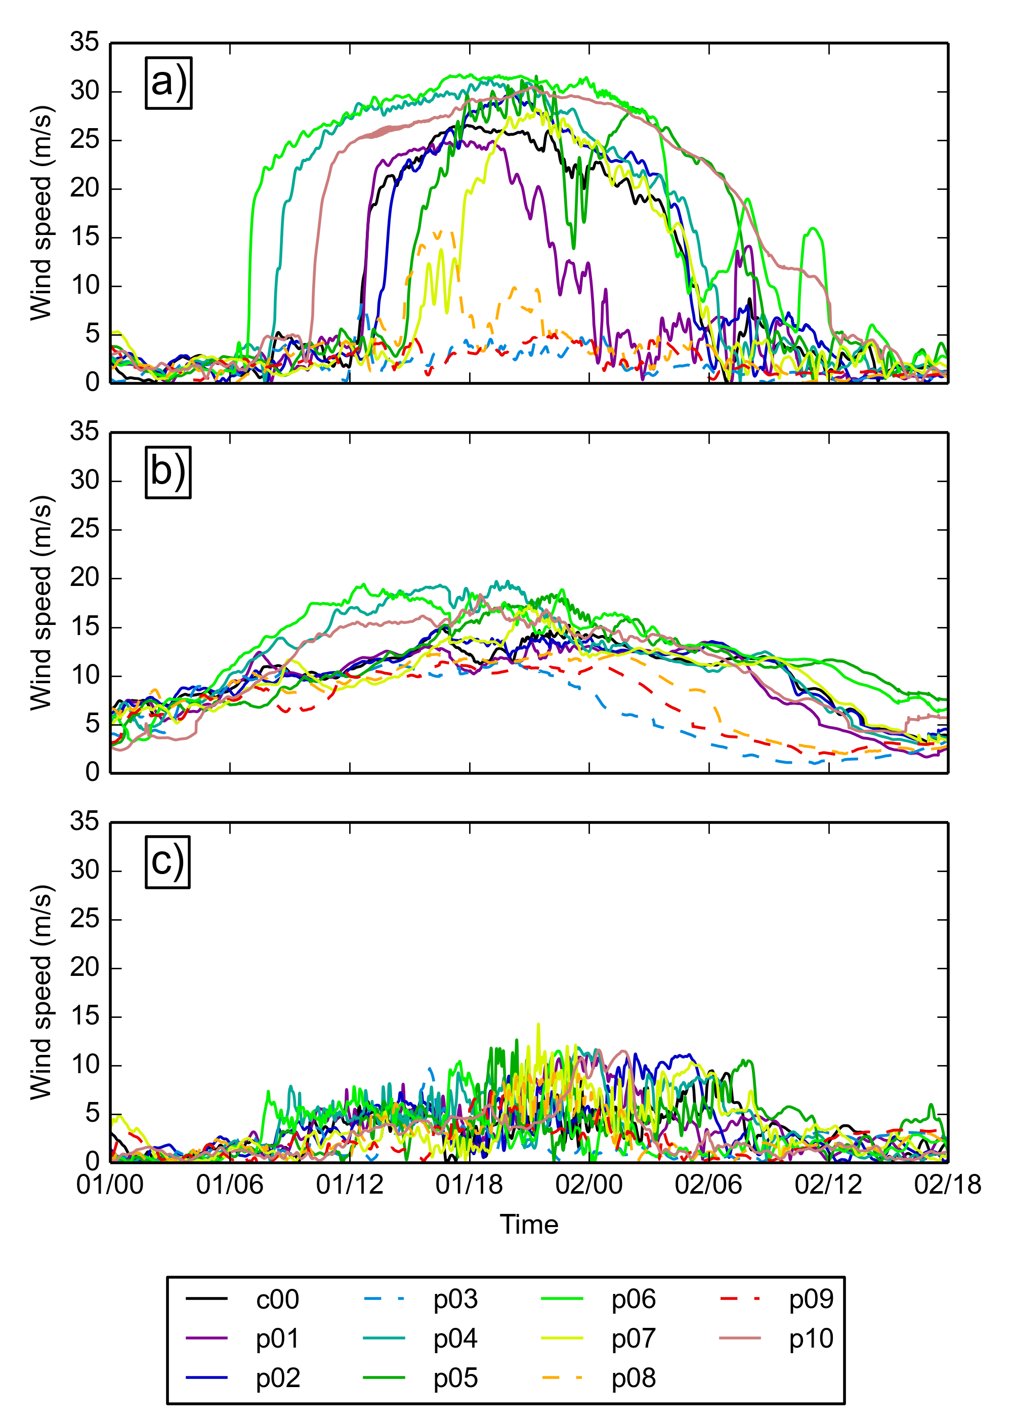

Figure 7: High-temporal-resolution WRF output of 10-m wind speeds at three locations near the Wasatch Front: (a) Centerville, (b) Ogden Peak (OGP), and (c) Salt Lake International Airport (KSLC).

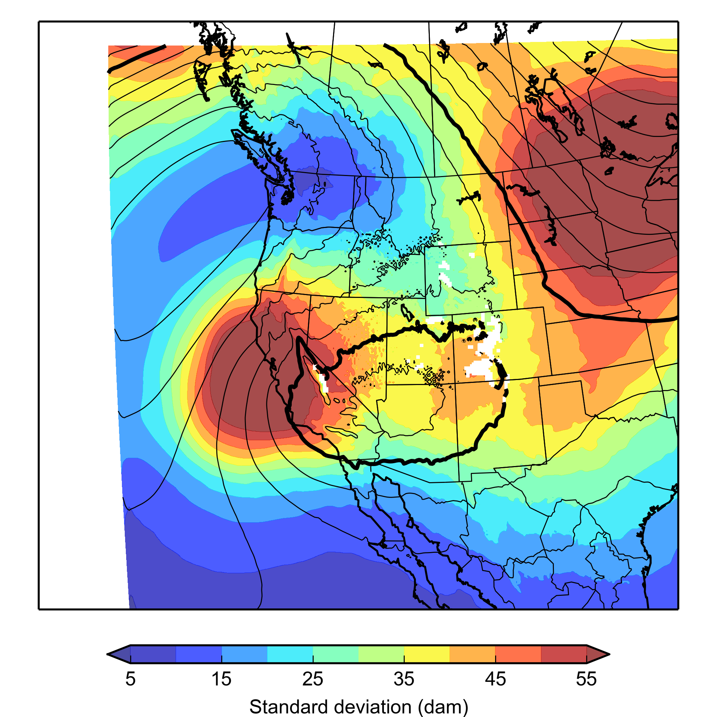

Figure 8: As in Fig. 3c, but taken from the 27Nov ensemble run

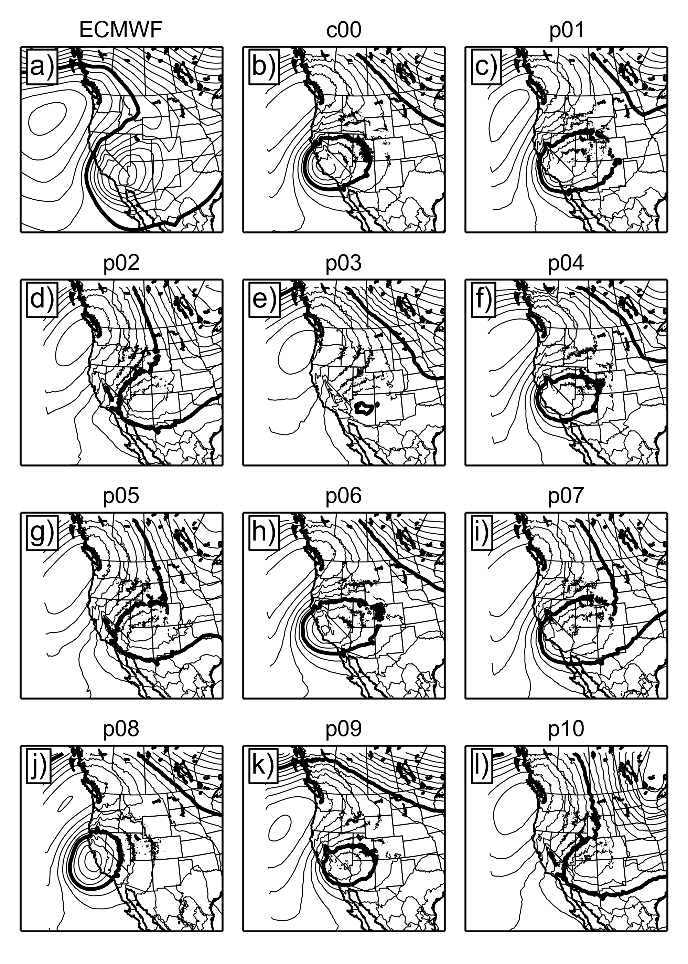

Figure 9: As in Fig. 4, but for the 27Nov ensemble run.

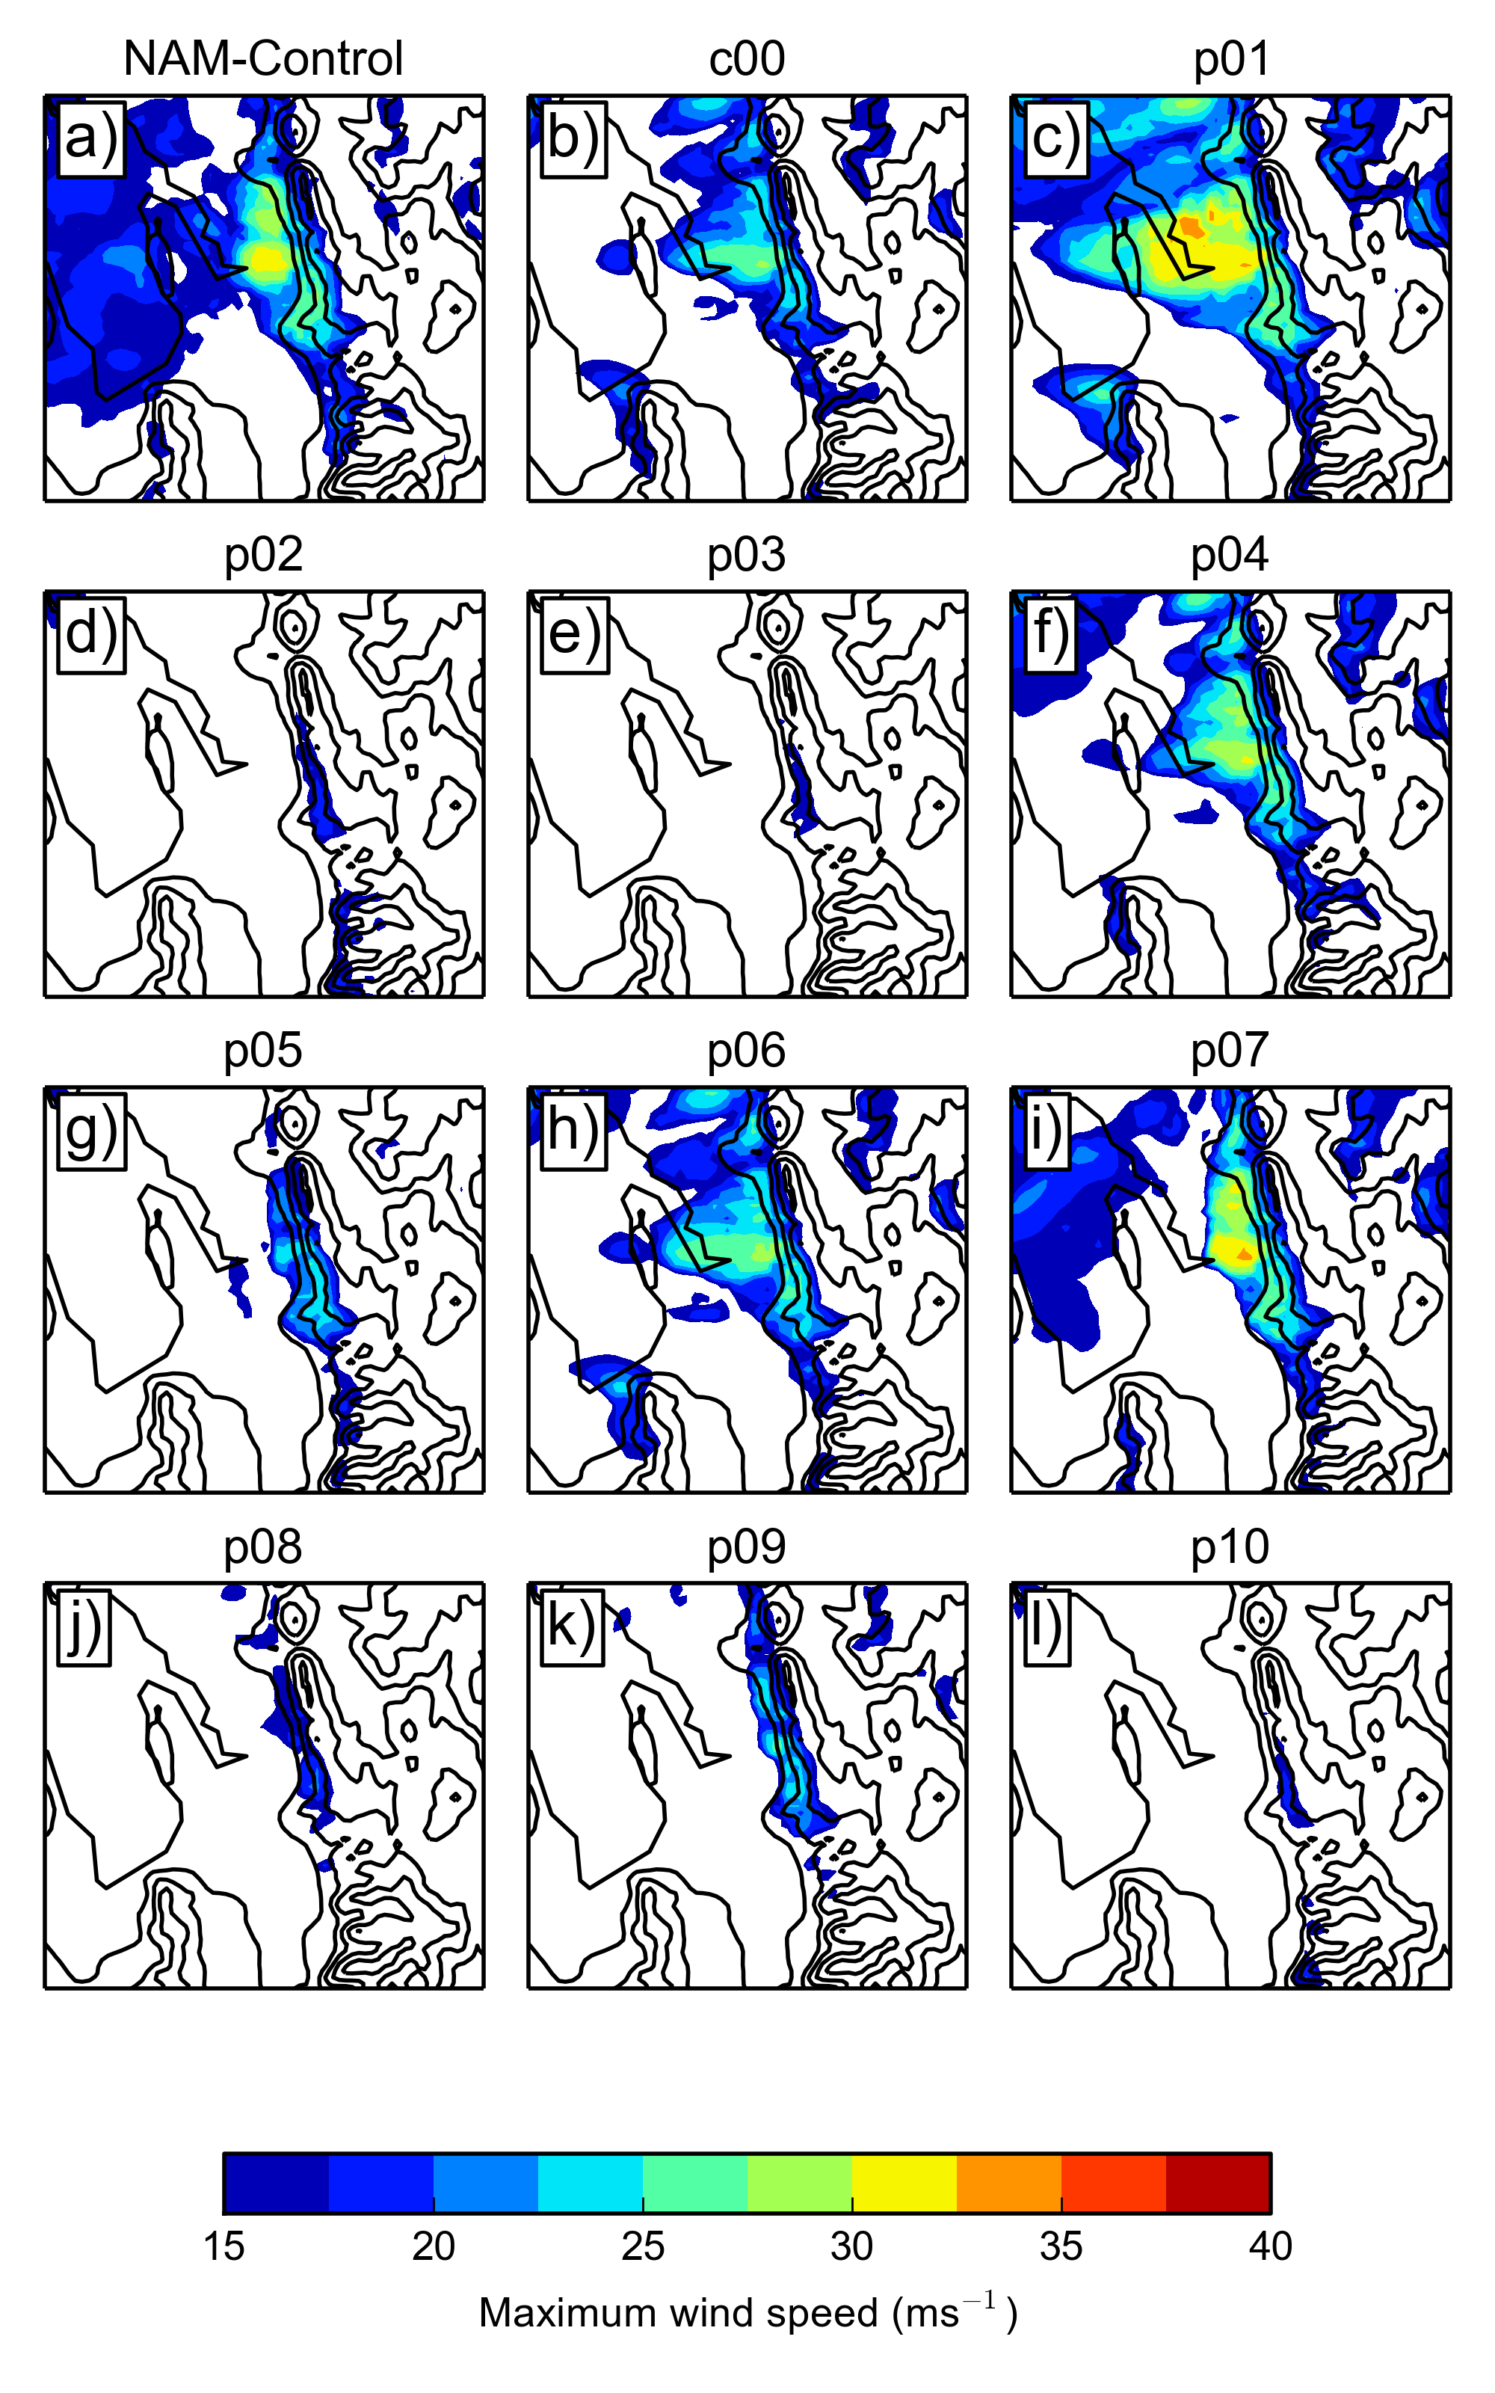

Figure 10: As in Fig. 5, but taken from the 27Nov ensemble run.

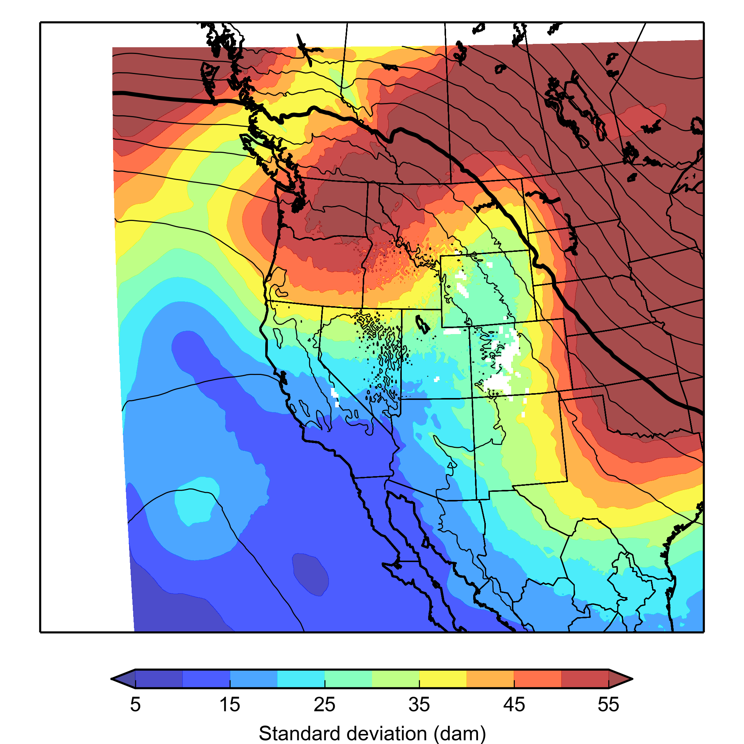

Figure 11: As in Fig. 3c, but taken from the 25Nov ensemble run.
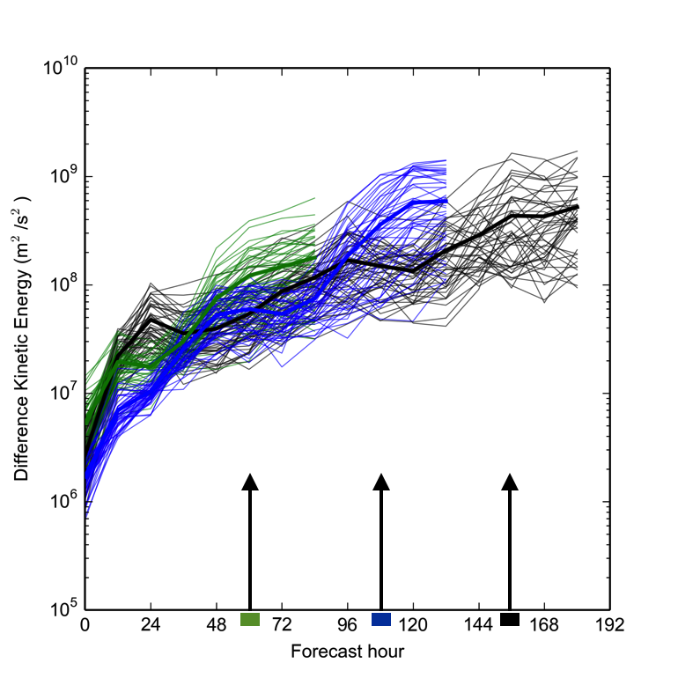

Figure 12: Difference Kinetic Energy, vertically integrated from the surface to 500 hPa at all grid points in the 4-km domain area, as a function of forecast hour and ensemble forecast pair. Values from the 29Nov (green), 27Nov (blue), and 25Nov (black) ensemble runs are shown. Arrows and color boxes on the x-axis denote the peak time of the windstorm (1200 UTC 1 December) for the three runs.

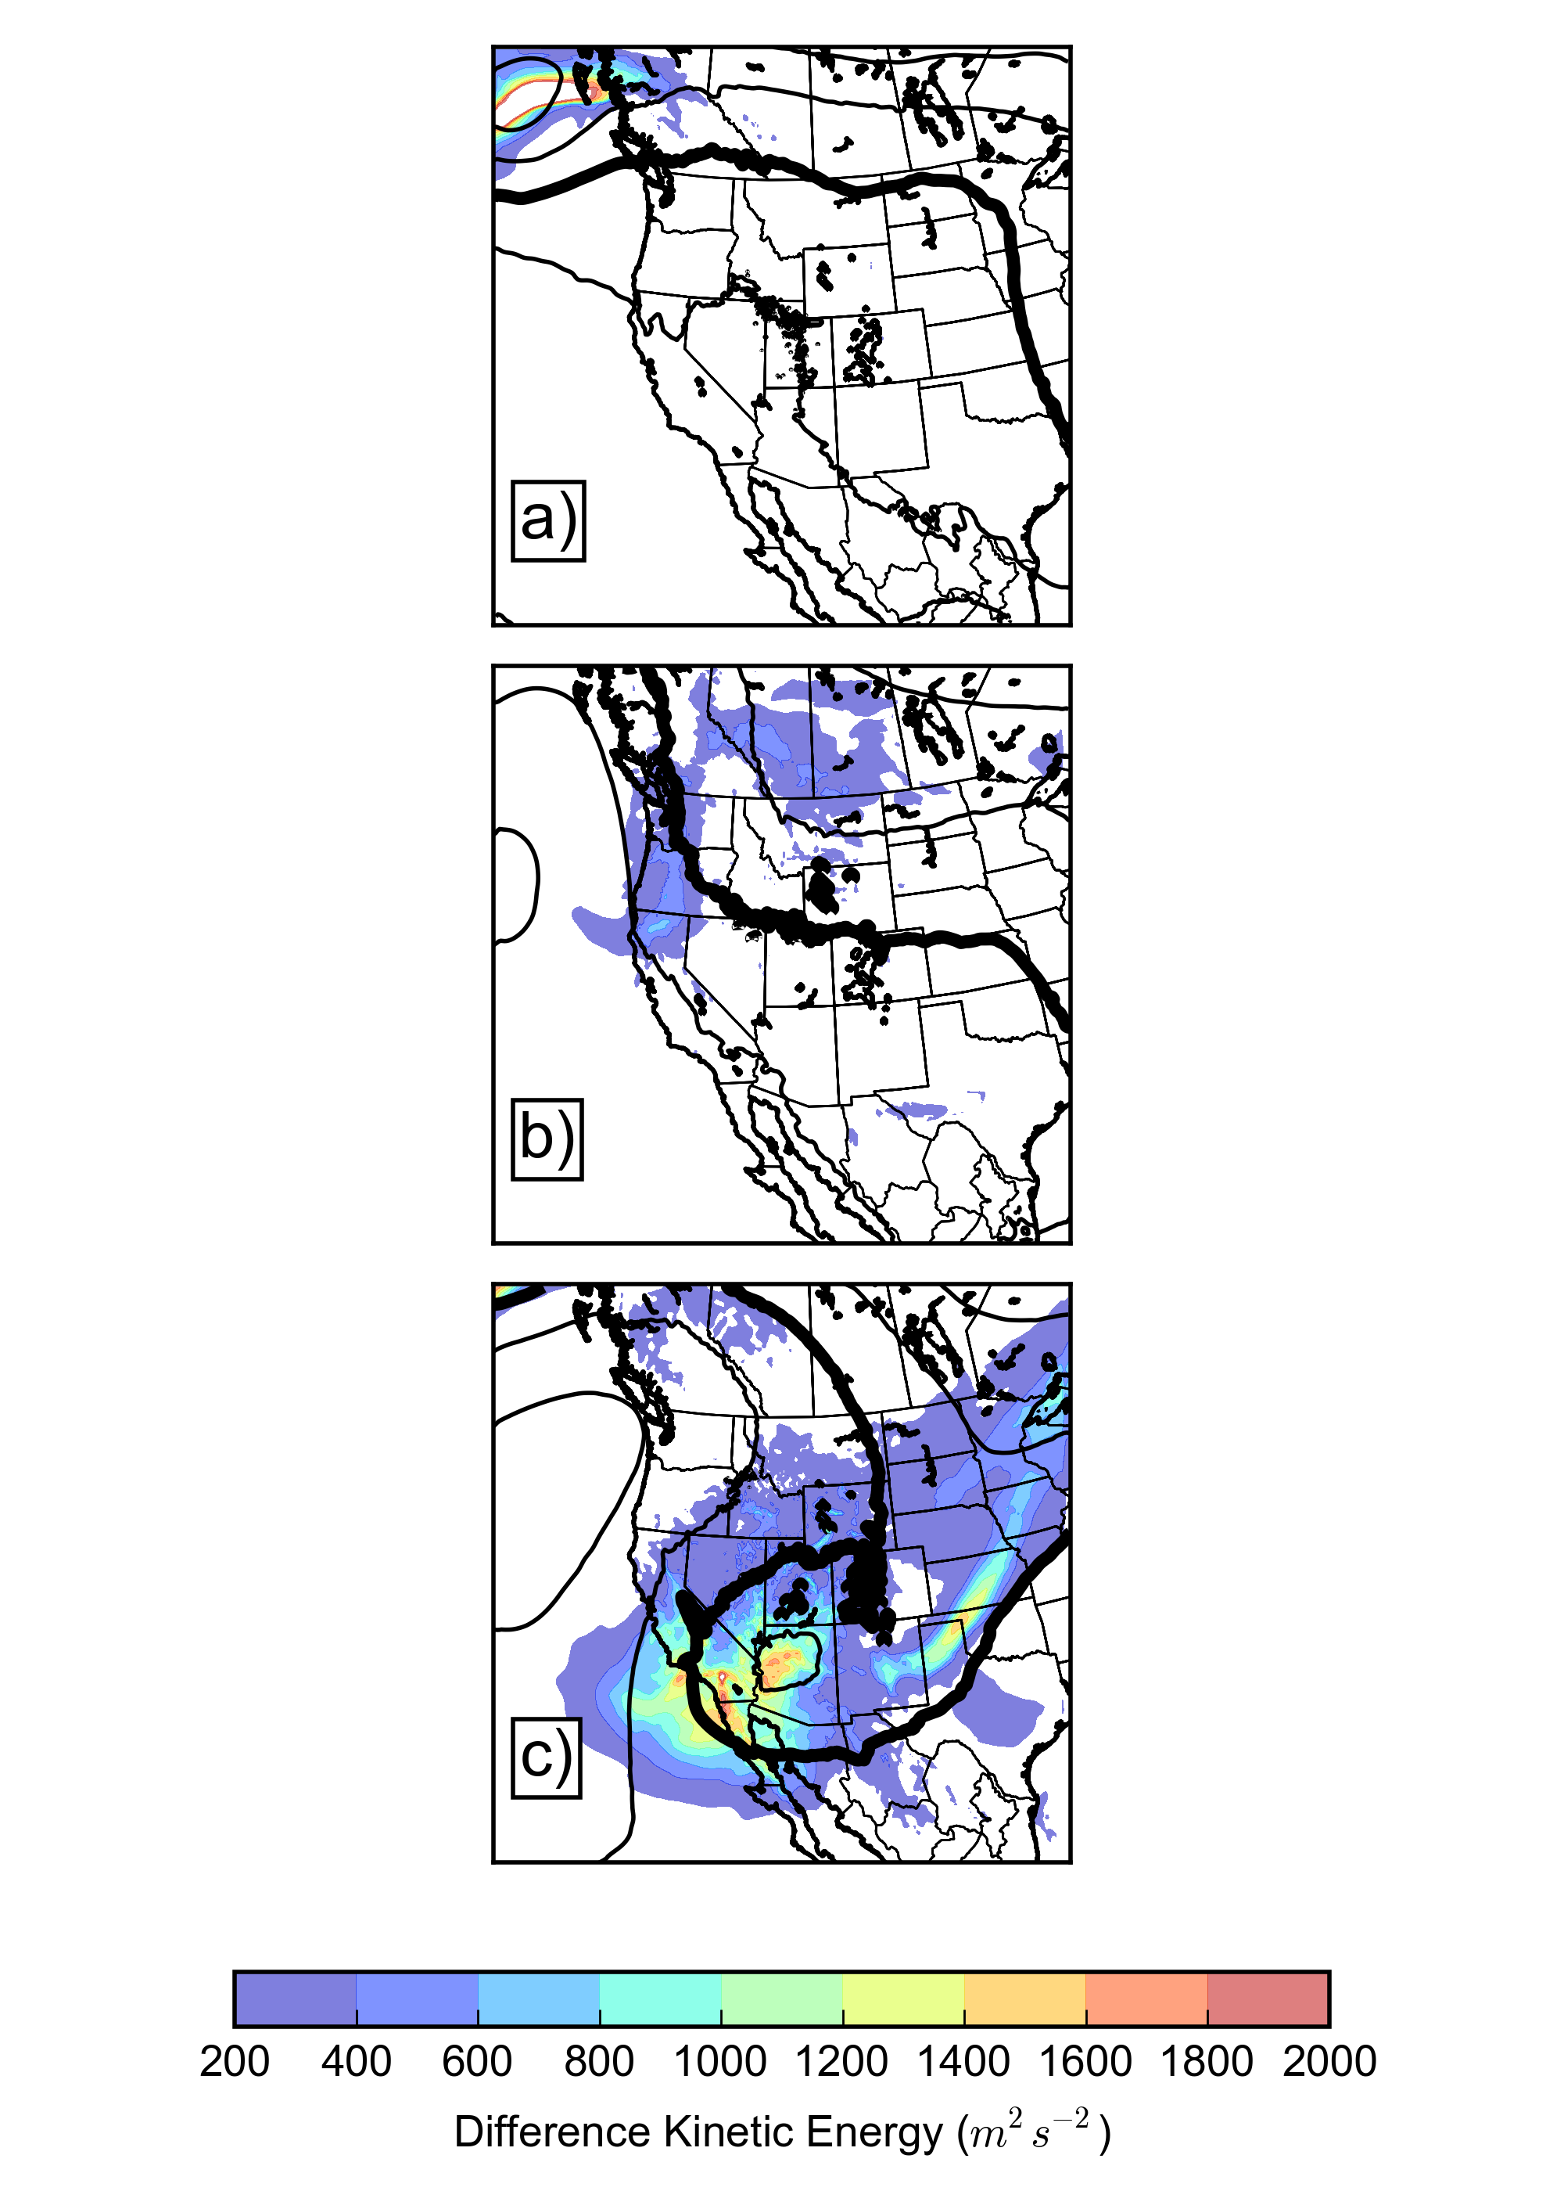

Figure 13: Vertically-integrated Difference Kinetic Energy in the lower troposphere from the 29Nov ensemble run valid at (a) 1200 UTC 29 November, (b) 1200 UTC 30 November, and (c) 1200 UTC 1 December. Black lines indicate 700 hPa geopotential height, contoured every 90 m for reference. Thick line denotes the 3060-m isohypse.
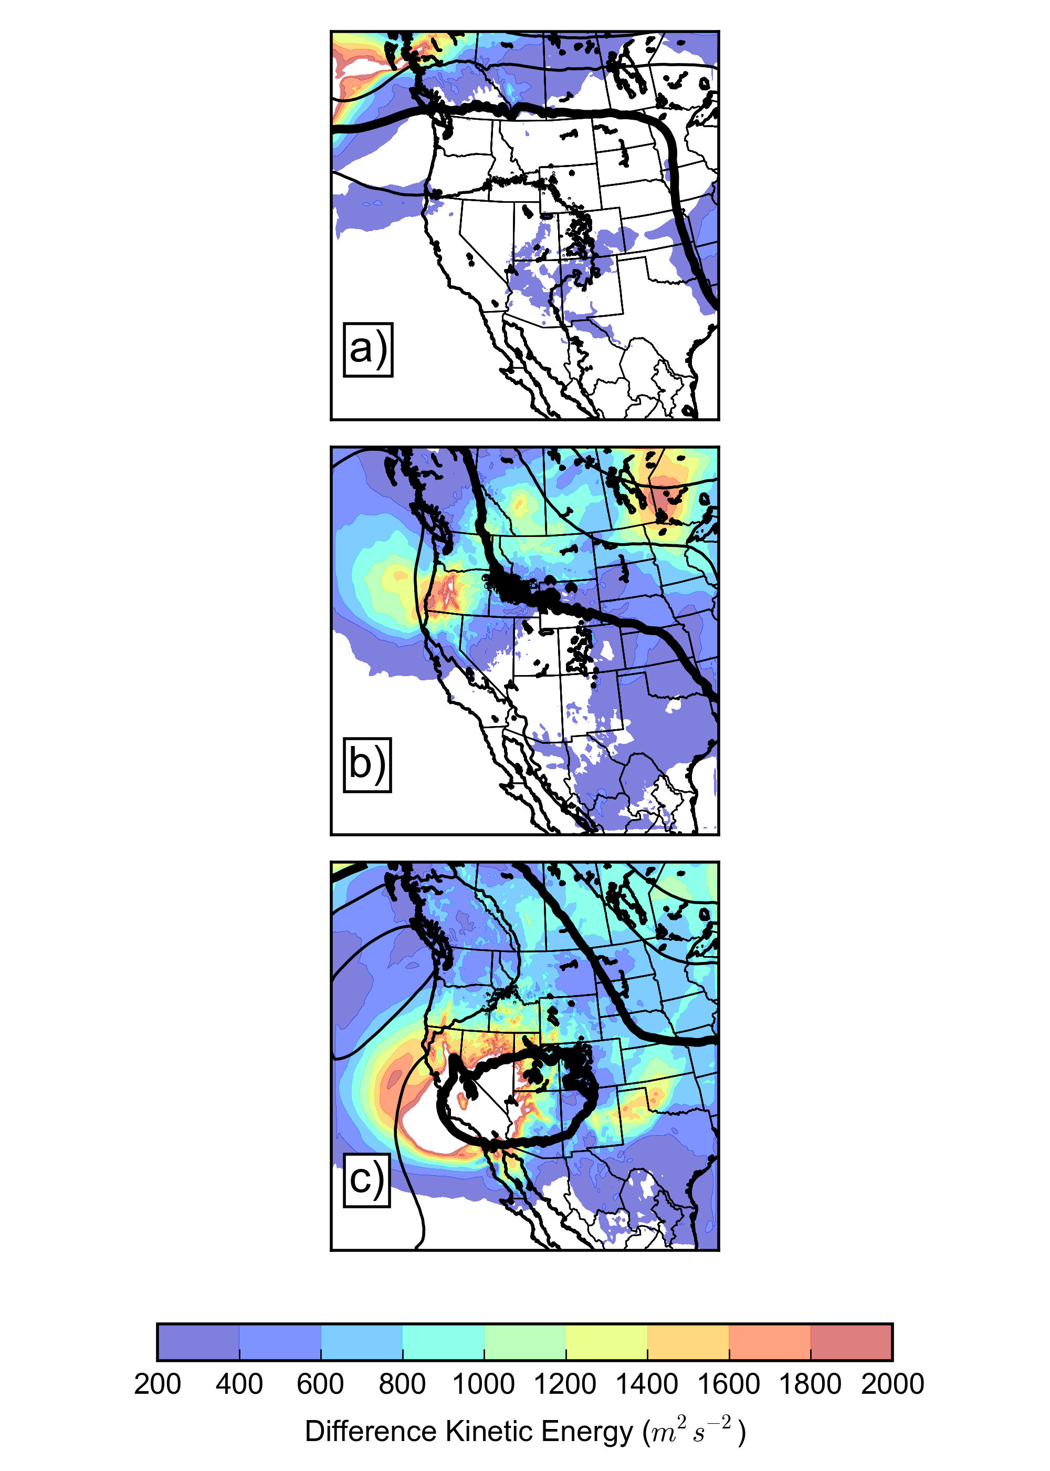

Figure 14: As in Fig. 13, but from the 27Nov ensemble run.

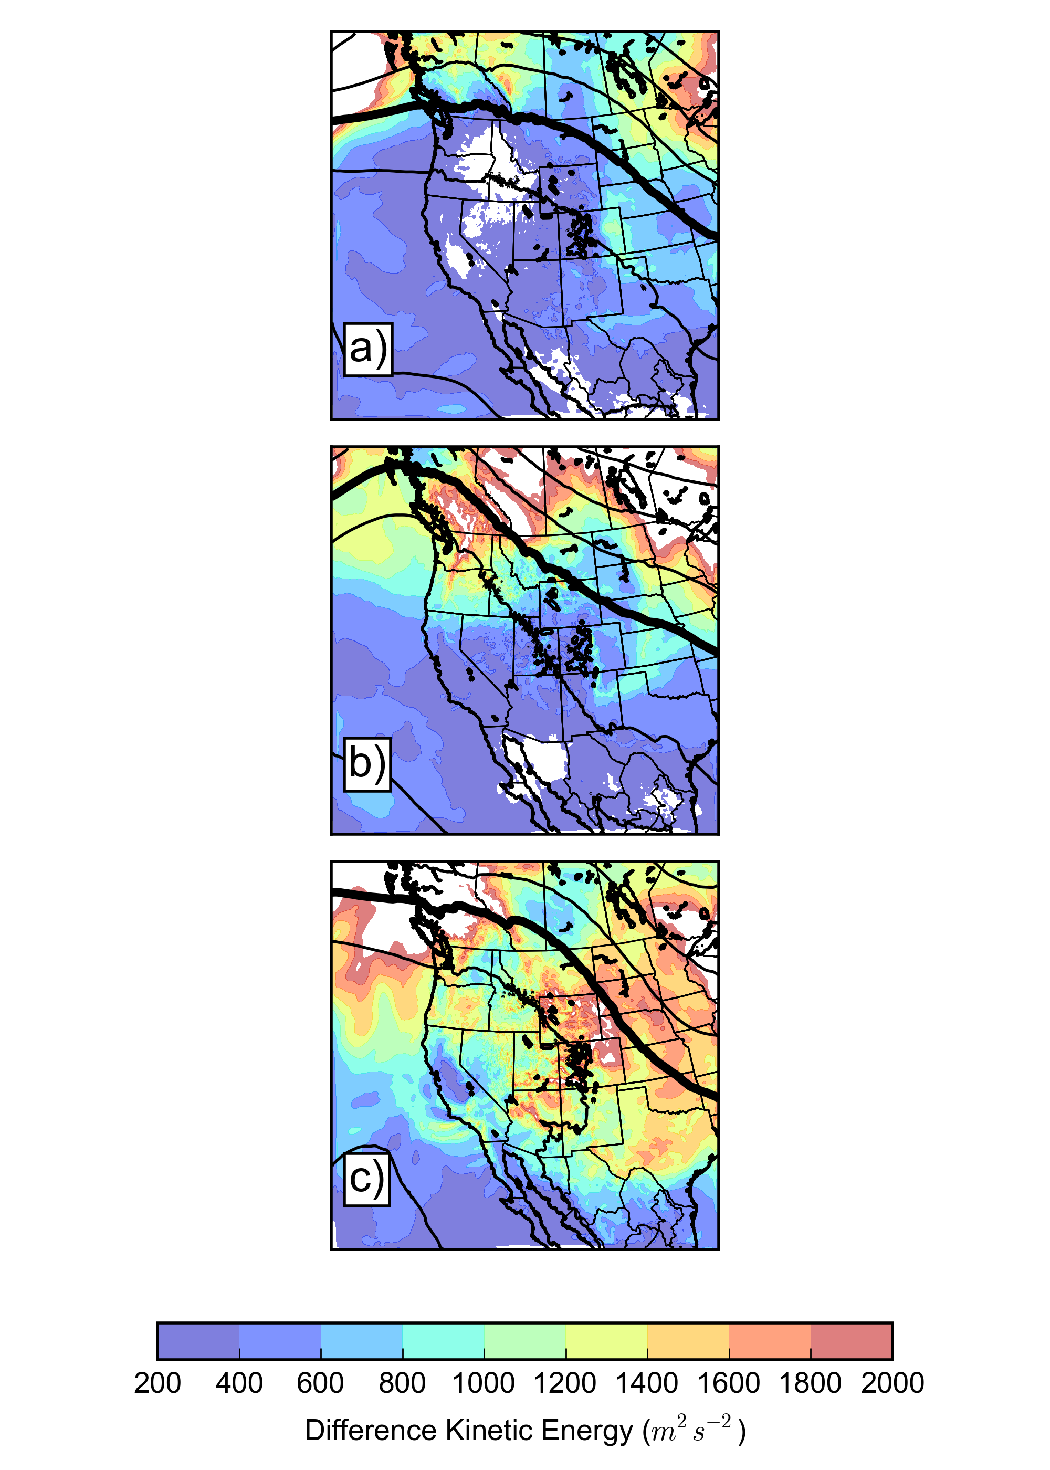

Figure 15: As in Fig. 13, but from the 25Nov ensemble run.

