The Persistent Cold-Air Pool Study

Neil Lareau¹, Erik Crosman, C. David Whiteman, John D. Horel, Sebastian W. Hoch

Department of Atmospheric Sciences
University of Utah
135 S 1460 E, Rm 819 WBB
Salt Lake City, Utah 84112-0110

and

William O. J. Brown, Thomas W. Horst

National Center for Atmospheric Research
P. O. Box 3000
Boulder, Colorado 80307-3000

To be submitted to BAMS: 30 November 2011

¹Corresponding author: Neil Lareau, 135 S 1460 E, Rm 819, Salt Lake City, UT 84112-0110, phone: (860)-716-0417, neil.lareau@utah.edu.

Abstract:
The Persistent Cold-Air Pool Study (PCAPS) was conducted in Utah’s Salt Lake Valley from 1 December 2010 to 7 February 2011. The field campaign’s primary goal was to improve understanding of the physical processes governing the evolution of multi-day cold-air pools (CAPs) that are common in mountain basins during the winter. Meteorological instrumentation deployed throughout the Salt Lake Valley provided observations of the processes contributing to the formation, maintenance, and destruction of 10 persistent CAP episodes. The close proximity of PCAPS field sites to residences and the University of Utah campus allowed many undergraduate and graduate students to participate in the study.
Ongoing research, supported by the National Science Foundation, will use the PCAPS data set to examine CAP evolution. Preliminary analyses reveal that variations in CAP thermodynamic structure are attributable to a multitude of physical processes affecting local static stability, e.g., synoptic-scale processes impact changes in temperatures and cloudiness aloft while variations in boundary-layer forcing modulate the lower levels of CAPs. During episodes of strong winds, complex interactions between the synoptic and mesoscale flows, local thermodynamic structure, and terrain lead to both partial and complete removal of CAPs. The strength and duration of CAP events are shown to affect the local concentrations of pollutants such as PM_{2.5}.

Capsule
Persistent cold-air pools that affect air quality in urban basins around the world were studied in Utah’s Salt Lake Valley.

1. Introduction
A cold-air pool (CAP) is defined as a topographic depression filled with cold air. CAPs occur when atmospheric processes favor cooling of the air near the surface, warming of the air aloft, or both. The resulting stable stratification prevents the air within the basin from mixing with the atmosphere aloft while the surrounding topography prevents lateral displacement and favors air stagnation. CAPS are common in mountain valleys during periods of light synoptic winds, high atmospheric pressure, and low insolation (Daly et al. 2009).
CAPs may be classified as diurnal, forming during the night and decaying the following day, or persistent, lasting multiple days (Whiteman et al. 2001). Diurnal CAPs are generally dominated by radiational cooling and are often associated with a surface-based temperature inversion. They accumulate in depth throughout the night only to be destroyed the next day by the growth of the convective boundary layer (Kondo et al. 1989; Whiteman et al. 2008). These short-lived CAPs have been studied in a number of field campaigns (e.g., Atmospheric Studies in Complex Terrain Experiment (ASCOT), Neff and King 1989; Peter Sinks Experiment, Clements et al. 2003; Vertical Transport and Mixing Experiment, Doran et al. 2002; Meteor Crater Experiment, Whiteman et al. 2008; Cold Air Pooling Experiment, Price et al. 2011).
Persistent CAPs are considerably more complex. They are most common during the winter and arise due to a multitude of atmospheric processes occurring across a range of scales (Wolyn and McKee 1989; Whiteman et al 2001; Zhong et al. 2001; Reeves and Stensrud 2009; Gillies et al. 2010). Consequently, the vertical profiles of temperature and humidity within persistent CAPs are highly variable. For example, Whiteman et al. (2001) used observations collected during two persistent CAP episodes to illustrate that synoptic-scale subsidence, differential temperature advection, latent heating, radiative flux divergence, downslope flows, clouds, and boundary layer convection all modulate CAP thermodynamic structure. A companion modeling investigation explored the comparative importance of some of these processes, finding that in some instance low clouds may prolong CAP duration (Zhong et al. 2001).
When persistent CAPs occur within urbanized basins (and increasingly in rural areas as well) the emissions from vehicles, home heating, and industrial sources accumulate within the stagnant air and can lead to hazardous air quality (Reddy et al. 1995; Pataki et al. 2005, 2006; Malek et al. 2006; Silcox et al. 2011). Dense fog, low clouds, and light precipitation may also occur and can adversely impact air and ground transportation. In fact, a recent plane crash near Ogden, UT was attributed to dense fog during a CAP (Deseret News, 6 December 2010)
While the general conditions favoring CAP formation are well documented (Wolyn and McKee 1989; Zhong et al. 2001), the exact mechanisms governing their evolution are not well-known and remain poorly resolved in forecast models (Reeves and Stensrud 2009; Reeves et al. 2011). Even relatively small model errors in CAP evolution can have large impacts on temperature and air-quality forecasts. As an example, a model forecast in which the initialized CAP is inadequately resolved may prematurely indicate the complete removal of the CAP during the passage of a weak storm, whereas the CAP may actually persist for many more days until a more substantive storm arrives. Such erroneous forecast projections can affect steps taken to mitigate health and environmental impacts during persistent CAPs (e.g., limiting outdoor activity, encouraging reduced driving, or curtailing industrial emissions). One source of forecast error may be model parameterizations of sub-grid scale turbulent mixing, which are known to perform poorly in strongly stable environments (Fernando and Weil 2010; Baklanov et al. 2011; Baker et al. 2011).
Given the growing demand for improved forecasts of persistent CAPs in urban basins, there remains a need for new observational and modeling investigations capable of resolving the multi-scale nature of persistent CAPs. To address this need, a three-year investigation supported by the National Science Foundation is currently underway by scientists at the University of Utah and Michigan State University. The goals of this study are: 1) To identify and observe the meteorological processes that lead to the formation, maintenance, and breakup of persistent CAPs, 2) to determine the consequences of these processes on air pollution transport and diffusion in urban basins, and 3) to assess how meteorological models can be improved to provide more accurate simulations of long- lived CAPs. The Persistent Cold-Air Pool Study (PCAPS), which is the field portion of the three-year investigation, was conducted from 1 December 2010 to 7 February 2011 in Utah’s Salt Lake Valley to gain unprecedented observations of persistent CAP evolution. The remainder of this paper describes the PCAPS field campaign and initial research findings.
2. The Persistent Cold-Air Pool Study
a. Experiment Design
A novel aspect of the PCAPS field campaign was the prominent role of University of Utah graduate students, including the two lead authors of this paper, in experiment design and implementation. In collaboration with the project’s Principal Investigators, a group of several students devised a two-tiered observational strategy for documenting the life cycle of persistent CAPs. First, continuously operating meteorological instruments were distributed throughout the Salt Lake Valley to provide data during the entire field campaign. Intensive Observation Periods (IOPs) where then declared whenever a CAP was expected to form and persist for more than one day. During each IOP, additional resources were deployed to target the specific physical processes expected to impact CAP evolution. Real-time observations from PCAPS instrumentation were subsequently used to modify IOP operations as each event unfolded.
b. The Salt Lake Valley
The PCAPS field campaign was undertaken in the Salt Lake Valley (SLV) of northern Utah, which is located on the eastern fringe of the semi-arid Great Basin of the western United States (Fig. 1). The regional topography is dominated by steep and narrow north-south oriented mountain ranges separated by broad and gently sloping valleys. The SLV (~1300 MSL) is a small portion (~30 km square) of a larger basin encompassing much of northwest Utah including the Great Salt Lake (GSL). It is home to ~ 1 million residents. The valley is confined by the Wasatch (~3000 MSL) and Oquirrh (~2500 MSL) mountains to its east and west, respectively, and separated from the neighboring Utah Valley to its south by the lower Traverse Mountains. The Jordan Narrows gap allows exchange of air between the two valleys (Chen et al. 2004; Pinto et al. 2006). A series of steep east-west trending canyons are incised into the Wasatch while the Oquirrhs feature comparatively broad slopes.
During the winter the SLV experiences frequent CAPs, which are often accompanied by dense fog and unhealthy air quality (Horel et al. 2002). In fact, the 24-h mean concentration of fine particulate aerosol with diameters less that 2.5 µm (PM_{2.5}) often exceeds the National Ambient Air Quality Standard (NAAQS) of 35 µg m⁻³ during persistent CAP episodes (U.S. EPA 2011; Silcox et al. 2011). High levels of carbon dioxide, carbon monoxide, and ozone may also occur (Pataki et al. 2005; 2006). One recent study even suggests that emergency room visits with a primary diagnosis of asthma are 42 % higher during the late stages of prolonged CAP events as compared to non-CAP days (Utah Asthma Program 2010). The combination of polluted air and fog also restricts visibility, which significantly detracts from the otherwise scenic snow-capped mountain vistas for which the region is well known. Correspondingly, considerable public awareness accompanies CAP events, which are colloquially referred to as “inversions,” and a number of local advocacy groups work to mitigate their impacts.

c. Instrumentation
In this section we detail the observing platforms used during PCAPS. Observing sites are showing in Fig. 1 and photographs of many of the instruments are included in Fig. 2.

1) REMOTE SENSORS

Two NCAR radar wind profilers, a scanning pulsed Doppler LiDAR, and a miniSoDAR (Fig2d-f) provided continuous observations of winds above the SLV during PCAPS. The radar wind profilers (915 and 449 MHz), located in the valley center, characterized the wind shear within and above (~50-3000 m AGL) each CAP as well as the occasional penetration of strong winds into the valley atmosphere. Changes in wind occurring closer to the ground (0-200m AGL) were determined with the miniSoDAR that was situated near the GSL to observe land and lake breezes. The LiDAR provided additional observations of winds aloft along the western edge of the SLV at the Bingham Canyon Mine site.
The vertical temperature structure within the SLV was determined by means of a Radio Acoustic Sounding System (RASS; Fig. 2e), which operated in concert with the 915 MHz radar. Data from the RASS provide high temporal sampling during periods of rapid transition. Additional measurements of temperatures aloft were collected with a microwave radiometer provided by researchers from San Jose and San Francisco State Universities.
A laser ceilometer, located at the NCAR Integrated Sounding System (ISS) site ~0.5 km south of the profilers, was used to measure aerosol and hydrometeor backscatter (Fig. 2g). These data are particularly useful in visualizing boundary layer structure and provide an objective indication for the presence of low and mid-level clouds.

2) SURFACE METEOROLOGICAL STATIONS

Monitoring the complete surface energy balance at 7 locations distributed throughout the SLV (Fig. 1) was of fundamental importance during the campaign. These sites were chosen to span the geographical extent of the valley and to represent varying land use, ranging from urban to agricultural. Each location housed an NCAR Integrated Surface Flux Station (ISFS) equipped with a 3-D sonic anemometer, fast response temperature and humidity sensors, solar and terrestrial radiometers, and soil temperature probes (Fig. 2a).
Five automated weather stations (Fig. 2b) were installed at the south end of the SLV along a vertical transect of the Traverse Mountains (Fig. 1) to monitor variations in wind, temperature, and humidity during CAP events. These sites are also useful in diagnosing cross barrier exchange between the Utah and Salt Lake Valleys (Chen et al. 2004; Pinto et al. 2006).
Additional vertical profiles of temperature and humidity were established with Hobo® data loggers distributed at 50-m elevation increments along three transects: one ascending a prominent ridge on the west slope of the Wasatch Mountains, and two along the east slopes of the Oquirrh Mountains. Recording measurements every 5 minutes, these data loggers act as temperature pseudo-soundings capable of documenting rapid changes in the vertical thermodynamic structure.
The PCAPS field campaign also benefitted from more than 100 preexisting surface meteorological stations distributed in and around the SLV. These data, available through MesoWest (Horel et al. 2002), provided detailed observations of the spatial heterogeneity within the CAPs.
An air quality observation network, operated by the Utah Division of Air Quality (DAQ) provided hourly and 24-hour mean measurements of criterion pollutants, including concentrations of PM_{2.5}. This network was supplemented by a line of PM_{2.5} filter samplers that ran up a sloping residential neighborhood at the north end of the Salt Lake Valley (Silcox et al. 2011).

3) IOP OBSERVATIONS

Radiosondes launched from the NCAR ISS site provided the principal observations of CAP thermodynamic structure during each IOP. Over 115 Viasala radiosondes where launched throughout the project, augmenting the 138 regularly scheduled NWS soundings deployed at the nearby Salt Lake International Airport (Fig. 1). The temporal interval of the ISS soundings ranged from once every 3 hours during periods of rapid transition (e.g. “mix-out” events, cloud formation) to once a day for routine monitoring of CAPs.
Three additional mobile radiosonde systems (GRAW) were used at sites throughout the SLV to provide contemporaneous thermodynamic profiles during targeted observations of lake-breeze fronts, periods of differential side-wall heating, canyon drainage flows, and partial “mix-out” of the CAP during strong winds. In total 57 GRAW radiosondes were deployed, significantly enhancing sampling of the horizontal variability in CAP vertical structure.
The most unusual instrument platform used during PCAPS was an instrumented powered paraglider (Fig. 2j). The manned paraglider, which was equipped with temperature, humidity, and pressure sensors, was used on 6 IOP days to perform horizontal boundary layer transects and repeated vertical profiles. Some of the unique observations collected by the paraglider are described in a sidebar accompanying this paper.
In addition to enhanced upper air observations, surface meteorological measurements were augmented during IOPs by two vehicles equipped with GPS, wind, temperature, humidity, and pressure sensors. These vehicles recorded horizontal variations in CAP structure (Fig. 2i).
d. Participants
The PCAPS field campaign was a collaboration of university and government scientists, graduate and undergraduate students, and interested members of the community. Faculty and students at the University of Utah formed the core of the PCAPS operations and science team, while scientists from the National Center for Atmospheric Research (NCAR) installed, maintained, and operated the principal observing platforms. Collaborators from San Francisco and San Jose State Universities provided additional instrumentation and expertise.
Taking advantage of the general interest in the poor air quality that accompanies our local “inversions”, students and members of the community at large were recruited to participate in PCAPS. Over 50 individuals responded to the call for help and were trained prior to the field study. The urban and residential setting of PCAPS then facilitated over 500 hours of volunteer service time, which included assistance with launching weather balloons, driving mobile meteorological stations, supporting motor-glider operations, installing meteorological instruments, and forecasting CAP evolution.

3. Initial Findings
a. CAP evolution and air pollution
Figure 3a shows a measure of CAP strength within the SLV for the entire PCAPS period in terms of the potential temperature deficit. This deficit, calculated from ISS and NWS radiosonde data, is the difference between the potential temperature at each level and the potential temperature at the crest of the confining topography (2500 m). Generally, large (small) deficits indicate a strongly stable (well-mixed) atmosphere within the valley. Multi-day CAPs episodes (identified by using a deficit threshold of -8 K) were punctuated by short windows of weaker stratification usually associated with the passage of cyclonic synoptic-scale weather systems. All of the strong CAP events were included in the IOPs (Fig. 3a). The surface albedo, a proxy for snow cover, varied significantly from one event to the next (Table 1). Additional pertinent details for each IOP are presented in Table 1.
Figure 3b presents the daily midnight-to-midnight (MST) average PM_{2.5} concentration measured in the valley during PCAPS. By comparing the top and bottom panels of Fig. 3, it is apparent that CAP strength and duration both affect the concentration of fine particulate aerosols, though variations in emissions may also play a role (e.g., reduced commuter traffic during IOP4 over the Christmas holiday). During each of the four longest CAPs (IOPs 1, 5, 6 and 9) PM_{2.5} concentrations exceeded the NAAQS. Silcox et al. (2011) show that PM_{2.5} concentrations in the SLV between 1 January and 20 February 2011 were highly correlated (r² = 0.78) with the potential temperature deficit, and that pollutant concentrations generally increased with CAP duration and decreased with increasing elevation. Layers of haze and clouds of varying depth were visible during many of these events (Fig. 4).

b. CAP vertical structure
A wide variety of thermodynamic profiles were observed during PCAPS. A representative sample of temperature, dew point temperature, and wind profiles is provided in Fig. 5. Following Whiteman et al. 2001, the characteristics of these soundings can be viewed in the context of the processes that lead to changes in the lapse rate at a particular level:
- Differential heating: vertical variations in the heating rate within the column, including the contributions of radiational heating and cooling, turbulent fluxes of sensible heat, and the latent heating associated with evaporation and condensation.
- Horizontal and vertical advection: transport into the valley of markedly different stability from the ambient state, e.g., the descent of a subsidence inversion into the valley.
- Differential temperature advection: vertical gradients in the sign or magnitude of horizontal temperature advection, e.g., warm-air advection aloft combined with cold-air advection near the surface.
- Vertical Deformation: Differential vertical motions within the vertical column acting to compress or disperse isentropes.
The first sounding, from near the end of IOP3, demonstrates a “classic” nocturnal inversion (Fig. 5a). Following a night of clear skies and radiational cooling, the temperature inversion extends from the surface to 830 hPa, above which the temperature decreases at a nearly adiabatic rate. Conversely, the dew point temperature decreases rapidly with height reaching a minimum at the top of the inversion layer. Veering winds occur above the CAP, while weak winds are observed near the surface.
The sounding in Fig. 5b, which was collected during IOP 9, demonstrates the impact of boundary layer clouds on CAP structure. The profile data indicate a layer of stratocumulus clouds between 850 and 810 hPa capped by a strong inversion. Within and below the cloud layer the lapse rate is nearly moist adiabatic suggesting that cloud top radiational cooling generates weak moist convection within the boundary layer. Cloud top cooling is also the hypothesized source of the base of the sharp elevated inversion. Similar thermodynamic profiles were observed during IOPs 1, 4, 5 and 9 reflecting that CAPs with stratiform clouds often exhibit internal mixing and are not characterized by continuous strong stability extending from the surface upwards.
On some occasions clouds and precipitation were observed within CAPs without substantive vertical mixing. For example, during IOP 6 snow falling from clouds aloft resulted in evaporative cooling and eventual saturation within the CAP but did not generate overturning (Fig. 5c). The temperature inversion in this case was somewhat weakened but the CAP nonetheless persisted for an additional 3 days. Though CAPs are often associated with clear weather conditions, during PCAPS significant cloud cover and occasional precipitation accompanied many of the CAPs.
Synoptic-scale subsidence was commonly observed during the onset of CAPs throughout the field campaign. This process typically generates an elevated inversion layer accompanied by extremely low dew point temperatures (e.g. Fig. 5d). The dryness of the layer, which is presumed to result from adiabatic warming, helps to distinguish it from warming due to horizontal warm-air advection. This particular subsidence inversion can be traced from one sounding to the next as it descended into the valley atmosphere during the beginning of IOP 4. Interestingly, two days later strong southerly winds acted to displace and erode the same CAP (Fig. 5e). At that time a shallow surface based inversion was observed beneath a moderately stable and mechanically-mixed layer. Winds near the ground were light from the east but exceeded 15 m s⁻¹ immediately above the temperature inversion. The resulting wind shear across the top of the CAP is significant during this case, suggesting that turbulent mixing is likely. These extremely shallow inversion layers are occasionally visually striking due to sharp vertical gradients in humidity and aerosols (e.g., Fig. 4c).
Multiple stable layers were observed on many occasions during PCAPS (Fig. 5f, IOP 5) generally arising from two or more of the processes that control static stability. In this particular case, two elevated inversions are present, one near the mountain crest and another within the valley. Tenuous cloud layers are found near the base of both inversions. The specific mechanisms that formed these two features are not clear, though synoptic-scale subsidence, warm air advection, and cloud top radiational cooling are all likely sources.
c. IOP 5 CAP life cycle
The CAP occurring during IOP 5 is chosen as an illustrative example of persistent CAP evolution due to its duration, complexity, and significant societal impacts. This particular event occurred during the quiescent interlude between two major storm systems, the first of which preconditioned the valley atmosphere for CAP formation by emplacing a cold air mass at low levels and providing fresh snow cover, which in turn fostered strong surface radiational cooling. Both upper-level synoptic-scale and near surface local-scale forcings influenced the subsequent CAP formation, maintenance, and break-up. The thermodynamic signatures of these processes are summarized in Fig. 6, which shows a time-height diagram of potential temperature within and above the SLV as measured by a combination of ISS and NWS radiosondes.
1) CHANGES ALOFT: SYNOPTIC-SCALE MODULATION
Changes in temperature aloft are easily visualized by variations along the trace of the 285 K adiabat in Fig 6. As the antecedent storm departs to the east on 1 January, a period of rapid warming, indicated by the steep descent of the 285 K contour, is observed aloft. The near vertical orientation and tight packing of isentropes during this period suggest strong horizontal gradients in vertical motion, consistent with localized subsidence found along the back edge of upper level troughs. The combination of continued subsidence and increased differential warm air advection causes the 285 K isentrope to continue its descent into the SLV during the subsequent 24 hours. As the region of warming and strong stability enters the upper reaches of the valley atmosphere it forms a capping inversion layer and effectively initiates the CAP late on 1 January.
As upper-tropospheric ridging builds over the region during the following two days (2-3 January), the 285K adiabat becomes increasingly horizontal while warming continues aloft. During this period differential vertical motion may be acting to increase the vertical gradient in potential temperature within the elevated inversion layer.
On 4 January a weak trough moved across the region initiating a period of cooling within the upper reaches of the valley atmosphere. Correspondingly, the 285 K isentrope ascends rapidly followed by an interval of free mixing along the top edge of the inversion. The cooling and elevated mixing weakens, but does not destroy, the CAP. By the next day (5 January) warming aloft resumes, restoring and then augmenting the capping inversion. From 6 to 8 January strong anticyclonic flow aloft generates a prolonged period of warming throughout the lower and mid troposphere likely due to a combination of many of the physical processes listed above.
Beginning late on 8 January, a cold upper-level trough and associated arctic cold front approach the region from the north. Cold air advection and synoptic-scale ascent rapidly cool the atmosphere above the valley, effectively “peeling back” the top of the CAP. The mid-tropospheric cold front arrives on 9 January and completely removes all of remaining ambient stability bringing an end to IOP 5. Interestingly, despite the robust upper-level baroclinicity, the change in surface temperature during the frontal passage is negligible because of the cold air within the CAP.
2) BOUNDARY LAYER EVOLUTION
Surface and boundary-layer processes also contribute to the CAP evolution during IOP 5 (Fig. 7). Diurnal variations in the net radiation at the surface (Fig. 7b) contribute to alternating nocturnal inversions and daytime convective boundary layers, which are identified by the near-surface dome-shaped patterns in potential temperature (Fig. 7a). These diurnal variations in thermodynamic structure take place beneath the synoptically-evolving stable layers aloft.
The strongest nocturnal inversions occur during clear nights (1, 2, 5, and 6 January), while weaker near surface stratification is observed when clouds, either aloft or within the boundary layer, limit radiational cooling at the ground. For example, weak nocturnal inversions and greater mixing are observed on the nights of 3 and 4 January during which time a thin layer of altostratus clouds, apparent as strong returned power from the laser ceilometer, are present near the mountain top level (Fig. 7a). The ceilometer also indicates the formation of boundary layer stratiform clouds overnight on both 7 and 8 January. Following an initial period of surface radiational cooling during the evening, these clouds form near the interface between the capping stable layer and the decaying convective boundary layer. In both instances the cloud base lowers through the night with surface fog forming during the predawn hours. Similar to the sounding in Fig. 5b, the thermodynamic structure during these periods shows a moist adiabatic surface layer topped by a sharp inversion.
We hypothesize that cloud top cooling is communicated to the sub-cloud layer by convective overturning. Given sufficient time, this cooling leads to progressive saturation of the layer and the eventual formation of fog. The elevated IR cooling also helps to generate the sharp inversion at the cloud top. The net result is the coupling of a boundary layer cooling process with synoptic-scale warming aloft which gives rise to a potential temperature deficit in excess of -25 K relative to crest-level conditions, representing the strongest CAP of the PCAPS field campaign. Hourly PM_{2.5} concentrations in excess of 90 μg m⁻³ were observed during this time (not shown).
An additional striking feature of the boundary layer evolution during IOP 5 is the vertical and temporal distribution of aerosol, which is indicated by the yellow and green shading in Fig. 7a. Taken within the context of the potential temperature structure (contours, Fig. 7a) and the surface energy balance (Fig. 7b), it is apparent that aerosol depth and concentration vary diurnally. The maximum aerosol depth tends to occur in the evening (0000 UTC), which lags from the time of maximum heating and convective boundary layer depth, while minimum depth occurs during the night.
Careful examination of Fig. 7a and similar figures for other IOPs indicates that aerosols are found within the stable layers aloft, which suggests that circulations within the CAP, generated in part by diurnally-varying slope and valley thermal flows, may contribute to three-dimensional transport of aerosols. Detecting such transport remains difficult even with all of the observing assets deployed during PCAPS. For example, the flow at three sites within the SLV indicates complex diurnal wind patterns. Within Parley’s Canyon (Fig. 7c), a major tributary valley along the east side of the SLV, a strong southwest up-valley flow occurs in the late afternoon with northeasterly down-valley flow occurring during the evening and throughout the night. Meanwhile, within the center of the SLV, the diurnal flow variations are more complex (Fig. 7d). During the afternoon a pronounced NW wind develops, which is a hybrid up-slope and up-valley flow. At night, oscillatory patterns in both wind speed and direction are observed. Finally, a drastically different flow regime is found near the Jordan Narrows (Fig. 7e). Here, episodes of strong southerly winds develop on clear nights but then persist into late morning. These flows are related to the drainage of air from the neighboring, and often colder, Utah Valley.
d. CAP “mix-out” during strong winds
Pseudo-warm fronts are sometimes observed during the break-up phase of CAPs (Whiteman et al. 2001). Colloquially referred to as “mix-out” by local forecasters, such events are known to occur within the SLV when strong winds preceding an approaching weather system interact with an extant CAP. Our first PCAPS IOP provided an excellent example of this phenomenon (Fig. 8). Strong southerly flow developed above the CAP as a synoptic-scale trough approached the region. Southerly winds were observed to first penetrate to the surface along the southern and western portions of the valley, displacing the CAP to the north (Fig. 8a). The boundary between the cold-moist air within the CAP and the warm, dry, and mechanically mixed air to the south form a pseudo-warm front. This boundary progressed northwards throughout the night as winds aloft increased (Fig. 8b). By 0600 UTC the warm front passed over the ISS site, providing a burst of strong southerly winds (Fig. 8h), a rapid jump in temperature (Fig. 8g), and sharp decrease in relative humidity (not shown). Two hours later, as the weak trough passed over the region, the CAP returned southward now as a pseudo-cold front (Figs. 8d and e). Temperatures returned to their previous values accompanied by northerly winds. By 1400 UTC, the cold front propagated south through the entire valley, restoring CAP conditions to all locations (Fig. 8e).
4. Summary and Future Research
The PCAPS field campaign provides detailed observations of the meteorological processes affecting persistent cold-air pools. Data were collected during ten distinct CAP events occurring within Utah’s Salt Lake Valley between 1 December 2010 and 7 February 2011. Initial analysis of PCAPS observations illustrates the complexity of the physical processes modulating CAP formation, maintenance, and destruction. In addition, the linkage between CAPs and fine particulate pollution was demonstrated over the entire PCAPS period.
We anticipate that the PCAPS dataset will provide a foundation for detailed analyses and numerical experiments that help address the larger goals for this three-year project outlined in the Introduction. Researchers at the University of Utah are currently working to analyze the key processes involved in persistent wintertime CAPs, while investigators at the Michigan State University are now focusing on modeling long-lived CAP events. Some key questions to be addressed using PCAPS data include:
- When are synoptic-scale processes (e.g., warm-air advection, subsidence) more important than local effects (e.g., radiational cooling, drainage flows)?
- How important is the initial surge of cold air into the valley and valley snow cover typically arising from the storm preceding long-duration CAPs?
- What is the role of turbulent mixing, topographic features, local pressure gradients, and large-scale advection in destroying CAPs?
- How do diurnal slope flows and valley winds interact with both developing and mature cold-air pools?
- How do clouds at both low and mid-levels influence the life cycle of persistent CAPs?
- How important is the horizontal advection of cold air from the Utah Valley, Great Salt Lake, or mountain tributary valleys to sustain CAPs?
- What causes the vertical mixing and transport of pollutants during CAPs, and the observed variations in BL height?

SIDEBAR: Paraglider Transects Through Lake Breeze Front
A powered paraglider piloted by Chris Santacroce was used to collect unique observations during PCAPS (Fig. 2j). A radiosonde was attached to Chris’s helmet as he sampled cross-sections and vertical profiles of boundary-layer temperature and humidity. Powered paragliders can fly at very low speeds without stalling (around 7 to 10 m s ⁻¹), which allows for unique sampling of the air by a human pilot. Imagine being able to ask a weather balloon to stop at a certain height, sample a cross-section and spiral back to the ground!
The paraglider was particularly useful to observe the boundary layer over the Great Salt Lake shoreline. Since the SLV opens to the north into the broader Lake basin, this larger basin serves as a reservoir for cold, higher humidity air during CAP events that pulses into the SLV. A flight was conducted over the southeast shore prior to and after the inland movement of a lake-breeze front on 13 December 2010. As shown in Fig. 9, the ascending (descending) flight occurred just before (after) the onshore movement of the cold, higher humidity low-level air associated with the lake breeze. The front subsequently penetrated the entire SLV in about three hours, rapidly strengthening the low-level inversion. The marked influence of lake-breeze fronts in replenishing low-level CAPs on several occasions during PCAPS was unexpected, as previous research suggested wintertime lake breeze fronts were rare (Zumpfe and Horel 2007). This cold and higher humidity air from over the Lake is also a major contributor to dense fog episodes and resulting flight delays at the nearby Salt Lake City International Airport. Unfortunately, forecasting the formation and break up of such dense fog episodes remains elusive (R. Graham and L. Dunn, 2010, personal communication).

Acknowledgments
The NCAR Earth Observing Laboratory (EOL) provided field and data processing support from their ISS and ISFS groups. We greatly appreciate the many contributions of EOL staff. Other PCAPS participating agencies included the Utah Division of Air Quality, the Utah Department of Transportation, the National Weather Service Forecast Office, Dugway Proving Ground, and Kennecott Utah Copper. University of Utah faculty members Geoff Silcox (Chemical Engineering) and David Bowling (Biology) operated a line of PM2.5 sensors and a network of snow-samplers, respectively. Andrew Oliphant and Craig Clements of San Francisco and San Jose State Universities operated a flux tower and microwave radiometer, respectively. We greatly appreciate the field and other assistance of our University of Utah colleagues: Joe Young, Chris Anders, Roger Akers and Chris Galli. Thanks are given to the 50 student and community volunteers who donated their time to facilitate PCAPS operations. This work is based upon research supported primarily by grant ATM-0938397 and secondarily by ATM-0802282 from the National Science Foundation (NSF). Any opinions, findings, conclusions or recommendations expressed in this material are those of the authors and do not necessarily reflect the views of the NSF.

References

Baker, K. R., H. Simon, and J. T. Kelly, 2011: Challenges to modeling “cold pool” meteorology associated with high pollution episodes. Environ. Sci. Technol., online publication date: 15-Aug-2011.

Baklanov, A. A., and Coauthors, 2011: The nature, theory, and modeling of atmospheric planetary boundary layers. Bull. Amer. Meteor. Soc., 92, 123–128.
Chen, Y., F. L. Ludwig, and R. L. Street, 2004: Stably stratified flows near a notched Transverse Ridge across the Salt Lake Valley. J. Appl. Meteor., 43, 1308–1328.

Clements, C. B., C. D. Whiteman, and J. D. Horel, 2003: Cold-air-pool structure and evolution in a mountain basin: Peter Sinks, Utah. J. Appl. Meteor., 42, 752–768.

Daly, C., D.R. Conklin, and M.H. Unsworth, 2009: Local atmospheric decoupling in complex topography alters climate change impacts. Int. J. Climatol., 30 (12), 1857-1864.

Doran, J. C., J. D. Fast, and J. Horel, 2002: The VTMX campaign. Bull. Amer. Meteor. Soc., 83, 537-551.
Fernando, H. J. S., and J. C. Weil, 2010: Whither the stable boundary layer? Bull. Amer. Meteor. Soc., 91, 1475-1484.
Gillies, R. R., S. Y. Wang, and M. R. Booth, 2010: Atmospheric scale interaction on wintertime intermountain west low-level inversions. Wea. Forecasting, 25, 1196–1210.

Horel, J., and Coauthors, 2002: Mesowest: Cooperative mesonets in the Western United States. Bull. Amer. Meteor. Soc., 83, 211–225

Kondo, J., T. Kuwagata, and S. Haginoya, 1989: Heat budget analysis of nocturnal cooling and daytime heating in a basin. J. Atmos. Sci., 46, 2917–2933.

Malek, E., T. Davis, R. S. Martin, and P. J. Silva, 2006: Meteorological and environmental aspects of one of the worst national air pollution episodes in Logan, Cache Valley, Utah, USA. Atmos. Res., 79, 108-122.

Neff, W.D., and C.W. King, 1989: The accumulation and pooling of drainage flows in a large basin. J. Appl. Meteor., 28, 518-529
Pataki, D. E., B. J. Tyler, R. E. Peterson, A. P. Nair, W. J. Steenburgh, and E. R. Pardyjak, 2005: Can carbon dioxide be used as a tracer of urban atmospheric transport? J. Geophys. Res., 110, [WE NEED PAGE NUMBERS HERE]
____, D. R. Bowling, J. R. Ehleringer, and J. M. Zobitz, 2006: High resolution monitoring of urban carbon dioxide sources. Geophys. Res. Lett., 33, L03813,
Petkovsek, Z., 1978: Turbulent dissipation of cold air lake in a basin. Meteorol. Atmos. Phys., 47, 237-245.

Pinto, J. O., D. B. Parsons, W. O. J. Brown, S. Cohn, N. Chamberlain, and B. Morley, 2006: Coevolution of down-valley flow and the nocturnal boundary layer in complex terrain. J. Appl. Meteor. Climatol., 45, 1429–1449.

Price, J. D., and Coauthors, 2011: COLPEX: Field and numerical studies over a
region of small hills. Bull. Amer. Meteorol. Soc. In press.

Reddy, P. J., D. E. Barbarick, and R. D. Osterburg, 1995: Development of a statistical model for forecasting episodes of visibility degradation in the Denver metropolitan area. J. Appl. Meteor., 34, 616–625.

Reeves, H. D., and D. J. Stensrud, 2009: Synoptic-scale flow and valley cold pool evolution in the western United States. Wea. Forecasting, 24, 1625–1643.

____, K. L. Elmore, G. S. Manikin, and D. J. Stensrud, 2011: Assessment of forecasts during persistent valley cold pools in the Bonneville basin by the North American Mesoscale model. Wea. Forecasting, 26, 447–467.

Silcox, G. D. , K. E. Kelly, E. T. Crosman, C. D. Whiteman, and B. Allen, 2011: Wintertime PM_{2.5} concentrations in Utah’s Salt Lake Valley during persistent, multi-day cold-air pools. Atmos. Environ., in press.

U.S. EPA, cited 2011: National Ambient Air Quality Standards (NAAQS). [available online at http://www.epa.gov/air/criteria.html.]

Utah Asthma Program, cited 2011: Utah Department of Environmental Quality, National Weather Service, Utah Department of Health (UDOH) Environmental Epidemiology Program, UDOH Environmental Public Health Tracking Network, UDOH Office of Health Care Statistics, 2010. Asthma and air pollution: associations between asthma emergency department visits, PM2.5 levels, and temperature inversions in Utah. [available online at http://www.cleanair.utah.gov/health_presentations/docs/Asthma_Air_Pollution.pdf.]

Whiteman, C. D., X. Bian, and S. Zhong, 1999: Wintertime evolution of the temperature inversion in the Colorado plateau basin. J. Appl. Meteor., 38, 1103–1117.
____, S. Zhong, W. J. Shaw, J. M. Hubbe, X. Bian, and J. Mittelstadt, 2001: Cold pools in the Columbia basin. Wea. Forecasting, 16, 432–447.
____, and Coauthors, 2008: METCRAX 2006 Meteorological experiments in Arizona's Meteor Crater. Bull. Amer.Meteor. Soc., 89, 1665-1680.

Wolyn, P. G., and T. B. McKee, 1989: Deep stable layers in the intermountain Western United States. Mon. Wea. Rev., 117, 461-472.

Zhong, S., C. D. Whiteman, X. Bian, W. J. Shaw, and J. M. Hubbe, 2001: Meteorological processes affecting evolution of a wintertime cold air pool in a large basin. Mon. Wea. Rev. 129, 2600-2613.

____, X. Bian, and C. D. Whiteman, 2003: Time scale for cold-air pool breakup by turbulent erosion. Meteor. Z., 12, 229-233.
Zumpfe, D. E., and J. D. Horel, 2007: Lake-breeze fronts in the Salt Lake Valley. J. Appl. Meteor. Climatol., 46, 196–211.

Figure Captions

Figure 1. Relief map showing location of PCAPS field campaign instrumentation. Green circles denote the location of Hobo® data loggers on the valley sidewalls. Purple circles denote the 7 NCAR ISFS stations. Blue circles indicate the two NCAR ISS facilities, and a red plus symbol denotes the SODAR site. Yellow circles indicate University of Utah automated weather stations, while pre-existing MesoWest surface stations are indicated with a black plus symbol. The Salt Lake International Airport is denoted as a black dot. The locations of special rawinsonde launches during specific IOPs are indicated by red triangles, while a blue plus shows the location of the LIDAR. The Hawthorne elementary school DAQ site is shown as a pink triangle. Mobile weather station transects, glider flight paths, and additional air quality monitoring locations are not shown on the map.

Figure 2. Photos of key PCAPS continuous and deployable instrumentation. See Fig. 1 for location of instruments. (a) NCAR ISFS, (b) U of U tripod, (c) U of U Hobo® temperature data loggers, (d) U of U Scanning doppler LiDAR, (e and f) NCAR ISS sites, (g) U of U mini-SoDAR, (h) U of U mobile radiosonde launch, (i) U of U mobile weather stations, and (j) instrumented motorized paraglider.

Figure 3. (a) Potential temperature deficit (K) during the PCAPS period 1 December 2010 – 7 February 2011. The deficit is taken relative to the potential temperature at 2500 m MSL. Darker colors within the solid black line denote a potential temperature deficit greater than 8 K (i.e., a strong CAP). The span of each IOP is indicated by the labeled horizontal lines. The details of each IOP are included in Table 1. (b) Midnight-to-midnight (MST) daily average PM_{2.5} concentration measured at the Hawthorne Elementary (dark bars), Rose Park (grey bars), and Cottonwood (white bars) DAQ monitoring locations within the SLV. The National Ambient Air Quality Standard of 35 μg m⁻³ is indicated by the grey horizontal line.

Figure 4. Photos of Salt Lake Valley inversions during PCAPS. Photo credits in parentheses. (a) 14 January 2011: combined fog and pollutants (Sebastian Hoch). (b) 2 December 2010: cloud-free deep (~700 m) polluted layer (Chris Santacroce). (c) 16 January 2011: Thin surface layer (<100 m) of fog and pollution (James Ehleringer), (d-f) cloudy inversions. d) 30 January 2011 (John Horel), (e) 7 January 2011 (David Bowling), (f) 24 December 2010: stratocumulus clouds extending to ~crest (Erik Crosman).

Figure 5. Skew-T Log P profiles of temperature (red) and dew point (green) during various IOPs. Wind speeds and direction are plotted with height to the right of each profile (1 barb = 5 ms⁻¹). (a) 0600 UTC 14 December 2010, (b) 0600 UTC 29 January 2011, (c) 0600 UTC 14 January 2011, (d) 1800 UTC 24 December 2010, (e) 1500 UTC 26 December 2010, and (f) 1800 UTC 3 January 2011.
Figure 6. Time-height plot of potential temperature during IOP-5. Isentropes are indicated by contours (bold contours every 5K , light contours every 1 K). The 3-hr change in potential temperature is indicated in shading to highlight periods of warming and cooling. The grey line at 2500 m indicates the approximate elevation of the mountain crests that enclose the Salt Lake Valley.

Figure 7. Boundary layer evolution during IOP-5. (a) Laser ceilometer backscatter (color scale) and potential temperature (contours, as in Fig. 6a). (b) Net radiation from ISFS 5 location. (C-E) Near-surface vector winds with colors indicating wind speed in m s⁻¹ at (c) Parley’s Canyon, (d) ISFS 3, and (e) ISFS 7.

Figure 8. Surface meteorological observations of the CAP displacement during strong southerly winds on 3 December 2010. Warm (cold) pseudo-front position is indicated as red (blue) lines. Station observations are indicated by circular markers and shaded to correspond to the observed air temperature. Vectors indicate wind speed and direction. (a) 0200 UTC 3 December, (b) 0400 UTC 3 December, (c) 0500 UTC 3 December, (d) 0600 UTC 3 December, (e) 0800 UTC 3 December, and (f) 0900 UTC 3 December. (g) Air temperature and (b) vector winds at ISS site, which is emphasized with a magenta outline.

Figure 9. 13 December 2010 PPG flight. (a) Launch preparation and (b) low-level temperature and dew point temperature data obtained from the PPG before (ascent) and after (descent) lake-breeze frontal passage.

TABLE 1. Overview of PCAPS IOPs. The albedo is calculated from the mean of the 7 ISFS stations (higher values are a proxy for snow cover). Maximum PM_{2.5} (µg ⁻³) are from midnight-to-midnight (MST) daily averaged data collected at DAQ valley sites. The number of radiosondes launched during an IOP is the total of twice-daily NWS sondes, ISS sondes, and University of Utah sondes. Refer to Fig. 1 for equipment locations.
IOP | Start date/time (UTC) | End date/time (UTC) | Length  (days) | Mean  albedo | Max PM_{2.5} (µg ⁻³) | # Sondes | Synopsis
01 | 01-12-2010 12:00 UTC | 07-12-2010 02:00 UTC | 5.6 | 0.67 | 50 | 31 | Strong CAP featuring a pronounced descending subsidence inversion, partial “mix-out” event during strong winds, lake-breeze front, and episodes of dense fog.
02 | 07-12-2010 12:00 UTC | 10-12-2010 15:00 UTC | 3.1 | 0.21 | 28 | 8 | Brief CAPs resulting from progressive large-scale pattern. Both CAPs form from an initial period of subsidence but become shallow with very weak CBL growth. IOP3 features a strong lake-breeze front, which significantly prolongs the CAP.
03 | 12-12-2010 12:00 UTC | 14-12-2010 21:00 UTC | 2.4 | 0.15 | 9 | 21
04 | 24-12-2010 00:00 UTC | 26-12-2010 21:00 UTC | 2.9 | -- | 24 | 21 | Brief but strong CAP with lowering subsidence inversion followed by “mix-out” from strong southerly winds.
05 | 01-01-2011 00:00 UTC | 09-01-2011 12:00 UTC | 8.5 | 0.80 | 68 | 59 | Longest-lived, strongest, most-polluted CAP during PCAPS. Further details highlighted in text.
06 | 11-01-2011 12:00 UTC | 17-01-2011 20:00 UTC | 6.3 | 0.72 | 45 | 22 | Strong CAP with abundant clouds observed aloft with precipitation falling into the CAP on three occasions.
07 | 20-01-2011 12:00 UTC | 22-01-2011 06:00 UTC | 1.75 | 0.17 | 12 | 7 | Weak CAP due to disturbed large-scale flow and weak nocturnal cooling due to cloud cover.
08 | 23-01-2011 12:00 UTC | 26-01-2011 12:00 UTC | 3 | 0.53 | 24 | 6 | Marginal CAP during which a subsidence inversion remains just above mountain crest level, thus not fully confining air within the basin. Diurnal CAPs play an important role near the surface.
09 | 26-01-2011 12:00 UTC | 31-01-2011 06:00 UTC | 4.75 | 0.25 | 40 | 66 | Forming following weak preconditioning, this strong CAP evolved to feature persistent strato-cumulus and fog late in the event.
10 | 02-02-2011 18:00 UTC | 05-02-2011 18:00 UTC | 3 | 0.21 | 23 | 19 | Weak event highlights the combined effects of weak synoptic forcing, strong insolation, and snow free ground. Strong NW winds penetrate to the surface to end the event.

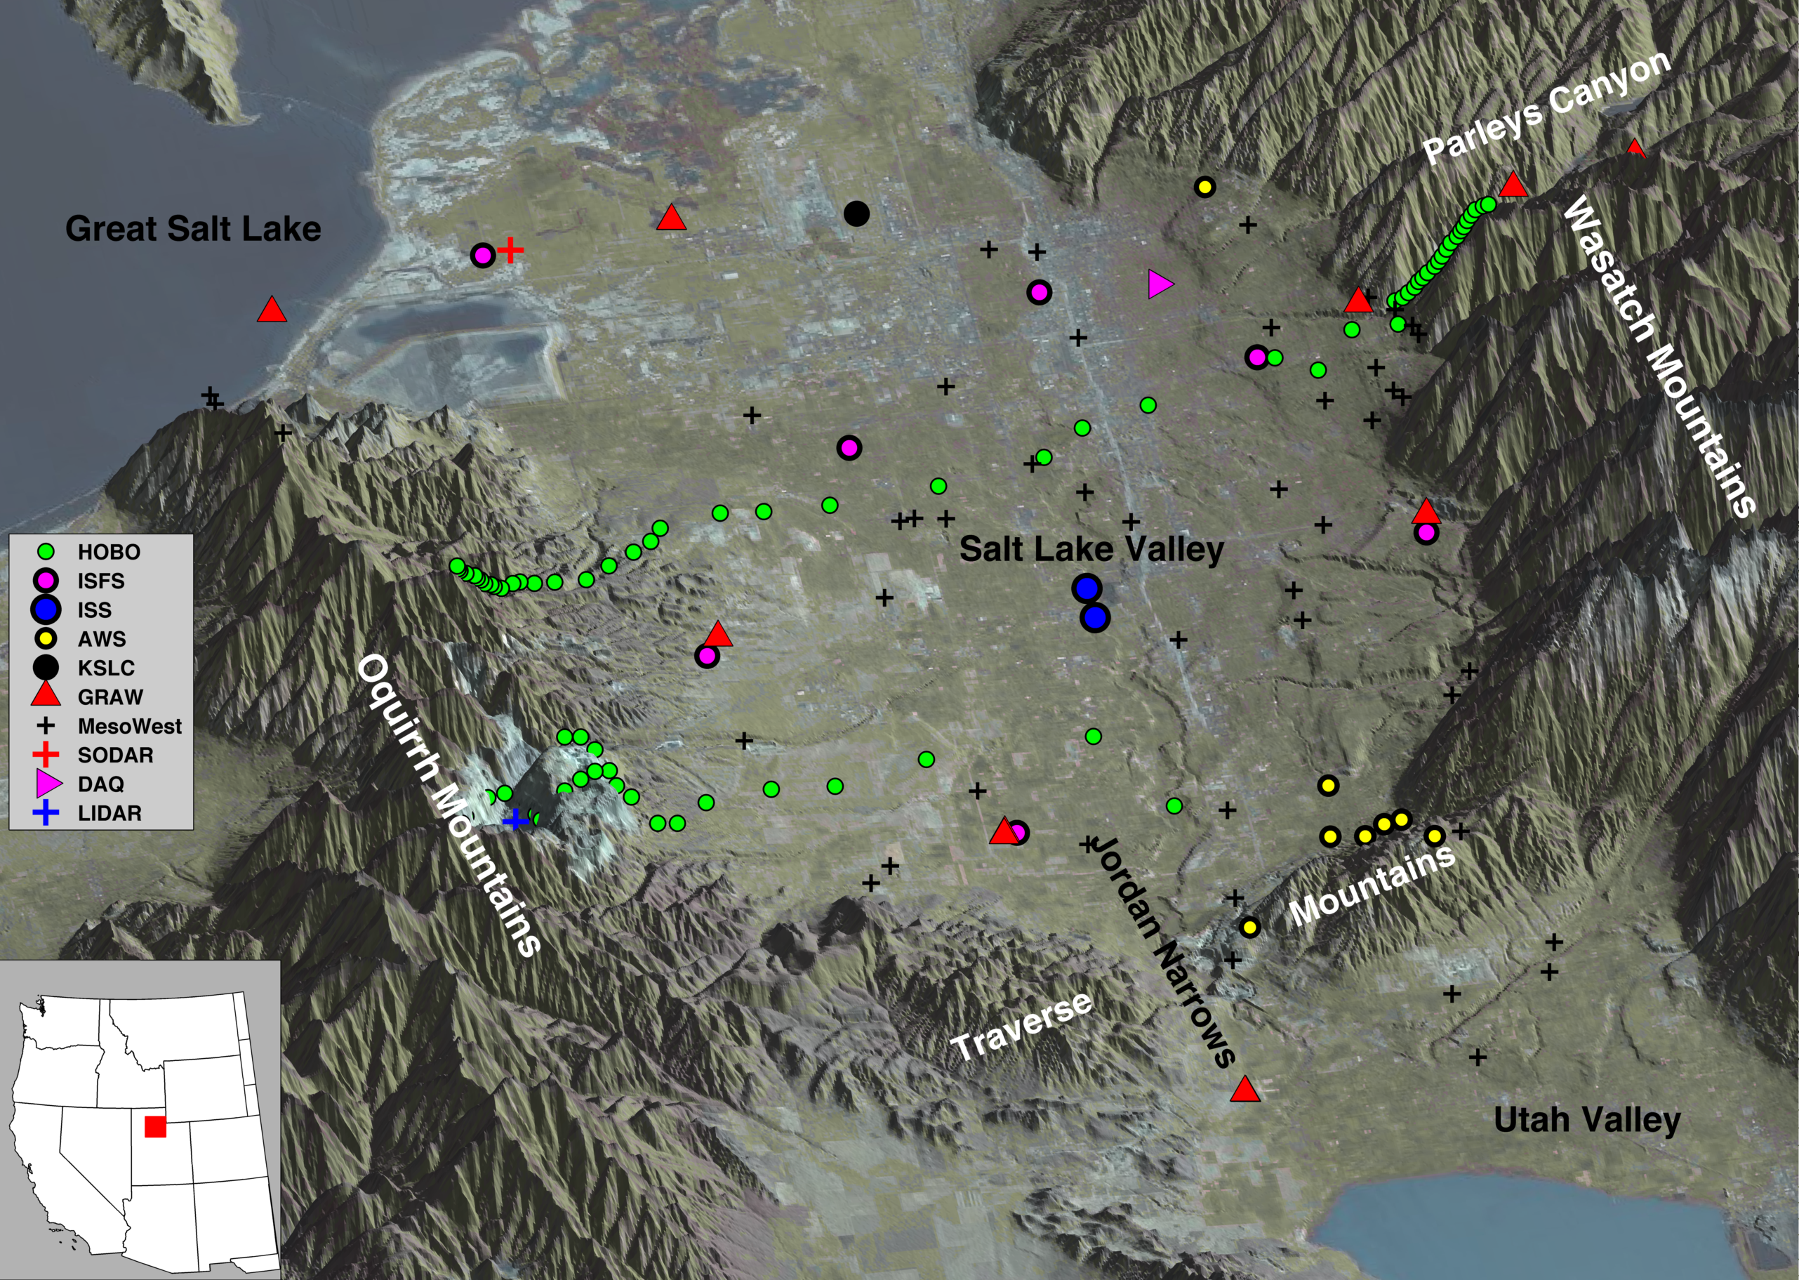
Figure 1. Relief map showing location of PCAPS field campaign instrumentation. Green circles denote the location of Hobo® data loggers on the valley sidewalls. Purple circles denote the 7 NCAR ISFS stations. Blue circles indicate the two NCAR ISS facilities, and a red plus symbol denotes the SODAR site. Yellow circles indicate University of Utah automated weather stations, while pre-existing MesoWest surface stations are indicated with a black plus symbol. The Salt Lake International Airport is denoted as a black dot. The locations of special rawinsonde launches during specific IOPs are indicated by red triangles, while a blue plus shows the location of the LIDAR. The Hawthorne elementary school DAQ site is shown as a pink triangle. Mobile weather station transects, glider flight paths, and additional air quality monitoring locations are not shown on the map.

Figure 2.Photos of key PCAPS continuous and deployable instrumentation. See Fig. 1 for location of instruments. (a) NCAR ISFS, (b) U of U tripod, (c) U of U Hobo® temperature data loggers, (d) U of U Scanning doppler LiDAR, (e and f) NCAR ISS sites, (g) U of U mini-SoDAR, (h) U of U mobile radiosonde launch, (i) U of U mobile weather stations, and (j) instrumented motorized paraglider.

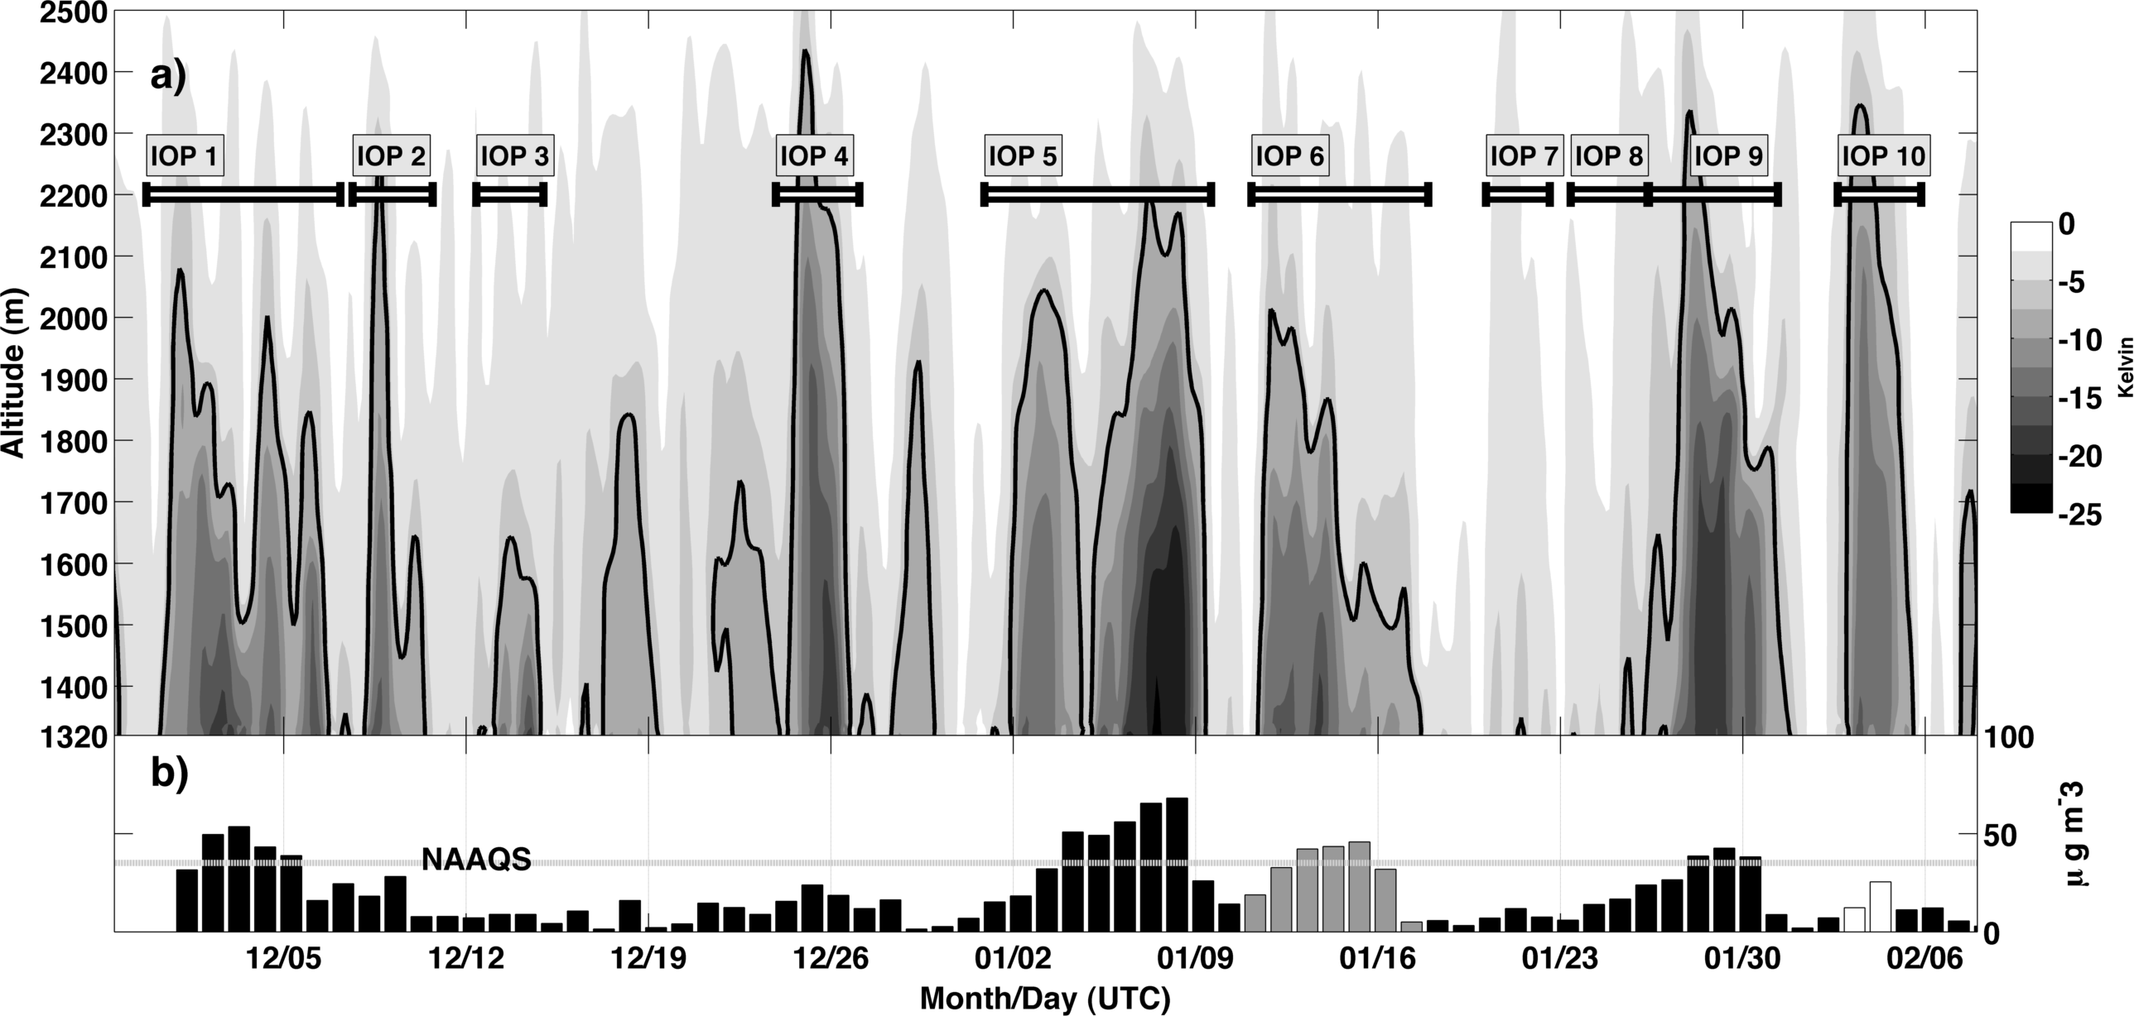
Figure 3. (a) Potential temperature deficit (K) during the PCAPS period 1 December 2010 – 7 February 2011. The deficit is taken relative to the potential temperature at 2500 m MSL. Darker colors within the solid black line denote a potential temperature deficit greater than 8 K (i.e., a strong CAP). The span of each IOP is indicated by the labeled horizontal lines. The details of each IOP are included in Table 1. (b) Midnight-to-midnight MST daily average PM_{2.5} concentration measured at the Hawthorne Elementary (dark bars), Rose Park (grey bars), and Cottonwood (white bars) DAQ monitoring locations within the SLV. The National Ambient Air Quality Standard of 35 μg m⁻³ is indicated by the grey horizontal line.

Figure 4. Photos of Salt Lake Valley inversions during PCAPS. Photo credits in parentheses. (a) 14 January 2011: combined fog and pollutants (Sebastian Hoch). (b) 2 December 2010: cloud-free deep (~700 m) polluted layer (Chris Santacroce). (c) 16 January 2011: Thin surface layer (<100 m) of fog and pollution (Jim Ehleringer), (d-f) cloudy inversions. d) 30 January 2011 (John Horel), (e) 7 January 2011 (Dave Bowling), (f) 24 December 2010: stratocumulus clouds associated with a deep inversion extending to near mountaintop level (Erik Crosman).

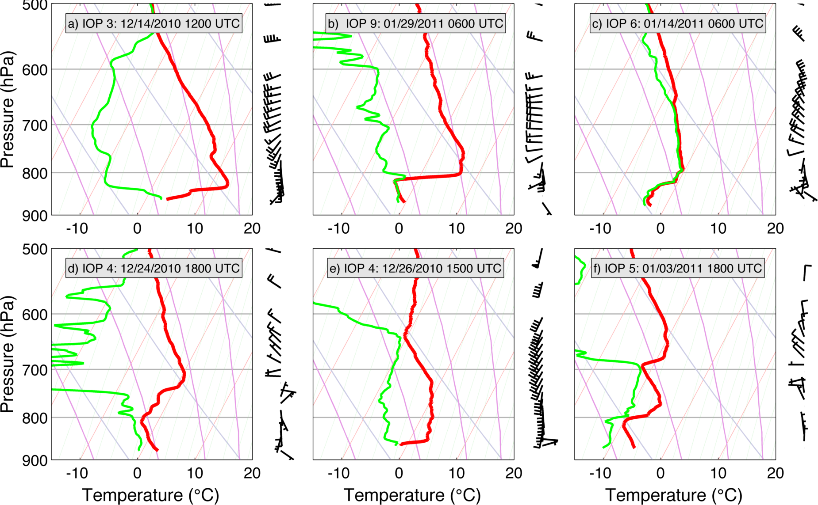

Figure 5. Skew-T Log P profiles of temperature (red) and dew point (green) during various IOPs. Wind speeds and direction are plotted with height to the right of each profile (1 barb = 5 ms⁻¹). (a) 0600 UTC 14 December 2010, (b) 0600 UTC 29 January 2011, (c) 0600 UTC 14 January 2011, (d) 1800 UTC 24 December 2010, (e) 1500 UTC 26 December 2010, and (f) 1800 UTC 3 January 2011.

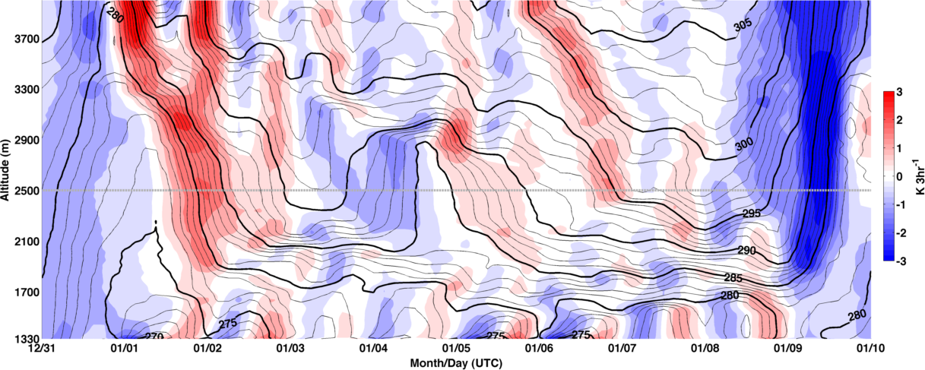
Figure 6. Time-height plot of potential temperature during IOP-5. Isentropes are indicated by contours (bold contours every 5K, light contours every 1 K). The 3-hr change in potential temperature is indicated in shading to highlight periods of warming and cooling. The grey line at 2500 m indicates the approximate elevation of the mountain crests that enclose the Salt Lake Valley.

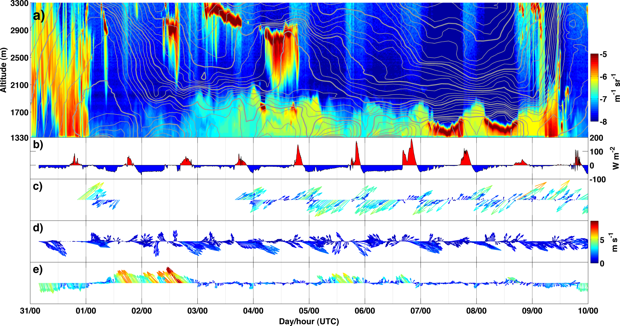
Figure 7. Boundary layer evolution during IOP-5. (a) Laser ceilometer backscatter (color scale) and potential temperature (contours, as in Fig. 6a). (b) Net radiation from ISFS-5 location. (c-e) Near-surface vector winds with colors indicating wind speed in m s⁻¹ at (c) Parley’s Canyon, (d) ISFS-3, and (e) ISFS-7.

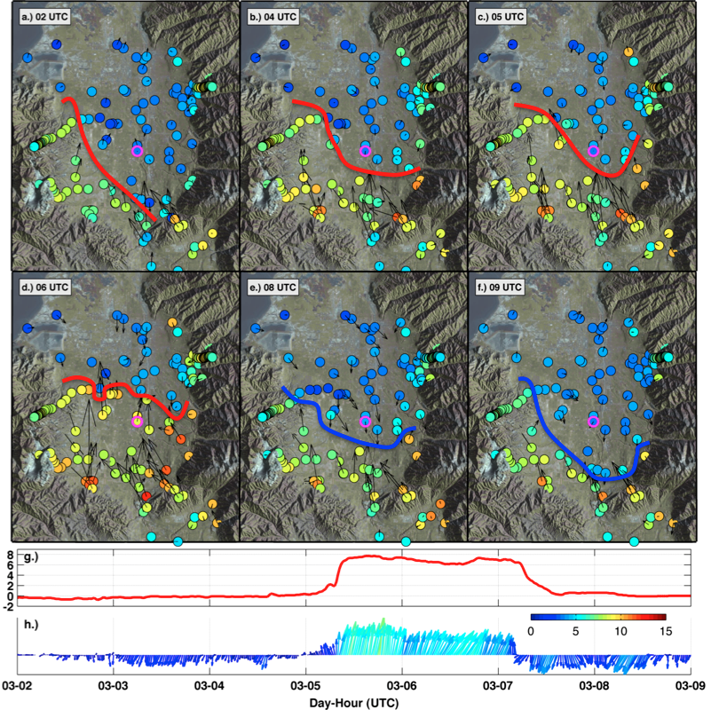
Figure 8. Surface meteorological observations of the CAP displacement during strong southerly winds on 3 December 2010. Warm (cold) pseudo-front position is indicated as red (blue) lines. Station observations are indicated by circular markers and shaded to correspond to the observed air temperature. Vectors indicate wind speed and direction. (a) 0200 UTC 3 December, (b) 0400 UTC 3 December, (c) 0500 UTC 3 December, (d) 0600 UTC 3 December, (e) 0800 UTC 3 December, and (f) 0900 UTC 3 December. (g) Air temperature and (b) vector winds at ISS site, which is emphasized with a magenta outline.

Figure 9. 13 December 2010 powered paraglider flight. (a) Launch preparation and (b) low-level temperature and dew point temperature data obtained from the paraglider before (ascent) and after (descent) lake-breeze frontal passage.

