Causes and Impacts of Interannual Variations in the Great Salt Lake

PROJECT SUMMARY

The level, salinity, and temperature of Utah’s Great Salt Lake respond to regional weather and climate through the interplay of local evaporation, passage of storms, and the distribution of precipitation throughout the watershed of its closed basin. In turn, the Lake and nearby playas (salt flats) contribute to the development of lake breezes, salt breezes, lake-breeze fronts, and lake-effect snowstorms that affect the populace and water resources of northern Utah. A three-year study is proposed to assess: (1) the variations in the surface temperature of the Great Salt Lake and nearby playas, (2) to what extent these variations affect local weather and climate, and (3) to what extent these variations are controlled by regional forcing by the atmosphere. The proposed research will integrate in situ and remote observations with regional reanalyses to improve understanding of the physical processes that control the interactions between the surface and atmospheric boundary layer. The period from 1981 to the present (spanning the years of record high lake levels in the mid-1980’s and recent low water years) will be studied on the basis of remote sensing data, including Advanced Very High Resolution Radiometer images from NOAA polar orbiting satellites, and North American regional reanalyses from the National Centers for Environmental Prediction. The satellite imagery and reanalysis products will be calibrated and related to: long-term records of atmospheric conditions at Salt Lake City International Airport and Hill Air Force Base, shorter-term records at over a dozen locations around the Lake and over the playas, and all available surface and sub-surface lake water samples of temperature and salinity collected by the Utah Geological Survey, Utah Department of Natural Resources, and United States Geological Survey.

Intellectual Merit: The proposed research will advance knowledge of the physical processes that control the spatial and temporal variations in the surface temperature of the Great Salt Lake and nearby playas and how those variations may in turn affect local weather and climate. This research is likely to engender broad scientific interest in many disciplines as a result of the complex interrelationships between weather and climate and the Great Salt Lake ecosystem. This study builds upon prior research of the Principal Investigator on natural climate variations and the weather of northern Utah and will be integrated with a proposed interdisciplinary program on the hydrological budget of the Great Salt Lake Basin.

Broader Impacts: This research is likely to have significant potential benefits to society through improved understanding of the weather and climate forcing that controls the physical state of the Great Salt Lake, which in turn controls the Lake’s complex ecology, habitat for migratory bird populations, and mineral assets. Improved understanding of how the variations in the physical state of the Great Salt Lake affect local weather and climate is critical for understanding local air quality issues (including airborne transport of heavy metals) and the potential influence of the Lake upon winter storms that directly affect the growing population in northern Utah as well as contribute to the available water resources of the region. The research will be integrated into university teaching and training of graduate students and will be of interest to educators and researchers in a number of disciplines. Project results will be disseminated through peer-reviewed scientific publications and presentations in order to enhance scientific and technological understanding. Efforts will be made to broaden participation of underrepresented groups in this research.
1. Introduction

As discussed by Warner (2004), a large fraction of the earth's land surface does not drain to the oceans. The ecosystem of Utah’s Great Salt Lake (GSL), the fourth largest terminal lake in the world and largest one in the Americas (Stephens 1990), depends upon the complex interactions between net precipitation within its basin, surface and subsurface runoff into the Lake, and evaporation from its surface. The habitats of the GSL support millions of migratory birds (Aldrich and Paul 2002) and an annual harvest of artemia cysts (brine shrimp crustaceans) valued at over $10 million (Kuehn 2002, Isaacson et al. 2002). Mineral commodities (salt, potash, and magnesium) are harvested from evaporation ponds around the shores of the Lake with annual sales over $300 million (Isaacson et al. 2002).
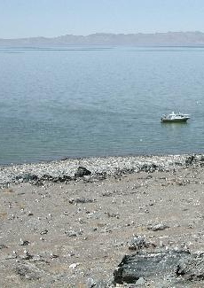
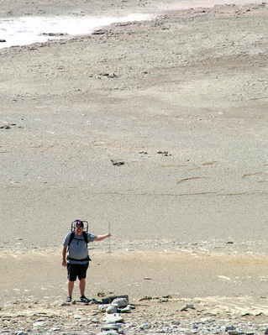
The dependence of the Lake's ecosystem and economic resources upon weather, climate, and hydrology is widely accepted (Gwynn 2002, Topping 2002). The level, areal extent, and volume of the GSL undergo large seasonal and interannual fluctuations. Many shorelines recede from spring to fall over distances approaching 1 km, providing varied habitats to migratory birds. Responding to the net hydrologic forcing within the GSL Basin, the Lake rose from its lowest recorded levels in the 1960's to the modern peak during the mid 1980's. Drought conditions within the Basin over the past 6 years have contributed to a sharp decline in lake level leading to levels not seen since 1970 (Fig. 1). Vast tracts of soils (with potentially harmful heavy metals deposited on them) have been exposed recently to airborne transport during high wind events.
x

The interannual climate signals responsible for such dramatic fluctuations in lake level are not clear (Lall and Mann 1995; Mann and Lall 1995). For example, Moon and Lall (1996) found that the low-frequency changes in lake level are related weakly to the planetary-scale air-sea interactions associated with the El Nino/Southern Oscillation phenomenon. Determining the climate forcing responsible for fluctuations in the GSL is important since the Lake serves as a recorder for all of the meteorological and hydrological inputs within its Basin, an area experiencing rapid population growth and increasing demand for water resources (Warner 2004).
Figure 1. (Top) View to west from Hat Island weather station in Sept. 2000. (Bottom) Similar view in Sept. 2003. The PI is pointing down at the location of a lake temperature sensor located roughly at the mark in the top image that was located 0.7 m below water in 2000. The nearest boat access in 2003 was more than 1 km to the north of the boat’s position in the top photo. Photos: D. Judd.

The weather and microclimates of the Wasatch Front (the narrow strip of densely populated land between the GSL and the Wasatch Mountains to the east) are in turn affected by the Lake. The Lake contributes to local thermally driven flows during quiescent periods (Hawkes 1947, Stewart et al. 2002, Ludwig et al. 2004, Zumpfe and Horel 2005) as well as enhanced precipitation downstream during winter storms (Carpenter 1993, Steenburgh et al. 2000; Steenburgh and Onton 2001; Onton and Steenburgh 2001; Steenburgh 2003). The need to improve understanding of the complex interactions of wind flows in the vicinity of the GSL led to two field studies during 2000 for stable (Doran et al. 2002) and unstable (Schultz et al. 2002) periods.
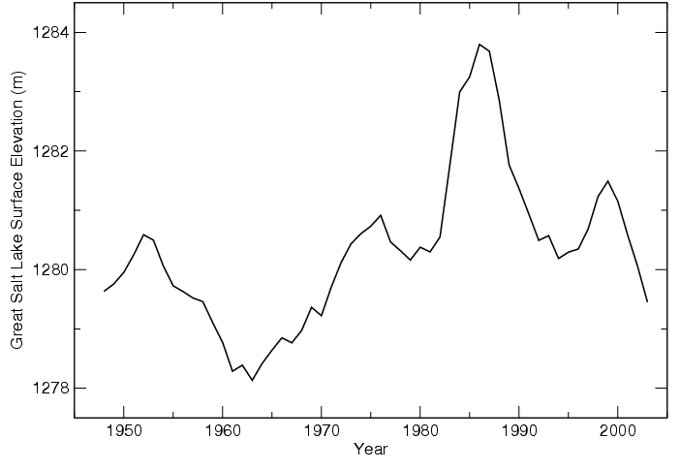
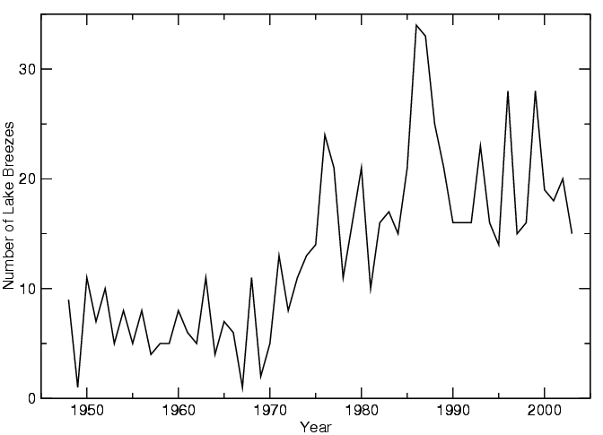
Low-frequency variations in GSL level affect some aspects of the local weather and climate. For example, as shown in Fig. 2, the number of strong lake-breeze frontal passages (defined on days without precipitation at the Salt Lake City Airport by a distinct wind shift to the north accompanied by a sharp increase in dew point temperature) during each April-October period was smaller in the late 1960’s and higher in the mid 1980’s (Zumpfe and Horel 2005). Although the year-to-year changes in the number of strong lake-breeze frontal passages are greater than those in the Lake surface elevation, the number of strong lake-breeze frontal passages at SLC is strongly correlated (0.75) with the average Lake surface elevation. Other factors, such as interannual variations in the seasonal position of the upper-tropospheric anticyclone over the western United States during summer, presumably contribute to the higher-frequency interannual fluctuations evident in Fig. 2.

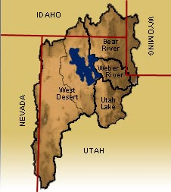
The hypersaline Great Salt Lake is a remnant of the late-Pleistocene era Lake Bonneville that covered over 50,000 km² of northern Utah and small portions of Nevada and Idaho (Bills et al. 2002). The lake area depicted in Fig. 3 is that observed during high water years; the surface area of the lake has varied from roughly 2500 km² in 1963 to over 8000 km² in 1986. A railroad causeway built in the 1950’s across the lake has led to distinctly different salinity in the north arm (~27% salinity currently) compared to the south arm (~18%). The former floor of Lake Bonneville in the West Desert is now playa, whose salt-laden soils lead to limited vegetation, and high albedo, thermal conductivity, and heat capacity (McCurdy, 1989; Rosen 1994; Tapper 1988; Physick and Tapper, 1990; Rife et al. 2002; Warner 2004). The lowest elevation playas of the West Desert are often covered seasonally by standing water or maintain high moisture content throughout much of the year. The high salinity of the GSL and the playas inhibits freezing and results in a significant reduction of saturation vapor pressure and latent heat flux compared to fresh water surfaces (Steinhorn 1997; Steenburgh et al 2000).
Figure 2. (Top) Average elevation of the Great Salt Lake (m) from 1949-2003. (Bottom) Number of strong lake-breeze fronts during April-October of each year. Zumpfe and Horel (2005).
Figure 3. The Great Salt Lake Basin is composed of the Bear, Weber, and Provo/Utah Lake drainages of the mountains to the east and the salt playas and mountains of the West Desert (From http://greatsaltlake.utah.edu/).

2. Research Objectives

The Great Salt Lake is both potentially a source of local climate variability as well as a regional monitor of climate variability arising from natural causes and basin-scale and global-scale anthropogenic impacts. The extensive desert playas to the west of the Great Salt Lake may also play a role as a result of their enhanced moisture fluxes and thermal contrasts compared to the surrounding higher desert regions. A three-year study is proposed to assess: (1) the variations in the surface temperature of the Great Salt Lake and the surrounding playas, (2) to what extent these variations affect local weather and climate, and (3) to what extent these variations are controlled by regional and remote forcing by the atmosphere.

A variety of in situ and remote observations will be integrated with the National Centers for Regional Prediction (NCEP) North American Regional Reanalysis products to improve understanding of the interactions between the lake and playa surface and atmospheric boundary layer. The period from 1981 to the present will be studied on the basis of remote sensing data, including Advanced Very High Resolution Radiometer images from NOAA polar orbiting satellites. This period encompasses the rapid rise of lake level in the early 1980’s, leading to the modern peak in 1986, as well as the rapid decline in lake level during recent years. The satellite imagery and reanalysis products will be calibrated and related to: long-term records of atmospheric conditions at Salt Lake City International Airport and Hill Air Force Base, shorter-term records at over a dozen locations around the Lake and over the playas, and all available surface and sub-surface lake water samples of temperature and salinity collected by the Utah Geological Survey, Utah Department of Natural Resources, and United States Geological Survey. The Principal Investigator has been involved during the past decade in the collection, archival, and analysis of surface environmental information in northern Utah and around the West as part of the MesoWest project (Horel 2002ab).

Specific research goals are:

- Document the spatial and temporal variations of the lake surface temperature (LST) of the GSL and the West Desert playa surface temperature (PST) over the period from 1981 to the present as deduced from satellite and calibrated against in situ observations.

- Investigate the impacts of spatial and temporal variations in LST and PST upon local thermally driven boundary layer circulations.

- Investigate the impacts of spatial and temporal variations in LST and, to a lesser extent PST, upon the occurrence, intensity, and duration of storms, especially lake-effect snow storms.

- Assess the regional atmospheric forcing that contribute to interannual variations in lake temperature and how those variations are related to the sharp rise in Lake level in the early 1980’s and the rapid declines during the past 6 years.

3. Background
3.1. Results from Prior NSF Support

The last proposal submitted by the Principal Investigator to NSF, entitled: “Evaluation and Application of the Eta Adjoint Model”, was funded during the period 1996-1998.

3.2. Great Salt Lake

As discussed by Gwynn (2002), scientific research and awareness of the GSL and its environs as an important ecosystem has increased in recent years. Management plans have been developed in the past decade by the various state agencies responsible for the mineral resources and ecosystems of the Lake and nearby salt flats of the West Desert.

While data on the physical state of the Lake have been collected manually for many years as part of routine sampling programs undertaken by researchers from the United States Geological Survey, Utah Geological Survey, and Department of Natural Resources, the near surface temperature probe installed off Hat Island (HAT in Fig. 4) by the Principal Investigator in September 1998 was the first long-term automated record of lake temperature. As the lake level dropped sharply in recent years, that sensor is now several kilometers from the nearest water (see Fig. 1). A similar sensor was installed in September 1999 off Gunnison Island (GNI), although it also is above water level now.

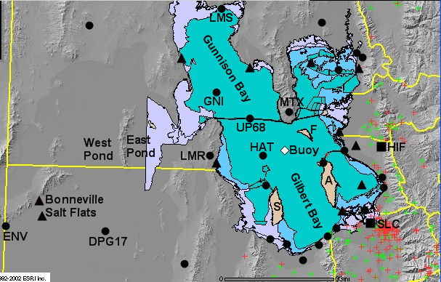
Figure 4. Locations on and around the Great Salt Lake referred to in the text.

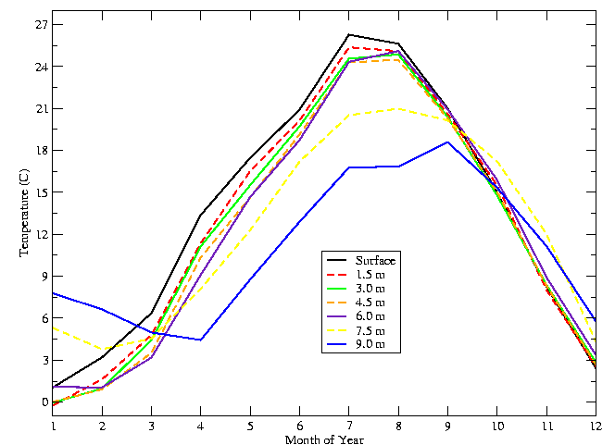
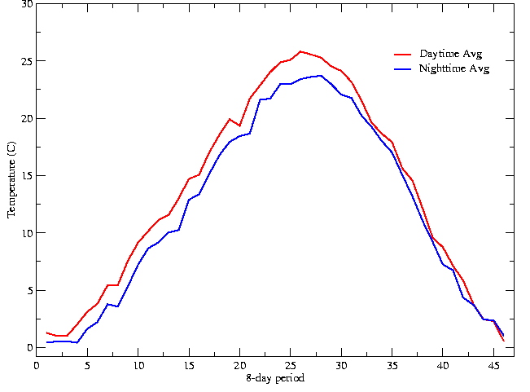
The seasonal evolution of lake temperature as a function of time of year and depth based on all the available manual temperature observations collected in Gilbert Bay (south arm of the lake) is shown in the top panel of Fig. 5. Notable features include the isothermal temperature profile above 6 m in the late summer and fall and the shallow thermocline during the spring. The manual sampling is too infrequent and sparse to estimate the variability quantitatively of lake temperature on other temporal scales (interannual, subseasonal, diurnal, etc.) and as a function of location within the lake.

Preliminary analyses have been completed to assess whether AVHRR imagery can be used to estimate the variability of LST on a variety of temporal and spatial scales. All available AVHRR images during the period 1985-2004 preprocessed by the NOAA/NASA Pathfinder program into 8-day averages at 4 km resolution have been examined by Crosman and Horel (2005). Averaging all of the pixels defined to be cloud free across the entire lake, the seasonal evolution of satellite-estimated LST is comparable to that observed in situ, with gradual warming in the spring compared to more abrupt cooling in the fall (Fig. 5). The larger day-night temperature differences evident in spring compared to fall may reflect the effects of vertical mixing.
Figure 5 . (Top). Month-to-month variation in temperature at the surface (black line) and at depth (colored lines) based on manual observations. Data courtesy of J. W. Gwynn, Utah Geological Survey. (Bottom) AVHRR satellite estimate of lake water surface temperature during each 8 day period of the year based upon images from 1985-2004.

Large year-to-year variability

Spatial variability in LST has been examined for selected case studies and short field programs by several investigators. For example, Zastrow and Ridd (2002) contrasted thermal imagery from Landsat in 1996 and 1984 and noted a number of temperature patterns related to lake depth and freshwater sources. Rich (2002) used data from drifter buoys over a 48 day period during summer 1991 to assess surface currents and temperature. Strong easterly currents to the west of the gap between Antelope and Fremont Islands (A and F respectively in Fig. 4) were attributed to a counterclockwise circulation arising from Ekman pumping. She hypothesized that prevailing southerly flow over the south arm of the Lake led to the Ekman pumping and also caused surface lake temperature to be warmer (colder) on the east (west) side of Gilbert Bay during June 1991.

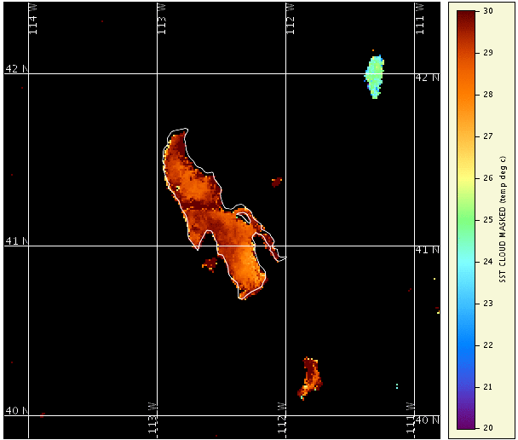
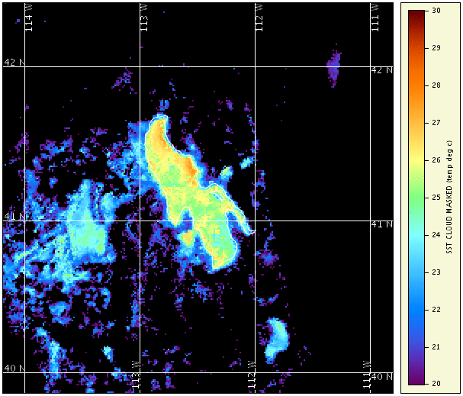
In order to further assess the extent to which AVHRR imagery can be used to examine temporal and spatial variability of LST, 1.5 km resolution images on overpasses with limited cloud cover during July 2003 from NOAA-16 were examined. Eighteen (twelve) day (night) images were composited in order to examine day-night temperature differences as a function of location (Fig. 6). LST tended to be higher on the west side of Gilbert Bay and lower near Antelope Island during both the night and day and generally higher in shallow areas as well. The cooler temperature of the freshwater Bear Lake in northeastern Utah is evident as well as the comparable diurnal variations in the shallow Utah Lake to the south. Land surface temperature in the West Desert regions is incompletely masked at night, such that areas of high moisture content in the West and East Ponds and Bonneville Salt Flats (see Fig. 4) are evident.

3.3 West Desert Playas

The Principal Investigator arrived at the University of Utah in 1986, as the level of the Great Salt Lake began to peak. As discussed by Austin (2002), pumps were installed in 1987 to move water from the GSL into the West Desert playas (imported into West Pond with return flow via East Pond; see Fig. 4) as an attempt to mitigate the rising lake levels that caused over $240 million in damages to public and private resources and facilities. Even before and after the pumps ceased operations in 1989 and terminated the extensive flooding of the playas, the playas serve as a source of moisture to the atmosphere during spring and early summer and provide distinct thermal and radiative contrasts with the surrounding dry soils at higher elevation (Tapper 1988; Physick and Tapper, 1990; Rife et al. 2002).
Figure 6. (Top). Daytime surface temperature during July 2003 derived from a composite of NOAA-16 AVHRR images with 1.5 km x 1.5 km resolution. (Bottom) As in the top except for nighttime. Separate cloud and land masks have been applied to the 18 daytime and 12 nighttime images used in the composites.

3.4 Weather and Climate Responses to the Great Salt Lake and Playas

The most obvious interactions between the GSL and the overlying atmosphere are distinctly different in the warm season compared to the cool season. During the warm season, temperature contrasts arising from the differences in surface characteristics between the GSL/playas and the surrounding mountains and upland valleys drive local winds towards the lake and playas at night and away from them during the day (Hawkes 1947; Whiteman 1990; Whiteman 2000; Stewart et al. 2002; Horel 2003). Lake breeze and salt breeze fronts (Zumpfe and Horel 2005; Rife et al. 2002) develop sharp discontinuities in moisture, temperature and wind that affect local air quality and on occasion contribute to severe weather, such as the 11 August 1999 tornado in Salt Lake City (Dunn and Vasiloff 2001). Elevated dew point temperatures are observed quite frequently in the spring over the West Desert playas as a result of the high moisture content of the salt flats (e.g., at DPG17 in Fig. 4).

Intraseasonal, seasonal, and interannual variations in cool-season precipitation in the GSL Basin are often dominated by the aggregate effects of the occurrence and duration of a few major winter storms (Cayan et al. 1999; Higgins et al. 2000). For example, Serreze et al. (2001) indicate that 10-23% of the annual mountain snowfall in sub-regions of the West typically falls during the largest snowfall event of the season. Steenburgh (2003) investigated one storm cycle in the Wasatch Mountains of northern Utah during which 100 inches of snowfall fell in 100 hours; this storm produced 15% of the snow water equivalent that fell in Salt Lake City watersheds during the 2001-2002 winter season.

In part as a result of the requirements for weather support for the 2002 Winter Olympics held in the vicinity of Salt Lake City, weather stations were deployed in the vicinity of the GSL to fill in critical gaps in the cooperative automated observing network that is supported by federal, state, and local agencies as well as commercial firms (Horel et al. 2002ab). A clear impact of the GSL upon winter storms occurs following the passage of cold fronts, when lake-effect snow bands often develop and lead to additional accumulations of 10-30 cm (Carpenter 1993). Using NWS radar data, local surface observations, and modeling studies, Dr. J. Steenburgh in the Department of Meteorology has led research on the factors contributing to lake-effect snowstorms (Steenburgh et al. 2000; Steenburgh and Onton 2001; Onton and Steenburgh 2001). Building on previous investigations of similar events over the Great Lakes, these studies have identified several critical characteristics of lake-effect snowstorms:
- Because the GSL never freezes due to its high salinity and the surface warms rapidly in response to solar heating, lake-effect precipitation has been observed from September through May.
- Lake-effect precipitation is most commonly characterized by the irregular development of precipitation echoes over and/or downstream of the Great Salt Lake. Occasionally, solitary wind-parallel bands develop. Sometimes, wide-areal coverage is observed to the lee. It is not uncommon for lake-effect precipitation to occur in concert with precipitation produced by large-scale or orographic processes.
- A difference in temperature between the lake-surface temperature and 700 hPa air temperature of at least 16 C is needed for lake-effect precipitation to develop, no inversion or stable layer base is present below 700 hPa, and directional wind shear through the boundary layer is limited. These are necessary but not sufficient conditions. For example, some cases of very large (>25 C) lake-700 hPa temperature differences have not produced lake-effect precipitation.
- Large lake-land temperature differences favor the development of thermally-driven land breezes, over-lake convergence, and lake-effect precipitation. Solitary wind-parallel bands may be initiated by convergence between a land-breeze and the large-scale flow, or between land-breezes from the opposing shorelines.
- Lake-effect precipitation exhibits considerable diurnal modulation and is most commonly initiated during the overnight hours when land-breeze convergence is favored. During periods of strong solar heating, lake-effect precipitation frequently disipates in the afternoon as scattered convection develops over the surrounding land.
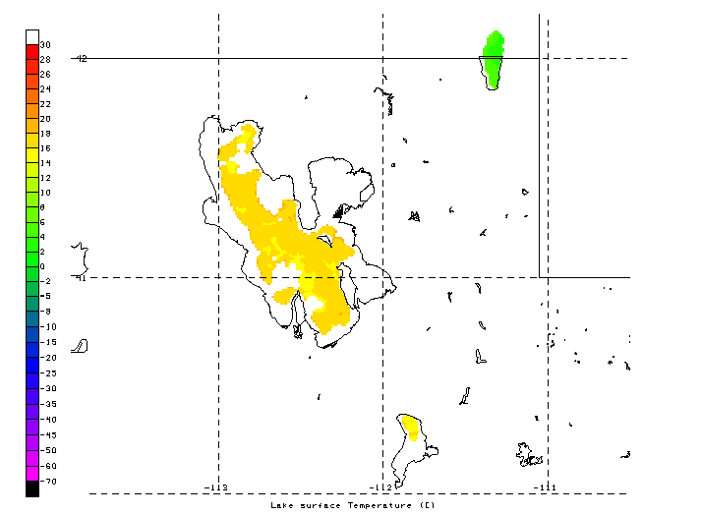
- Moisture fluxes from the GSL are not required for lake-effect precipitation to occur, but can enhance events. Because of the limited overwater fetch, upstream moisture is likely an important variable in many events.
3.5. Weather and Climate Forcing of the Great Salt Lake and Playas

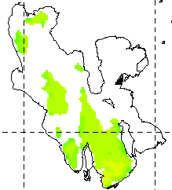
The immediate response of the lake state to atmospheric forcing can be quite clear. For example, Fig. 7 shows the rapid cooling of the lake surface after the passage of a strong cold front. Low-frequency variations in the level of the GSL and linkages to local and remote atmospheric forcing have intrigued many researchers (Lall and Mann 1995; Mann and Lall 1995; Moon and Lall 1996 + more). The availability of direct measurements of lake level from 1875 to the present has made it possible to investigate linkages to long-term precipitation records in nearby watersheds and the planetary-scale El Nino Southern Oscillation signal. However, since no such long-term records of lake temperature exist, it is not clear whether the lake temperature is sensitive to regional and remote climate forcing. Rodionov (1994) studied the linkages between climate forcing and anhropogenic influences upon the largest inland body, the Caspian Sea. Rodionv (1994) noted the sensitivity of the Great Lakes to low-frequency and interannual variations in storm tracks. Anthropogenic dessication of the Aral Sea combined with climate variability have been associated with regional climate changes in that region by Small et al. (2000). They used in situ observations and AVHRR data to infer a several degree C increase in temperature of the Aral Sea from 1960-1997 in spring while the temperature dropped significantly in fall. As discussed by Hostetler (1995), lakes continually respond to climatic conditions over broad spatial and temporal scales: lake temperature is governed by the balance of heat inputs and outputs and lake stratification depends strongly upon the seasonal atmospheric forcing.

4. Research Design and Methods

Knowledge of the spatial and temporal variations of the surface temperature of the GSL and surrounding playas is incomplete. How these variations arise as a result of atmospheric forcing and subsequent feedbacks to the atmosphere are not completely understood. This study will first focus on a careful analysis of remote sensing data calibrated against in situ observations to deduce the surface temperature of the GSL and surrounding land surfaces. Then, the variations in surface temperature on time scales from diurnal to interannual will be related to thermally-driven wind circulations during the warm season and the occurrence and intensity of winter storms in the cool season. Finally, linkages between the changes in surface temperature to local and regional climate forcing will be explored. The specific tasks and resources to be used are described below.
Figure 7. (Top). Lake temperature at 2057 UTC 14 April 2002 prior to the passage of a major cold front on the 15th. (Bottom). As in the top panel except for 0901 UTC 17 April 2002. The lake surface cooled by 8-10ºC as a result of the passage of the storm according to the AVHRR imagery.

4.1 Task 1. Spatial and Temporal Variations in GSL Lake Water Surface Temperature and Playa Surface Temperature

The first specific goal stated in Section 2 requires analyzing and calibrating AVHRR brightness temperature data over the period from 1981 to the present. Considerable experience has been gained over the past several years evaluating AVHRR imagery for estimating LST. The NOAA Coastwatch Program (http://coastwatch.noaa.gov/) began providing AVHRR multispectral brightness temperature images at 1.1 km nadir resolution sectorized for the GSL in 2001 to the Department of Meteorology for research applications and for operational weather support for the 2002 Winter Olympics (Horel et al. 2002b). With software also provided by Coastwatch, it has been possible to apply split window algorithms to the brightness temperature data to determine lake temperature and apply a variety of masks to eliminate clouds and surrounding land areas. Figs. 6 and 7 were derived from the Coastwatch data and software.

Longer term records of AVHRR images from 1981 to the present (NOAA satellites 7-17) are available from a variety of sources, although in different formats, spatial and temporal sampling, and cloud and land masks. For example, Fig. 5 was derived from the NOAA/NASA AVHRR Pathfinder products (http://podaac.jpl.nasa.gov/sst/) that have been post-processed since the launch of NOAA-9 in 1985 to define a sea surface temperature product at 4 km resolution for 8 day periods using consistent SST algorithms, improved satellite and inter-satellite calibration, quality control and cloud detection. Moderate-resolution Imaging Spectroradiometer (MODIS) instruments aboard the NASA Terra and Aqua satellites provide a sea surface temperature product since October 2000 as well.

While the existing sea surface temperature products available from Coastwatch or Pathfinder provide considerable insight into the variability of the LST of the GSL, it is clear that the processing methodology appropriate for the open ocean or coastal sea surface temperature needs to be adapted carefully for the GSL and its surroundings (Wicks and Bates 2002). Stowe et al. (1998) describe several of the cloud and land masks that are commonly used and which we have been applying to the Coastwatch data. For example, the following cloud and land masks have been applied in Fig. 6: (1) for images during the day- reflective gross cloud test; reflectance uniformity test, reflectance ratio cloud test, and channel 3 albedo test; (2) for both day and night overpasses- channel 4 minus channel 5 and thermal gross cloud test; and (3) for night images only- uniform low stratus test and cirrus test.

Suitability of applying these tests for the GSL and especially the playas needs to be reevaluated. Limitations of applying the split window technique for estimating land temperature are well established in part as a result of the sensitivity to surface emissivity ( Price 1984; Coll and Caselles 1997; Schmugge et al. 1998; Schmugge et al. 2002). Because we are interested in the temperature of nearly uniform surfaces (lake and salt playas) emissivity issues are mitigated to a large extent.

We propose to start from the AVHRR archive of multispectral brightness temperature Level 1B data (1.1 km nadir resolution) available from NOAA 7-17 satellites from the NOAA/NESDIS Comprehensive Large Array-data Stewardship System (http://www.saa.noaa.gov/nsaa/products/). We will adapt existing split window techniques for land and water surfaces and apply all the available inter-satellite calibrations to define the surface temperature of the GSL and playas of the West Desert in a consistent manner for the period from 1981 to the present. Clouds and other land surface types will be removed as best as possible using combinations of tests appropriate for day and night overpasses separately. Sensitivity of the estimated surface temperature to variations in lake salinity will be assessed as part of this study.

This approach to reanalyze all of the Level 1B AVHRR data is tractable because of the relatively small size of the study area. All available in situ measurements of surface temperature (manual survey observations, automated observations offshore Hat and Gunnison Islands, previous field program data, e.g., Rich 2002) will be used to calibrate the remote sensing information. Comparison to MODIS imagery during recent years will also be undertaken. As will be discussed further in Section 7, there is a strong likelihood that a buoy or permanent platform will be installed on the Great Salt Lake within the next year that will also serve as a means to calibrate future satellite imagery.

Using a new bathymetric analysis of the GSL being completed now by the United States Geological Survey (R. Baskin, personal communication, Nov. 2004), it will be possible to use the observed lake levels to define the estimated surface coverage of the lake as a function of year in order to help define the image pixels that are likely to be water. The shading in Fig. 4 denotes previous estimates of lake surface areas as a function of level. Darker (turquoise) shading denotes the 1280 m lake level; lighter (cyan) shading denotes additional areas covered by water when the lake is at 1283 m; light grey shading denotes additional areas that could be covered by water when the lake is at 1286 m (higher than that observed in the historical record but plausible under some global warming scenarios, Wagner 2003). Elevation shading in Fig. 4 ceases abruptly to the west of 113ºW simply because of the GIS layer available for the analysis.

Once the surface temperature has been defined from all available images, then it will be possible to diagnose and evaluate the spatial variations (order 1 km and greater) in surface temperature on time scales from diurnal to interannual over the GSL and playas. The Principal Investigator has considerable experience over the past twenty years evaluating natural climate variations and a variety of approaches can be brought to the analysis of the LST and PST in relationship to other data assets. Besides examining the major climate signals (diurnal, seasonal, annual, etc.), the data will be examined, for example, to assess the cooling typically experienced following the passage of strong cold fronts. Is that cooling smaller in the Fall because of the isothermal subsurface temperature structure evident in Fig. 5? In addition, how do the interannual variations in LST relate to changes in GSL level and salinity? Is the amplitude of the diurnal cycle in surface water temperature higher during low water years? What is the diurnal range of temperature on the playas as a function of time of year? Can periods when the diurnal range in temperature is smaller be used to define when the playas are serving as a significant moisture source to the atmosphere? What are the differences in the temperature characteristics of the playa during 1987-1989 (when the pumps from the GSL were active) compared to the conditions before and after?

This data set of lake and playa surface temperature from 1981 to the present will be made available online and via ftp in order to allow other researchers access to it. The relationship between variations in LWST to biological productivity would clearly be of interest to researchers examining the ecology of the GSL. As discussed by Steinhorn (1997), as the salinity of a hypersaline lake increases, the water temperature increases and evaporation rate decreases.

4.2 Task 2. Assess Impact of Lake and Playa Surface Temperature on Thermally Driven Circulations

The difference in air temperature over the GSL/playas and surrounding terrain contribute to thermally driven circulations with greatest intensity during stable periods (Stewart et al. 2002; Rife et al. 2002; Horel 2003). These diurnal thermally driven flows have considerable societal impact as a result of their role in the transport of pollutants. As shown in Fig. 2, Zumpfe and Horel (2005) investigated the link between lake level and strong lake breeze fronts and found a tendency for lake breeze fronts to occur more frequently when the lake level is higher, presumably as a result of the greater areal extent of the lake surface leading to a larger net temperature difference over lake and land. The LST and PST data set to be developed as part of the first task will make it possible to investigate such relationships in much greater detail. Zumpfe and Horel (2005) also found that lake breezes occur frequently from April-October

A hypothesis to be tested in this phase of the study is the following: the intensity of afternoon lake breezes is stronger and the generation of lake breeze fronts is more common during years when the LST is cooler when integrated over the entire surface area of the lake. Following the analysis approach used by Zumpfe and Horel (2005), this hypothesis will be examined during the period 1981-present using the long-term records at the Salt Lake City Airport to the south and Hill Air Force Base to the east (SLC and HIF respectively in Fig. 4).

In order to assess further the relationships between LST and PST upon the intensity and duration of local thermally-driven flows, the archive of weather observations in MesoWest will be used including those observations from operational stations that currently report conditions (circles near the lake and playas in Fig. 4 and green plus symbols farther away) and inactive and field program stations (triangles near the lake and playas in Fig. 4 and red plus symbols farther away). Data have been archived from some stations, such as DPG17, since 1997 and it may be possible to extend records further back from records maintained by the Dugway Army Proving Grounds and State Air Quality agency. Equipment has been deployed temporarily for a variety of reasons. For example, two stations were deployed on the Bonneville Salt Flats by the Utah Climate Center to monitor the conditions before and after the completion of the West Desert Pumping project.

Another hypothesis to be tested is as follows: a larger-scale diurnal mountain/plain circulation exists during stable periods between the Wasatch Mountains/upland valleys and the entire GSL/West Desert playa complex. Based on personal experience, feedback from Utah Department of Natural Resource researchers involved in frequent sampling trips on the Lake, and analysis of the weather observations in the vicinity of the GSL (e.g., HAT-Hat Island and LMR- Lakeside Mountain in Fig. 4), there is often a prevailing easterly flow across the center core of the GSL during late night and early morning that is particularly strong in the gap between Fremont and Antelope Islands (F and A respectively in Fig. 4). This easterly flow typically shuts down by late morning. Such diurnal mountain/plain circulations are common (Whiteman 2000), however, it has never been documented in this region. This larger-scale flow may help to explain the easterly lake surface currents observed by drifting buoys during summer 1991 Rich (2002) in the band between Fremont/Antelope and Hat Islands and help to induce the counterclockwise gyre often observed in Gilbert Bay. The LST data set will be examined along with the wind observations around the lake to test this hypothesis.

4.3 Task 3. Assess Impact of Lake and Playa Surface Temperature on Winter Storms

Lake-effect snowstorms have a significant impact upon the populace and economy of the Wasatch Front. With the exception of the occasional solitary snow band that can be seen from satellite, it is difficult to identify unambiguously the occurrence of lake-effect snow storms prior to the deployment in 1994 of the National Weather Service Promontory Point radar (MTX in Fig. 4). Based upon the examination of many GSL lake-effect snow-storms since 1994 combined with other modeling research and analysis of similar storms over the Great Lakes, the large-scale conditions favorable for lake-effect snowstorms have been summarized in Section 3.4. The North American Regional Reanalyses (NARRs) produced by the National Centers for Environmental Prediction provide an avenue to define the frequency of occurrence of the large-scale conditions favorable for lake-effect snowstorms over the GSL for the period from 1981 to the present. As described by Mesinger et al. (2003), the NARRs provide a long-term set of consistent climate data on a regional scale at 32 km resolution for the North American domain. The RR system uses the version of the Eta Model 3D-Var Data Assimilation System frozen in 2001 by NCEP (Rogers and DiMego 2001). Although the terrain field at 32 km is vastly superior to that used in the Global Reanalysis or other climate models, many details of the underlying terrain that force local circulations and lead to the complex distribution of precipitation in the GSL Basin are absent. The RRs use the NCEP Noah land surface model to represent soil, vegetation and snow. The RRs (consisting of an analysis and a first guess) are available at 3 hourly intervals.

The following hypothesis is proposed to be tested: lake-effect snowstorms are more likely to take place during periods of high water level when the lake temperature is warmer than usual. The occurrence of conditions favorable for lake-effect snowstorms that have been listed in Section 3.4 will be evaluated over the GSL from the NARRs from 1981 to the present. The list of lake-effect storms after 1994 will be combined with precipitation records and other surface observations (e.g., SLC, HIF, and other cooperative observer reports in the valleys and nearby mountains) for the entire period to determine the cases when: (1) the necessary conditions were analyzed by the NARR and a lake-effect storm took place; (2) the necessary conditions were analyzed but no lake-effect storm took place; and (3) the necessary conditions were not analyzed yet a lake-effect storm occurred. Then, the LST record will be examined to assess whether the occurrence or non-occurrence of the lake-effect storm is related to lake level and/or water temperature prior to the storm’s onset. A byproduct of this analysis will be to further evaluate the pre- to post-storm changes in LST.

4.4 Task 4. Causes for Recent Interannual Variations in Lake and Playa Surface Temperature

As mentioned in Section 6 (Collaborations), the GSL Basin is being proposed as a Hydrologic Observatory for which understanding the interannual variations in the level of the GSL will be a long-term goal. It is proposed here to focus upon assessing what are the causes for the year-to-year variations in LST that are likely to become apparent as the LST data set is created. Although LST will respond to many other factors (vertical mixing, salinity changes, etc.), it is to be expected that LST is sensitive to regional climate anomalies. In addition to relating monthly and seasonal anomaly maps of LST to regional circulation anomalies, it is clear from Fig. 7 that LST responds to higher-frequency forcing as well. The NARRs will be used to identify the prevailing large-scale circulation patterns as a function of year and season. In addition, the number of major storms that break up the normal spring warm up and fall cooling cycles (Fig. 5) will be identified. Results will likely be very sensitive to season. For example, persistent mid-tropospheric ridging in winter may not lead to above normal LST as a result of the frequent development of persistent fog and stratus over the GSL. Until the data set is constructed, it is impossible to know if there will be any large interannual variations in playa surface temperature, except perhaps for the years (1987-1989) when the West Desert pumping project was underway.

4.5 Summary

A large fraction of the earth's land surface does not drain to the seas, including vast stretches of Africa, Asia, and Australia (Warner 2004). Much of the interior of the western United States consists of desert basins and playas interspersed by narrow mountain ranges. Many of these areas are experiencing rapid population growth. Understanding the climate variations of such regions is becomingly increasinly important.

AVHRR brightness temperature data from 1981 to the present will be reprocessed to identify the surface temperature of the GSL and nearby playas. This data set will then be used to analyze and diagnose the spatial variations in lake and playa temperature on diurnal to interannual time scales. The sensitivity of the low-frequency changes in LST will be related to regional climate anomalies. In addition, the sensitivity of the atmosphere over and downstream of the lake and playas to the changes in surface temperature will be assessed.

5. Schedule

The preliminary research completed to date on the AVHRR satellite imagery, including examples of analysis of the AVHRR data shown in Figs. 5-7, is part of the M.S. thesis of Erik Crosman that is expected to be completed during Summer 2005. If this project is funded, Erik would then continue his Ph.D. level research over the next year focusing on Task 4.1, the determination of the lake and playa surface temperature from 1981 to the present. His research during the following two years would then continue related to Task 4.1 but include Task 4.2, the sensitivity of thermally-driven circulations to lake and playa surface temperature. A second M.S. level graduate student is proposed to be supported as part of this project and will begin analysis of Task 4.3 in the first year of the project that will continue into subsequent years. The Principal Investigator will work on Task 4.4 during all three years of the proposed project with collaboration with both students.

6. Intellectual Merit and Broader Impacts of the Proposed Research

6.1 Intellectual Merit

The proposed research will advance knowledge and understanding of the physical processes that control the spatial and temporal variations in the surface temperature of the Great Salt Lake and nearby land surfaces and how those variations may in turn affect local weather and climate. This research is likely to engender broad scientific interest in many disciplines as a result of the complex interrelationships between weather and climate and the Great Salt Lake ecosystem. This study builds upon prior research of the Principal Investigator on natural climate variations and the weather of northern Utah and will be integrated with a proposed interdisciplinary program on the hydrological budget of the Great Salt Lake Basin.

6.2 Broader Impacts

a. Potential benefits of proposed activity to society at large

This research is likely to have significant potential benefits to society through improved understanding of the weather and climate forcing that controls the physical state (temperature, level, salinity, etc.) of the Great Salt Lake, which in turn controls the Lake’s complex ecology, habitat for migratory bird populations, and mineral assets. Improved understanding of how the variations in the physical state of the Great Salt Lake affect local weather and climate is critical for understanding local air quality issues (including airborne transport of heavy metals) and the potential influence of the Lake upon winter storms that directly affect the growing population in northern Utah as well as contribute to the available water resources of the region.

In order to understand the regional ramifications of possible anthropogenically driven climate change, it is essential to understand the physical processes that control the current climate. As noted in the regional climate change assessment for the Rocky Mountains and Great Basin (Wagner 2003), "If temperatures and precipitation rise according to (model) projections, there will be sufficient water for all needs. But it is not clear that the western United States engineering infrastructure of dams, reservoirs, and aqueducts would be able to control the run-off, and severe flooding problems could develop. The Wasatch Front of Utah would be at distinct risk from rising levels of the Great Salt Lake."

b. Integration of research and teaching

The proposed research will be of interest to a number of departments (meteorology, biology, geography) at the University of Utah and elsewhere. The Principal Investigator has been involved for more than a decade in providing real time access to environmental information. We anticipate that in addition to the ongoing analysis of past lake records, we will continue to provide access to current temperature information which can be directly incorporated into many levels from survey to graduate level courses. An extensive web page with information related to the GSL and playas will continue to be maintained and updated as this research evolves (see http://www.met.utah.edu/research/saltlake).

c. Support for graduate students

This project involves the support of two graduate students. Erik Crosman will complete the requirements for the M.S. degree in Spring 2005 and will continue in the Ph.D. program conducting research on deriving lake and land temperature information from AVHRR images. A second graduate student will begin the M.S. program in Fall 2005 and will conduct research on the interannual variations in lake temperature, their causes, and impacts.

d. Dissemination of project results

Because of the interdisciplinary interest of this research, it is expected that two peer-reviewed manuscripts will be submitted per year to the Journal of Geophysical Research as well as American Meteorological Society journals. Project results will also be presented at AMS conferences as well as others, such as the or the Journal of Geophysical Researchbe integrated into university teaching and training of graduate students and will be of interest to educators and researchers in a number of disciplines. Project results will be disseminated through peer-reviewed scientific publications and presentations in order to enhance scientific and technological understanding. Efforts will be made to broaden participation of underrepresented groups in this research.

e. Promotion of diversity

The Principal Investigator has supported graduate students in the past from underrepresented groups. For example, the NCAR SOARS program will be contacted to identify possible undergraduates interested in continuing towards a graduate degree.

7. Collaborations

A number of factors make this project feasible at this point, including the potential for increased collaboration with scientists from many disciplines. Scientists from a number of universities and government agencies are submitting a proposal to define the GSL Basin as one of the NSF-sponsored Hydrological Observatories (HOs) that will be managed by the Consortium of Universities for the Advancement of the Hydrological Sciences (CUAHSI). Since only 2 HOs will be funded in the next couple of years and over 20 competitors are applying, the advantages for hydrologic studies of the GSL Basin have to be established clearly.
As an example of the commitment on the part of the University of Utah to the HO, a $1.5 million proposal has been submitted by President Young of the University of Utah to the private Keck Foundation to showcase the hydrologic research opportunities in the GSL Basin. Initial indications to this proposal by the Keck foundation have been very favorable. As the first component of the eventual HO, a transect of instrumentation from the GSL to the Weber River Basin is emphasized in the Keck proposal. The existing infrastructure for real-time collection of environmental information from around the GSL Basin, which is managed by the Principal Investigator, is proposed to be upgraded as well as the deployment (at the location roughly indicated in Fig. 4) either of a buoy or permanent platform capable of withstanding the harsh lake environment. If a buoy is deployed, it will be operated jointly with the NOAA Data Buoy Center. The platform or buoy will provide an additional means to validate the remote sensing estimates of lake surface temperature investigated here as well as provide information on subsurface conditions and surface fluxes of heat and moisture.

The MesoWest effort, managed by the Principal Investigator, to collect, archive, and redistribute environmental information from around the GSL and the West is an example of successful collaboration between government agencies at the federal, state, and local level as well as participation from commercial firms and academic institutions. This study will rely heavily upon the continued participation of these groups in order to continue to monitor weather conditions in the vicinity of the Great Salt Lake and playas.

8. References Cited

Anati, D., 1997: The hydrography of a hypersaline lake. The Dead Sea: The Lake and Its Setting. T. Niemi, Z. Ben-Avraham, J. Gat Eds. Oxford Monographs on Geology and Geophysics No. 36. Oxford University Press. New York, NY. 89-103.

Aldrich, T. and D. Paul, 2002: Avian ecology of Great Salt Lake. Great Salt Lake: An Overview of Change. J. W. Gwynn. Ed. Special Publication of the Utah Department of Natural Resources. ISBN 1-55791-667-5. 584 pp. 343-374.

Baskin, R., 1998: Locating shoreline and submarine springs in two Utah Lakes using thermal imagery. Modern and Ancient Lake Systems. J. Pitman and A. Carroll Eds. Utah Geological Association Guidebook 26. Salt Lake City, UT. 51-58.

Bates, G., F. Giorgi, S. Hostetler, 1993: Towards the simulation of the effects of the Great Lakes on climate. Mon. Wea. Rev., 121, 1373-1387.

Bussieres, N. and W.M. Schertzer,2003 : The Evolution of AVHRR-Derived Water Temperatures over Lakes in the Makenzie Basin and Hydrometeorological Applications. Journal of Hydrometeorology. 4, 660-672.

Bills, B., and coauthors, 2002: Geodynamics of Lake Bonneville. Great Salt Lake: An Overview of Change. J. W. Gwynn. Ed. Special Publication of the Utah Department of Natural Resources. ISBN 1-55791-667-5. 584 pp. 7-31.

Carpenter, D. M., 1993: The lake effect of the Great Salt Lake: Overview and forecast problems. Wea. Forecasting, 8, 181-193.

Cayan, D. R., K. Redmond, L. Riddle, 1999: ENSO and hydrologic extremes in the western United States. J. Clim., 12, 2881-2893.

Coll C. and V. Caselles, 1997 : A split-window algorithm for land surface temperature from AVHRR data: validation and algorithm comparison. Journal of Geophysical Research . Vol 102(D14), 16697.

Crosman, E., and J. Horel, 2005: Climatology and variability of satellite-derived temperature of the Great Salt Lake. 2005 Aquatic Sciences Meeting, Amer. Soc. Limn. Ocean., Salt Lake City, February 2005.

Doran, C., J. Fast, J. Horel, 2002: The VTMX 2000 Campaign. Bull. Amer. Meteor. Soc., 83, 537-551.

Dunn, L. B., and S. V. Vasiloff, 2001: Tornadogenesis and operational considerations ofthe 11 August 1999 Salt Lake City tornado as seen from two different doppler radars. Wea. Forecasting, 16, 377-398.

Gwynn, W. 2002: Great Salt Lake: An Overview of Change. J. W. Gwynn. Ed. Special Publication of the Utah Department of Natural Resources. ISBN 1-55791-667-5. 584 pp.
Hawkes, H. B., 1947: Mountain and valley winds - with special reference to the diurnal mountain winds of the Great Salt Lake region. Ph.D. dissertation, Ohio State University, 312 pp.

Higgins, R., J.-K. Schemm, A. Leetma, 2000: Extreme precipitation events in the western United States related to tropical forcing. J. Clim., 13, 793-820.

Horel, J., M. Splitt, L. Dunn, J. Pechmann, B. White, C. Ciliberti, S. Lazarus, J. Slemmer, D. Zaff, J. Burks, 2002a: MesoWest: Cooperative Mesonets in the Western United States. Bull. Amer. Meteor. Soc., 83, 211-226.

Horel, J., T. Potter, L. Dunn, W. J. Steenburgh, M. Eubank, M. Splitt, and D. J. Onton, 2002b: Weather support for the 2002 Winter Olympic and Paralympic Games. Bull. Amer. Meteor. Soc., 83, 227-240.

Horel, J., 2003: Terrain-forced mesoscale circulations. Handbook of Weather, Climate, and Water: Dynamics, Climate, Physical Meteorology, Weather Systems, and Measurements. Edited by T. Potter and B. Colman. Wiley and Sons. 562-573.

Hostetler,S.W., 1995: Hydrological and Thermal Response of Lakes to Climate: Description and Modeling, Physics and Chemistry of Lakes, 2nd ed. Lerman, A., Gat, J., and D. Imboden, eds. Springer-Verlag Berlin. p63-82.
Isaacson, A., F. Hachman, R Robson, 2002: Economics of the Great Salt Lake. Great Salt Lake: An Overview of Change/. J. W. Gwynn. Ed. Special Publication of the Utah Department of Natural Resources. ISBN 1-55791-667-5. 584 pp. 187-201.

Kondratyev, K., and N. Filatov, 1999: Limnology and Remote Sensing- A Contemporary Approach. Springer, London UK. 406 pp.

Kuehn, D., 2002: The brine shrimp industry in Utah. Great Salt Lake: An Overview of Change. J. W. Gwynn. Ed. Special Publication of the Utah Department of Natural Resources. ISBN 1-55791-667-5. 584 pp. 259-272.

Laird, N.F., and D.A. R. Kristovitch, 2002 : Variations of sensible and latent heat fluxes from a Great Lakes buoy and associated synoptic weather patterns. J. Hydrometeor., 3, 3-12.

Lall, U., Mann, M.,1995 : The Great Salt Lake: a barometer of low-frequency climatic variability. Water Resources Research , Vol. 31, No.10, p2503-2515.

Lazarus, S., C. Ciliberti, J. Horel, K. Brewster, 2002: Near-real-time Applications of a
Mesoscale Analysis System to Complex Terrain. Wea. Forecasting, 17, 971- 1000.

Ludwig, F., J. Horel, C. D. Whiteman, 2004: Using EOF analysis to identify important surface wind patterns in mountain valleys. J. Climate and Appl. Meteor., 43, 969-983.

Madsen, D., 1989: Exploring the Great Salt Lake: the Stansbury Expedition of 1849-50. University of Utah Press. 1989. 889 pp.

McCurdy, G., 1989: Radiation balance of a desert salt playa. M.S. Thesis. Utah State University. Logan.

Mesinger, F. and others, 2003: NCEP Regional Reanalyses. Symp. on Oberving and Understanding the Variability of Water in Weather and Climate, Long Beach, CA., Feb 2003.

Onton, D. J., and W. J. Steenburgh, 2001: Diagnostic and sensitivity studies of the 7 December 1998 Great Salt Lake-effect snowstorm. Mon. Wea. Rev., 129, 1318-1338.

Physick, W., and N. Tapper, 1990: A numerical study of circulations induced by a dry salt lake. Mon. Wea. Rev., 118, 1029–1042.

Prata AJ. Land surface temperature derived from the advanced very high resolution radiometer and the along-track scanning radiometer 2. Experimental results and validation of AVHRR algorithms. J Geophys. Res. 1994; 99(D6):13025–58.

Price J.C., 1984: Land surface temperature measurements from the split window bands of the NOAA 7 advanced very high resolutions radiometer. J Geophys. Res., 89, 7231–7.

Rich, J., Great Salt Lake south arm circulation: currents, velocities, and influencing factors. Great Salt Lake: An Overview of Change/. J. W. Gwynn. Ed. Special Publication of the Utah Department of Natural Resources. ISBN 1-55791-667-5. 584 pp. 187-201.

Rife, D, T. Warner, F. Chen and E. Astling. 2002: Mechanisms for diurnal boundary layer circulations in the Great Basin Desert. Mon. We.r Rev., 130, 921–938.

Rodionov, S., 1994: Global and Regional Climate Interaction: The Caspian Sea Experience. Kluwer Academic, Dordrecht, Netherlands. 241 pp.

Rodionov, S., 1994: Association between winter precipitation and water level fluctuations in the Great Lakes and atmospheric circulation patterns. J. Climate, 7, 1693-1706.

Rogers, E., and G. DiMego, 2001: Spring 2001 Change Package for MesoEta- CAFTI Briefing. Available online at ftp://ftp.ncep.noaa.gov/pub/emc/wd20er/caftimay01/v3_document.htm.

Rosen, M. R., 1994: The importance of groundwater playas: A review of playa classifications and the sedimentology and hydrology of playas. In: Paleoclimate and Basin Evolution of Playa Systems, The Geological Society of America Special Paper 289, M. R. Rosen (Ed.), 112 pp.

Rouse, W.R., C. Oswald,J. Binyamen, P.D. Bkanken, W.M. Schertzer, and C. Spence, 2003: Interannual and Seasonal Variability of the Surface Energy Balance and Temperature of the Great Slave Lake. J. Hydrometeor., 4, 720-730.

Schmugge, T., W. Kustas, J. Ritchie, T. Jackson, A. Rango, 2002: Remote sensing in hydrology. Advances in Water Resources, 25, 1367-1385.

Scott, R. W., and F. A. Huff, 1996: Impacts of the Great Lakes on regional climate conditions. J. Great Lakes Res., 22, 845-863.

Segal, M., M. Leuthold, R. W. Arritt, C. Anderson, and J. Shen, 1997: Small lake daytimebreezes: some observational and conceptual evaluations. Bull. Amer. Meteor. Soc., 78, 1135-1147.

Serreze M., M. Clark, A. Frei, 2001: Characteristics of large snowfall events in the montane western United States as examined using snowpack telemetry (SNOTEL) data. Wat. Res. Res., 37, 675-688.

Steenburgh, W. J., S. F. Halvorson, and D. J. Onton, 2000: Climatology of lake-effect snowstorms of the Great Salt Lake. Mon. Wea. Rev., 128, 709-727.

Steenburgh, W. J., and D. J. Onton, 2001: Multiscale analysis of the 7 December 1998 Great Salt Lake-effect snowstorm. Mon. Wea. Rev., 129, 1296-1317.

Steenburgh, W. J., 2003: One hundred inches in one hundred hours: Evolution of a Wasatch Mountain winter storm cycle. Wea. Forecasting, 18, 1018-1036.

Steinhorn, I., 1997: Evaporation esimtate for the Dead Sea: essential considerations for saline lakes. he Dead Sea: The Lake and Its Setting. T. Niemi, Z. Ben-Avraham, J. Gat Eds. Oxford Monographs on Geology and Geophysics No. 36. Oxford University Press. New York, NY. 89-103. 122-132.

Stewart, J. Q., C. D. Whiteman, W. J. Steenburgh, and X. Bian, 2002: A climatological study of thermally driven wind systems of the U.S. Intermountain West. Bull. Amer. Meteor. Soc., 83, 699-708.

Stephens, D., 1990: Changes in lake levels, salinity, and the biological community of Great Salt Lake, 1847-1987. Hydrobiologia, 197, 139-146.

Stephens, D., 1998: Salinity-induced changes in the aquatic ecosystem of Great Salt Lake, Utah. Modern and Ancient Lake Systems. J. Pitman and A. Carroll Eds. Utah Geological Association Guidebook 26. Salt Lake City, UT. 1-8.

Stowe, L., P. Davis, and E. McClain,1999: Scientific basis and initial evaluation of the of the CLAVR-1 Global Clear Cloud Classification Algorithm for the Advanced Very High Resolution Radiometer. J. Atmosph. and Oceanic Techn., 16, 656-681.

Tapper, N. J., 1991: Some evidence for a mesoscale thermal circulation over dry salt lakes. Paleography, Paleoclimatology, Paleoecology, 84, 259-269.

Topping, G., 2002: Great Salt Lake: An Anthology. Utah State University Press, Logan UT. 276 pp.

Walton, C. C., W. G. Pichel, J. F. Sapper, and D. A. May, 1998: The development and operational application of nonlinear algorithms for the measurement of sea surface temperatures with the NOAA polar-orbiting environmental satellites. J. Geophys. Res., 103, 999-1028.

Wagner, F., 2003: Preparing for a Changing Climate: Rocky Mountain/Great Basin Regional Climate Assessment. Utah State University. 244 pp. Available from http://www.cnr.usu.edu/publications/book.pdf.

Warner, T., 2004: Desert Meteorology. Cambridge University Press, Cambridge, 595 pgs.

Whiteman, C. D., 1990: Observations of thermally developed wind systems in mountainous
terrain. Atmospheric Processes over Complex Terrain, Meteor. Monograph., No.
45, Amer. Meteor. Soc., 5-42.

Whiteman, C. D., 2000: Mountain Meteorology: Fundamentals and Applications. Oxford University Press, 355 pp.

Wick, G.A. and J.J. Bates,2002: Satellite and skin-layer effects on the accuracy of sea surface temperature measurements from GOES satellites. J. Atmos. Oceanic Techn., 19,1834-1848.

Zastrow, L., and M. Ridd, 2002: Satellite imaging and analysis of the Great Salt Lake. Great Salt Lake: An Overview of Change/. J. W. Gwynn. Ed. Special Publication of the Utah Department of Natural Resources. ISBN 1-55791-667-5. 584 pp. 313-324.

