Dimitri Yatsenko
CS6790 (part 3)
Assignment 1

Original Solutions
1.a Simply fitting the polynomial to the observations only yielded approximations of the background, completely ignoring the contribution of the background. After considering the interpolation error, the analysis is poorer than the background alone.
The polynomial fit to the observation innovations with low polynomial orders introduces interpolation error. The analysis is sometimes worse than both the background and the observation. When the polynomial degree is increased, the interpolation yields erratic behavior between observations points.
The polynomial fit is a poor interpolator; therefore, I will exclude it from the rest of the analysis and focus on the other methods.
1.b A low radius (< 10) of influence in the Barnes analysis has the effect of updating the analysis only around the observation points. The analysis curve merges back into the background when away the observation points. With a low radius, the analysis matches the observation results closely.
With a very high radius, neighboring observations interfere with each other and the analysis does not go through observations very well. Through visual analysis only, I found that the radius of 8 or 10 matched the truth the best.
1.c The optimal interpolation (OI) gave better (visually) results with the decorrelation scale of about 8 or 10 as well. (See Figure 1)
1.d The Bratseth solution matches the optimal interpolation fairly closely. The solutions differ because, after ten iterations, the iterative solution has not yet approached the optimum.
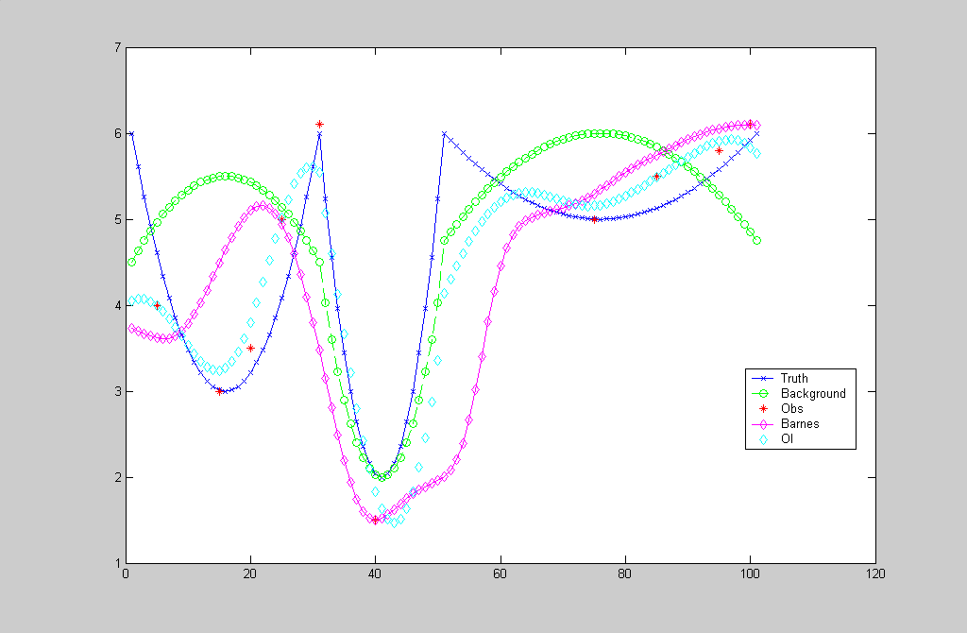
Figure 1. Barnes and optimal interpolation results with the radius of influence and the decorrelation scales of 12.

Analysis Quality
Figure 2 depicts the analysis quality as a function of the radius. The OI method almost always yields the best quality. The best quality is achieved at the decorrelation scale of 6.
The Bratseth solution was consistently better than the Bratseth matrix solution

Figure 2. Analysis of the four methods as a function of the radius

Scaling of the observation error
Figure 1 shows the analysis quality of the four methods as a function of the observation error scale. Again, the optimal interpolation provided better results in most cases.
The Bratseth solution gave better results when the observations were perfectly accurate.
Figure 3. Analysis quality as a function of observation error scaling (radius = 10).

2D Analysis
Figure 4 depicts the improvement of the analysis quality due to the consideration of the vertical distance in the calculations. The vertical influence radius was set at 10% of the horizontal influence radius.
Figure 4. Improvement due to the consideration of the vertical distance

Code Improvements
To start, I converted several loops into matrix operations. The resulting code became much more compact without any loss of clarity.
Also, I noticed that the code provided with the assumption did not really produce any iterations to refine d in the Bratseth matrix solution. The following loop did not do anything:
for i=1:101
xbrm = xb' + pbht * mi * d'
dbrm = (eye(10,10) - a * mi)*d' + d';
end
I replaced it with what I thought would be the solution described in the notes:
dbrm = d';
for n=1:10
dbrm = (eye(10,10) - a * mi)*dbrm + dbrm;
end
xbrm = xb' + pbht * mi * dbrm;
However, instead of converging to the OI solution, this solution diverged. I suspect that the a or m matrices are not defined correctly for this approach.
I will investigate more today to understand why the Bratseth matrix solution diverged and resumbit the assignment.

Code and Report
The attached code in dimeteo3.m contains my changes to example.m.

