Steven Callahan
Math 6790
Meteorology Final Project

The goal is to produce the best possible analysis of temperature over a domain and assess the sensitivity of the parameters. The images shown below are the initial background and terrain data for the truncated domain.

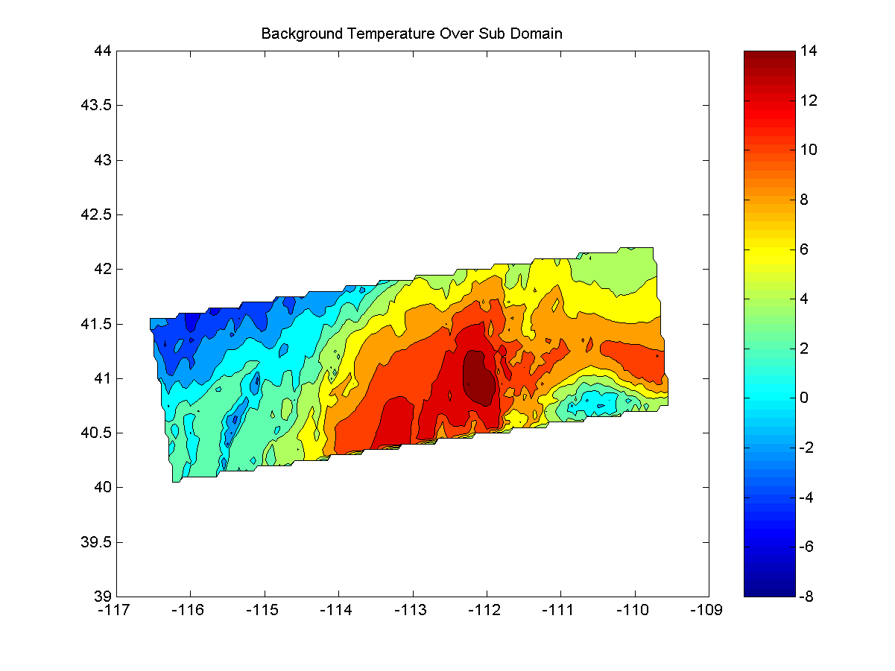
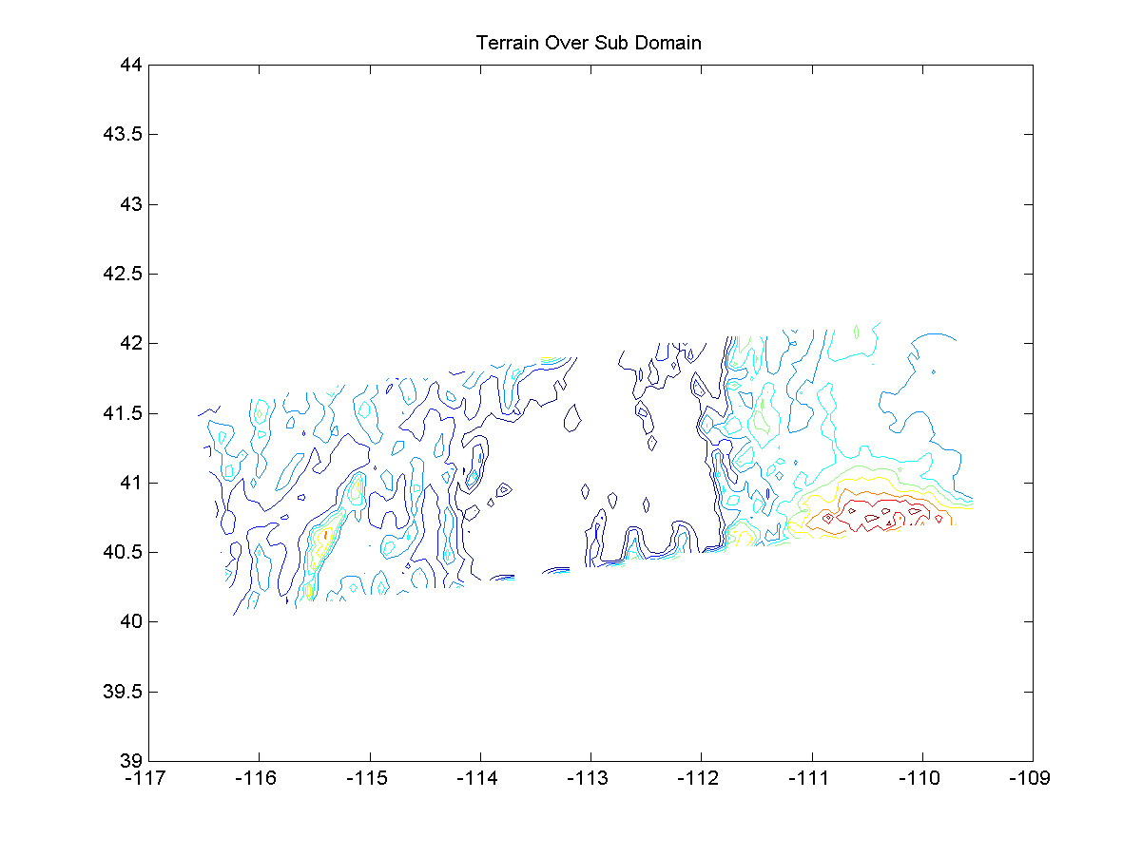

1. I incorporated what I learned from the first assignment to set up the necessary variables and matrices.
- The variable sigo was set up to be an input from the user. The matrix po was then generated using sigo as the diagonals.
- The variable sigb was set up to be an input from the user. The background error covariance matrix pb was then generated by multiplying sigb to the background error correlation.
- I modified the code so that the background errors decorrelate as a function of elevation in addition to longitude and latitude. This was done by adding a dz component to r2. The elevation was only given 1/50 of the weight of longitude and latitude.
- After I plot the 3DVar analysis of the system, I also plot the 3DVar with observation points shown as a black ‘x’ on top of the contour map.

2. I created an analysis of the system with 3DVar. As parameters, I used a background error decorrelation scale of 50km,
a background error variance of 50km, and an observation error variance of 25km. Shown below are these plots without observations and with observations.

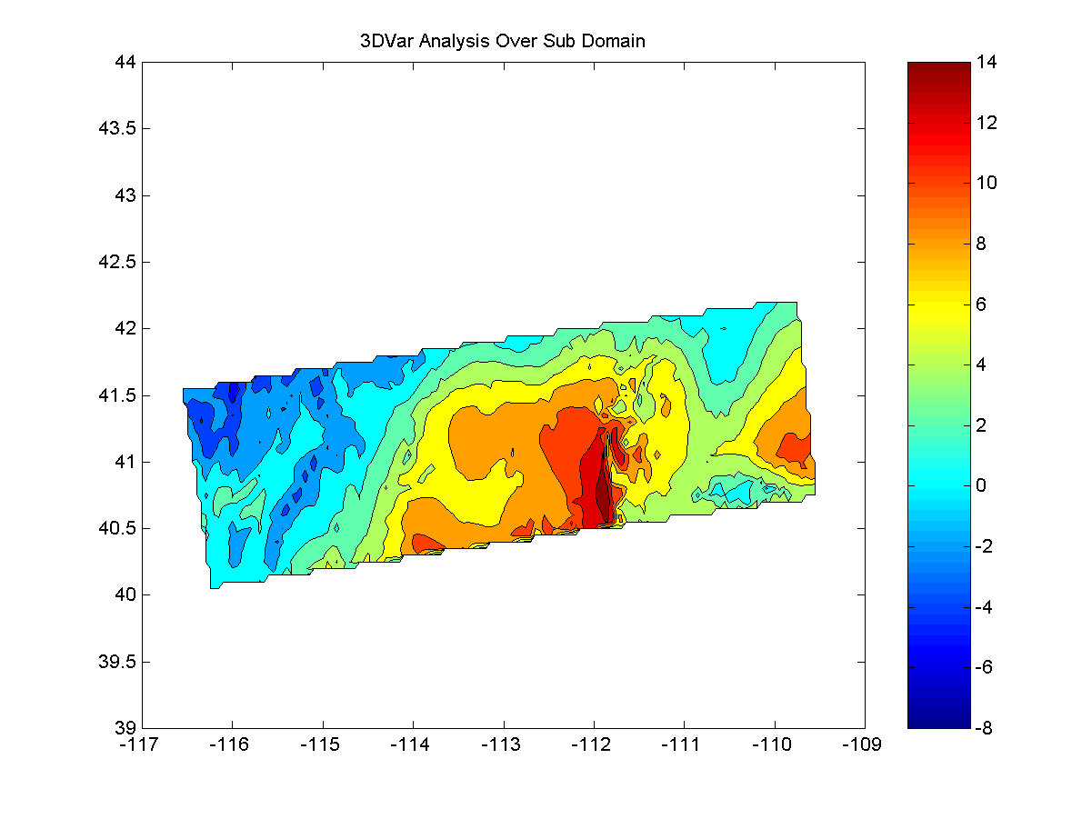
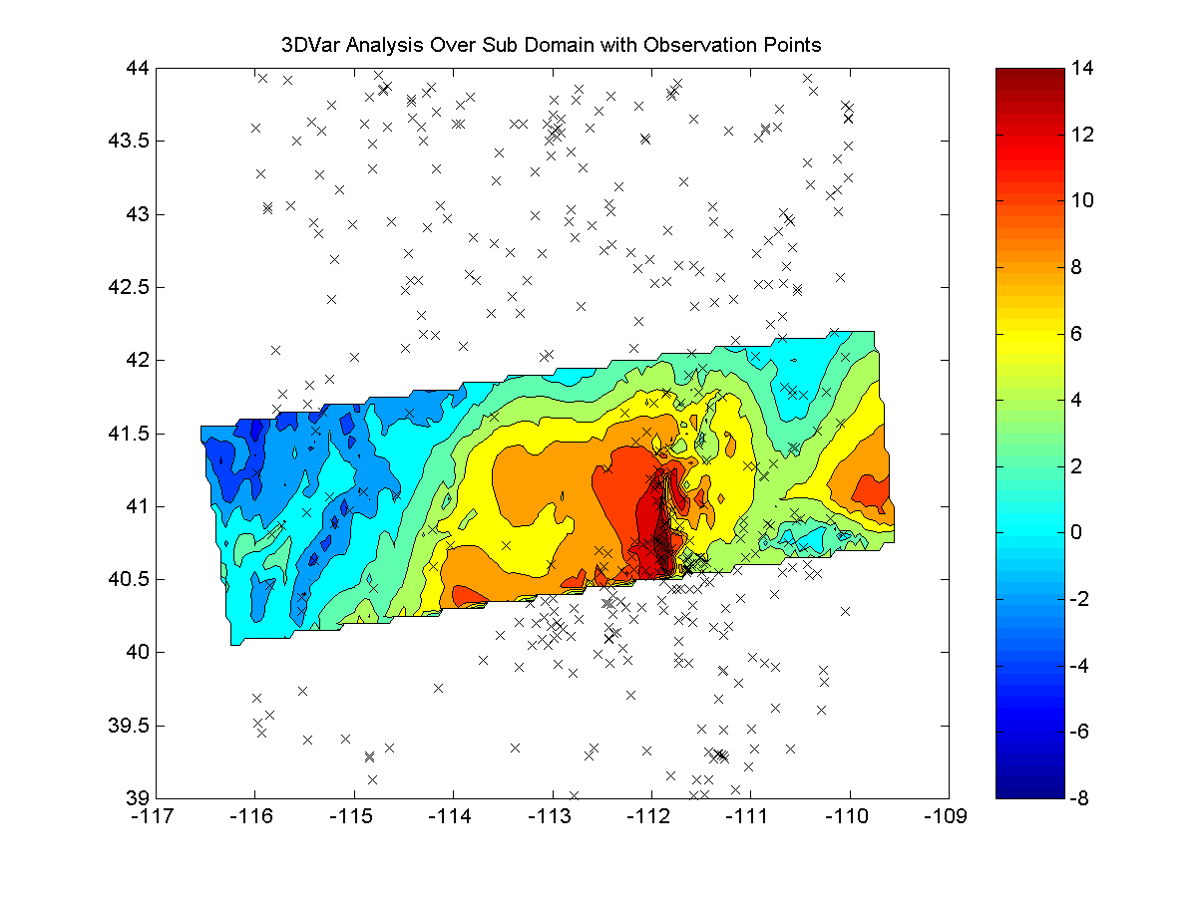

In comparison, here is a plot with a background error decorrelation scale of 50km, a background error variance of 50km, and an observation error variance of 50km.

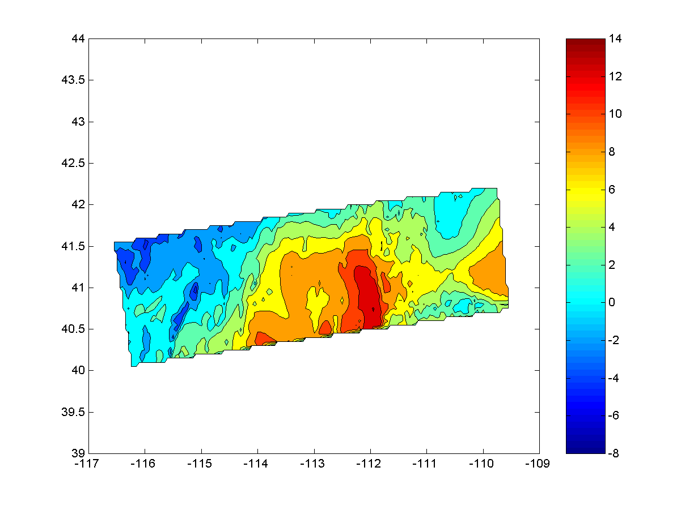

You can see by comparing these three images the difference that the observation and background error variance. The first two pictures follow the observations pretty closely, especially in areas dense with observations. The second picture follows the background more closely in these areas.

  - I extended my code to work on the entire domain by optimizing the matrices to be sparse, speeding up the calculations to build these matrices, and combining matrix calculations into fewer loops. I also prompt the user as to which calculation he/she would like to perform. However, even with these optimizations, I still run out of memory on my machine during the 3DVar calculation.

  - I adapted the current code to use a generalized minimum residual (GMRES) linear solver. The GMRES solver actually performed a little better than the Conjugate Gradient method provided. The timing results for the two methods are:

CGS = 295.406 seconds
GMRES = 155.703 seconds

The code provided also plots this analysis. This image shows a background error decorrelation scale of 50km, a background error variance of 50km, and an observation error variance of 25km.

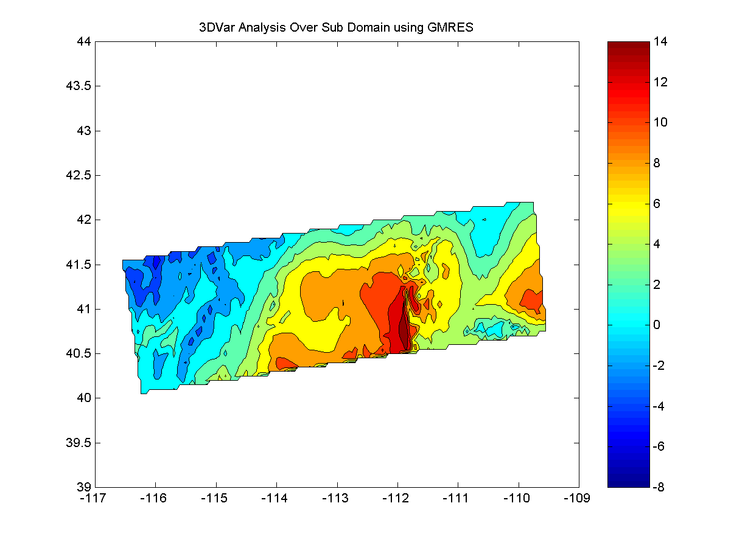

The results from the GMRES solver appear to be the same as those from CGS.

5. I read the two papers and made the following assessment:

3DVar MM5

The 3DVar MM5 method uses several techniques to speed up previous methods. First, it can be shown that the leading eigenvector in the vertical direction contains the largest contribution to the background error. By removing trailing eigenvectors, the computational cost of 3DVar can be significantly improved without a loss in quality. Another optimization is done by preprocessing the observations to make sure that bad data is removed. The paper also makes a contribution by including the cyclostrophic term in the mass-wind balance equation for better analysis of hurricanes and typhoons. Finally, the paper introduces a system that permits efficient performance on distributed-memory systems.
This method has several advantages. First, because of the truncation of eigenmodes in the vertical component of the background error covariance, it is computationally 30%-40% faster than previous 3DVar methods. It is also easily parallelized. The disadvantages are that when the background has already been used as an analysis, a conservative approach is needed to avoid over fitting observations. Also, it is not currently efficient on a large variety of computational platforms.

RUC

The Rapid Update Cycle is a method that has an hourly assimilation cycle of observations, thus allows for a current analysis and a short-range forecast. This is done by assimilating recent observations with previous RUC forecast as a background. Observations minus the innovations are used to create an error field that can incrementally by adding to the background. This falls into the category of sequential data assimilation methods; therefore it can be classified in the Kalman filtering framework.
The obvious benefit of this system is that it can quickly and efficiently assimilate new observation data. Therefore, it is very good for short-term forecasts. Some work still needs to be done with assimilation of radar and satellite-based observations. Also, RUC needs to improve its horizontal resolution.

Conclusion
From this project, it is easy to see how much computation is required to do numerical weather prediction. Even the truncated domain took me about ten minutes to analyze. This project gave me a good idea of the problems and optimizations that need to occur in order to accurately predict the weather.

