Steven Callahan

Math 6790

Meteorology Project 1

1.
a. Polynomial fit does not give a decent analysis with any order. The best choices are from about 3 to 5. After degree 5, it starts to diverge rapidly.

b. Smaller radii of influence for the Barnes analysis follow the background in the areas where there is no observation. As the radius of influence increases, the approximation goes toward an average of the background and observation.

c. The background error decorrelation describes how closely the approximation will follow the background. Smaller numbers will jump back to the background where there is no observation. Larger values go away from the background and follow only the observation.

d. When the Bratseth radius of influence matches the background error decorrelation, the results for Bratseth and OI are almost identical. If you vary the Bratseth radius above or below the background error decorrelation the Bratseth solution degrades rapidly.

- With the default inputs (2,10,10,10), which give the best answers, the analysis quality from best to worst is as follows:

Method | Quality
Bratseth | 2.6866
3D Var | 2.6708
OI | 2.6707
Bratseth Matrix | 2.4629
Poly O | 1.1451
Poly OC | 0.9425
Barnes | 0.6101

In addition, the background quality = 0.9321. The OI and 3D Var qualities are better than the background quality for all values of background error decorrelation.

- If a scale factor is entered for the background variance, it changes the OI and Bratseth qualities. With a scale of 5, the following qualities are obtained:

Method | Quality
Bratseth | 2.4724
3D Var | 2.4719
OI | 2.4719
Bratseth Matrix | 2.0862

If you keep increasing this scale, the Bratseth, 3D Var, and OI analyses converge. At a scale of 10 the following qualities are obtained:

Method | Quality
Bratseth | 1.9543
3D Var | 1.9543
OI | 1.9543

4.
a. I changed the weight matrix for the Barnes analysis to incorporate the vertical radius influence. I made the vertical influence 20% of the horizontal influence. With the same parameters as above, the quality dramatically increased. Here is the quality for Barnes:

Method | Quality
Barnes | 4.1968

That is an increase in quality of 3.5867!

b. I also changed the background error matrix so that it includes the vertical radius. In addition, I changed the correlation matrix. Both of these matrices now incorporate a vertical influence of 20%. Here are the quality results:

Method | Quality
Bratseth | 3.0031
Bratseth Matrix | 2.5261
3D Var | 2.4760
OI | 2.4759

These results are interesting because the quality of the Bratseth solution improves by 0.3165, it also improves for the Bratseth Matrix by 0.0632. However, the OI quality decreases by 0.1948.

2D Analysis

- For the final part of the first project, I decided to use splines to fit the observation points and the observation points with corrections. This was not a very successful method. In general, it performed better than the polynomial fit, except in areas with little information. The quality results demonstrate that these problem areas cause the overall quality to be much worse than any other method. The results are show below along with the plots.

Method | Quality
Spline O | 0.2121
Spline OC | 0.6355

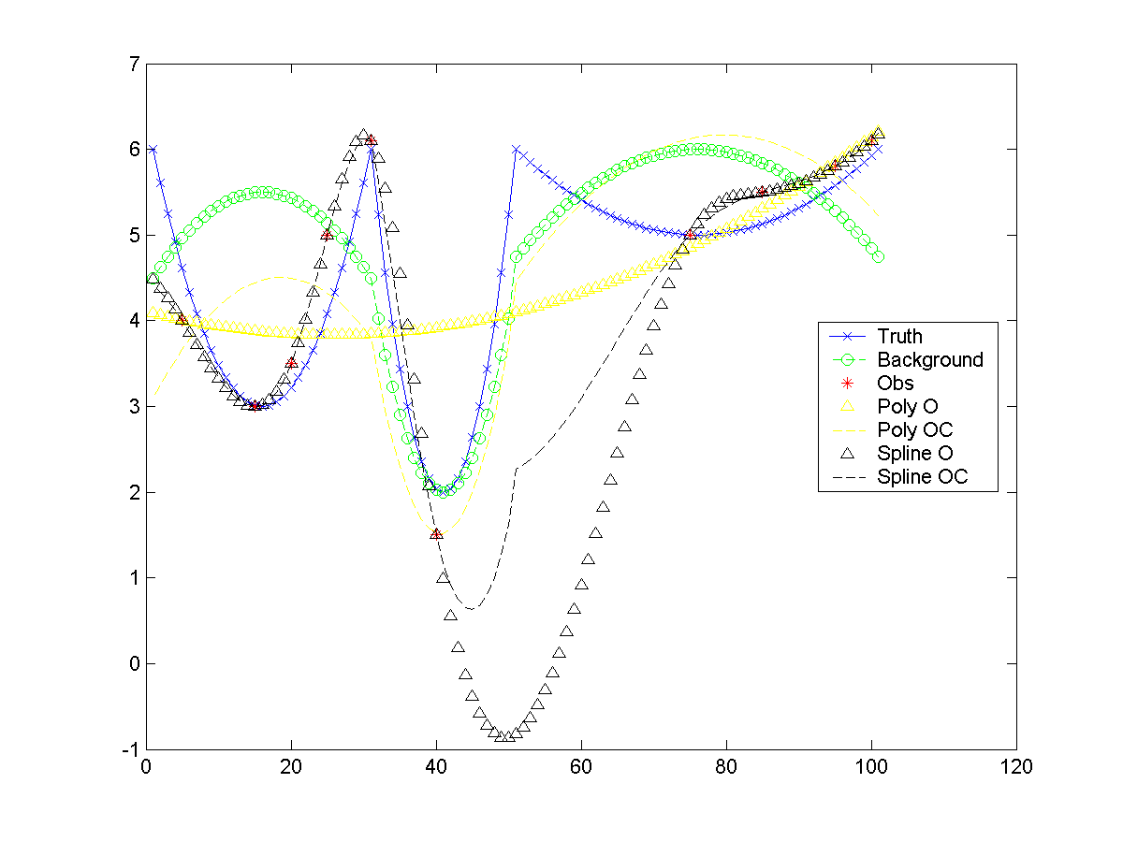
Analysis with polynomial fit and splines

