CHAPTER 3

RESULTS

3.1 Ozone Concentrations during 16-30 June 2015

The focus of this study is on the 16-30 June 2015 period when the highest ozone concentrations of the summer were observed in the Salt Lake Valley. Large-scale ridging aloft dominated with high temperatures, generally light winds, and mostly clear skies. In contrast to mid August 2015 when regional transport of smoke impacted ozone concentrations (Horel et al. 2016), the production and destruction of ozone during the The time series in Fig. 3.1a illustrates the high levels of solar radiation in the Salt Lake Valley near the summer solstice with occasional small decreases primarily during late afternoons arising from intermittent cloud cover.

The numbers of ozone measuring sites in the rural, lake, and urban categories (Table 2.2) that exceed the NAAQS of 70 ppb over an 8 h period are shown in Fig. 3.2 for each day. Of the 8 rural sites, at least one location exceeded the standard on 13 of the 15 days while at least one of the 8 GSL shore sites exceeded the standard during 11 days. Not unexpectedly, the large amounts of incoming solar radiation combined with abundant concentrations of precursor chemicals led to at least one of the 11 urban sites to exceed the standard during all but one of the days during this period.

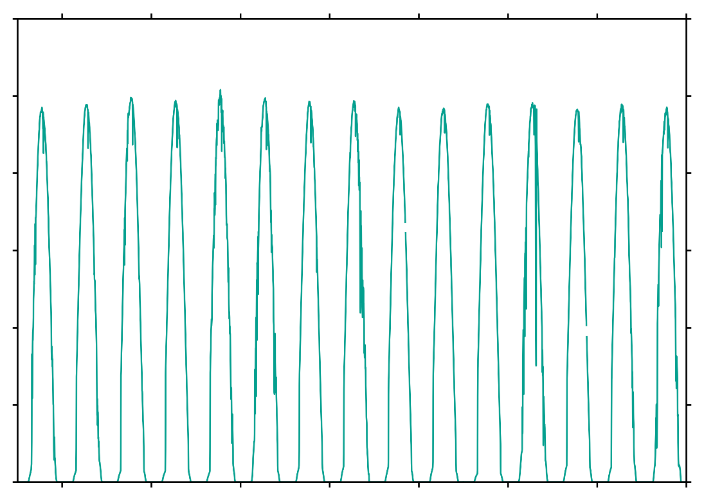

1200

1000

800

600

400

200

000

Solar Radiation [W m-2]

17

19

21

23

25

27

29

June 2015

Figure 3.1 a). Incoming solar radiation (W m-2) at the MTMET station in the Salt Lake Valley from 16-30 June 2015. See Fig. 3.3 for the location of MTMET. b) 8-hr average ozone concentrations for all stations from 16-30 of June.

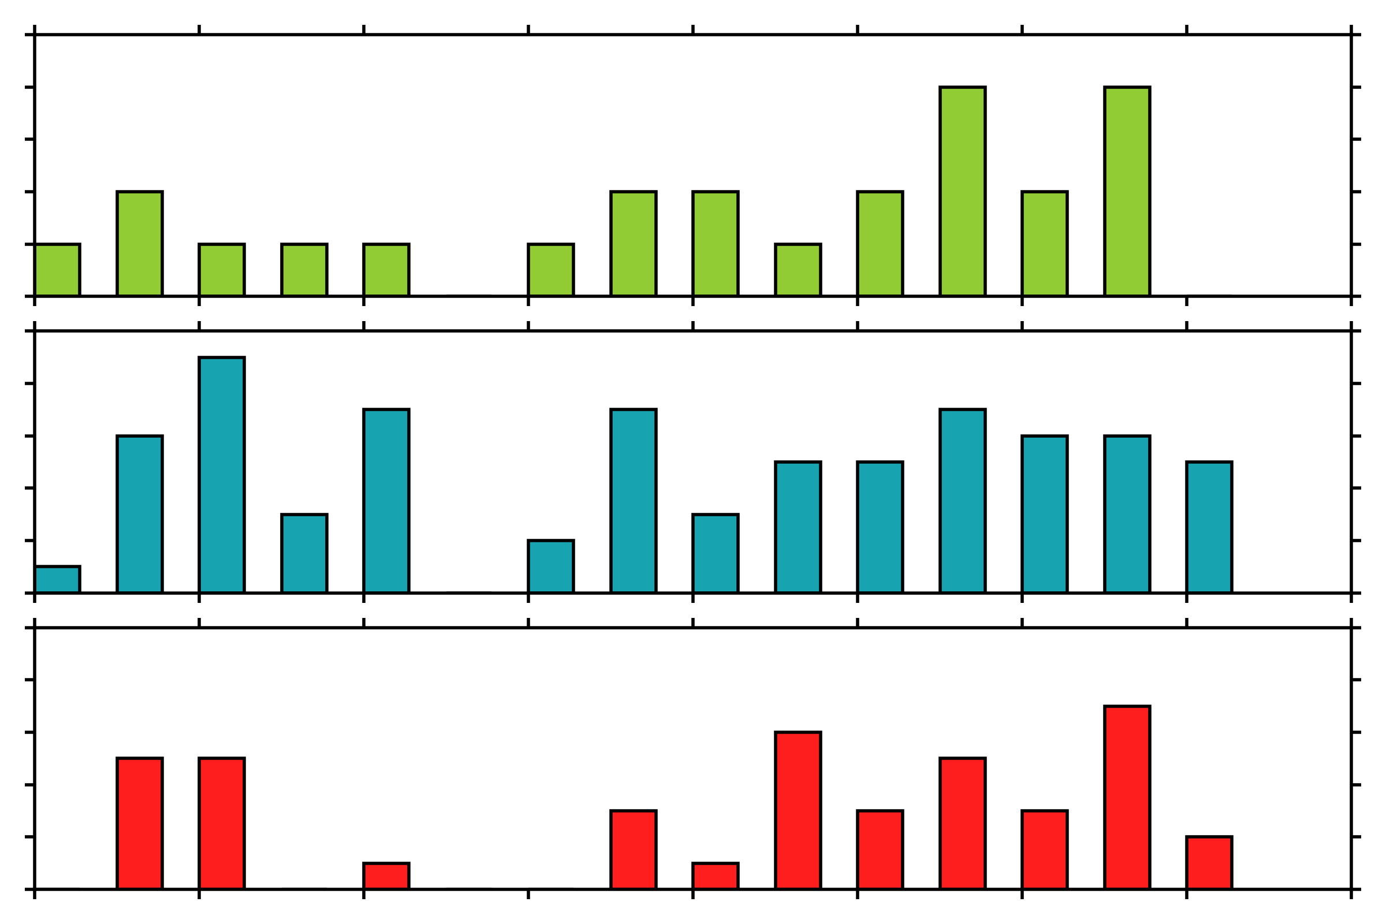

5

4

3

2

1

0

10

8

6

4

2

0

10

8

6

4

2

0

18

20

22

24

26

28

30

June 2015

Number of Stations

Figure 3.2. Number of stations each day from 16-30 June 2015 that exceed 70 ppb during an 8-h period categorized as follows: a) rural, b) lake, and c) urban.

Figure 3.3 shows the time series of 8-h running means of ozone concentration for sites in the rural, lakeshore, and urban categories. The diurnal cycle dominates at each site, but the amplitudes of the diurnal variations vary widely. For example, with the exception of the “rural” site in Logan (QL4, lower purple curve in Fig. 3.2a) that has a city population of ~50000, all of those sites tend to have small diurnal ranges with ozone concentrations during this period primarily between 40 and 70 ppb. Lakeshore sites far removed from the Wasatch Front urban corridor have similar small diurnal ranges while those close to the Wasatch Front tend to experience nocturnal titration dropping ozone levels to ~20 ppb while reaching peaks over 70 ppb in the afternoon (Fig. 3.2b) . As expected, large diurnal swings with lower minima are observed in the Wasatch Front’s urban corridor where titration prevails at night.

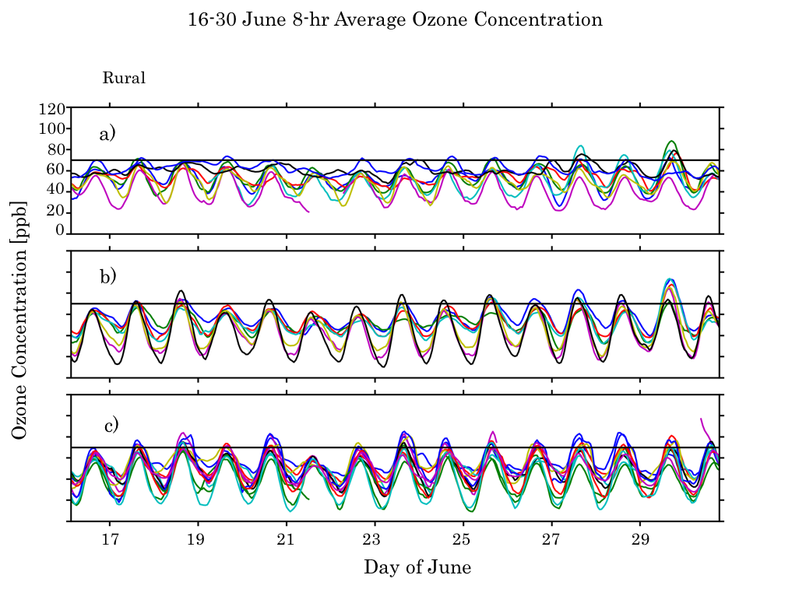

Figure 3.3. Running 8-hr averages of ozone for: a) rural, b) lakeshore, and c) urban stations. The current ozone NAAQS standard of an 8-h average of 70 ppb is denoted by the horizontal lines.

Horel et al. (2016) used ozone air pollution roses in the vicinity of the Salt Lake Valley to summarize the ozone concentrations as a function of wind direction during the night (8 PM – 8 AM local) and day (8 AM – 8 PM local) for the entire summer 2015 period. Fig 3.4 shows similar ozone pollution roses restricted to the 16-30 June period over the larger study domain (Figs. 3.4a,b) as well as in the vicinity of the Salt Lake Valley (Figs. 3.4c,d). Ozone concentrations below 55 ppb occur frequently at night in most locations (Figs. 3.4a,c) when the prevailing wind directions tend to be locally down slopes, canyons, and valleys and generally towards the GSL. For example, at rural sites at the northern and southern extremes of the GSL (Locomotive Springs, LMS, and Erda, QED, respectively), land breezes directed towards the GSL are most common from 8 PM – 8 AM accompanied by ozone levels below 55 ppb (Fig. 3.4a). One deviation from this general pattern is the nighttime northeasterly winds prevailing on the western shores of the GSL at Badger Island (BGRUT) and Lakeside Mountain (O3S06) that are associated with the prevailing nocturnal mountain/plain circulation extending westward from the Wasatch Mountains across the GSL (note the prevailing winds on Fremont Island at lake level, O3S07, and at its crest, O3S08). Concentrations greater than 55 ppb are more frequent overnight at Badger Island and Lakeside Mountain than at the other rural or lake sites (Fig. 3.4a). Pronounced nocturnal downslope and down valley circulations accompanied by low ozone levels prevail in the Salt Lake Valley as well (Fig. 3.4c). However, the high elevation sites (Farnsworth Peak, FWP, in the Oquirrh Mountains and Snowbird, S2OZN, in the Wasatch Mountains) are often exposed to ozone levels greater than 55 ppb during the 8 PM – 8 AM period, indicative of the higher “background” ozone levels prevailing over the region.

The wind roses for the 8 AM – 8 PM period tend to exhibit locally up slope, canyon, and valley flows and generally away from the GSL (Figs. 3.4b,d). Since ozone levels usually peak during late afternoon, higher ozone concentrations are often transported during the afternoon across the eastern and southern lake shores into the Wasatch Front, e.g., at stations to the southeast of the GSL (e.g., Syracuse, QSY, Farmington Bay, O3S02, Bountiful, QBV, and Saltaire, QSA). Local afternoon upslope flows are evident on the western (Herriman, QH3) and eastern (Mountain Meteorology Lab, MTMET) slopes of the Salt Lake Valley as well as the upvalley transport of higher ozone concentrations in Little Cottonwood Canyan (S2OZN). Since the predominant flow across the central portion of the GSL continues to be from the east-northeast during much of the day, higher ozone concentrations tend to be transported across BGRUT towards the west-southwest. At the crest of the Oquirrh Mountains (FWP located 1500 m above the GSL), winds tended to be bidirectional from the west/southwest with southeasterly winds associated with higher ozone concentrations indicative of upslope flows carrying higher ozone concentrations from the Salt Lake Valley.

4 Ozone wind roses for 16-30 June 2015 during: (a,c) night (8 PM – 8 AM) and (b,d) day (8 AM – 8 PM) local time. The length of each of the 16 cardinal direction colored wedges represents the percentage of time the ozone concentrations fall within each colored range when the wind is blowing from that direction according to the scale in the lower left.

2 Ozone eduring June 2015

Blaylock et al. (2016) describe the strong lake breeze front that transported high ozone concentrations down the Salt Lake Valley during the late afternoon of 18 June 2015. As discussed in Chapter 2, this episode took place during one of the Intensive Observing Periods of the GSLSO3S during which the ozone observations at the fixed locations were supplemented by mobile observations from vehicles, TRAX, and the KSL helicopter. Figure 3.5 shows the vertical profiles of potential temperature, mixing ratio, and wind from the morning and afternoon soundings at the Salt Lake International Airport. Strong stability in the morning below 2000 m MSL is replaced in the afternoon by a deep well-mixed layer. As discussed by Blacklock et al. (2016), relatively strong southerly winds evident in the morning sounding contributed to convergent frontogenesis later in the day that delayed the eventual push of the afternoon northerly lake breeze evident in the afternoon sounding below 200 m AGL.

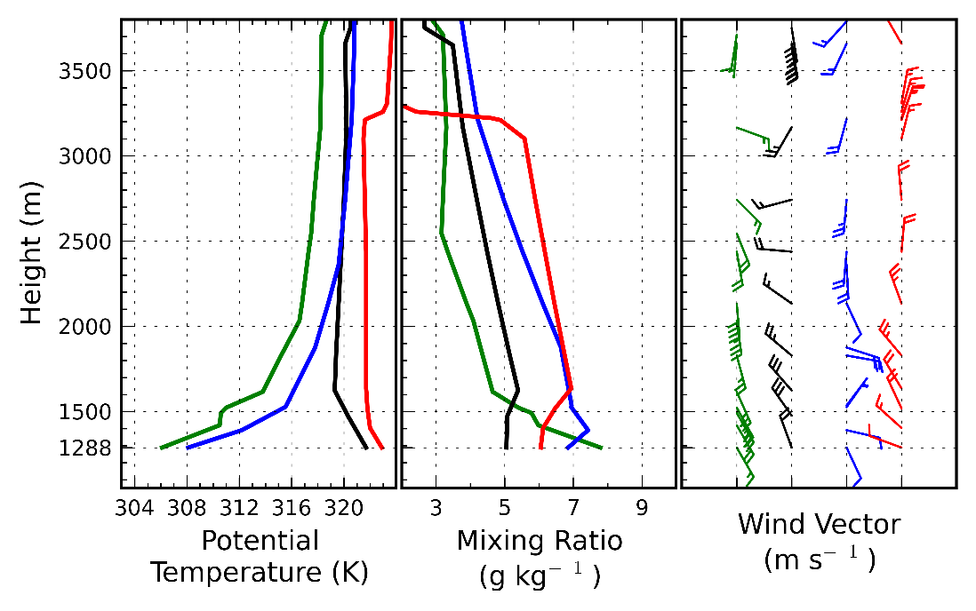

Figure 3.5. Vertical profiles of potential temperature (K), mixing ratio (g kg -1), and vector wind at the Salt Lake International Airport during the morning (green) and afternoon (black) 18 June 2015 and during the morning (blue) and afternoon (red) 27 June 2015. Half and full barbs denote speeds of 0.5 and 1.0 m s-1, respectively.

A nominally west to east cross section of ozone concentration and wind direction from the crest of the Oquirrh Mountains to the Wasatch Mountains on the eastern side of the Salt Lake Valley is shown in Fig. 3.6. Ozone concentrations in both mountain ranges remained between 60-70 ppb throughout the day, indicating in a crude sense the ambient ozone levels. At Neil Armstrong Academy (NAA) on the western edge of the urban core of the Salt Lake Valley, ozone levels are very low over night and remain around 60 ppb through much of the day. As discussed by Blaylock et al. (2016), a strong lake breeze front passed NAA at ~1600 MDT and passed the Mountain Meteorology Lab (MTMET) at 1700 MDT leading to abrupt increases in ozone to ~80-90 ppb.

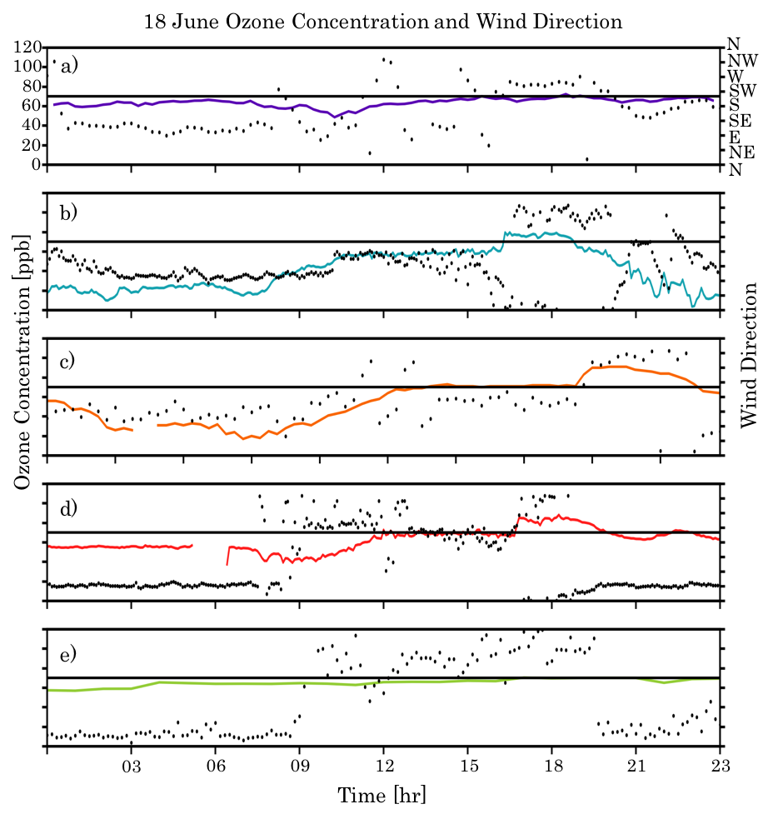

Figure 3.6. Time series of ozone (ppb) and wind direction at: a) Farnsworth Peak (FWP),b) Neil Armstrong Academy (NAA), c) Hawthorne (DAQ), d) Mountain Meteorology Lab (MTMET), and e) Snowbird (S2OZN).

Ozone concentration and vector wind analyses from 0600-2300 MDT 18 June 2015 are shown in Fig. 3.7. In order to focus where ozone data are more abundant, the plotting domain is reduced from the full analysis domain shown in Fig. 1.1, e.g., restricted on the north to where the causeway crosses the main portion of the Great Salt Lake. Ozone concentrations from the fixed and mobile platforms are displayed as well in order to help diagnose the features of the ozone analyses.

During the early morning (06-08 MDT), ozone concentrations are low (< 30 ppb) below 1500 m extending northward from the Salt Lake Valley along the Wasatch Front to the east of the GSL. Observations from the fixed sites as well as from the light rail car on the Green TRAX line and several vehicles traveling to the east of the GSL help to generate these analyses. The upper reaches of the Salt Lake Valley (~1500 m ASL, the lowest elevation contour) tend to have concentrations 10-15 ppb higher than that at lower elevations. The ozone concentrations above 2000 m ASL of ~50 ppb in the Oquirrh Mountains to the west and ~60 ppb in the Wasatch Mountains to the east of the Salt Lake Valley are strongly constrained in the analysis by the observations at Farnsworth Peak (FWP) and Snowbird (S20ZN), respectively. Down slope and valley winds tend to dominate with relatively strong easterly cross-lake flow evident in the central GSL as well.

During the late morning (09-11 MDT), ozone levels increase, most notably by 11 MDT to the southeast of the GSL to the north of the Salt Lake Valley. One of our vehicles transiting the GSL causeway at the northern edge of the figures highlights how concentrations over the GSL in that region are lower than those observed by another vehicle transiting the narrow corridor between the GSL and the Wasatch Mountains. Southerly winds down the Salt Lake Valley continue during this period while northerly winds begin to develop over the main portion of the GSL.

Ozone concentrations during midday (12-15 MDT) continue to rise particularly between Antelope Island and the Wasatch Mountains. Concentrations tend to remain lower across the causeway to the north. Southerly winds continue in the southern half of the Salt Lake Valley while the lake breeze begins to penetrate into its northern reaches.

During the next 2 hours (16-17 MDT), ozone observations from the KSL helicopter supplement the other observations. The sensitivity tests described in chapter 2 are performed for 17 MDT when the helicopter helps define the sharp contrast in ozone concentrations across the lake breeze front at that time (Blaylock et al. 2016). Due to the lack of observations over the lake itself, the UU2DVAR analysis at 16 MDT likely underestimates the ozone concentration over the southern lake then as suggested by the observations on the western shore at Badger Island (BGRUT) and to the southwest of the lake at Saltaire (QSA). Higher ozone concentrations are apparent behind the lake breeze front in the Salt Lake Valley and lower levels in front of it.

The position of the lake breeze front at 18 MDT is broadly consistent with the radial velocity data from the Salt Lake Terminal Doppler Weather Radar and other observations (Blaylock et al. 2016). Ozone concentrations in the central and southern Salt Lake Valley are now higher than those further north. Westerly flow towards the Wasatch Mountains at 18-19 MDT is consistent with the peak ozone concentrations observed at Snowbird at 19 MDT. The late evening helicopter transects at 20-21 MDT help to define the lowering ozone levels with increasing titration evident after sunset (22-23 MDT). Ozone levels remain higher at Snowbird and Farnsworth Peak during this period.

Overall, the UU2DVAR analyses help to define and unify many of the temporal and spatial features evident in the disparate sources of ozone observations. However, there are also noticeable non-physical artifacts introduced by how the background fields are defined and the bogusing of the lakeshore observations over the lake. For example, since the Snowbird observation is the only one available in the Wasatch Mountains unless the helicopter traverses them, its concentrations largely defines what is analyzed in those mountains. Obviously artificially smooth geometric shapes are present at times over the GSL. Those often arise when there are large discrepancies between the background concentration based on the median of the available lakeshore observations and individual lakeshore observations that are bogused over the lake. Sharp discontinuities across the lake shore are also introduced as a result of the assumption to minimize observations over the lake from influencing those onshore and vice versa. This has been difficult to overcome for other variational analyses such as the Real Time Mesoscale Analysis (Tyndall and Horel 20XX).

|  |  |
| --- | --- |
|  |  |
|  |  |
|  |  |
|  |  |
|  |  |
|  |  |
|  |  |
|  |  |
|  |  |

7O shaded according to the colorbar during8 2015 at hourly intervals from 0600 – 2300 MDT. Vector wind analyses at every 4th gridpoint superimposed where half and full barbs denote speeds of 0.5 and 1.0 m s-1. Observations of ozone concentrations at fixed sites (squares) and from mobile observations (circles) are shown using the same colorbar. Elevation contoured in light grey at 500 m intervals beginning at 1500 m.

3Ozone eduring 27 June 2015

The spatial and temporal evolution of ozone and surface wind is now examined for 27 June 2015 when the greatest number of exceedances of the 70 ppb NAAQS 8-h standard during the summer was observed (Fig. 3.2). Figure 3.5 highlights that the boundary layer tended to be warmer with lighter morning down valley flow and afternoon lake breeze on this day relative to that on 18 June.

Using the same pseudo cross section used for the previous case, the ambient background ozone levels on this day are ~10 ppb higher than those on 18 June (Fig. 3.8). Nocturnal titration drove ozone levels to near 0 ppb at NAA increasing to over 80 ppb later in the day while peak ozone concentrations at QHW and MTMET were over 100 ppb. Those peak concentrations occurred earlier in the day since the lake breeze was not delayed as it was on 18 June. Of particular note is the peak 90 ppb concentration at Snowbird reached at 18 MDT..

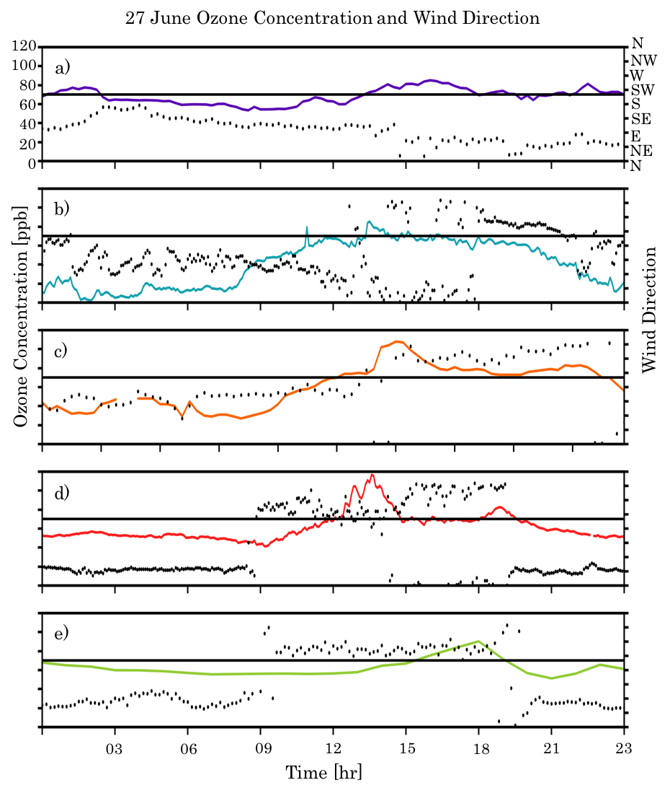

Figure 3.8. Time series of ozone (ppb) and wind direction at: a) Farnsworth Peak (FWP),b) Neil Armstrong Academy (NAA), c) Hawthorne (DAQ), d) Mountain Meteorology Lab (MTMET), and e) Snowbird (S2OZN).

As shown in Fig. 3.9, ozone concentrations during the early morning hours (06-09 MDT) are broadly similar to those on 18 June with low values below 1500 m in the urban areas and higher values at Farnsworth Peak and Snowbird. The only mobile asset on this day supplementing the fixed site observations is the sensor onboard the light rail car traversing the red line in the Salt Lake Valley. The winds during the early morning are again for the most part down slope and down valley with the easterly winds across the GSL’s central core.

Ozone levels increase throughout this region during the late morning. By solar noon (13 MDT), they are analyzed to be over 70 ppb over the GSL with even higher concentrations to its southeast. A well-defined lake breeze extends southwestward into the Salt Lake Valley accompanied by the high ozone levels. During midafternoon (14-16 MDT), ozone concentrations tend to increase throughout the domain, including at the high elevation sites, Farnsworth Peak and Snowbird. The highest ozone concentrations are observed along the western lakeshore at Badger Island and nearby Lakeside Mountain (O3S06, not shown as it lies off the western edge of the figure) as well as Erda (QED) in the Tooele Valley directly to the south of the GSL and Saltaire (QSA) near its southwestern shore. Increasing ozone levels observed at Snowbird led to the highest concentrations analyzed in the Wasatch Mountains at 18 MDT. Ozone levels then dropped sharply during the late evening and early night hours.

As mentioned regarding the analyses completed for 18 June, some artificial features are apparent in the analyses, particularly the lower concentrations over the southern portions of the GSL relative to the lakeshore at 15 MDT. However, overall the ozone analyses help to integrate the available ozone observations such that the critical spatial and temporal changes become evident as the day progresses.

|  |  |
| --- | --- |
|  |  |
|  |  |
|  |  |
|  |  |
|  |  |
|  |  |
|  |  |
|  |  |
|  |  |

9 REPEAT previous fig cap changing date.

3.4 Composite Diurnal Variation in Ozone during 16-30 June 2015

As a means to examine the “typical” evolution of ozone during days that experience high ozone levels, Figure 3.10 shows the averages over 3-h blocks of the hourly ozone and surface wind analyses during the 16-30 June 2015 period. These composite ozone analyses depend on all of the available fixed site observations as well as all of the intermittent mobile observations available at times during this period. Average ozone concentrations within those 3-h intervals at each fixed site are also shown in Fig. 3.10. Using as a reference the averages of the Farnsworth Peak observations in the Oquirrh Mountains as an indicator of the free-atmosphere ozone concentrations, the background ozone levels throughout the day vary by a limited amount, remaining between 50 and 60 ppb. Composite ozone levels at Snowbird in the Wasatch Mountains downwind of the Salt Lake Valley tend to be higher, between 60-70 ppb. Much larger diurnal swings (20-70 ppb) are evident in some of the lowest elevations of the Wasatch Front.

Both the station averages and the composite analyses illustrate the general tendency for the lowest and highest concentrations to take place in the urban corridor of the Wasatch Front. Lakeshore observations and the resulting analyses over the main body of the GSL suggest that the GSL may not necessarily be a reservoir of high ozone overnight nor generally during the day. The highest ozone concentrations observed and analyzed in the afternoon tend to be sandwiched between the GSL and the Wasatch Front, particularly in the Farmington Bay region.

The composite wind analyses help to define the typical diurnal wind circulations emphazing the strong role of thermally-forced circulations arising from the lake and the surrounding terrain. Down slope and valley circulations combine with land breezes overnight in many locations. A notable exception is the relatively strong easterly flow across the central portions of the GSL from 21-08 MDT presumably resulting from the larger-scale mountain-plain circulation between the Wasatch Mountains and the GSL Basin. By midday, up slope and up valley circulations combined with lake breezes dominate these composites until sunset.

As noted earlier limitations imposed by the available observations and assumptions regarding the background error covariances can introduce artificial fatures in these composite analyses. For example, the differences in composite ozone across the easternmost shorelines of the GSL are likely too abrupt.

|  |  |
| --- | --- |
| 00-02 MDT | 03-05 MDT |
| 06-08 MDT | 09-11 MDT |
| 12-14 MDT | 15-17 MDT |
| 18-20 MDT | 21- 23 MDT |

Figure 3.10. Composite ozone concentration analyses averaged over 3-h blocks during the period 16-30 June 2015 shaded according to the colorbar. Composite vector wind analyses at every 4th gridpoint superimposed where half and full barbs denote speeds of 0.5 and 1.0 m s-1. Averaged ozone concentrations during those periods are indicated at fixed sites (squares). Elevation contoured in light grey at 500 m intervals beginning at 1500 m.







|  |  |
| --- | --- |
|  |  |
|  |  |
|  |  |
|  |  |
|  |  |
|  |  |
|  |  |
|  |  |
|  |  |

|  |  |
| --- | --- |
|  |  |
|  |  |
|  |  |
|  |  |
|  |  |
|  |  |
|  |  |
|  |  |
|  |  |

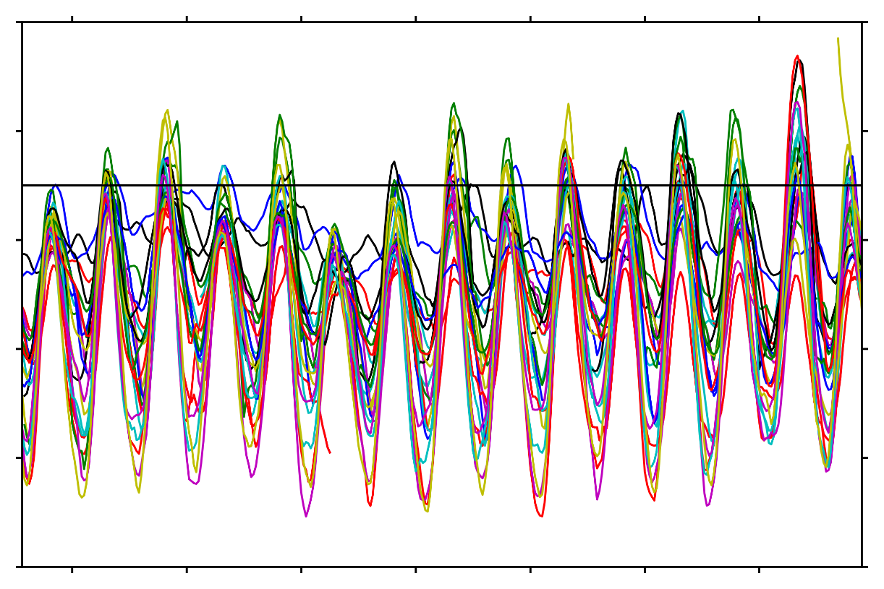

100

80

60

40

20

00

Ozone Concentration [ppb]

017

019

21

23

25

27

29

Three hour averages of ozone concentration and wind direction for 18 June from 0000-2300 MDT were generated using UU2DVAR analysis. Figure 3.3.a-i. shows 3-hr averages of ozone concentrations and wind direction throughout the Salt Lake Valley and nearby Great Salt Lake. The averages in Figure 3.3 reveal elevated ozone concentrations in the early morning and late night hours over the Great Salt Lake, while the valley’s highest ozone concentrations occur during the daytime hours.

Wind direction averages show that the flow during the morning and nighttime hours tends to be easterly in the Northern arm of the lake, while the Southern arm tends to be more westerly. The flow over the lake is affected by the upvalley winds in the Southern arm while easterly flow is a result of an airmass exchange between cooler air at higher elevations and warmer air in the valleys that takes place during the nighttime hours. However, the winds generated result in an advection of ozone and ozone pollution rich air over the Great Salt Lake, resulting in elevated concentrations overnight. High ozone concentrations are also seen at higher elevations as upslope flows near the Wasatch and strong winds off of the lake transport polluted air from lower elevations.

The average ozone concentration in urban areas from 00-11 MDT and 21-23 MDT is lower than that of the Great Salt Lake and rural areas. However, at peak insolation hours, the Salt Lake Valley’s rate of ozone creation increases. In each of the 12-14, 15-17, and 17-19 MDT 3-hr average panels, several stations in the urban areas in the Salt Lake Valley and between the shores of the Great Salt Lake and the Wasatch mountains reached a 3-hr average exceeding 70ppb.

As slope and valley flows affect the flow over the Great Salt Lake through the 09-11MDT time period, high ozone averages are found over the lake rather than in the valley. At 12-14 MDT, a change in average wind direction occurs, resulting in more northerly wind across the entire Great Salt Lake with surrounding land areas

tovertical profiles evidentozone concentrations Ozone distribution analysis was performed by UU2DVAR on June 27for the hours of 1200,1400,1600,1800 MDT. Peak insolation occurs during these hours providing energy to drive photochemical reactions with ozone precursors to form ozone. In addition, upslope and canyon flows from the nearby Wasatch Mountains are initiated as well as the lake breeze. The ozone analyses show the wind speed and direction to display how these flows distribute ozone from the Great Salt Lake to surrounding urban and rural locations.

In the early morning hours, ozone is transported through downslope winds and lake/land breezes to create a reservoir of ozone and ozone precursors from the surrounding urban areas. This reservoir stays stagnant over the lake during the morning hours and can be seen in the UU2DVAR analysis for 1200 MDT.

At 1200 MDT, elevated concentrations within the ozone reservoir are seen over the Great Salt Lake. The initiation of the lake breeze is evident as winds begin to flow away from the Great Salt Lake into the surrounding areas. We can see along the west side of the lake where stronger winds are coming off the lake that high ozone concentration begins to settle into the area. Areas along the urban corridor between the lake and the Wasatch also exhibit high ozone concentrations with contributions to ozone levels made by the lake-breeze along the shores. We are also able to see the upslope flows that are beginning to initiate around the slopes of FWP and S2OZN that will eventually advect higher ozone concentrations from lower elevations to rural and high elevation locations.

As insolation continues to increase from 1200 to 1400 MDT, we see a drastic rise in ozone levels across the entire domain. Ozone concentrations have reached high levels over the lake, as well as over parts of the Salt Lake Valley. Assessing the winds over the lake, the lake breeze continues to transport high concentrations into the surrounding areas. Areas near the Lakeside station (O3S06) on the western shore exhibit high ozone and it can clearly be seen that this ozone is being advected into the area from over the lake. Looking at areas in the Salt Lake Valley, transportation of high ozone and ozone precursors from the lake breeze as well as valley flows contribute to this increase in ozone along with the still increasing insolation. Ozone transportation via upslope flows is evident at FWP and S2OZN as we see a drastic increase in ozone concentrations at this hour, with winds indicating that some upslope flow on the northern slopes of FWP is saturated with ozone coming from over the lake. Winds near S2OZN, a higher elevation site than FWP, show that upslope and up canyon flows are still continuing to advect ozone from urban areas at lower elevations as the higher elevation sites have yet to experience their peak in ozone.

By 1600 MDT, most of the areas in the valley have become uniform in ozone concentration, with the exception to the southwest of the lake. In this location winds are southerly, running parallel to the shoreline. The area with elevated ozone concentrations is at the convergence of several wind directions from the lake/land breeze and surrounding complex terrain flows. Evidence that the upslope flows that began to initiate around 1200 MDT beginning to carry ozone to higher elevations is clear in this analysis. Some stations in the valley remain in the yellow color, indicating locally lower ozone concentrations. These values, although not much less than surrounding areas, are likely low due to the interstates I-80, I-15, and I-215 effects on titration of ozone.

As the lake/land breeze begins to make its way to the southeastern portion of the valley around 1800 MDT, upslope flows can still be seen transporting ozone to S2OZN, where it will remain overnight. Although lake ozone concentrations have decreased with the dispersion of ozone into the valley from the lake breeze, areas over the lake still remain more elevated than surrounding urban areas. Now past peak insolation, we see that concentrations begin to drop, with urban areas seeing the lowest ozone concentrations. Urban areas experience lower ozone concentrations, especially around this hour when rush hour is ending, due to the titration from NOx emissions.

Another way of evaluating the movement of ozone over the GSL to surrounding urban and rural areas is to examine a cross section within the valley. This cross section is aligned from west to east and includes stations at Neil Armstrong Academy (NAA), QHW, MTMET, and S2OZN. During the nightly hours, ozone is advected by flows over the Great Salt Lake. This reservoir of ozone and precursors sit over the lake for much of the day, until the ozone saturated air mass moves into the urban areas later in the afternoon with the associated wind shift seen in Figure #.

All low elevation stations start at very low values of ozone, but rapidly begin to increase when the sun rises, just before 0800 MDT. The Hawthorne site begins to increase first, likely as a result of local downslope and canyon winds that carry ozone down from higher elevations. Ozone concentrations at the Snowbird location, however, remained elevated throughout most of the day and has small fluctuations in ozone levels.

The urban stations located within the Salt Lake Valley all peak around 1300 MDT, while S2OZN did not peak until 1745 MDT. Urban stations such as NAA peaked with an ozone concentration of 85.42 ppb, with QHW and MTMET reaching 108.00 ppb and 116.70 ppb respectively. Snowbird had a peak value of 90.27 ppb. In the ozone concentration timeseries for each station on June 27, we see that coinciding at the time of the lake breeze, ozone concentrations begin to increase to their peak values.

Snowbird’s ozone levels peaked almost four-hour after the urban stations in the valley. Thermal upslope flows that occur in the late afternoon hours are generated and transport ozone from lower elevation urban sites to the higher elevation sites.

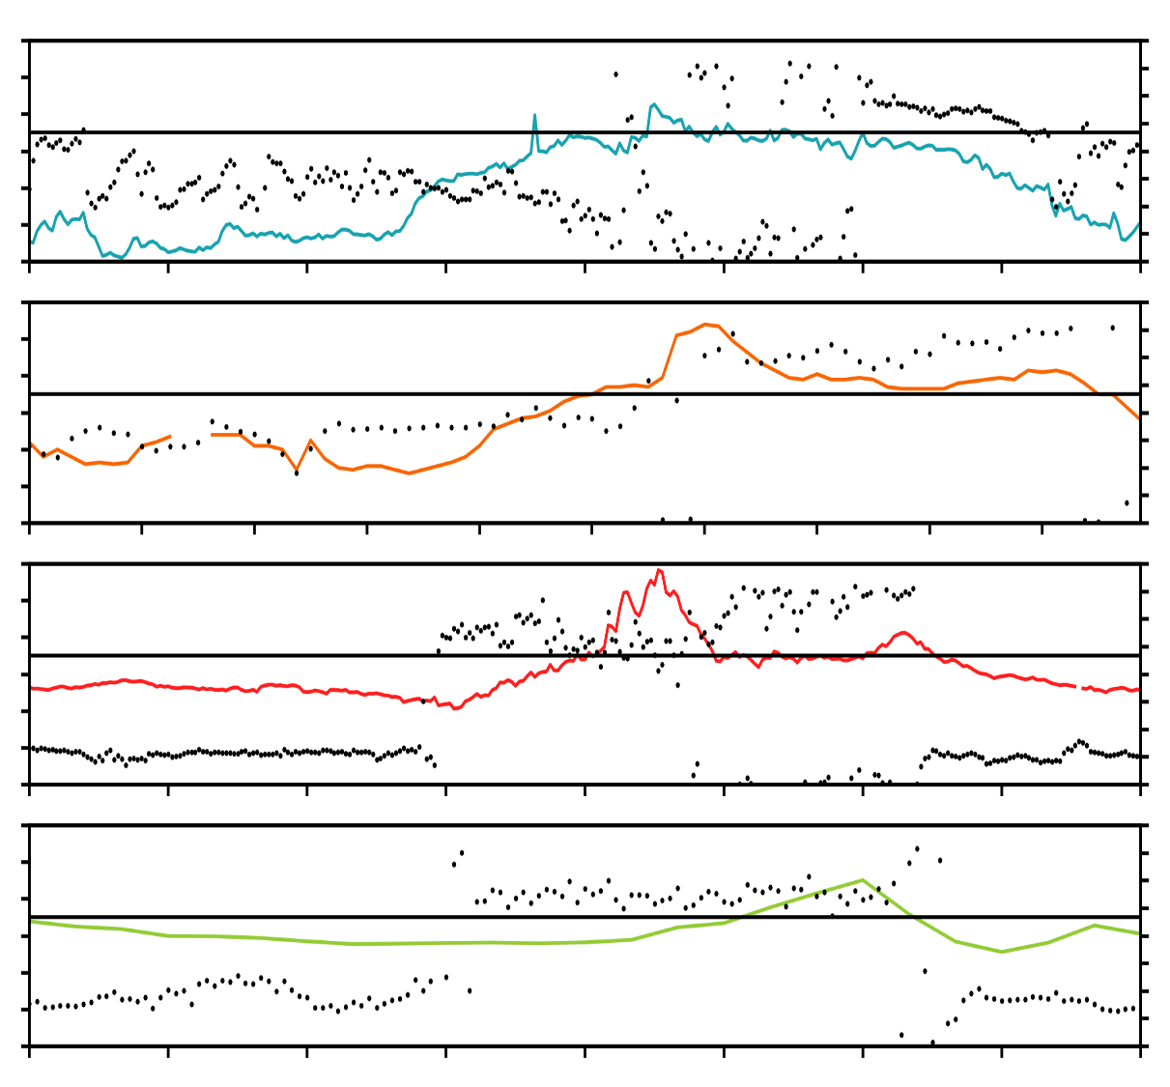

03

00

20

40

60

80

100

120

N

NW

W

SW

S

SE

E

NE

N

06

09

12

15

18

21

23

Ozone Concentration [ppb]

Wind Direction

Time [hr]

27 June Ozone Concentration and Wind Direction

Figure 3.6 Cross-section of ozone concentrations and wind directions on June 27. a) Neil Armstrong Academy (NAA) ozone concentration and wind direction. b) Hawthorne (QHW) ozone concentration and wind direction. c) Mountain Meteorology (MTMET) ozone concentration and wind direction. d) Snowbird (S2OZN) ozone concentration and wind direction

3.4 Observations for Station Category Classification

Categories of rural, lake, urban, and high elevation stations for individual treatment within the UU2DVAR analysis were made in Table 3.1 based off of the classifications in Table 2.2. These classifications are important for station treatment in the UU2DVAR ozone concentration analysis as each category of stations is handled differently within the analysis. However, these classifications are also noteworthy as they can give us insight as to where the highest ozone concentrations typically occur around the Great Salt Lake. Throughout 16-30 June, each station that exceeded the current NAAQS ozone standard of 70 ppb for an 8-hr average concentration was classified into the rural, urban, lake, or high elevation category. Table 3.2 shows how many of these stations in each category that exceeded 70 ppb on each day during our time period of interest.

Lake and urban categories had the most stations, resulting in being the categories with the most exceedances of the current standard. The lake category had 7 stations while the urban category had 12 stations. Out of these two categories, all lake stations reported 36 instances of an exceedence of 70 ppb while all urban stations reported a staggering 76 occurrences in 14 days (Table 3.3). Figure 3.7.a and 3.7.b show the 8-hr average ozone concentrations for each lake and urban station of the 14 days. Out of any category on any day, June 29 had all lake stations reporting 70ppb and above for the location’s 8-hr average ozone concentration. Throughout the last 14 days of June, Lake (urban) stations averaged 2.57 (5.14) stations exceeding the NAAQS standard for 8-hr average ozone concentration.

The rural category accounts for a small amount of stations, but are also vital in understanding how ozone is distributed in the vertical profile as well as investigating the role biogenics could be playing in rural areas. High-elevation locations reported a total of 15 instances of stations reporting 70 ppb or greater. Rural stations only had 8 observed 8-hr ozone concentrations exceeding 70 ppb or greater. Figure 3.7.c and 3.7.d show the 8-hr average ozone concentrations for each high-elevation and rural station of the 14 days.

The results of the classification of stations based on location near and around the Great Salt Lake show where the highest 8-hr average ozone concentrations tend to be within the area. Although the lake category only has 7 stations, at least 2.57 stations exceeded the NAAQS standard every day for two weeks. This robust average could be indicative of the reservoir of ozone over the Great Salt Lake that sloshes back and forth into the valley in the afternoon, recirculating ozone and precursors from urban areas back over the lake.

Rural stations, as well as urban stations, only had two days that had zero stations reaching over 70ppb. The case for the urban stations is likely that although NOx titration does lower ozone concentrations, emissions of precursors during the day with sufficient insolation will create ozone in photochemical reactions at a rate that is faster than the NOx can titrate. Rural stations may not receive enough ozone precursors from urban areas to maintain high ozone concentrations.

However, the high-elevation rural sites like Farnsworth Peak (FWP) and Snowbird (S2OZN) may have several factors playing into the frequently high ozone concentrations. First, there is long-range transport of aerosols and precursors from upstream sources, such as California and Asia to consider. Downwind transportation of these aerosols can come from upstream urban areas, but can also come from wildfires in the Western United States and Canada. The ozone precursors at high elevations are exposed to strong UV rays, which increases the ozone concentration. Ozone at higher elevations are also less likely to be titrated by NOx. Secondly, these high-elevation rural sites have ozone concentrations that are largely affected by upslope and downslope winds that occur every day. The diurnal fluctuation of ozone concentration at high-elevation sites is not as large as the diurnal fluctuations that occur at the surface in urban areas. This is due to the slope flows that result in an air mass exchange from the surface to higher elevations due to differential heating. The air mass from the surface is saturated with ozone and ozone precursors, consequently resulting in higher nighttime ozone concentrations as a function of wind direction (Figure 3.3). The slope flows in the ozone-wind roses at FWP and S2OZN confirm that high concentrations of ozone are advected to higher elevations at night via slope and other thermal flows. Due to the relatively small diurnal change in ozone concentrations, as well as not being typically affected by urban emissions during peak insolation hours, the utilization of these stations for the background ozone concentration in the analysis is justified.

Rural stations had the fewest stations reading over 70 ppb at an average of 1.57 reports per day. The rural stations (QHV, QED) high ozone concentrations appear to be strongly affected by valley and slope flows, which can be seen in Figure 3.3. At QHV, this could be a result of the exchange of air mass that occurs in the morning, when the ozone and precursor saturated air mass returns to the surface. The QED station in Tooele is influenced by valley and lake-breeze flows and appear to play a larger role in high ozone concentrations. Up valley flows are likely advecting ozone and precursors to this location from suburban areas. The reason that rural stations didn’t report as high of ozone concentrations could be simply due to their relatively remote locations, thus a lack of available ozone precursors from urban areas are available to generate high ozone. Another explanation could be that biogenics and other vegetation play a role in lowering ozone, however, biogenics is out of the scope of our study.

experiencing onshore flow from the lake. The high ozone concentration over the lake from earlier hours is now being pushed into the Salt Lake Valley and other surrounding urban areas. Not only is the airmass from over the polluted with ozone, but it is also saturated with ozone precursors from urban areas that are transported by wind in the nightly hours. These precursors photochemically reacted with the strong insolation provided that day (Figure 3.2). Though the sun rises earlier than ozone peaks, it takes time for the rate of ozone creation to begin to rise, especially over the urban areas.

Titration by NOx must also be considered in the averages as two major urban corridors (Interstate-15 and Interstate-80) line the valley and along the Wasatch Front and Great Salt Lake. Urban emissions can contain other aerosols that can eliminate ozone, thus driving lower ozone concentrations in the valley, which can be seen in panel 3.3.c when commuters begin their day. The lag in ozone concentration build up in the urban areas is exhibited in panel 3.3.d. The average concentrations in urban areas between 06-08 MDT and 09-11 MDT jumped up to nearly 40ppb. Lake and rural areas also saw a substantial jump of about 30ppb.

After peak hours most urban areas show roughly 70ppb 3-hr ozone concentrations, with a peak of 80ppb at O3S02 station. Many rural and lake stations, however, have ozone concentrations that remain steady between 60 and 70ppb. Panel i. in Figure 3.3. shows that the 3-hr averages from 21-23 MDT begin to fall in urban areas. This decrease in ozone is a result of titration from commuters returning home from work, as well as an increase in solar radiation for photochemical production. Winds also return to offshore, allowing the Great Salt Lake to recieve any ozone left from urban areas through flows.

3.5 Results of the UU2DVAR Sensitivity Test

In order to assess the skillfulness of the mobile data that was collected via truck, TRAX train, and helicopter, a comparison of ozone analyses with mobile observations and without mobile observations was conducted. Two analyses, one with mobile observations and one without, were run with the UU2DVAR to see the difference between analyses ozone averages.

In Figure 3.8 the differences in the ozone average analyzed with the mobile data and without the mobile data from June 18, 1400 MDT are exhibited. With mobile observations abundant in the Salt Lake Valley at this time Figure # shows that the UU2DVAR analysis underestimates ozone concentrations without mobile observations. Also at this time, mobile observations were collected via truck along a causeway in the middle of the Great Salt Lake. In this area, underestimation by the non-mobile ozone analysis is apparent as well. This hour was chosen specifically to seek out the skillfulness of the KSL5 helicopter data on UU2DVAR ozone analyses at higher altitude locations.

Along the Wasatch Front in the Salt Lake Valley, areas of higher elevation are in slightly more agreement than within the valley. During this hour, the helicopter pilot flew a North-South route along the I-15 corridor mostly in the Salt Lake Valley and also flew west towards Farnsworth Peak. This allowed the high elevation stations (Farnsworth Peak (FWP) and Snowbird (S2OZN)) to have more data points between the surface and their high elevation stations to interpolate a better analysis. The ozone concentration analysis with mobile observations and the analysis without mobile observations became more in agreement on the prediction of ozone concentration at higher elevations, with small differences between the two analyses.

This difference map between the two UU2DVAR analyses shows the usefulness of the mobile data. There is a difference in how the ozone concentration distribution is affected by the mobile observations, especially along the Wasatch Mountains and across the middle of the lake. We can see where the analyses come into closer agreement where the KSL5 helicopter flew (mostly in the Salt Lake Valley) in the middle of the lake. The higher elevation stations up north did not fair as well, as there were still large differences between the two analyses. The analysis with mobile operations may present an overestimation bias, especially within the valley and lake where mobile observations are available.

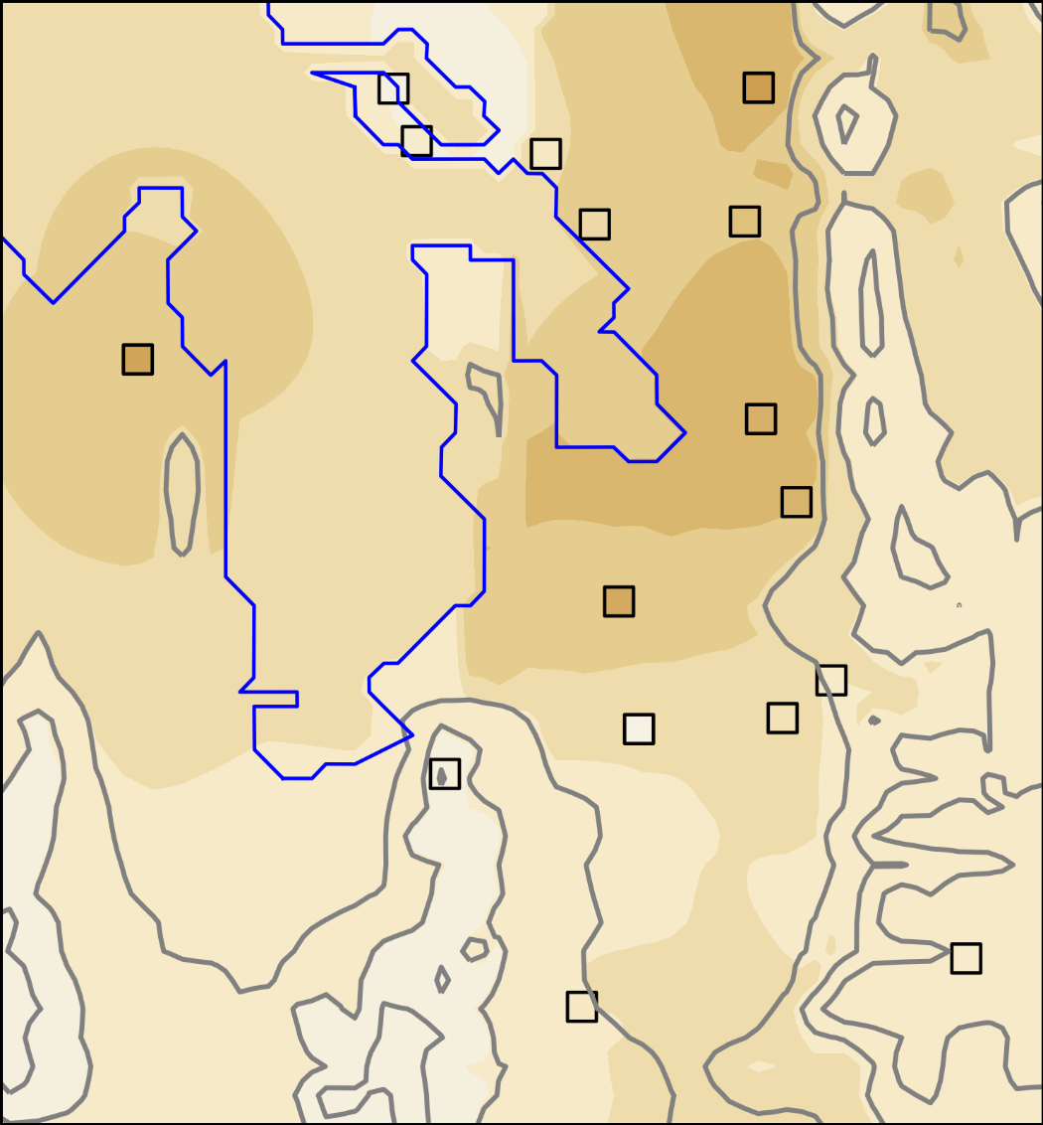

Figure 3.8.a. UU2DVAR analysis without mobile operations. Stations are denoted by squares.

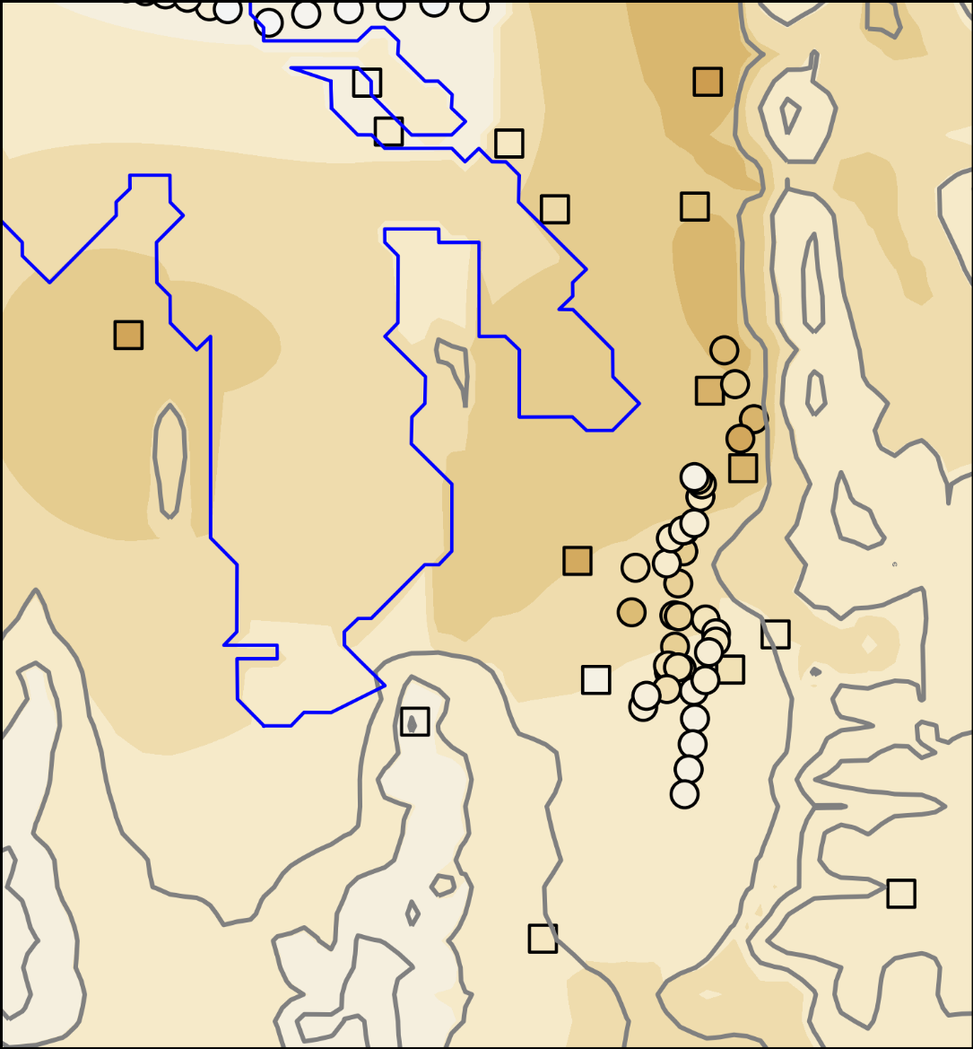

Figure 3.8.b. UU2DVAR analysis mobile operations. Stations are denoted by squares.

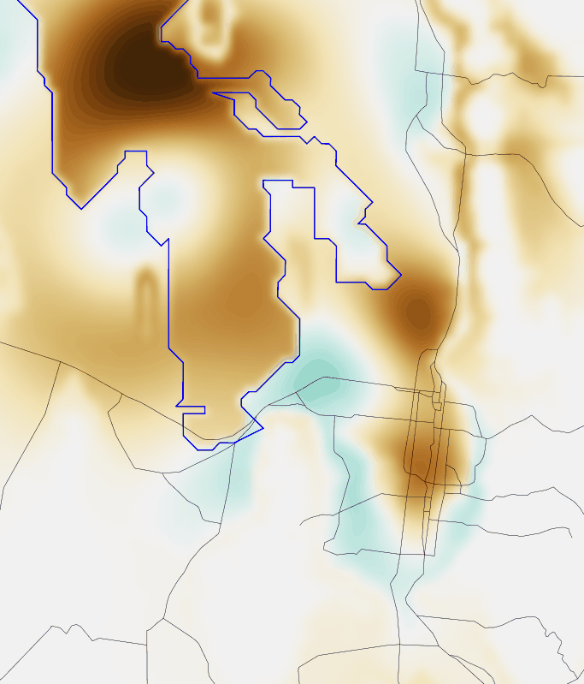

Figure 3.8.c. Difference between UU2DVAR ozone concentration analysis with mobile operations and without mobile operations.

|  |  |  |
| --- | --- | --- |
|  |  |  |
|  |  |  |
|  |  |  |

Figure 3.9. UU2DVAR sensitivity tests adjusting horizontal and vertical decorrelation length scale