Air QUAlity Research In the western United States (AQUARIUS)
Content Draft for White Paper

Section 1. Overview of the impact of meteorological “cold-air pool” conditions on wintertime air quality in the Western US

A persistent cold-air pool (PCAP) is a stably-stratiﬁed boundary-layer airmass sheltered from lateral and vertical mixing by the surrounding topography that lasts from days to weeks (Lareau et al. 2013). PCAPs form most frequently during winter when a combination of warming aloft and cooling near the surface lead to stable stratification and air mass stagnation in mountain basins and valleys (Dorninger et al. 2011, Reeves et al., 2011, Lareau et al., 2013, Sheridan et al. 2014, Holmes et al. 2015, McCaffrey et al. 2019, Sun and Holmes, 2019, Ivy et al., 2019). PCAPs occurring in urban or heavily agriculture basins often lead to elevated levels of particulate air pollution, low clouds, and fog, which is hazardous for ground and air travel (Whiteman et al., 2001, Whiteman et al. 2014, Vanreken et al., 2017, Franchin et al. 2018). The large-scale synoptic metoerology can be simulated using numerical weather preidciton models driven by reanlaysis data sets like NAM (Wei et al. 2013 & Lu and Zhong 2014), However, the forecasting and numerical modeling of PCAPS are difficult due complex and coupled land and atmosphere processes, such as the interactions amongst the surface state (e.g., snow cover), surface fluxes of heat and moisture, boundary layer budgets (e.g., turbulence, temperature, moisture, etc), cloud formation, thermally driven terrain flows, and synoptic-scale processes (e.g., advection, large scale pressure gradient force) (Holtslag,et al. 2011, Lareau et al. 2013, Smith, 2019, Sun et al. 2020).
Generally fair weather arising from high pressure and regional-scale warm air advection and subsidence above the mountain ranges of the Western US are a key factor to the formation of the stable stratification that traps cold air in basins and valleys. The depth, intensity, and duration of PCAPs depend on the characteristics of the underlying surfaces within the basins (e.g., dry or wet soils or the presence of snow cover), the surface energy and radiation budget, and complex interactions between regional- and local-scale flows with the surrounding terrain (Neeman et al. 2015, Lareau and Horel, 2015a, Foster et al. 2017). Long-duration PCAPs are most common in deep, enclosed basins that tend to be sheltered from passing weather disturbances more than shallow or partially enclosed ones (Clements et al. 2003, Vosper et al. 2008, Hoch et al., 2010, Sheridan 2019). Once PCAPs are established, many other factors that affect radiative, sensible, and latent heat fluxes at the surface and within the entire depth of the PCAPs become important, e.g., time of year, presence of low clouds within PCAPs and mid- and high-level clouds above them. Figure 1 illustrates many of these meteorological processes. PCAPs are weakened or destroyed by weather systems accompanied by strong winds, cold air advection, or precipitation (Lareau et al. 2013).
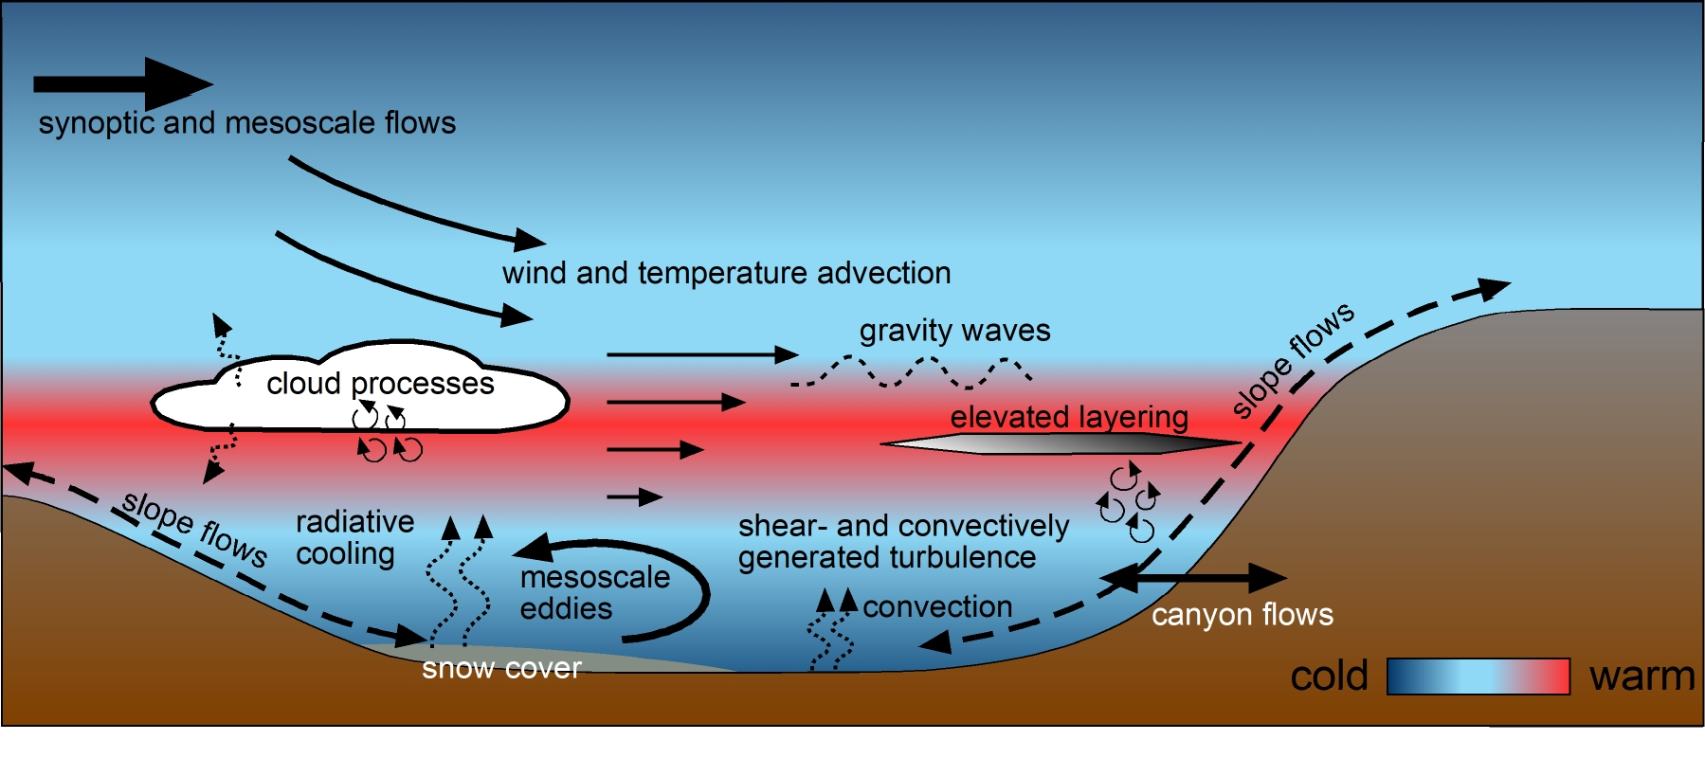
Figure 1. Placeholder Figure from DeWekker et al. 2018 for PCAP physical processes. Do we have a volunteer willing to make a summary schematic of the physical processes impacting PCAPs?

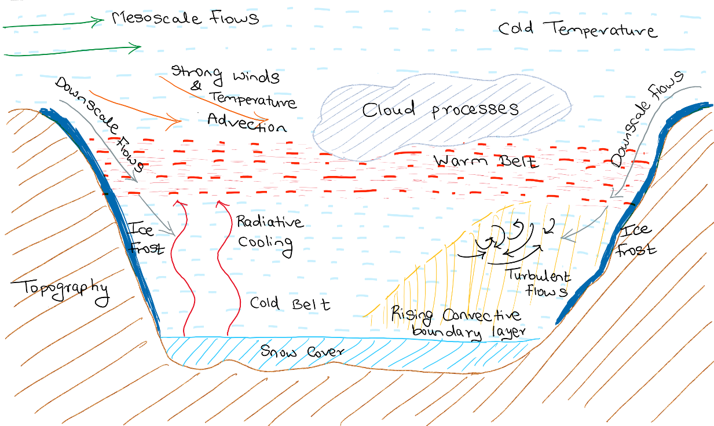

Schematic of the physical processes impacting the PCAPS

While the meteorological factors that dominate the setup, maintenance, and demise of PCAPs in the western US are broadly known, the complex thermodynamic, radiative, and dynamical processes evolving within a PCAP in specific basins and valleys are not well documented, understood, analyzed, or forecasted during PCAP episodes. As illustrated in Fig. 2, the local environment, meteorological boundary-layer processes, and chemical processes are highly intertwined and need to be studied as a coupled system (Baasandorj et al. 2017, Womack et al. 2019; Faloona et al. 2020). The lifecycles of the meteorological and chemical characteristics and processes have been shown to vary considerably during PCAPs. Table 1 illustrates some of the key coupled meteorological and chemical processes that vary during the PCAP lifecycle. Volunteer – please work on fleshing out Table 1 and adding references. The AQUARIUS workshop identified several key focus areas where targeted meteorological-chemical coupling observations should be conducted: Large-scale forcing, terrain-forced and thermally-driven flows, radiative processes and feedback (clouds, albedo, solar angle), vertical and horizontal transport and mixing processes, boundary-layer structure and layering, and clouds (wet vs dry PCAPsPCAPs) (Table 1 and Figure 2).

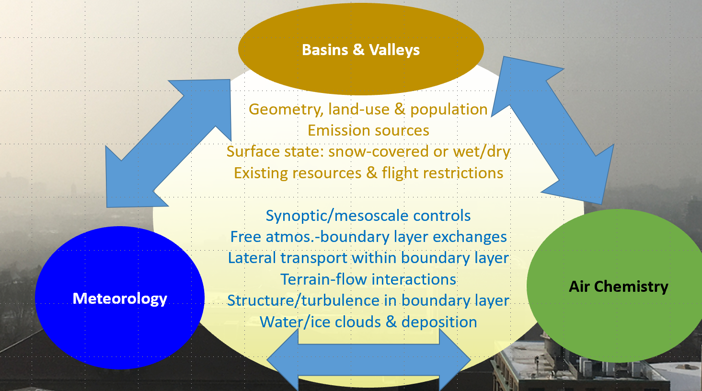
Figure 2. Schematic of the various coupled meteorological, chemical, and topographical processes that occur in wintertime PCAPs. Please help by coming up with something better!!

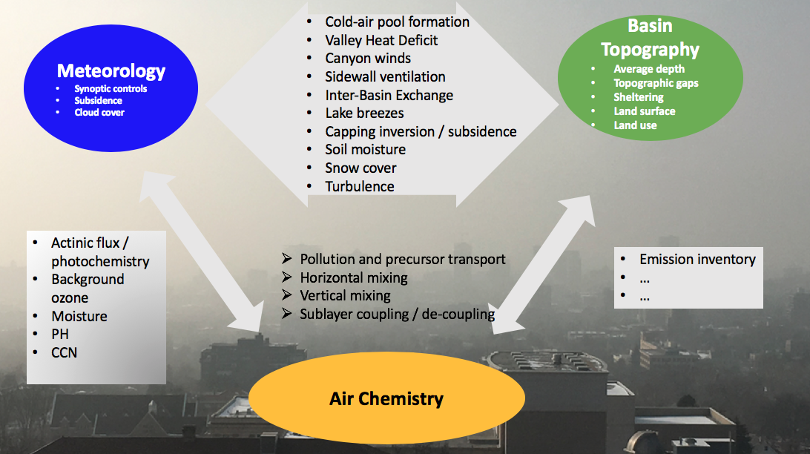

Coupled PCAPS Meteorological Characteristic | Coupled PCAPS Chemical Characteristic | Changes noted during the lifecycle of the PCAP
Moisture and low clouds/fog | - Cloud/fog chemistry versus particle- and gas-phase chemistry  - Photolysis  - Gas-particle partitioning | Water vapor and clouds increase through anthropogenic and natural processes during a PCAP lifecycle, forming fog and potential wet chemistry processes that are not well-studied. (Chachere and Pu 2016)Water vapor and clouds increase through anthropogenic and natural processes during a PCAP lifecycle. Cloud and fog formation likely enhances the importance of aqueous and heterogenous chemical pathways that are not well-studied. during winter PM episodes. Humidity generally promotes uptake of semi-volatile gases by particles, and cloud/fog cover reduces actinic flux and photolysis reactions.
Vertical temperature structure and layering of moisture | Vertical layering of pollutants | PCAP vertical structures are highly complex and variable throughout the lifecycle. How chemical aging and particle growth processes couple to vertical meteorological processes is unknown. (Lareau et al. 2013)PCAP vertical structures are complex and variable, and strongly impact internal mixing processes. Vertical layering of air masses leads to distinct pollutant layers that may be coupled or decoupled from surface emissions and other pollutant layers at different times. The overall effect of vertical meteorological layering on this complexity impacts chemical aging, particle growth, and vertical pollutant distribution and the response of pollution to emission controls is poorly understood.
Exchange and transport processes | Oxidant, pollutant, and precursor transport and concentration | Boundary-layer mixing and terrain-driven flows transport pollutants, precursors, and oxidants resulting in vertical, spatial and . Outflowstemporal variations in PCAP chemical compositiontemporally. Secondary pollutant formation has been found to be sensitive to oxidant abundance during winter PM episodes. Oxidants may be depleted in isolated atmospheric layers, but entrainment of oxidants from canyons – relatively clean airaloft (e.g., the regional background) or recirculated polluted/aged air?from sidewall flows could sustain chemistry that would otherwise be limited by lack of oxidants.
Diurnal meteorological forcing | Photochemistry | Complex feedbacks between vertical layers, mixing of precursors, and actinic flux. Secondary pollutant formation cycles follow different formation pathways during nighttime and daytime conditions. Vertical mixing may be relatively homogeneous in certain basins during daytime, but the surface layer may be decoupled from residual layer(s) at night.
PCAPS depthFog and/or aerosol loading decreasing surface net radiation (increasing heat defecit) | Concentration changesIncreased photochemical gradients | Spatial and temporal variability of air volumeA potential positive feedback between PCAP lifetime, PM buildup, and increased PCAP stratification.
Vertical/horizontal layering of turbulenceDay-to-day meteorological changesSynoptic ridging leading to weak winds and strong subsidence | Damköhler numbers, chemical vs. transport/mixing time scalesPrecursor emissionsClear skies and greater actinic fluxes, as well as greater overnight radiative cooling | Diurnal variations as well as variations related to gravity waves at multiple time scalesPrecursors emissions could have a day-to-daySynoptic variability depending on weathermay involve different transport regimes that affect the background photochemical conditions, for instance, emissions associated with heating.
Land-atmosphere interaction Radiation/energy balance | Photochemical chemistry | Snow melting, dry deposition on snow -> surface albedo changes

Table 1. Examples of coupled meteorological and chemical processes and noted variations in characteristics over PCAP lifecycle. Volunteers – please add to the table.

Add some relevant/related results from PCAPS studies elsewhere in the world, e.g. in UK (COLPEX, Price et al., 2011) and France (Passy-2015 field campaign (Paci et al., 2015, Staquet et al., 2015; Largeron and Staquet 2016) in the Chamonix-Mont-Blanc Valley in France) ?

A key goal of AQUARIUS is to improve our understanding of the production, transformation, cycling, and destruction of chemical species during the life cycle of PCAPs. Establishing an experimental design to provide the meteorological and air chemistry observations to meet this goal is essential. No previous field campaign has provided the breadth and depth of contemporaneous observations at the surface and aloft that could address For example, while the PCAPS project established many of the meteorological controls on PCAPS intensity and duration, it lacked the detailed chemical the complex coupled meteorological and turbulence observations to resolve the chemistry processes impacting PCAP air quality and internal variability, which strongly affects the societal impact of a given cold-air pool.of importance. As we will elaborate in future sections, observing the complexity of coupled chemistry and meteorological processes in mountain basins requires nimble multi-. The willsensor networks and innovative deployment strategies (e.g., plane, in situ and surface-based remote, mobile, drones, IOTs) to link the chemistry and meteorology. Specifically, the science plan factors in the strength and weaknesses of diverse sensor types for the complex and evolving boundary layer and air quality conditions observed during PCAPs. One goal of the AQUARIUS field campaign is the collection of the highly complex dataset that is required to evaluate – and identify the key weaknesses of – current forecast model capabilities during the study, to develop and test new parameterizations of key processes, and to ulimately improve research and operational simulations of PCAPs from both the meteorological and air quality point of views. Considerable work is underway or has been conducted in recent years improving model simulations of PCAPs (e.g., Lareau and Horel 2015b, Ahmadov et al. 2015, Foster et al. 2017, Tran et al. 2018, Sun and Holmes 2019; Kelly et al. ; Sun et al. 20202018).

The coupling between meteorology and chemistry is highly complex. All of the meteorological forcing variables shown in Figure 1 interact with a wide range of chemical processes. PCAPsPCAPs can be long-lived, lasting one to two weeks, during which a complex and varied array of coupled meteorological and chemical processes occur. The evolution of PCAPsPCAPs can be characterized by an onset or development phase, mature or steady state phase, and a breakup or decay phase. The meteorological and chemical characteristics of each of these phases vary, thus it is expected that meteorological and chemical process coupling varies similarly through the lifecycle of PCAPsPCAPs. AQUARIUS observational design will target the entire evolution of PCAPs so that the importance of various processes throughout the lifecycle of PCAPsPCAPs can be quantified. The development/onset phase of PCAPsPCAPs is often characterized in colder regions by fresh a snow cover and a resulting high surface albedo, cold temperatures, clear skies, and ample but low-angle solar radiation. As PCAPsPCAPs mature, frequently a transition from a clear or dry PCAP to a fog-filled, moist, or stratus-capped PCAP is observed. The initial clear phase sees the accumulation or ramp-up of the concentrations of NOx, particulate pollution, and pollution precursors. Observations from the Salt Lake Basin in Utah show that phase is often accompanied by the lowering of a strong subsidence capping inversion and strong near-surface diurnal temperature variations, adding a nocturnal near-surface inversion and daytime convective surface layer to the complex thermal structure of the PCAP. During this phase, photochemical processes are favored (???), thermally-driven exchange processes at the edges of the PCAP play an important role in coupling and mixing processes, and nocturnal de-coupling and daytime re-coupling of the near-surface with the rest of the PCAP influence chemical processes (N2O5 chemistry ???). Further, moisture is typically accumulating in the basin, ultimately leading to saturation, fog development, and a stratus deck below the capping inversion. This transition fundamentally changes the thermal structure of the PCAP. Top-down convection throughout the entire diurnal cycle, reduced solar and higher thermal downward fluxes dramatically reduce the near-surface diurnal temperature variation and eliminates diurnal de- and re-coupling of the surface layer where the majority of emissions occur, potentially changing the chemical processes by keeping the entire PCAP coupled and mixed. This transition leads to a reduction or shut-off of deeply-penetrating thermally-driven sidewall and canyon flows, reducing background ozone injections, and reduction in UV radiation for photochemical processes, and thus to fundamental changes in the chemical processes.
PCAPsPCAPs
During the breakup or decay phase, the depth of the PCAP typically continues to decrease while concentrations of criteria pollutants may increase.

Additional discussion of the state-of-scientific understanding related to key meteorological-chemical coupling during PCAPs and potential new scientific understanding that would result from coupled meteorological and chemical measurements during the AQUARIUS field campaign for four major topic areas are described below:

Topic area #1: Solar-radiation-atmospheric boundary-layer-chemistry coupling (Volunteers please contribute; Hoch, Kelly, Oldroyd, Holmes?)

Formation of secondary pollutants requires that precursor emissions are oxidized to their secondary products. Under wintertime conditions, daylight hours are limited, temperatures are cold, and, as a result, daytime photochemistry that produces secondary pollutants may be limited. Since many important reactions that drive secondary pollutant formation are photolytic, characterizing the distribution of actinic flux is important to understand the influence of photochemical processes during PCAPs episodes. This can be challenging in wintertime due to the influence of snow cover on albedo as well as the presence of fog and cloud during parts of the episode. Variations in actinic flux in the boundary-layer during the winter season are modulated by solar zenith angle, length of daylight, cloud cover, snow cover, and other surface properties. These variations subsequently impact boundary-layer temperature structure, vertical and horizontal transport and cycling of pollutants, temperature-dependent chemical processes, and photochemical reaction rates. Two prior studies (Pal & Haeffelin, 2015; Trousdell et al., 2019) have shown a strong dependence between surface downwelling shortwave radiation and midday boundary layer depth during all seasons including winter. While traditional boundary layer theory assumes a primary dependence most directly on sensible heat flux, both of these studies found a much better correlation with downwelling shortwave. This suggests a possible coupling between cloud and/or aerosol shading and convective mixing that we would be able to test in the AQUARIUS field campaigns. Greater understanding of radiative feedback processes with respect to coupled meteorology and chemistry is needed during PCAPs. Feedbacks between surface state (e.g., snow cover vs. no snow cover) albedo and photochemical rates have been shown to be important, but more comprehensive evaluation of the coupling between surface shortwave, sensible/latent heat and turbulence fluxes and surface state, and their subsequent impacts on the production and destruction of pollutants, is needed. Detailed observations of photolysis rates and actinic fluxes are important to be able to quantify photochemical-meteorological coupling.

Topic area #2: Dry-and moist chemistry-atmospheric coupling. (Volunteers please contribute; Lareau, Kelly, Karle?)

Atmospheric moisture has an important influence on the formation of secondary particulate matter. Under cool, humid conditions, condensation of semi-volatile species onto particles is favorable, whereas such formation is relatively unfavorable under warm, dry conditions. Moreover, the formation of cloud and fog dramatically alters the formation pathways of secondary PM. Aqueous chemistry follows very different pathways in cloud and fog than in aerosol particles, because cloud and fog droplets are highly dilute, whereas particles have high ionic strengths that lead to highly nonideal chemistry (Pye et al., 2019). Urban areas are known to enhance boundary-layer water vapor during wintertime through anthropogenic emissions (Salmon et al. 2017). Complex feedbacks exist between natural and anthropogenic water vapor and particulate aerosol emissions within a PCAP, and the subsequent development of aqueous particulate pollution, low clouds and fog. For example, fog in some Utah Valleys is associated with the cessation of PM_{2.5} growth. Why? Is this The onset of low clouds, for example, changes the mixing structure within PCAPS from bottom-up to top-down turbulence, but with unknown impacts on the chemistry. related to a change in chemistry, cloud scavenging, or meteorology? Although some work on chemical processes in fogs has been conducted in the past (Collett et al., 1999; Ge et al., 2012; Herckes et al., 2015), a comprehensive understanding of the role of cloud and fog in wintertime PM episodes in western remains elusive and requires an integrated measurement campaign to address. Greater understanding of these feedbacks between aerosols, water vapor, clouds and fog, and atmospheric boundary-layer structure and evolution is needed. How does the chemistry vary between wet (cloudy) and dry (non-cloudy) PCAPs? Does fog impact sulfur or organic oxidation? Does aerosol chemistry differ during high and low humidity conditions? Does different chemistry occur during shallow near-surface fog versus an elevated stratus layer? Chemistry in liquid phase surrounding the aerosol particle?

The relationship between the fog and aerosols, especially the particulate matter (PM), is complex in nature. Intense fog not only reduces aerosol loading through wet removal but can also provide a medium for aqueous-phase chemical reactions by altering particle size distribution by selectively removing water-soluble species. As a result, there will be a transformation of the primary aerosols into secondary aerosols as observed by (Dall’osto et al. 2009) in their study. In a comprehensive study conducted by (JACOB et al. 1984) in the San Joaquin Valley, California, authors observed that the valley fog appeared to limit the accumulation of the PM concentration in the stagnant stratifies air mass. The fact that PCAP is also a stagnant air mass with limited mixing both vertically and horizontally can help us correlate and understand the interaction of the fog and PM.

Extensive foggy conditions imply a significant reduction in pollutant’s concentration on a regional scale, especially in highly polluted areas characterized by cold winter and stagnant atmospheric conditions. In some cases, light foggy conditions were also associated with an increase in PM_{2.5} concentrations as compared to standard winter days. This increase in PM_{2.5} concentrations indicated significance of wet removal in the light fog process (Bisht et al. 2016). During the daytime marked with strong convective layer growth, the fog dissipates as the fog droplets evaporate. This evaporation of the moisture then gives rise to a new set of aerosol particles, which are hygroscopic and with higher concentrations can convert into the haze as described in detail by (Pandis, Seinfeld, and Pilinis 1990). The relative humidity (RH) in the surrounding environment and the hygroscopicity of the aerosol chemical constituents determine the water content of the aerosols found in the region.

Dense fog does play an important role in scavenging and removing aerosol particles in the air. This scavenging process can be through both nucleation and impaction. However, in general nucleation scavenging dominates in cloud and in fog scavenging (Seinfeld and Pandis 1998). The cessation of the PM_{2.5} growth in some Utah valleys due to dense foggy conditions, to a certain extent, can be associated with the surface and condensed phase chemistry. In terms of meteorology, we know that turbulent mixing of air plays an important role in determining the development of the PCAPs. It can also enhance the efficiency of fog droplets collecting fine particles by the collision-coalescence process. The development of turbulence in the fog can also be associated with a decrease in PM_{2.5} concentrations (Zhu et al. 2019).

Organic aerosols account for highest percentage of PM_{2.5} followed by ammonium sulfate, ammonium nitrate, black and brown carbon. (Baasandorj et al. 2017) observed ammonium nitrate is the principal component of PM_{2.5} in the Utah Valleys during the high pollution days and ammonium sulphate is a minor contributor. Organic and inorganic PM precursors via combined atmospheric photochemical and aqueous processes can result in secondary pollutants such as sulfate. It is a well-established fact that sulfate (SO₄⁻²) is omnipresent in the atmosphere and is one key component of the fine PM family. Atmospheric sulfur chemistry is still a unsolved problem. Sulfate levels are frequently underpredicted by the atmospheric chemistry models (Wang et al. 2016).

It is expected that aerosol properties will show sensitivity towards the RH. Depending on its composition, aerosol particle interacts with water and can change its size and chemical composition depending on the ambient RH. Lab studies by (Winkler 1988) observed that high humidity conditions play an essential role in many physical, optical, physicochemical, and chemical interactions of aerosol particles with surrounding environment. However, there exists uncertainties between the field observations during the campaigns and the lab measurements.
It seems to be that dry/wet deposition needs to be discussed here. I am not an expert though…
Maybe: The transition from cloud free / clear to cloudy / foggy PCAP as described above often coincides with a plateauing of PM2/5 concentrations. It is unclear what the leading causes are for this, but different hypothesis should be tested. These may include different chemical pathways (reactions in water phase on the surface aerosols), reduction in photochemical processes, changes in deposition, changes in cold pool mixing due to changes in temperature stratification (see above), reduction in sidewall ventilation, reduction of ozone injections through tributaries, …

Topic area #3: Boundary-layer-transport processes-chemistry coupling. (Volunteers please contribute; Hoch, Kelly, DeWekker, Karle, Faloona, Holmes, Oldroyd?)

The chemical processes that lead to secondary pollutant formation are sensitive to the mixing of diverse air masses that may have undergone varing degrees of local chemical aging or are primarily composed of fresh emissions or regional background air. Pollutant formation chemistry may be favorable only in certain parts of the vertical column due to titration effects of NOx emissions in the shallow surface layer or the limited oxidant abundance in certain vertical layers. Since poor air quality at the surface often involves mixing of pollutants formed aloft to the ground, the effects of intermittent vertical stratification on chemistry must be thoroughly characterized to improve the models used in air quality management and health assessments. The coupling between vertical meteorological properties within PCAPs and vertical profiles of chemical precursors and particulate pollution are a key research area for AQUARIUS. Quantifying vertical and horizontal airmass trajectories and their coupling with chemical processes is critically needed. For example, what is the relative importance of sidewall ventilation, daytime PBL growth (including, entrainment fluxes),, subsidence, and horizontal advection processes for transporting chemical reactants and products, as well as thermodynamic variables, within multi-layered PCAPs and between basins?? What are the dry deposition rates for critical compounds such as O₃, NO_{x}, NO_{y}, and PM? How many distinct chemical-meteorological layers exist and what are the time scales at play for transport processes within these layers? How much do these processes vary between basins, over time, with height and depth of PCAP, .?.?and how are the affected by transitions between clear and cloudy PCAPs, etc? Turbulence, near the surface and aloft, is a key meteorological phenomenon that is intrinsically linked to vertical mixing processes within PCAPs. Characterization of spatial and temporal variations in turbulence within PCAPs is a difficult but critical task for understanding vertical transport processes and meteorological coupling. Characterizing the sources of For example, while previous campaigns have provided limited characterized surface turbulence is equally important to this understanding. Potential sources(e.g., surface flux data during PCAPS), no observation of the vertical structure of turbulence include wind shear at the surface and across multiple layers within the PCAP as well as have been obtained, including the critical entrainment flux at the interface between the PCAP and the free atmosphere aloft. In addition, the presence of gravity waves between the layers and their occasional breaking are the source of intermittent turbulence. Other sources of turbulence include daytime heating of valley floor and sidewallsupper edge of the PCAP, which impacts scalar concentrations of heat, water vapor, and pollution.This can be accomplished by profiling with potential presence of coherent turbulence structures. The presence of clouds can further complicate turbulence sources and sinks and the resulting turbulence structure.tethered balloons or small aircraft.

The formation and the lifespan of the PCAPs depends on the wind speed above the basin especially the synoptic mesoscale flows that can erode the PCAP. Some of the studies have found out that when wind speeds above the valley exceeds a specific limit, the nocturnal inversion layer in the valley can be interrupted. This ultimately results in weakening of the inversion layer’s intensity. The intensity of the wind required to affect the inversion will differ depending on the regional topography such as the valley shape and depth. For example (Yasuda, Kondo, and Sato 1986) found out that with the downslope wind speed of 4 m/s at the ridge surrounding the valley, the cold air pool in a V-shaped basin collapsed quickly. In another study in Colorado (Orgill et al. 1992) concluded that the cold air pool erosion processes were activated when the wind speed above the valleys exceeded 5 m/s in western Colorado. It will be interesting to investigate that threshold windspeed aloft that leads to the erosion of the PCAP.

Atmospheric processes such as high pollution episodes and effective dispersion of the pollutants can be understood with the help of air mass trajectory analysis. A comprehensive experimental determination of the air trajectories is only possible during a complex and significant campaign such as PCAPS. To obtain flow patterns, models such as Air Resources Laboratory (ARL’s) Hybrid Single-Particle Lagrangian Integrated Trajectory (HYSPLIT) with atmospheric transport, dispersion and deposition simulations (Draxler et al. n.d.); the FLEXTRA model developed by the European Center for Medium-Range Weather Forecasts (ECMWF) which permits boundary layer trajectories and calculations with vertical wind component equal to zero (Stohl 1998); and Meteorological data Explorer (METEX) which is flexible in terms of accepting meteorological data in variety of formats (Zeng, Matsunaga, and Mukai 2010) can be used. It is significant to trace the transportation of the precursors and secondary pollutants formed as result of photochemistry. The air trajectory analysis from these models during the PCAPs can help in better understanding of the photochemistry involved. The back trajectories can provide useful information on the origin of the airmass and can be used to understand better the origins of PM_{2.5} concentrations in SLV. The cluster analysis can, nevertheless, provide a good indication of the geographic locations most strongly associated with elevated concentrations of PM_{2.5}. It will be interesting to study how injections of the precursors during the transport can change the air mass feature and its impact at the downslope sites where pollution episodes occur.

It is a well-known fact that aerosols do both absorption and scattering of the solar radiation reaching the ground and reduce its intensity. This reduces the sensible heat fluxes which contributes towards the diurnal evolution of PBL. Aerosols also contribute towards increasing atmospheric stability hence suppressing the dispersion of pollutants within PBL resulting in increase in their concentrations. Precise determination of the planetary boundary layer heights (PBLH) is crucial in understanding the interaction of the aerosols with meteorology. It can also help in improving the meteorological forecasts, pollutant dispersion, and air quality studies and enhance the accuracy of the numerical weather prediction models during PCAPs. There are several methods of the PBLH detection, but each of them performs well only for well-defined PBL structures and under specific meteorological conditions. A combination of several methods and instruments is necessary to evaluate the complete diurnal cycle of PBL (Collaud Coen et al. 2014).

An extensive inter-comparison between experimental PBLH using instruments (using the remote sensing instruments) and that obtained from various models such as WRF (using popular PBL schemes) and HYSPLIT (using meteorological data such as NAM 12 km). This will be a good opportunity to test the reliability of the computed model results with that obtained from the experiments. Along with the wind trajectories, HYSPLIT model also compute PBLH assuming that the depth of the PBLH is equal to the height at which the potential temperature changes by 2 K as compared to the ground level. The most common meteorological archive information used in the HYSPLIT model for calculating PBLH was EDAS (Eta Data Assimilation System) 40 km resolution. However, the EDAS dataset is no longer updated since January 2019. So, it will be interesting to use NAM 12km or HRR 3km dataset to calculate PBLH. The values can be verified with PBLH obtained from ceilometer and soundings. Intercomparing them will help us a great deal in understanding which amongst the current available datasets predicts the PBLH more precisely especially during the PCAPs. (Perrone and Romano 2018) established a relationship between the PBLH (using LIDARS and numerical prediction models) and particle scattering coefficient at the surface using nephelometers. It will be worth validating the claims made by the authors during the study of PCAPs.

Another topic of interest is the degree of nonstationarity of the PCAPS affected by the various processes mentioned above and it impact of chemical reactions. Lagrangian-based approaches to track the evolution of an airmass and its physical and chemical characteristics rather than Eularian ‘point’ measurements are needed to arrive at a better understanding of the impact of nonstationary boundary layers on the chemistry.

Topic area #4: Inter-basin, intra-basin, and sidewall/canyon exchange-chemical coupling. (Volunteers please contribute; Stutz, Simpson, Hoch, Kelly, Oldroyd, DeWekker, Faloona?)
Secondary pollutant formation depends on the availability of oxidants to drive atmospheric oxidation mechanisms. In isolated air masses, pollutant formation processes may terminate when the key oxidants become depleted. Replenishment of oxidants through entrainment from aloft or sidewall mixing can promote sustained production of secondary pollutants throughout a PCAPs episode. Episodes that terminate through oxidant depletion may respond favorably to VOC emission controls, whereas episodes that experience oxidant replenishment might be insensitive to VOC controls. Despite the importance of entrainment processes for air quality management during PCAPs, the extent of oxidant entrainment is not well quantified in Western basins. Previous studies have hypothesized the importance of horizontal transport processes on the chemical processes within PCAPs (e.g., Baasandorj et al. 2017). In Utah basins oxidant injection from tributary canyons, or agricultural ammonia from inter-basin transport have been two recent topics of interest. In the San Joaquin Valley the entrainment of nitrate PM produced overnight in the residual layer was found to be responsible for approximately 80% of the near surface levels in the morning hours (Prabhakar et al., 2017). The exact origins of the nocturnal air aloft can thus have a dramatic influence on the next day’s PM levels regionally, and observing the 3D flow patterns can be crucial. The scales of basins have a large impact on the relative importance of inter (between) and intra (within) basin exchange. transport processes. Workshop participants agreed that many previous field studies have not had the spatial data collected of both meteorological and chemical measurements to answer the above questions. Different regions within basins will have different emissions and chemistry, as well as variations in meteorology. Better understanding of spatial variations in thermodynamic/dynamic and chemical emissions and processes are all needed in order to tackle these important questions. Care as to how to sample the canyon and slope regions is needed in order to design experiments of exchange processes along the valley slopes (Oldroyd et al. 2016). Comparison of vertical profiles away from basin walls (e.g. from towers or via remote sensing) to pseudo profiles taken with sensors vertically deployed up a sidewall can probe the role of canyon wall exchange.

Role of sloped sidewall flows:
The degree to which side wall flows, return flows, secondary circulations, and entrainment by buoyantly-driven downslope (katabatic) flows impact mixing, ventilation or entrainment/injection of relatively cleaner air or oxidants into the CAP is largely unknown and require a multiscale observational approach. Stably-stratified, quiescent periods associated with CAP formation can also lead to buoyantly-driven downslope (katabatic) flows over valleys/basin side walls or down a sloped valley itself (Prandtl 1942; Defant 1949; Whiteman 2000; Serafin et al. 2018). Through cold air advection down the slopes, katabatic flows may enhance the development of CAPs, especially in the early formation stages (Gryning et al. 1985; De Wekker and Whiteman 2006; Mahrt et al. 2010; Choukulkar et al. 2012; Burns and Chemel 2014b; Arduini et al. 2016); however, the growth of the CAP can overtake the slope-layer inversion and cause the katabatic winds to weaken, cease, or ‘peel off’ the sidewall (intrude) and flow horizontally toward the basin center for elevations within the CAP (Clements et al. 2003; Mahrt et al. 2010; Whiteman et al. 2010; Haiden et al. 2010; Soler et al. 2014). These CAP and katabatic flow interactions can generate waves (Burns and Chemel 2014a, 2015), or perturbations that lead to CAP ‘sloshing’ and enhanced mixing (Lehner et al. 2015; Lareau and Horel 2015; Jeglum et al. 2017) that are not fully understood quantitatively and difficult to parameterize in models. When approaching CAPs, a katabatic jump (analogous to a hydraulic jump) may also develop, again generating turbulence and strong vertical motions (Gallée and Schayes 1992; Yu et al. 2005; Yu and Cai 2006). Through principles of mass and/or heat conservation, katabatic slope flows can generate cross-valley circulations, vertical scalar transport, especially in closed basins where convergence can generate uplifting motions, and mesoscale heat transport (Hennemuth 1986; Kuwagata and Kimura 1997; Noppel and Fiedler 2002; Weigel et al. 2007; Choukulkar et al. 2012; Arduini et al. 2016).

Furthermore in valleys, turbulent surface fluxes have been shown to scale better with the slope-scale variables from the regions above than with the local variables (Rotach et al. 2008), and turbulence characteristics for katabatic flows, such as the turbulent flux divergence observed near the surface in katabatic flows (e.g., Oldroyd et al. 2014; Grachev et al. 2016; Stiperski et al. 2019), can extend over the horizontal terrain below, forming a layer akin to an advected internal boundary layer (Mahrt et al. 2018). These studies confirm that idealized, constant-flux surface layer, horizontal-terrain theories and parameterizations are insufficient for modeling flows in basins and valleys in the presence of side wall drainage flows and motivate the need for advanced turbulence models for CAPs. In sum, side wall katabatic flows and CAP interactions can generate a wide range of multi-scale phenomena that lead to varying degrees of mixing (Soler et al. 2002; Trachte et al. 2010; Martínez et al. 2010; Choukulkar et al. 2012; Serafin et al. 2016; Jeglum et al. 2017). Predicting when, where and how these interactions will occur, and especially, understanding how to parameterize the associated mixing during these interactions are difficult tasks requiring a suite of spatially distributed turbulence measurements to drive new parameterization development and model capabilities.

To fully understand how flows over sloped side walls impact CAP development and growth, dynamics, mixing and transport in basins and valleys, it is critical to understand key characteristics about the slope-scale winds and katabatic flows, such as their spatiotemporal development and decay, the depth of the surface exchange layer, and the physical processes driving turbulence generation and maintenance or suppression. In essence, we need to be able to predict their presence and structure; however, these flows exhibit a number of characteristics that pose significant modeling challenges.
- Drainage flows over side-walls typically exhibit a shallow jet-shaped velocity profile with an elevated peak near the surface, of order 10 m deep with peaks located as low as 1-5 m (Oldroyd et al. 2014; Grachev et al. 2016). The turbulent surface exchanges, driving heat and mass transport, occur over this shallow layer and hence, the grid resolution of most basin-scale models will be insufficient to resolve the dynamics below the jet peak and some may miss the katabatic layer entirely. Even relatively high-resolution models will need some methodology to parameterize the mean advective and turbulent transport occurring in this the shallow layer.
- The specific roles that dry versus wet soil moisture conditions play in energy flux partitioning and therefore, the onset, depth and strength of drainage flows are inconsistent between studies (Banta and Gannon 1995; Chow et al. 2006; Schmidli et al. 2009; Sastre et al. 2015; Jensen et al. 2017). Additionally, Foster at al. (2017) showed that modeled katabatic flows are sensitive to the treatment of snow in the land surface model, but little experiment work has been done, specifically addressing this question. These indicate a need to better understand the sensitivity to and impact of surface boundary conditions on katabatic flows and for systematic studies across a variety of climatic zones.
- Given the static stability and shallow flow layer, anisotropy in katabatic flows may skew turbulence scaling relations, posing additional modeling challenges (Stiperski and Calaf 2017; Sfyri et al. 2018)
- The extent to which other SBL phenomena like intermittency (Pardyjak et al. 2002) and submeso motions (see Mahrt 2009) complicate katabatic modeling have not been systematically studied, but likely play some role. In particular, submeso motions can drive horizontal diffusion and contaminant dispersion (Mahrt and Mills 2009; Mahrt et al. 2010) but are very difficult to parameterize (Vercauteren et al. 2016).
- In addition, surface turbulence decoupling near the katabatic jet peak may occur due to the sign change in the velocity gradient, momentum fluxes and slope-parallel buoyancy fluxes (Horst and Doran 1988; Denby 1999; Grachev et al. 2016). However, significant turbulence transport, which is often negligible over horizontal terrain, tends to transfer TKE toward the jet peak from below and above, and serves as an important turbulence coupling mechanism to maintain non-zero TKE at the peak (Arritt and Pielke 1986; Horst and Doran 1988; Denby 1999; Smeets et al. 2000; Söderberg and Parmhed 2006).
- Nearly all numerical weather prediction models rely on turbulence parameterizations that were empirically derived over horizontal, homogeneous terrain exhibiting a constant-flux surface layer (e.g., those base on Monin-Obukhov similarity theory, or MOST). Not only does sloping terrain violate the horizontal terrain assumption, katabatic flows exhibit strong turbulent flux divergence, or a strong variation with distance from the ground, making these widely used turbulence parameterizations inadequate for katabatic flows (Oldroyd et al. 2014; Grachev et al. 2016).
- Mechanisms of turbulence kinetic energy (TKE) generation occur differently over slopes than for horizontal terrain. As in most stable boundary layer flows, kelvin-Helmholtz shear instabilities and shear-driven mixing are important in katabatic flows, and perhaps more so due to high velocity gradients observed throughout the jet profiles (Strang and Fernando 2001a, b; Monti et al. 2002); however, the role that buoyant suppression/production of TKE plays in slope flows differs from that over horizontal terrain due to the contributions of the slope-parallel buoyancy fluxes in the net vertical buoyancy flux (Horst and Doran 1988; Denby 1999; Oldroyd et al. 2016). For the a statically stable stratification, this contribution can reduce buoyant TKE suppression (Horst and Doran 1988; Denby 1999) and even lead to buoyant TKE production for, especially for relatively steep slopes (Oldroyd et al. 2016). This phenomenon opens new questions regarding how to characterize stability over slopes and how to parameterize the effects of the slope-parallel buoyancy flux (Oldroyd et al. 2016).
- Many studies aimed to evaluate turbulence closure models and scaling relations or develop new scaling relations to replace traditional, horizontal-terrain MOST-based relations for katabatic flows in WNP simulations. These range from bulk transfer models (e.g., Manins and Sawford 1979; Fitzjarrald 1984; Lalaurette and André 1985; Kondo and Sato 1988), eddy-diffusivity models stemming from Prandlt’s (1942) slope-flow model (e.g., Defant 1949; Lee and Kau 1984; Ye et al. 1990; Burkholder et al. 2011; Shapiro et al. 2012; Shapiro and Fedorovich 2014), variable eddy-diffusivity models to account for a more complicated turbulence structure (e.g., Rao and Snodgrass 1981; Grisogono and Oerlemans 2001, 2002; Grisogono 2003; Parmhed et al. 2004; Kavčič and Grisogono 2007; Giometto et al. 2017), Richardson number models (e.g., Pardyjak et al. 2002), flux-gradient parameterizations based on MOST (e.g., Lee and Kau 1984; Ye et al. 1990; Gallée and Schayes 1992), local MOST-based flux-gradient closure schemes (e.g., Horst and Doran 1988; Forrer and Rotach 1997; Oldroyd et al. 2014; Grachev et al. 2016; Stiperski et al. 2019), TKE closures (e.g., Arritt and Pielke 1986; Nappo and Rao 1987), and higher-order turbulence closure models (e.g., Horst and Doran 1988; Oerlemans 1998; Denby 1999; Goger et al. 2018). So far, no closure scheme has been shown to be comprehensively appropriate for all slope angles or locations in the katabatic layer. This is partially due to a limited number studies with a sufficient resolution of turbulence measurements until relatively recently (e.g., Oldroyd et al. 2014; Grachev et al. 2016; Fernando et al. 2018; Stiperski et al. 2019) and partially related to the dearth of systematic, long-term measurements outside of Alpine environments (Stiperski and Rotach 2016). While these more recent studies with high spatial resolution turbulence observation have started to chip away holes in our understand of turbulence in katabatic flows (as discussed above), there is an insufficient sampling of katabatic flows over a range of slope angles (see Oldroyd et al. 2016) and climate zones to robustly assess turbulence closure models or to propose new ones that hold for multiple slope angles and a range of surface boundary conditions and canopy covers.

Sensible surface heat fluxes along the surface and basin/valley sidewalls, as well as in the adjacent canyons are important for driving the wind systems important for inter/intra basin, and sidewall/canyon exchange. Spatial variability in these surface heat fluxes can be caused by many factors, including patchy snow cover, sidewall orientation, land-cover variability (e.g. urban vs rural), and elevation-related factors. Strength and direction of the wind systems induce convergence/divergence regions with rising and sinking motions at multiple scales. Even in stable wintertime conditions, shallow layers with upslope flows can be present along the valley and canyon sidewalls. The subsequent venting processes transport pollutant out of the cold air pool, but can be recirculated back in it and generate elevated pollution layers.

Section 2. Recommended Study Design for Ground-based Vertical Profiles

Section 2a. Introduction (Volunteers please contribute)

Ground-based vertical profiles of atmospheric and chemical species will be a cornerstone observational platform for understanding meteorological and chemical coupling during the AQUARIUS field campaign. In order to address the AQUARIUS science questions pertaining to coupled meteorology and chemistry, the study design for ground-based vertical profiles for meteorological-chemical coupling must take into account a number of important points, including spatial representation, in situ and remote sensing methods, and spatial collocation of meteorological and chemical measurements. An overview of potential observational platforms to be deployed and their purposes are illustrated graphically in Figure. 3.

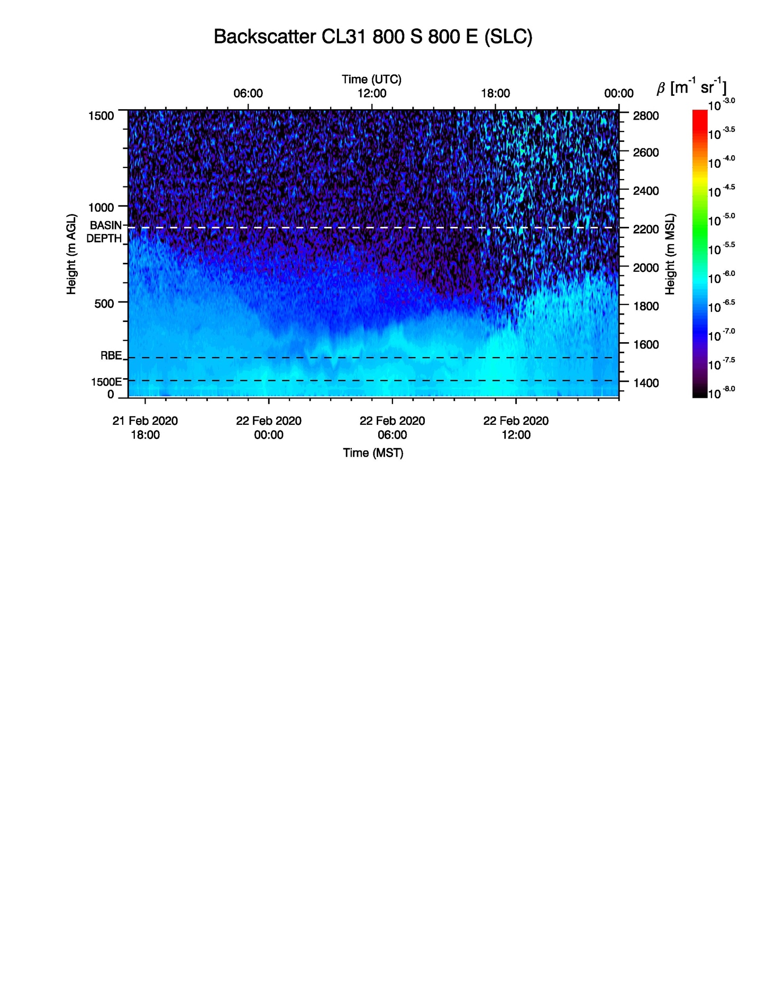

Example of (aerosol) ceilometer resolving low-PM air being injected into the Salt Lake Basin nocturnal CAP. Air is injected through a smaller tributary canyon with its mouth at the elevation marked “RBE”.

Aerosol lidars and ceilometers will be used to monitor the temporal and spatial variations in aerosol backscatter with is a good proxy (???) for particulate pollution concentrations

Figure 3. Schematic of recommended ground-based vertical profiling instruments (Wind LiDAR) to be used during AQUARIUS. Here, different scanning strategies of a LiDAR are indicated that can resolve the vertical profile of the horizontal winds (conical PPI scans, VAD retrieval), the vertical structure of turbulence (sigma_w, vertical stares), and mass transport through a tributary canyon (RHI scans). (Hoch can you make one for us?)

Doppler wind LiDARs are ideally suited to be deployed to observe the flow within, above, and along the edges of the basin PCAPs. The vertical profile of the horizontal winds, as well as turbulence on the PCAP top should be investigated with these instruments. Other applications for wind LiDAR measurements are sidewall ventilation, tributary flows, PCAP top-down erosion, and inter-basin exchange processes

Section 2b. Co-located Atmospheric and Chemical Measurements (Volunteers please contribute).

Ground-based vertical profiles must resolve intra- and inter-basin chemical and meteorological processes during AQUARIUS. It is critical that these vertical profiles be include collocatedand atmosphericinstrumentationto diagnose much as possible. Additionally, because the vertical mixing in atmospheric models is parameterised using relationships between the turbulent fluxes and mean profiles it is crutical that these vertial profile measuremetns be collocated with surface energy balance stations and sensors to measure atmospheric turbulence. co-variation of meteorology and chemistry, including meteorological and chemical exchange processes. These vertical profiles must also be adequately resolved in both time and space such that the detailed relationships between meteorological and chemical processes can be determined. This approach will allow mass, moisture, heat, and chemical budgets of basin air masses to be quantified in unprecedented detail. For example, co-located vertical profiles of the vertical velocity, water vapor, and chemical composition would enable computation of flux and flux divergence profiles needed to estimate the boundary budget of these quantities Lareau 2019). Numerical modeling can used to help inform difficult choices about sensor distribution to ensure these column observations best resolve in inter- and intra-basin exchange and mixing processes, and to inform location, scope, and size of the AQUARIUS study domain..

Regions of interest in individual basins could be defined where certain processes could be targeted:
Example sidewall ventilation: a pseudo-vertical transect of chemistry from basin floor to PCAP top could be combined with slope-normal wind and aerosol lidar scans, to quantify the timing, strength and importance of this process during the life cycle of a PCAP event.

Example Inter-Basin exchange: vertical profile of wind and chemistry allows an estimate of pollution and/or precursor transport under the changing conditions of a PCAP life cycle.

Example coupling / de- / re-coupling of different reservoirs in the PCAP. Vertical chemistry profiles can the combined with wind LiDAR observations (vertical stares) to investigate the importance of different vertically separated reservoirs where different chemical may dominate. Understanding and resolving the timing of the de-coupling (night) and re-coupling via a surface based convective BL may be crucial to fully replicate and correctly model chemical processes.

Section 2c. Basin Vertical Profiling Instrumentation (Volunteers please contribute and list and describe your vertical profiling instruments Oldroyd, Holmes, DeWekker, Hoch, Stutz, Simpson)

All available types of vertical profiling instrumentation, both in situ and remote sensing, will need to be utilized during AQUARIUS to address the science questions. Surface observation sites will also need to be situated in a way that their observations can be related to vertical profile data.
A wide array of vertical profiling instrumentation will need to be utilized, keeping carefully in mind the conditions under which some profiling platforms cannot be utilized due to flight restrictions or weather conditions, especially fog. High towers, tall buildings, or terrain slopes on the edges of basins will also need to be utilized for obtaining vertical and “psuedo-vertical” profiles of some atmospheric and chemical measurements.
Many turbulence measurements (both vertically and horizontally) will be needed in order to capture the impact of varying meteorological processes (e.g., canyon or slope flows) on the turbulence budget to then couple with chemical process observations. Doppler lidar observations will, for example, provide an unprecedented view of mixing processes over the PCAP depth, including near the top interface of PCAPS where shear and buoyancy interactions can change PCAP structure. To date these processes have not been measured, but are known to strongly impact PCAP evolution via top-down fluxes (e.g., Lareau and Horel 2015b). Similarly there is a need to better quantify near-surface fluxes that drive mixing from the bottom up and depend on the surface state and terrain heterogeneity. These surface data are also critical in contextualized lidar-observed variations in mixing aloft.
Vertical remote sensing will be a critical component of adequately observing the vertical, temporal, and spatial evolution of boundary-layer meteorology and the depth and layering of particulate pollutants. Ground-based wind and aerosol LiDARs, ceilometers, sodars, and other remote sensing instruments will be carefully deployed in order to get a full picture of meteorological and chemical coupling. The types of sensors include:

- Aerosol and Water Vapor lidars (air pollution, water vapor)
  - Differential Absorption and/or Raman Lidar for water vapor mixing ratio
- Aerosol ceilometer (air pollution and meteorology)
- Wind lidar (meteorology)
  - Vertical velocity, vertical velocity variance or TKE, horizontal wind components.
  - Also provides cloud base detection, boundary layer height estimate, aerosol layering.
- Wind sodar (meteorology)
  - Profiles of the horizontal wind components
- Radiometer (meteorology)
  - Long-path Differential Optical Absorption Spectroscopy LP-DOAS (pollution, mixing)Estimate of the vertical temperature profile, static stability, relative humidity, and cloud liquid water path.
- DOAS

In addition to fixed location vertical profiling, there is the potential for mobile vertical profilers to map the spatial structure of the basin atmosphere. Truck or trailer mounted Doppler lidars, for example, can be used to probe variations in the vertical velocity, boundary layer mixing height, and elevated aerosol layers. While these data are not as easily collocated with other measurements, they can provide important spatial context for time-series measurements at fixed site sensors. Figure. X shows and example of mobile Doppler lidar profiling in complex terrain, revealing spatial differences in aerosol backscatter, vertical velocity, and boundary layer height. Similar sampling could be used during AQUARIUS.
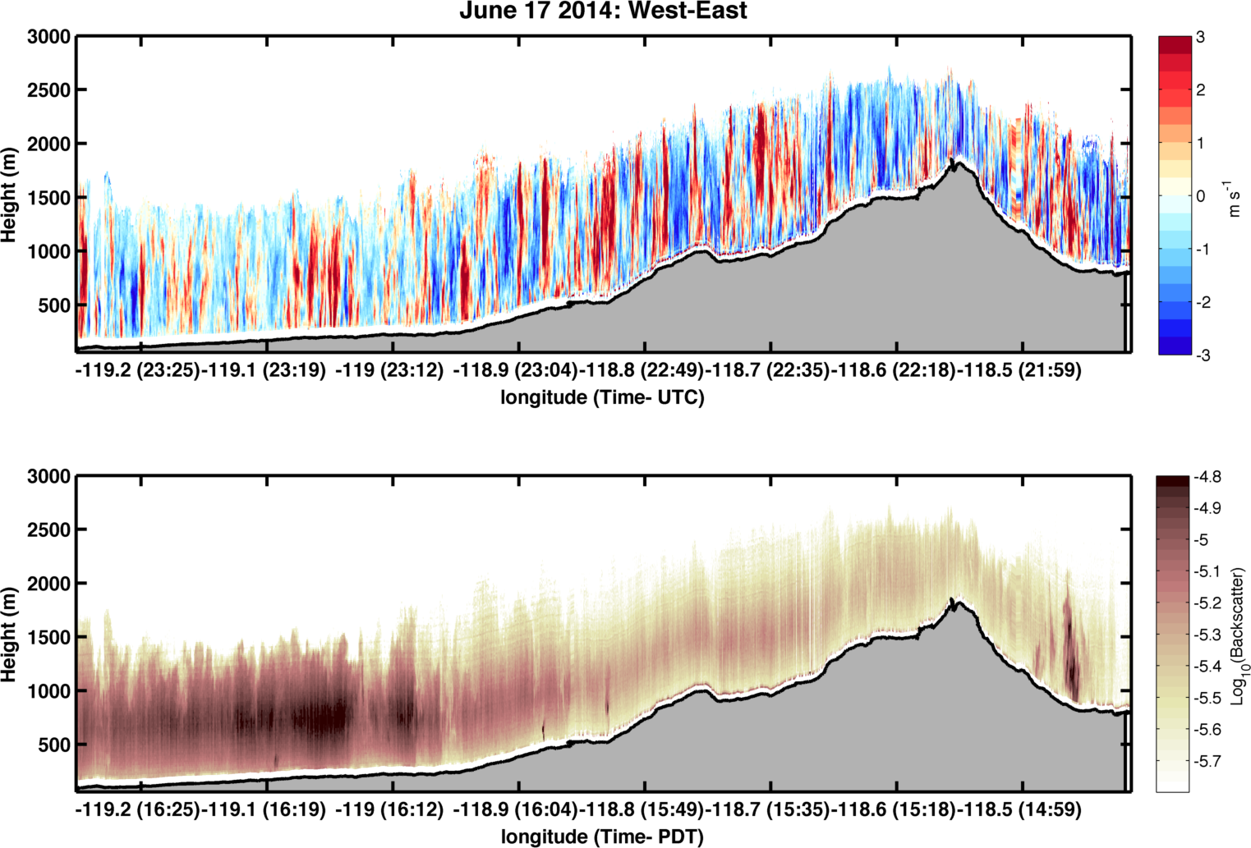
Figure 1. Example of mobile-lidar observations of variation in boundary layer vertical velocity (top) and aerosol backscatter (bottom) in complex terrain.

Vertical in-situ sensing will also be utilized in AQUARIUS observational design. Multiple rawinsonde systems, tethersondes, and small drones are all recommended and would help supplement the remote sensing systems. However, in some basins federal aviation regulations may make most drones and tethersondes unusable. The types of sensors include:

- Rawinsonde vertical profiles (meteorology)
- Weather stations deployed along basin slopes (meteorology, pseudo-vertical approach)

Section 2d. Basin Vertical Profiling Deployments (Volunteers, Stutz, Simpson, Hoch, Oldroyd, Holmes, DeWekker…) please contribute.
Should we do a comparison of Cache, SLV, and CA Central Valley?)

The size of the basins studied will determine the vertical sampling approach that is utilized during AQUARIUS. For a small basin such as Utah’s Cache Valley, a single central vertical profiling site may be adequate. For the medium-sized Salt Lake Valley and expansive California Central Valley, multiple vertical profiling sites are likely needed to capture important spatial variations in meteorology and chemistry. Alternatively, airborne or mobile ground-based systems equipped with instruments such as Doppler and Raman lidars can be deployed to capture spatial variability of meteorology (including turbulence) and chemistry. For example, vertical profiles at basin boundaries will assist in quantifying background pollution and meteorological parameters as well as intra-basin transport processes. Recent field campaigns in these basins highlight the importance of capturing the meteorological variability and air-pollution coupling (Baasandorj et al. 2017, Faloona et al. 2020)
Sufficient data collection to ensure spatial gradients are captured across the basin of interest is important. There must be adequate observation locations spatially (and with adequate temporal consistency) that a 3-D representation of the atmospheric state for both chemical and meteorological properties is obtained. The spatial representation aspect will be easier for small basins and more difficult for larger basins. A holistic and interdisciplinary and multi-agency approach is needed, where existing infrastructure such as National Weather Service daily rawinsonde launches, weather stations from public and private sectors available on MesoWest (Horel et al. 2002), wind sodars, and ceilometers will be supplemented with instrumentation dedicated to AQUARIUS. For
One approach is a process-focused deployment, selecting regions of interest within a basin to investigate the details of known coupled chemical-meteorological processes, for example, mobile lidar observations might help fill in important data gaps in large basins. a sidewall, a tributary, a topographic gap, a deep PCAP, etc. This would allow a deeper study of known processes and could lead to the quantification of the individual processes.
Chemical processes driven by mixing need to be resolved alongside the turbulence, mixing and transport meteorological measurements so that these two processes can be linked together in the study analysis. Coupled turbulence, meteorological (including turbulence and the surface energy balance) data on towers and high buildings at multiple locations within the basins are needed. For example, in the Salt Lake Valley, locations such as the KSL radio towers near the Great Salt Lake, the LDS building downtown, and the University of Utah WBB building that houses the Department of Atmospheric Sciences, have been identified as potential sites. Many of these stations should be collocated withLong-path DOAS using an array of retro-reflectors at different altitudes (e.g. deployed on a ground based tower) allows for continuous observations of vertical profiler (for a minimum of temperature, wind speed,profiles of gases such as NO₂, SO₂, O₃, HONO, HCHO, and NO₃. The profiles of these gases probe both vertical mixing processes and humidity) to collect data that can be used to investigate the validity of MOST during PCAPSchemical transformations.

Section 3. AQUARIUS Model Improvement Goals (Volunteers please contribute to this section. Particularly the modelers Saide, Kelly, Holmes, Mallia, Oldroyd).

Section 3a. Introduction

Comprehensive atmospheric chemical transport models (CTMs) driven by output from mesoscale meteorological models are the preferred tools for air quality management and forecasting. CTM parameterizations for atmospheric mixing and other processes are developed for broad application and generally perform well in characterizing summertime ozone and PM_{2.5} pollution. However, achieving good model performance is more challenging for simulations of the meteorology and air quality conditions during wintertime PCAPs episodes in Western air basins. For instance, model performance issues have been identified in CTM studies for the San Joaquin Valley (SJV) and suggest that key processes may not be fully resolved, although modeling for SJV has achieved reasonable results overall in some cases (Ying et al., 2008; Chen et al., 2014; Kelly et al., 2018). For smaller basins such as Salt Lake City, CTM modeling is more challenging and relatively limited in the literature, in part because inadequate simulations of meteorology often preclude meaningful scientific application of CTMs.

To improve model simulations of PCAPs, perform research to , chemistry,considerable work is underway or has been conducted in recent yearsPCAPs (e.g., Lareau and Horel 2015b, Ahmadov et al. 2015, Foster et al. 2017, Tran et al. 2018, Sun and Holmes 2019; Kelly et al. , Sun et al. 20202018). Some of the key meteorological processes that are very difficult to model in stable wintertime boundary layers include vertical temperature and humidity structure, cloudiness, turbulent mixingd and boundary-layer flows (Baklanov et al., 2011, Price et al., 2011, Holmes et al. 2015). Issues with emission inventories and chemical mechanisms also limit the ability to simulate air pollution processes in western basins. However, meteorological modeling issues are especially important to address because meaningful investigations of emissions and chemistry are challenging without reliable meteorological modeling. Prior work has used constrained box-modeling to provide insights on chemical processes in the absence of reliable CTM modeling (e.g., Womack et al., 2019), and experts at the AQUARIUS workshop indicated that reliance on box-modeling is an outstanding issue in characterizing chemical processes during PCAPs episodes. Moreover, weather and air quality forecasters have difficulty providing timely and accurate guidance regarding PCAPs metrics such as their intensity, duration and decay due to the issues with meteorological and CTM modeling of PCAPs.

PCAPs fail to represent the accumulation of pollutants The AQUARIUS study seeks to address the three inter-related factors of importance for air quality simulation for challenging PCAPs conditions: (1) model meteorology (mixing and transport), (2) emission inventories and modeling, and (3) atmospheric chemistry. A careful study design will be used to address these factors by integrating a comprehensive suite of meteorological and chemistry measurements with numerical forecast modeling. This novel approach will facilitate a thorough characterization of the key PCAPs processes to inform research to improve model emission inventories and chemistry and physics parameterizations.
e.g., ,, cloudiness air quality the

Section 3b. Measurements for Model Evaluation

The AQUARIUS workshop identified a clear need to perform comprehensive measurements of coupled meteorological-chemical processes to improve observationsair quality characterization and inform rigorous evaluation and validation of air quality modelsmodels. Typically, only routine is monitoring is available to characterize air quality and meteorological in Western basins. Such monitoring is useful in identifying model performance issues but not sufficient for diagnosing the causes of problems at a process level. In limited cases, field studies have been performed to provide measurements for diagnostic model evaluation. However, these efforts have focused on either chemistry (e.g., UWFPS, 2017) or meteorology (e.g., PCAPS) and were not designed to address the effects of the coupled meteorological-chemical processes that dominate secondary pollutant formation processes. The goal of AQUARIUS is to couple these observations, and to do so at high resolution,characterize and provide new scientific insight on meteorological-chemical coupling during PCAPs episodes through an integrated campaign of meteorological and chemical measurements. The lack of such measurements limits the detailed model evaluation necessary to begin developing improved model parameterizations. Characterizing collocated vertical profiles of key meteorology and chemistry variables at many sites will be critical to this effort and that the temporal and spatial resolution of . Collecting data is sufficient to evaluate model performance.
To this end, AQUARIUS will focus on process level data observations that can be compared directly high resolution simulations (e.g., LES) and thus facilitate identification of critical shortcomings in subgrid parameterizations for these processes in coarse resolution models. For example, Doppler lidar vertical profiles acquired at 1 second temporal resolution and 18 m vertical resolution will yieldneeded to characterize turbulence quantification (w’,w’w’,w’w’w’) over the depth the PCAP. Collocated high resolution aerosol backscatter and water vapor mixing ratio observations can then be used to compute covariance terms that appear in boundary layerand other physical process (e.g., w’q’) and that strongly impact boundary layer development. These data coupled with surface flux observationsto inform improved model parameterizations will also be especially important. Ideally, such measurements will be collected in multiple Western basins because processes are expected to differ among basins due to differences in basin geometry and vertical profiles of chemical composition, will yield unprecedented representation of the coupled atmosphere-chemistry system in PCAPS. emission sources and other factors.

Section 3c. Improving Emission Inventories

Gridded fields of pollutant and precursor emissions are key inputs to the photochemical models used in air quality management. Adequate characterization of emissions can be challenging for the multitude of pollutants and sources present in a typical air basin. An important use of the spatially distributed chemical and meteorological observations will be to provide top-down constraints on the emissions from key sectors in the air basins. The detailed coupled meteorological-chemical observations will be used to improve quantification of known emission sources, potentially identify currently unknown emissions sources, better characterize the temperature and activity dependence of emissions, and differentiate primary vs. secondary sources for various pollutants (e.g., particulates, formaldehyde). Some specific emission-related sectors to be considered using AQUARIUS data include agricultural, mobile, and natural sources (e.g., soil NO). Spatially distributed surface and aircraft-based measurements of pollutant concentrations will be the primary data source for investigating pollutants emissions. To relate emissions to these ambient concentration measurements, photochemical grid models and other models (e.g., back trajectories) may be used. Such integration of modeling and measurements will . Specifically, previous studies. Also, emissions will be evaluated by using them to drive air quality models and evaluate them during periods outside PCASPs, where models are expected to have suggested emissions inventoryless uncertainties related to NOx and NH3, which leads to underestimates of the ammonium nitrate formation in chemical transport models. . Thus, it is important to for measurements to be continuous and over an extended period of timecapture these conditionsimprove emissions characterization and make study findings directly relevant to modeling for typical regulatory assessments.

Section 3c. Needed Photochemical Model Improvements

Several coupled meteorology and air pollution modeling studies have been conducted for conditions of stable boundary-layers in California’s Central Valley and several Utah Basins. Studies in California’s Central Valley have included both 3D Eulerian grid models (e.g., Kleeman et al., 2005; Ying et al., 2008a, 2008b, 2009; Zhang et al., 2010; Ying, 2011; Chen et al., 2014; Kelly et al. 2018; Chen et al., 2020) and box models (e.g., Pun et al. 2009). High resolution modeling for the Central Valley appeared to capture the main features and limiting precursor for ammonium nitrate formation during winter PM_{2.5} episodes. However, several model performance limitations were identified, and many questions remain related to emissions, radical sources, transport, and vertical oxidant entrainment due to the lack of comprehensive coupled and meteorological measurements in previous campaigns. For the smaller valleys in Utah, accurate modeling with 3-D chemical transport models is more challenging than for the Central Valley. As a result, key studies of atmospheric chemistry in Utah valleys have relied on box modeling (e.g., Womack et al., 2019). Many questions remain on how to configure models to adequately simulate meteorology and air quality conditions in Utah valleys during PCAPs episodes. PM_{2.5} nitrate is typically underpredicted in western basins, including in Utah and California, during winter PM_{2.5} episodes using operational 12-km national modeling (e.g., Kelly et al., 2019). To improve operational and research modeling for PCAPs,
the AQUARIUS campaign seeks to address the full range of challenges in simulating the atmospheric chemistry of pollutant formation in stable wintertime boundary layers, including limitations in parameterizations of chemical processes, representations of photochemistry and radical sources, characterizations of surface albedo and snow cover, and emissions inventories (Zhu et al. 2019). It is difficult to isolate these processes to determine which one (i.e., emissions, chemistry, or meteorology) causes the greatest uncertainty in the air quality modeling for PCAPS. Future studies, with observations from meteorology-chemistry coupled field campaigns would allow for these different processes to be evaluated in a systematic manner to better isolate the uncertainties in the chemical transport modeling.

Section 3d. Evaluation of air quality forecasts

Operational centers provide forecasts which are used for warning the population about air quality events. Thus, besides evaluating research grade models specifically configured for this project, it is also necessary to evaluate the operational forecasts systems to provide guidance on their errors and possible ways to improve them. Since these forecasts are available in near-real time, they can be used during the field experiment to have a preliminary assessment of their performance and help in campaign planning. Additionally, modeling groups participating in the field campaign will deploy their own forecasts specifically tailored to the campaign needs. These will include higher resolution in regions with intensive sampling, model configuration that has found to perform better for PCASPs, and preliminary assumptions on how emissions vary with weather conditions. Additionally, the forecasts can be combined into a PCAP “ensemble” that could also be evaluated to assess potential improvements on forecasting these events based on multiple models.

Section 3e. AQUARIUS Modeling Goals

The recommended model improvement goals for AQUARIUS to are as follows:

- Collect detailed and spatially comprehensive meteorological observations, including 3-D turbulence from the surface up to the top of the PCAP, that are sufficient to validate the model and determine model weaknesses and assist in future turbulence parameterization development and evaluation. Turbulence measurements have generally been few and far between, despite the importance of turbulence (both within the stable boundary-layer and at the interface with the free atmosphere above the PCAP). Having collocated vertical profile instruments and turbulence sensors will be crucial to obtain the datasets necessary to improve the meteorological parameterization. Additionally, many of the chemical transport models use the flux-profile relationship for heat or moisture to simulate the pollutant mixing. Therefore, by collecting data for the vertical profiles of pollutant species and turbulent fluxes of the species, model improvements to simulate the pollutant mixing can also be investigated.

- Build a real-time suite (array) of forecast models that can be blended into a PCAP “ensemble” that can be validated and evaluated and utilized as forecast support for the science team while addressing forecasting and model improvement goals.

- Evaluate turbulence properties of high-resolution models and carefully validate against unprecedented coupled meteorological-chemical observations collected during AQUARIUS. It is currently not well understood of using a high-resolution WRF-LES model during PCAPS would better simulate the turbulence and vertical profiles in the lowest part of the ABL (i.e., <2km) compared to the standard WRF simulations. Having the observational datasets for a rigorous model evaluation of numerical weather prediction models, turbulence models, and chemical transport models will allow for detailed numerical studies to be preformed. Not all of the turbulence models and numerical weather prediction models are capable of being coupled to an atmospheric chemistry model, therefore this evaluation will become necessary when assessing which NWP parameterizations work with coupled meteorology-chemistry simulations and which parameterizations would be best to improve.

- Using high-resolution meteorological modeling that has been carefully validated against measurements, simulate the formation of secondary pollutants during the study period. If evidence exists that performance issues are related to limitations in model emissions, attempt to resolve those issues using emission sensitivity simulations or by updating bottom-up emission estimates as appropriate. If evidence exists that performance issues are related to limitations in model chemistry, attempt to resolve those issues by updating model chemical mechanisms using process-based empirical parameterizations or other approaches. Once model simulations of secondary pollutant formation are adequate based on high-resolution modeling, attempt to parameterize processes such that they can be represented using typical air quality model configurations that might be applied at coarser scales. The goal is to incorporate understanding developed through the field study into downstream modeling applications for air quality management and health assessments.

REFERENCES

Ahmadov, R., et al. (2015), Understanding high wintertime ozone pollution events in an oil‐ andnatural gas‐producing region of the western US, Atmos. Chem. Phys., 15( 1), 411– 429, doi:10.5194/acp-15-411-2015.

Arduini G, Staquet C, Chemel C (2016) Interactions Between the Nighttime Valley-Wind System and a Developing Cold-Air Pool. Boundary-Layer Meteorol 161:49–72. https://doi.org/10.1007/s10546-016-0155-8

Arritt RW, Pielke RA (1986) Interactions of nocturnal slope flows with ambient winds. Boundary-Layer Meteorol 37:183–195. https://doi.org/10.1007/BF00122763

Axelsen SL, van Dop H (2009a) Large-eddy simulation of katabatic winds. Part 1: Comparison with observations. Acta Geophys 57:803–836. https://doi.org/10.2478/s11600-009-0041-6

Axelsen SL, van Dop H (2009b) Large-eddy simulation of katabatic winds. Part 2: Sensitivity study and comparison with analytical models. Acta Geophys 57:837–856. https://doi.org/10.2478/s11600-009-0042-5

Baasandorj, M., Hoch, S. W., Bares, R., Lin, J. C., Brown, S. S., Millet, D. B., Martin, R., Kelly, K., Zarzana, K. J., Whiteman, C. D., Dube, W. P., Tonnesen, G., Jaramillo, I. C., and Sohl, J.: Coupling between Chemical and Meteorological Processes under Persistent Cold-Air Pool Conditions: Evolution of Wintertime PM_{2.5} Pollution Events and N2O5 Observations in Utah's Salt Lake Valley, Environ. Sci. Technol.,(2017) 51, 5941–5950, https://doi.org/10.1021/acs.est.6b06603.

Baklanov, A. A., and Coauthors, 2011: The nature, theory, and modeling of atmospheric planetary boundary layers. Bull. Amer. Meteor. Soc., 92, 123–128.

Banta RM, Gannon PT (1995) Influence of soil moisture on simulations of katabatic flow. Theor Appl Climatol 52:85–94. https://doi.org/10.1007/BF00865509

Basu S, Lacser A (2017) A Cautionary Note on the Use of Monin–Obukhov Similarity Theory in Very High-Resolution Large-Eddy Simulations. Boundary-Layer Meteorology 163:351–355. https://doi.org/10.1007/s10546-016-0225-y

Burkholder BA, Fedorovich E, Shapiro A (2011) Evaluating Subgrid-Scale Models for Large-Eddy Simulation of Turbulent Katabatic Flow. In: Salvetti MV, Geurts B, Meyers J, Sagaut P (eds) Quality and Reliability of Large-Eddy Simulations II. Springer Netherlands, pp 149–160

Burns P, Chemel C (2014a) Evolution of Cold-Air-Pooling Processes in Complex Terrain.
Boundary-Layer Meteorol 150:423–447. https://doi.org/10.1007/s10546-013-9885-z

Burns P, Chemel C (2015) Interactions Between Downslope Flows and a Developing Cold-Air Pool. Boundary-Layer Meteorol 154:57–80. https://doi.org/10.1007/s10546-014-9958-7

Burns P, Chemel C (2014b) Evolution of Cold-Air-Pooling Processes in Complex Terrain. Boundary-Layer Meteorol 150:423–447. https://doi.org/10.1007/s10546-013-9885-z

Burns SP, Sun J, Lenschow DH, et al (2011) Atmospheric Stability Effects on Wind Fields and Scalar Mixing Within and Just Above a Subalpine Forest in Sloping Terrain. Boundary-Layer Meteorology 138:231–262. https://doi.org/10.1007/s10546-010-9560-6

Businger JA, Wyngaard JC, Izumi Y, Bradley EF (1971) Flux-Profile Relationships in the Atmospheric Surface Layer. Journal of the Atmospheric Sciences 28:181–189. https://doi.org/10.1175/1520-0469(1971)028<0181:FPRITA>2.0.CO;2

Cheng Y, Parlange MB, Brutsaert W (2005) Pathology of Monin-Obukhov similarity in the stable boundary layer. Journal of Geophysical Research: Atmospheres 110:. https://doi.org/10.1029/2004JD004923

Choukulkar A, Brewer WA, Sandberg SP, et al (2017) Evaluation of single and multiple Doppler lidar techniques to measure complex flow during the XPIA field campaign. Atmospheric Measurement Techniques 10:247–264. https://doi.org/10.5194/amt-10-247-2017

Choukulkar A, Calhoun R, Billings B, Doyle J (2012) Investigation of a Complex Nocturnal Flow in Owens Valley, California Using Coherent Doppler Lidar. Boundary-Layer Meteorol 144:359–378. https://doi.org/10.1007/s10546-012-9729-2

Chow FK, Weigel AP, Street RL, et al (2006) High-Resolution Large-Eddy Simulations of Flow in a Steep Alpine Valley. Part I: Methodology, Verification, and Sensitivity Experiments. J Appl Meteor Climatol 45:63–86. https://doi.org/10.1175/JAM2322.1

Clements, C.B., Whiteman, C.D. and Horel, J.D. (2003) Cold‐air‐pool structure and evolution in a mountain basin: Peter Sinks. Journal of Applied Meteorology and Climatology, 42, 752– 768

DeWekker, S.F.J.; Giovannini, L.; Gutmann, E.; Knievel, J.C.; Kossmann, M.; Zardi, D. Meteorological applications benefiting from an improved understanding of atmospheric exchange processes over mountains. Atmosphere 2018.

De Wekker SFJ, Whiteman CD (2006) On the Time Scale of Nocturnal Boundary Layer Cooling in Valleys and Basins and over Plains. J Appl Meteor Climatol 45:813–820. https://doi.org/10.1175/JAM2378.1

Defant F (1949) Zur Theorie der Hangwinde, nebst Remerkungen zur Theorie der Berg- und Talwinde [A Theory of Slope Winds, Along With Remarks on the Theory of Mountain Winds and Valley Winds]. Archiv fuer Meteorologie Geophysik und Biolimatologie Ser. A, 1:421–450

Denby B (1999) Second-Order Modelling of Turbulence in Katabatic Flows. Boundary-Layer Meteorology 92:65–98. https://doi.org/10.1023/A:1001796906927

M. Dorninger, C.D. Whiteman, B. Bica, S. Eisenbach, B. Pospichal, R. Steinacker. Meteorological events affecting cold-air pools in a small basin. J. Appl. Meteorol. Climatol., 50 (2011), pp. 2223-2234.

Dyer AJ (1974) A review of flux-profile relationships. Boundary-Layer Meteorology 7:363–372. https://doi.org/10.1007/BF00240838

Faloona, I.C., S. Chiao, A.J. Eiserloh, R.J. Alvarez, G. Kirgis, A.O. Langford, C.J. Senff, D. Caputi, A. Hu, L.T. Iraci, E.L. Yates, J.E. Marrero, J. Ryoo, S. Conley, S. Tanrikulu, J. Xu, and T. Kuwayama, 0: The California Baseline Ozone Transport Study (CABOTS). Bull. Amer. Meteor. Soc., 0, https://doi.org/10.1175/BAMS-D-18-0302.1

Fernando HJS, Mann J, Palma JMLM, et al (2018) The Perdigão: Peering into Microscale Details of Mountain Winds. Bull Amer Meteor Soc 100:799–819. https://doi.org/10.1175/BAMS-D-17-0227.1

Fitzjarrald DR (1984) Katabatic Wind in Opposing Flow. J Atmos Sci 41:1143–1158. https://doi.org/10.1175/1520-0469(1984)041<1143:KWIOF>2.0.CO;2

Foken T (2008) Micrometeorology. Springer-Verlag Berlin Heidelberg, Berlin, Heidelberg

Forrer J, Rotach MW (1997) On the turbulence structure in the stable boundary layer over the Greenland ice sheet. Boundary-Layer Meteorology 85:111–136. https://doi.org/10.1023/A:1000466827210

C. Foster, E. Crosman, J. Horel. Simulations of a cold-air pool in Utah's Salt Lake Valley: sensitivity to land use and snow cover. Boundary-Layer Meteorol. (2017) 164, pages63–87(2017)

A. Franchin, D.L. Fibiger, L. Goldberger, E.E. McDuffie, A. Moravek, C.C. Womack, E.T. Crosman, K.S. Docherty, W.P. Dube, S.W. Hoch, B.H. Lee, R. Long, J.G. Murphy, J.A. Thornton, S.S. Brown, M. Baasandorj, A.M. Middlebrook. Airborne and ground-based observations of ammonium-nitrate-dominated aerosols in a shallow boundary layer during intense winter pollution episodes in northern Utah.

Gallée H, Schayes G (1992) Dynamical aspects of katabatic wind evolution in the Antarctic coastal zone. Boundary-Layer Meteorol 59:141–161. https://doi.org/10.1007/BF00120691
\
Giometto MG, Grandi R, Fang J, et al (2017) Katabatic Flow: A Closed-Form Solution with Spatially-Varying Eddy Diffusivities. Boundary-Layer Meteorology 162:307–317. https://doi.org/10.1007/s10546-016-0196-z

Goger B, Rotach MW, Gohm A, et al (2018) The Impact of Three-Dimensional Effects on the Simulation of Turbulence Kinetic Energy in a Major Alpine Valley. Boundary-Layer Meteorology 168:1–27. https://doi.org/10.1007/s10546-018-0341-y

Goger B, Rotach MW, Gohm A, et al (2019) A New Horizontal Length Scale for a Three-Dimensional Turbulence Parameterization in Mesoscale Atmospheric Modeling over Highly Complex Terrain. J Appl Meteor Climatol 58:2087–2102. https://doi.org/10.1175/JAMC-D-18-0328.1

Grachev AA, Leo LS, Sabatino SD, et al (2016) Structure of Turbulence in Katabatic Flows Below and Above the Wind-Speed Maximum. Boundary-Layer Meteorology 159:469–494. https://doi.org/10.1007/s10546-015-0034-8

Grisogono B (2003) Post-Onset Behaviour of the Pure Katabatic Flow. Boundary-Layer Meteorology 107:157–175. https://doi.org/10.1023/A:1021511105871

Grisogono B, Axelsen SL (2012) A Note on the Pure Katabatic Wind Maximum over Gentle Slopes. Boundary-Layer Meteorol 145:527–538. https://doi.org/10.1007/s10546-012-9746-1

Grisogono B, Oerlemans J (2001) Katabatic Flow: Analytic Solution for Gradually Varying Eddy Diffusivities. J Atmos Sci 58:3349–3354. https://doi.org/10.1175/1520-0469(2001)058<3349:KFASFG>2.0.CO;2

Grisogono B, Oerlemans J (2002) Justifying the WKB approximation in pure katabatic flows. Tellus A 54:453–462. https://doi.org/10.1034/j.1600-0870.2002.201399.x

Gryning S-E, Mahrt L, Larsen S (1985) Oscillating nocturnal slope flow in a coastal valley. Tellus A 37A:196–203. https://doi.org/10.1111/j.1600-0870.1985.tb00281.x

Haiden T, Whiteman CD, Hoch SW, Lehner M (2010) A Mass Flux Model of Nocturnal Cold-Air Intrusions into a Closed Basin. J Appl Meteor Climatol 50:933–943. https://doi.org/10.1175/2010JAMC2540.1

Heinemann G (2004) Local Similarity Properties of the Continuously Turbulent Stable Boundary Layer over Greenland. Boundary-Layer Meteorology 112:283–305. https://doi.org/10.1023/B:BOUN.0000027908.19080.b7

Hennemuth B (1986) Thermal asymmetry and cross-valley circulation in a small alpine valley. Boundary-Layer Meteorol 36:371–394. https://doi.org/10.1007/BF00118338

Hoch, S.W. and Whiteman, C.D. (2010) Topographic effects on the surface radiation balance in and around Arizona's Meteor Crater. Journal of Applied Meteorology and Climatology, 49, 1114– 1128

Högström U (1988) Non-dimensional wind and temperature profiles in the atmospheric surface layer: A re-evaluation. Boundary-Layer Meteorology 42:55–78. https://doi.org/10.1007/BF00119875

Holmes, H. A., J. K. Sriramasamudram, E. R. Pardyjak, and C. D. Whiteman, 2015: Turbulent fluxes and pollutant mixing during wintertime air pollution episodes in complex terrain. Environ. Sci. Technol., 49, 13 206–13 214, https://doi.org/10.1021/acs.est.5b02616.

Horel, J., and Coauthors, 2002: MesoWest: Cooperative mesonets in the western United States. Bull. Amer. Meteor. Soc., 83, 211–225.

Horst TW, Doran JC (1988) The Turbulence Structure of Nocturnal Slope Flow. Journal of the Atmospheric Sciences 45:605–616. https://doi.org/10.1175/1520-0469(1988)045<0605:TTSONS>2.0.CO;2

Horst TW, Doran JC (1986) Nocturnal drainage flow on simple slopes. Boundary-Layer Meteorol 34:263–286. https://doi.org/10.1007/BF00122382

Holtslag, A.A.M., Svensson, G., Baas, P., Basu, S., Beare, B., Beljaars, A.C.M., Bosveld, F.C., Cuxart, J., Lindvall, J., Steeneveld, G.J., Tjernström, M., Van De Wiel, B.J.H., Holtslag, A.A.M., Svensson, G., Baas, P., Basu, S., Beare, B., Beljaars, A.C.M., Bosveld, F.C., Cuxart, J., Lindvall, J., Steeneveld, G.J., Tjernström, M. and Van De Wiel, B.J.H. (2013) Stable atmospheric boundary layers and diurnal cycles: challenges for weather and climate models. Bulletin of the American Meteorological Society, 94(11), 1691–1706. https://doi.org/10.1175/BAMS-D-11-00187.1.

Jeglum ME, Hoch SW, Jensen DD, et al (2017) Large Temperature Fluctuations due to Cold-Air Pool Displacement along the Lee Slope of a Desert Mountain. J Appl Meteor Climatol 56:1083–1098. https://doi.org/10.1175/JAMC-D-16-0202.1

Jensen DD, Nadeau DF, Hoch SW, Pardyjak ER (2017) The evolution and sensitivity of katabatic flow dynamics to external influences through the evening transition. Quarterly Journal of the Royal Meteorological Society 143:423–438. https://doi.org/10.1002/qj.2932

C.E. Ivey, S. Balachandran, S. Colgan, Y. Hu, H.A. Holmes. Investigating fine particulate matter sources in Salt Lake City during persistent cold air pool events. Atmos. Environ., 213 (2019), pp. 568-578

Kaimal JC, Wyngaard JC (1990) The Kansas and Minnesota experiments. Boundary-Layer Meteorol 50:31–47. https://doi.org/10.1007/BF00120517

Kavčič I, Grisogono B (2007) Katabatic flow with Coriolis effect and gradually varying eddy diffusivity. Boundary-Layer Meteorol 125:377–387. https://doi.org/10.1007/s10546-007-9167-8

James T. Kelly, Shannon N. Koplitz, Kirk R. Baker, Amara L. Holder, Havala O.T. Pye, Benjamin N. Murphy, Jesse O. Bash, Barron H. Henderson, Norman C. Possiel, Heather Simon, Alison M. Eyth, Carey Jang, Sharon Phillips, Brian Timin, 2019. Assessing PM2.5 model performance for the conterminous U.S. with comparison to model performance statistics from 2007-2015, Atmospheric Environment, 214, 116872, ISSN 1352-2310,
https://doi.org/10.1016/j.atmosenv.2019.116872.

Kelly, J. T., Parworth, C. L., Zhang, Q., Miller, D. J., Sun, K., Zondlo, M. A., Baker, K. R., Wisthaler, A., Nowak, J. B., Pusede, S. E., Cohen, R. C., Weinheimer, A. J., Beyersdorf, A. J., Tonnesen, G. S., Bash, J. O., Valin, L. C., Crawford, J. H., Fried, A., & Walega, J. G. (2018). Modeling NH₄NO₃ over the San Joaquin Valley during the 2013 DISCOVER‐AQ Campaign. Journal of Geophysical Research: Atmospheres, 123, 4727– 4745. https://doi.org/10.1029/2018JD028290

Kondo J, Sato T (1988) A simple model of drainage flow on a slope. Boundary-Layer Meteorol 43:103–123. https://doi.org/10.1007/BF00153975

Kuwagata T, Kimura F (1997) Daytime Boundary Layer Evolution in a Deep Valley. Part II: Numerical Simulation of the Cross-Valley Circulation. Journal of Applied Meteorology 36:13. https://doi.org/10.1175/1520-0450(1997)036<0883:DBLEIA>2.0.CO;2

Lalaurette F, André J-C (1985) On the integral modelling of katabatic flows. Boundary-Layer Meteorol 33:135–149. https://doi.org/10.1007/BF00123387

Lareau, N. P., E. Crosman, C. D. Whiteman, J. D. Horel, S. W. Hoch, W. O. J. Brown, and T. W. Horst (2013), The persistent cold‐air pool study, Bull. Am. Meteorol. Soc., 94( 1), 51– 63, doi:10.1175/Bams‐D‐11‐00255.1

Lareau, N.P. and Horel, J.D. (2015)a Dynamically induced displacements of a persistent cold‐air pool. Boundary‐Layer Meteorology, 154(2), 291–316. https://doi.org/10.1007/s10546-014-9968-5.

Lareau, N.P. and J.D. Horel, 2015b: Turbulent Erosion of Persistent Cold-Air Pools: Numerical Simulations. J. Atmos. Sci., 72, 1409–1427, https://doi.org/10.1175/JAS-D-14-0173.1

Lareau, N.P., 0: Subcloud and Cloud-Base Latent Heat Fluxes during Shallow Cumulus Convection. J. Atmos. Sci., 0, https://doi.org/10.1175/JAS-D-19-0122.1

Lee HN, Kau WS (1984) Simulation of three-dimensional wind flow over complex terrain in the atmospheric boundary layer. Boundary-Layer Meteorol 29:381–396. https://doi.org/10.1007/BF00120537

Lehner M, Whiteman CD, Hoch SW, et al (2015) A Case Study of the Nocturnal Boundary Layer Evolution on a Slope at the Foot of a Desert Mountain. J Appl Meteor Climatol 54:732–751. https://doi.org/10.1175/JAMC-D-14-0223.1

Mahrt L (1999) Stratified Atmospheric Boundary Layers. Boundary-Layer Meteorology 90:375–396. https://doi.org/10.1023/A:1001765727956
Mahrt L (2009) Characteristics of Submeso Winds in the Stable Boundary Layer. Boundary-Layer Meteorol 130:1–14. https://doi.org/10.1007/s10546-008-9336-4
Mahrt L, Mills R (2009) Horizontal diffusion by submeso motions in the stable boundary layer. Environmental Fluid Mechanics 9:443–456. https://doi.org/10.1007/s10652-009-9126-7
Mahrt L, Richardson S, Seaman N, Stauffer D (2010) Non-stationary drainage flows and motions in the cold pool. Tellus A 62:698–705. https://doi.org/10.1111/j.1600-0870.2010.00473.x
Mahrt L, Thomas CK, Grachev AA, Persson POG (2018) Near-Surface Vertical Flux Divergence in the Stable Boundary Layer. Boundary-Layer Meteorol 169:373–393. https://doi.org/10.1007/s10546-018-0379-x

Mahrt L, Vickers D, Nakamura R, et al (2001) Shallow Drainage Flows. Boundary-Layer Meteorology 101:243–260. https://doi.org/10.1023/A:1019273314378

Manins PC (1992) Vertical fluxes in katabatic flows. Boundary-Layer Meteorol 60:169–178. https://doi.org/10.1007/BF00122066

Manins PC, Sawford BL (1979) A Model of Katabatic Winds. J Atmos Sci 36:619–630. https://doi.org/10.1175/1520-0469(1979)036<0619:AMOKW>2.0.CO;2

Martínez D, Jiménez MA, Cuxart J, Mahrt L (2010) Heterogeneous Nocturnal Cooling in a Large Basin Under Very Stable Conditions. Boundary-Layer Meteorol 137:97–113. https://doi.org/10.1007/s10546-010-9522-z
Yann Largeron, Chantal Staquet,Persistent inversion dynamics and wintertime PM10 air pollution in Alpine valleys, Atmospheric Environment, Volume 135, 2016, Pages 92-108,
ISSN 1352-2310, https://doi.org/10.1016/j.atmosenv.2016.03.045.

McCaffrey, K., J.M. Wilczak, L. Bianco, E. Grimit, J. Sharp, R. Banta, K. Friedrich, H.J. Fernando, R. Krishnamurthy, L.S. Leo, and P. Muradyan, 2019: Identification and Characterization of Persistent Cold Pool Events from Temperature and Wind Profilers in the Columbia River Basin. J. Appl. Meteor. Climatol., 58, 2533–2551, https://doi.org/10.1175/JAMC-D-19-0046.1

Monin AS, Obukhov AM (1954) Basic Laws of Turbulent Mixing in the Atmospheric Surface Layer. Trudy Geofiz, Instituta Akademii Nauk, SSSR (Proceedings of Geophysics Institute, National Academy of Science, SSSR) 24:163–187

Monti P, Fernando HJS, Princevac M, et al (2002) Observations of Flow and Turbulence in the Nocturnal Boundary Layer over a Slope. Journal of the Atmospheric Sciences 59:2513–2534. https://doi.org/10.1175/1520-0469(2002)059<2513:OOFATI>2.0.CO;2

Munro DS (1989) Surface Roughness and Bulk Heat Transfer on a Glacier: Comparison with Eddy Correlation. Journal of Glaciology 35:343–348. https://doi.org/10.3189/S0022143000009266

Munro DS, Davies JA (1978) On fitting the log-linear model to wind speed and temperature profiles over a melting glacier. Boundary-Layer Meteorol 15:423–437. https://doi.org/10.1007/BF00120604

Nadeau DF, Pardyjak ER, Higgins CW, Parlange MB (2013) Similarity Scaling Over a Steep Alpine Slope. Boundary-Layer Meteorology 147:401–419. https://doi.org/10.1007/s10546-012-9787-5

Nappo CJ, Rao KS (1987) A model study of pure katabatic flows. Tellus A: Dynamic Meteorology and Oceanography 39:61–71. https://doi.org/10.3402/tellusa.v39i1.11740

E.M. Neemann, E.T. Crosman, J.D. Horel, L. Avey. Simulations of a cold-air pool associated with elevated wintertime ozone in the Uintah Basin, Utah. Atmos. Chem. Phys., 15 (2015), pp. 135-151

Nieuwstadt FTM (1984a) The Turbulent Structure of the Stable, Nocturnal Boundary Layer. Journal of the Atmospheric Sciences 41:2202–2216. https://doi.org/10.1175/1520-0469(1984)041<2202:TTSOTS>2.0.CO;2

Nieuwstadt FTM (1984b) Some aspects of the turbulent stable boundary layer. Boundary-Layer Meteorol 30:31–55. https://doi.org/10.1007/BF00121948

Noppel H, Fiedler F (2002) Mesoscale Heat Transport Over Complex Terrain By Slope Winds – A Conceptual Model And Numerical Simulations. Boundary-Layer Meteorology 104:73–97. https://doi.org/10.1023/A:1015556228119

Obukhov AM (1971) Turbulence in an atmosphere with a non-uniform temperature. Boundary-Layer Meteorol 2:7–29. https://doi.org/10.1007/BF00718085

Oerlemans J (1998) The atmospheric boundary layer over melting glaciers. In: Chapter 6 in: Clear and Cloudy Boundary Layers (Eds: A. A. M. Holtslag and P. G. Duynkerke). Royal Netherlands Academy of Arts and Sciences, pp 129—153

Oerlemans J, Björnsson H, Kuhn M, et al (1999) Glacio-Meteorological Investigations On Vatnajökull, Iceland, Summer 1996: An Overview. Boundary-Layer Meteorology 92:3–24. https://doi.org/10.1023/A:1001856114941

Oldroyd HJ, Katul G, Pardyjak ER, Parlange MB (2014) Momentum balance of katabatic flow on steep slopes covered with short vegetation. Geophysical Research Letters 41:4761–4768. https://doi.org/10.1002/2014GL060313

Oldroyd, H.J., Pardyjak, E.R., Higgins, C.W. et al. Buoyant Turbulent Kinetic Energy Production in Steep-Slope Katabatic Flow. Boundary-Layer Meteorol 161, 405–416 (2016). https://doi.org/10.1007/s10546-016-0184-3

Pardyjak ER, Monti P, Fernando HJS (2002) Flux Richardson number measurements in stable atmospheric shear flows. Journal of Fluid Mechanics 459:307–316. https://doi.org/10.1017/S0022112002008406

Parmhed O, Oerlemans J, Grisogono B (2004) Describing surface fluxes in katabatic flow on Breidamerkurjökull, Iceland. Q J R Meteorol Soc 130:1137–1151. https://doi.org/10.1256/qj.03.52

Prandtl L (1942) Führer durch die Strömungslehre. Vieweg und Sohn, Braunschweig

A. Paci, C. Staquet, et al.The Passy-2015 field experiment: an overview of the campaign and preliminary results Proc. of the 33rd International Conference on Alpine Meteorology, Innsbruck, Austria (2015)

J. Price, S. Vosper, A. Brown, A. Ross, P. Clark, F. Davies, V. Horlacher, B. Claxton, J. McGregor, J. Hoare, et al. COLPEX: field and numerical studies over a region of small hills
Bull. Am. Meteorol. Soc., 92 (12) (2011), pp. 1636-1650
Pal, S. and Haeffelin, M.: Forcing mechanisms governing diurnal, seasonal, and interannual variability in the boundary layer depths: Five years of continuous lidar observations over a suburban site near Paris, J. Geophys. Res. - Atmos., 120, 11936–11956, 2015. doi:10.1002/2015JD023268.

Prabhakar, G., C. L. Parworth, X. Zhang, H. Kim, D. E. Young, A. J. Beyersdorf, L. D. Ziemba, J. B. Nowak, T. H. Bertram, I. C. Faloona, Q. Zhang, and C. D. Cappa, Observational assessment of the role of nocturnal residual-layer chemistry in determining daytime surface particulate nitrate concentrations, Atmos. Chem. Phys., 17, 14747–14770, 2017. https://doi.org/10.5194/acp-17-14747-2017

Pun, B., R. Balmori, and C. Seigneur (2009), Modeling wintertime particulate matter formation in central California, Atmos. Environ., 43( 2), 402– 409, doi:10.1016/j.atmosenv.2008.08.040.

Rao KS, Snodgrass HF (1981) A nonstationary nocturnal drainage flow model. Boundary-Layer Meteorol 20:309–320. https://doi.org/10.1007/BF00121375

H.D. Reeves, K.L. Elmore, G.S. Manikin, D.J. Stensrud. Assessment of forecasts during persistent valley cold pools in the Bonneville Basin by the North American Mesoscale Model. Wea. Forecasting, 26 (2011), pp. 447-467, 10.1175/WAF-D-10-05014.1

Rotach MW, Andretta M, Calanca P, et al (2008) Boundary layer characteristics and turbulent exchange mechanisms in highly complex terrain. Acta Geophys 56:194–219. https://doi.org/10.2478/s11600-007-0043-1

Sastre M, Yagüe C, Román-Cascón C, Maqueda G (2015) Atmospheric Boundary-Layer Evening Transitions: A Comparison Between Two Different Experimental Sites. Boundary-Layer Meteorol 157:375–399. https://doi.org/10.1007/s10546-015-0065-1

Schmidli J, Poulos GS, Daniels MH, Chow FK (2009) External Influences on Nocturnal Thermally Driven Flows in a Deep Valley. J Appl Meteor Climatol 48:3–23. https://doi.org/10.1175/2008JAMC1852.1

Serafin S, Adler B, Cuxart J, et al (2018) Exchange Processes in the Atmospheric Boundary Layer Over Mountainous Terrain. Atmosphere 9:102. https://doi.org/10.3390/atmos9030102

Serafin S, De Wekker SFJ, Knievel JC (2016) A Mesoscale Model-Based Climatography of Nocturnal Boundary-Layer Characteristics over the Complex Terrain of North-Western Utah. Boundary-Layer Meteorol 159:495–519. https://doi.org/10.1007/s10546-015-0044-6

Sfyri E, Rotach MW, Stiperski I, et al (2018) Scalar-Flux Similarity in the Layer Near the Surface Over Mountainous Terrain. Boundary-Layer Meteorol 169:11–46. https://doi.org/10.1007/s10546-018-0365-3

Shapiro A, Burkholder B, Fedorovich E (2012) Analytical and Numerical Investigation of Two-Dimensional Katabatic Flow Resulting from Local Surface Cooling. Boundary-Layer Meteorol 145:249–272. https://doi.org/10.1007/s10546-011-9685-2

Shapiro A, Fedorovich E (2014) A Boundary-Layer Scaling for Turbulent Katabatic Flow. Boundary-Layer Meteorol 153:1–17. https://doi.org/10.1007/s10546-014-9933-3

Skyllingstad ED (2003) Large-Eddy Simulation of Katabatic Flows. Boundary-Layer Meteorology 106:217–243. https://doi.org/10.1023/A:1021142828676
Smeets CJPP, Duynkerke PG, Vugts HF (2000) Turbulence Characteristics Of The Stable Boundary Layer Over A Mid-Latitude Glacier. Part II: Pure Katabatic Forcing Conditions. Boundary-Layer Meteorology 97:73–107. https://doi.org/10.1023/A:1002738407295

Smeets CJPP, Duynkerke PG, Vugts HF (1999) Observed Wind Profiles and Turbulence Fluxes over an ice Surface with Changing Surface Roughness. Boundary-Layer Meteorology 92:99–121. https://doi.org/10.1023/A:1001899015849

Smeets CJPP, Duynkerke PG, Vugts HF (1998) Turbulence Characteristics of the Stable Boundary Layer Over a Mid-Latitude Glacier. Part I: A Combination of Katabatic and Large-Scale Forcing. Boundary-Layer Meteorology 87:117–145. https://doi.org/10.1023/A:1000860406093

Smith, R. B., 2019: 100 years of progress in mountain meteorology research. A Century of Progress in Atmospheric and Related Sciences: Celebrating the American Meteorological Society Centennial, Meteor. Monogr., No. 59, Amer. Meteor. Soc., https://doi.org/10.1175/AMSMONOGRAPHS-D-18-0022.1

Salmon, O. E., Shepson, P. B., Ren, X., Marquardt Collow, A. B., Miller, M. A., Carlton, A. G., Cambaliza, M. O., Heimburger, A., Morgan, K. L., Fuentes, J. D., & Stirm, B. H. (2017). Urban emissions of water vapor in winter. Journal of Geophysical Research: Atmospheres, 122, 9467– 9484. https://doi.org/10.1002/2016JD026074

Sheridan PF (2019) Synoptic-flow interaction with valley cold-air pools and effects on cold-air pool persistence: influence of valley size and atmospheric stability. Q J R Meteorol Soc 145:1636–1659. https://doi.org/10.1002/qj.3517

P.F. Sheridan, S.B. Vosper, A.R. Brown Characteristics of cold pools observed in narrow valleys and dependence on external conditions. Q. J. R. Meteorol. Soc., 140 (2014), pp. 715-728, 10.1002/qj.2159

Söderberg S, Parmhed O (2006) Numerical Modelling of Katabatic Flow Over a Melting Outflow Glacier. Boundary-Layer Meteorol 120:509–534. https://doi.org/10.1007/s10546-006-9059-3

Solanki R, Singh N, Kiran Kumar NVP, et al (2019) Impact of Mountainous Topography on Surface-Layer Parameters During Weak Mean-Flow Conditions. Boundary-Layer Meteorol 172:133–148. https://doi.org/10.1007/s10546-019-00438-3

Soler MR, Infante C, Buenestado P, Mahrt L (2002) Observations Of Nocturnal Drainage Flow In A Shallow Gully. Boundary-Layer Meteorology 105:253–273. https://doi.org/10.1023/A:1019910622806

Soler MR, Udina M, Ferreres E (2014) Observational and Numerical Simulation Study of a Sequence of Eight Atmospheric Density Currents in Northern Spain. Boundary-Layer Meteorol 153:195–216. https://doi.org/10.1007/s10546-014-9942-2

Stiperski I, Calaf M (2017) Dependence of near‐surface similarity scaling on the anisotropy of atmospheric turbulence. Quarterly Journal of the Royal Meteorological Society. https://doi.org/10.1002/qj.3224

Stiperski I, Holtslag AAM, Lehner M, et al (2019) On the turbulence structure of deep katabatic flows on a gentle mesoscale slope. Quarterly Journal of the Royal Meteorological Society n/a: https://doi.org/10.1002/qj.3734

Stiperski I, Rotach MW (2016) On the Measurement of Turbulence Over Complex Mountainous Terrain. Boundary-Layer Meteorology 159:97–121. https://doi.org/10.1007/s10546-015-0103-z

Strang EJ, Fernando HJS (2001a) Entrainment and mixing in stratified shear flows. Journal of Fluid Mechanics 428:349–386. https://doi.org/10.1017/S0022112000002706

Strang EJ, Fernando HJS (2001b) Vertical Mixing and Transports through a Stratified Shear Layer. J Phys Oceanogr 31:2026–2048. https://doi.org/10.1175/1520-0485(2001)031<2026:VMATTA>2.0.CO;2
C. Staquet, A. Paci, et al.The Passy project: objectives, underlying scientific questions and preliminary numerical modeling of the Passy Alpine valley Proc. of the 33rd International Conference on Alpine Meteorology, Innsbruck, Austria (2015)

Sun, X. and H.A. Holmes, 2019: Surface Turbulent Fluxes during Persistent Cold-Air Pool Events in the Salt Lake Valley, Utah. Part I: Observations. J. Appl. Meteor. Climatol., 58, 2553–2568, https://doi.org/10.1175/JAMC-D-19-0053.1

Trachte K, Nauss T, Bendix J (2010) The Impact of Different Terrain Configurations on the Formation and Dynamics of Katabatic Flows: Idealised Case Studies. Boundary-Layer Meteorol 134:307–325. https://doi.org/10.1007/s10546-009-9445-8

T. Tran, H. Tran, M. Mansfield, S. Lyman, E. Crosman. Four dimensional data assimilation (FDDA) impacts on WRF performance in simulating inversion layer structure and distributions of CMAQ-simulated winter ozone concentrations in Uintah Basin

Umphrey C, DeLeon R, Senocak I (2017) Direct Numerical Simulation of Turbulent Katabatic Slope Flows with an Immersed-Boundary Method. Boundary-Layer Meteorol 164:367–382. https://doi.org/10.1007/s10546-017-0252-3

van der Avoird E, Duynkerke PG (1999) Turbulence in a Katabatic Flow. Boundary-Layer Meteorology 92:37–63. https://doi.org/10.1023/A:1001744822857
Trousdell, J. F., Conley, S. A., Post, A., and Faloona, I. C.: Observing entrainment mixing, photochemical ozone production, and regional methane emissions by aircraft using a simple mixed-layer framework, Atmospheric Chemistry and Physics, 16, 15433–15450, 2016. https://doi.org/10.5194/acp-16-15433-2016.

VanReken, T. M., and Coauthors, 2017: Role of persistent low-level clouds in mitigating air quality impacts of wintertime cold pool conditions. Atmos. Environ., 154, 236–246, https://doi.org/10.1016/j.atmosenv.2017.
Vercauteren N, Mahrt L, Klein R (2016) Investigation of interactions between scales of motion in the stable boundary layer. Quarterly Journal of the Royal Meteorological Society 142:2424–2433. https://doi.org/10.1002/qj.2835

Vosper, S.B. and Brown, A.R. (2008) Numerical simulations of sheltering in valleys: the formation of nighttime cold‐air pools. Boundary‐Layer Meteorology, 127(3), 429–448. https://doi.org/10.1007/s10546-008-9272-3.

Whiteman, C. D., S. W. Hoch, J. D. Horel, and A. Charland, 2014: Relationship between particulate air pollution and meteorological variables in Utah’s Salt Lake Valley. Atmos. Environ., 94, 742–753, https://doi.org/10.1016/j.atmosenv.2014.06.012.

Womack, C.C., E.E . McDuffie, P.M. Edwards, R. Bares, J.A. de Gouw, K.S. Docherty, W.P. Dubé, D.L. Fibiger, A. Franchin, J.B. Gilman, L. Goldberger, B.H. Lee, J.C. Lin, R. Long, A.M. Middlebrook, D.B. Millet, A. Moravek, J.G. Murphy, P.K. Quinn, T.P. Riedel, J.M. Roberts, J.A. Thornton, L.C. Valin, P.R. Veres, A.R. Whitehill, R.J. Wild, C. Warneke, B. Yuan, M. Baasandorj, S.S. Brown (2019). An odd oxygen framework for wintertime ammonium nitrate aerosol pollution in urban areas: NO_{x} and VOC control as mitigation strategies (2019). 46, 4971–4979, Geophys. Res. Lett, 10.1029/2019GL082028

Weigel AP, Chow FK, Rotach MW (2007) The effect of mountainous topography on moisture exchange between the “surface” and the free atmosphere. Boundary-Layer Meteorol 125:227–244. https://doi.org/10.1007/s10546-006-9120-2

Whiteman CD (2000) Mountain meteorology: fundamentals and applications. Oxford University Press, New York

Whiteman, C. D., S. Zhong, W. J. Shaw, J. M. Hubbe, X. Bian, and J. Mittelstad 2001: Cold pools in the Columbia basin. Wea. Forecasting, 16, 432–447.

Whiteman CD, Hoch SW, Lehner M, Haiden T (2010) Nocturnal Cold-Air Intrusions into a Closed Basin: Observational Evidence and Conceptual Model. J Appl Meteor Climatol 49:1894–1905. https://doi.org/10.1175/2010JAMC2470.1

Wood CR, Lacser A, Barlow JF, et al (2010) Turbulent Flow at 190 m Height Above London During 2006–2008: A Climatology and the Applicability of Similarity Theory. Boundary-Layer Meteorology 137:77–96. https://doi.org/10.1007/s10546-010-9516-x

Ye ZJ, Garratt JR, Segal M, Pielke RA (1990) On the impact of atmospheric thermal stability on the characteristics of nocturnal downslope flows. Boundary-Layer Meteorol 51:77–97. https://doi.org/10.1007/BF00120462

Yu Y, Cai X, King JC, Renfrew IA (2005) Numerical simulations of katabatic jumps in coats land, Antartica. Boundary-Layer Meteorology 114:413–437. https://doi.org/10.1007/s10546-004-9564-1
Yu Y, Cai X-M (2006) Structure and Dynamics of Katabatic Flow Jumps: Idealised Simulations. Boundary-Layer Meteorol 118:527–555. https://doi.org/10.1007/s10546-005-6433-5

Yu, L., Zhong, S. and Bian, X. (2017) Multi‐day valley cold‐air pools in the western United States as derived from NARR. International Journal of Climatology, 37(5), 2466–2476. https://doi.org/10.1002/joc.4858.

Zhu, S, Mac Kinnon, M, Shaffer, BP, Samuelsen, G, Brouwer, J and Dabdub, D. 2019. An uncertainty for clean air: Air quality modeling implications of underestimating VOC emissions in urban inventories. Atmos Environ 211: 256–267. DOI: 10.1016/j.atmosenv.2019.05.019

