Response to reviewer #2.

The reviewer raises a number of well-considered major points to improve the manuscript and remove errors, each of which we have addressed. The largest change in the manuscript is a rewriting of the section describing the CAP tilt (Section 3.5). That section has been significantly changed by removing most of the mathematical expressions in favor of a simplified explanation using a shallow water approximation for the CAP system and placing the emphasis on the conceptual understanding of the forces acting on the CAP. We have also added some additional analysis of pressure variations as evidence of the dynamics. More details of the revisions are provided below. We have also included a handful of figures with this response to help address questions about the Barnes analysis and its sensitivity to tunable parameters. Additional details for each point raised by the reviewer are provided below.
Finally, following the request of the Editor, the total number of figures in the manuscript has been reduced from 19 to 15. In some instances figures have been combined by removing less important panels and replacing others.

1.) Yes, we do mean PM_{2.5}. The text has been altered to clarify this point. However, we have also removed the PM_{2.5} panel from Fig. 2 in order to consolidate the total number of figures in the manuscript as per the Chief Editors request. The PM2.5 data is now referred to as “not shown”.
2.) We have altered this figure using a different line style.
3.) Labels for the South Mountain (SM) stations, including SM6, have been included on Fig. 1. We have also updated the figuring using color-coding for these stations following the colors used later in the manuscript.
4.) We have changed the overview figure to a plan view of the Salt Lake Valley with shading representing the height. This should aid in a quantitative assessment of the slopes within the valley. We have added a number of other features to the Fig as well, including the location of the “upstream sounding” in Lehi, UT and the transect used in the numerical simulations and conceptual diagrams.
5.) The Barnes analyses presented in Figs. 6-9 use a horizontal e-folding scale of 20, 10, and 5 km for 3 successive iterations. The vertical e-folding distance is 75 m. This parameter limits the impact of laterally adjacent but vertically separated observations. The vertical value was chosen based on the average spacing of the HOBO temperature data loggers, which form transects of the valley at ~50 m elevation steps. The lateral spacing of the observations throughout the valley are on the order of a 1-10 km. No cut off scale is applied. We have added a line to the text specifying the selection of these parameters.
The horizontal scale of the underlying topographic grid was chosen to provide high-resolution visual indications of the terrain features in the SLV. That resolution is somewhat excessive, as you point out, but does not affect the conclusions of the analysis.
To more specifically address concerns about the analysis sensitivity Fig. 1 of this response shows a comparison of analyses at 0600 UTC using horizontal radii of 2.5, 5, 10, and 20 km respectively. The vertical radius is held constant at 75 m for these analyses. Not surprisingly the lower e-folding radii (e.g. 2.5 km) provide a more structured analysis drawn closer to the observations. The longer radii favor a smoother field and reduced gradients between stations. Inspections suggest that the 2.5 km analysis is over fit to the observations while the 15 km analysis washed out salient features in the observations, including the sharpness of the front between adjacent observation sites. In the manuscript we use a blend of these scales by reducing the radius in each step to first generate a smooth analysis and then build in some of the observed temperature structure.
A second set of comparisons, Fig 2, shows the analysis using the 20, 10, and 5 km horizontal scales used in the original manuscript but varying vertical radii across 50, 75, 100, and 200 m. The results of the analysis are relatively insensitive to these variations with only minor changes in the frontal zone.
Finally, I have also included the 2-D variational analysis as Fig. 3 for reference. The details of this system are well beyond the scope of this paper, but are summarized in Tyndall and Horel (2012). The analysis is qualitatively and quantitatively similar to the Barnes analysis outside of the region affected by the Great Salt Lake, which is treated differently in the variational analysis. No tuning was applied to try to match one version of the analysis with the other.
We have included a line in the manuscript to highlight the parameters used and to note that the resulting analysis is somewhat sensitive to the parameter choices, but that these variations do not substantially change our interpretation of the data. I have also altered the text to indicate that the large cross front gradients are localized estimates from adjacent surface observations. For example station pairs along the Harkers ridge HOBO transect (green dots on the west side of the valley in Fig. 1) as well as the ISS-S and ISS-N sites provide key locations to assess the magnitude of the front, such as in Fig. 9, which shows the time lagged frontal passages at the two ISS sites.
6.) Since the statement is speculative I have removed it, but discuss this later relative to the modeling results in Fig. 8.
7.) We have removed the “quasi-2D” statement and simply describe the model as it is configured so as to avoid confusion. We have also added a brief statement indicating that there are minor terrain variations in the span wise direction to allow for some of the 3-D effects.
8.) SM 6 has been added to the figure caption and labeling.
9.) We have corrected the font sizes on all figures.
10.) The dots in the Figure have been modified to be color coded according to station. This was a useful suggestion.
11.) We now mention that north is to the right in the figure caption.
12.) Fig. 13 has been removed to reduce the total number of figures. As you pointed out the data were scaled inappropriately.
13.) The Fig 14 caption has been changed to indicate pre cold frontal.
14.) This figure has been fixed, using different colors for each line. We have also added two panels, which I discuss in my response to point #16.
15.) The erroneous and/or poorly explained elements of this paragraph have been removed. Specifically I have removed much of the speculative discussion regarding the shape of the front, shear, and friction focusing instead on the observed morphologic differences between the warm and cold front passages and highlighting the role of the cold front in restoring CAP conditions through he valley.
16.) To address your concerns we have substantially reworked this section in favor or a more conceptual description of the observations and replaced the complicated expressions for dynamic tilt and momentum flux with a simpler shallow water approximation of the CAP system. In that context the force balance can be expressed in one simple equation. The balance is between the CAP slope (dh/dx), the pressure gradient aloft (dp/dx), and the shear stress acting on the CAP (cd*U^2). These are the key aspects that we hope to communicate in this section, and one of the conclusions of the paper. I have still included the expression from Zangl (2003) because it allows us to quantitatively demonstrate that the slope of the CAP exceeds that necessary to offset the pressure gradient aloft, thus highlighting the importance of the wind stress term. Since the formulation is already published I would prefer to not include an appendix with a lengthy derivation, I have however tried to make the text more clear as to how the equation is arrived at.
To support the arguments for CAP dynamics I have also included two additional panels in Fig 11. The first shows the pressure gradient between the two soundings and the second the surface pressure gradient as a function of time over the northern portion of the valley. Both panels show that the CAP experiences periods of antitriptic balance wherein the slope of the CAP is strongly affected by the wind aloft and exceeds that necessary for the static adjustment.
Finally the Li et al. (2009) approximation for variations in surface pressure anomaly has been moved to the final section on basin-scale oscillations. This equation is a useful way to estimate the magnitude of the pressure changes at the surface due to the changes in CAP depth. The equation is more appropriate for the HOBO data because the pressure variations aloft are small during the time period of interest, thus the assumptions introduced by Li et al. are relatively well justified.

17.) Line 550 was corrected to read “upside-down” boundary layer.
18.) We have changed the equation in section 3.6 to indicate the critical threshold value of 0.25 for the gradient Richardson number.

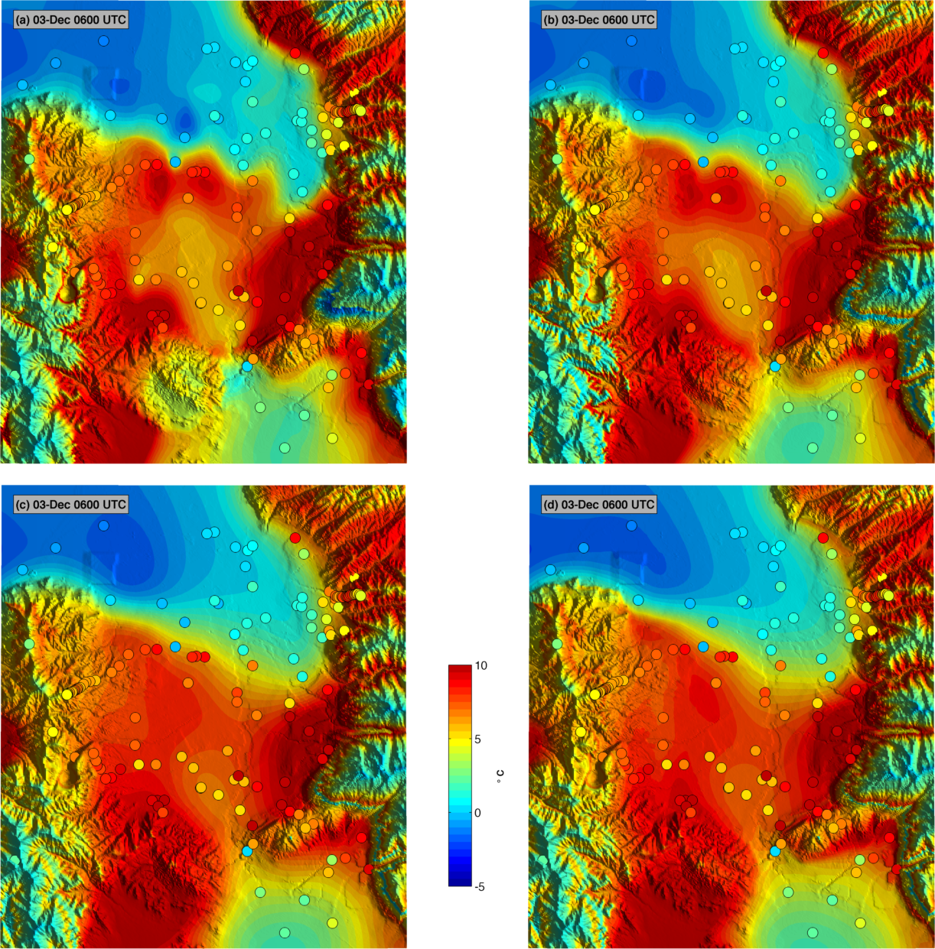
Figure 1. Sensitivity of the Barnes analysis to the horizontal e-folding radius at 0600 UTC using three iterations. Top left: 2.5 km, Top Right: 5 km, Bottom Left: 10 km, Bottom Right: 20 km.

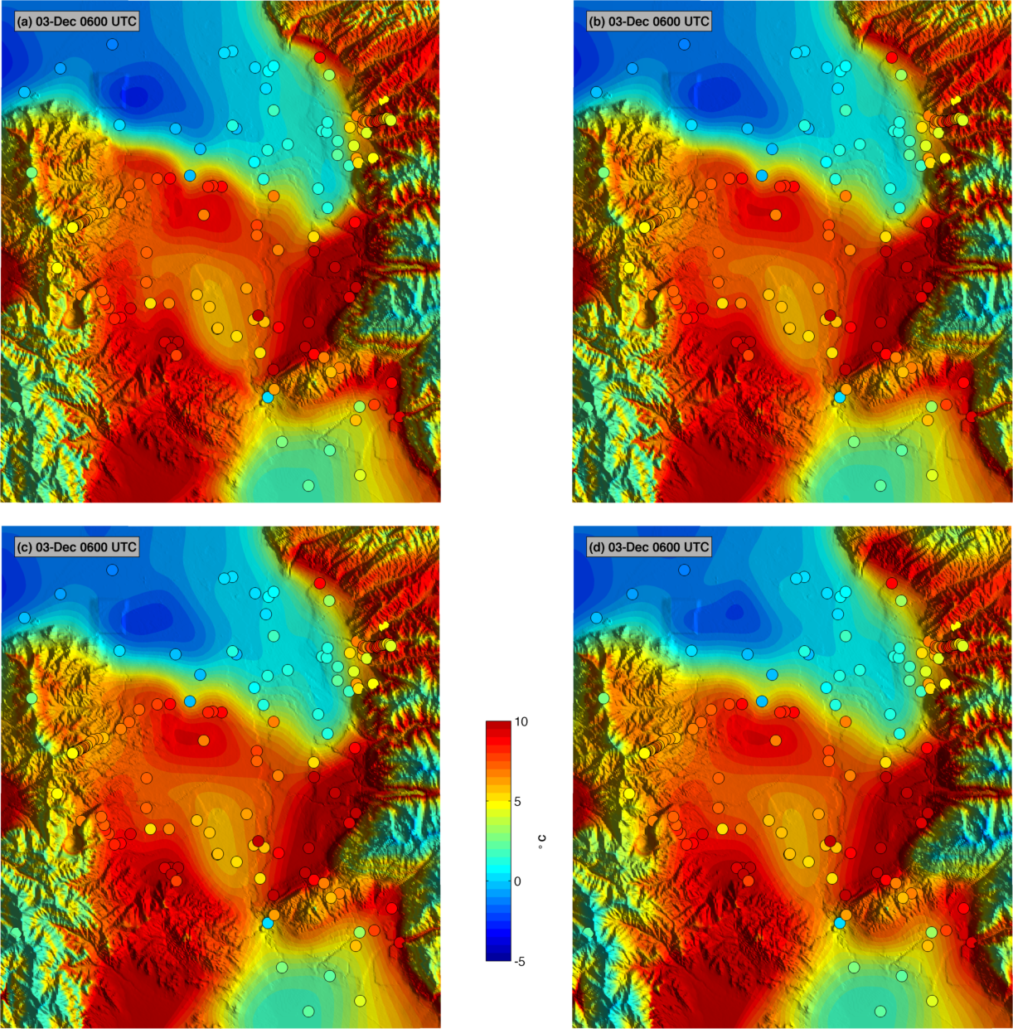
Figure 2 Sensitivity of Barnes analysis at 0600 UTC to variations in the vertical e-folding radius. Each panel uses three passes with 20,10, and 5 km horizontal scales. Top left: 50 m, Top Right: 75 m, Bottom left: 100 m, 200 m.

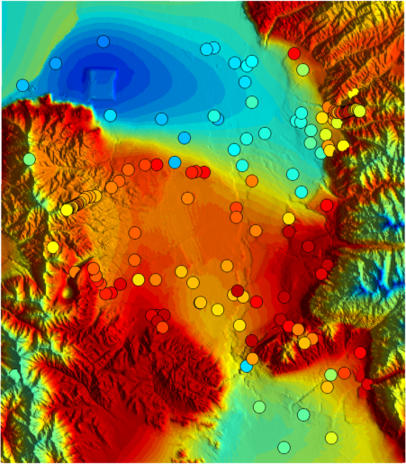
Figure 3 Univeristy of Utah 2-D variation analysis at 0600 UTC.

