Neil Lareau
Response to Review #3.

- Another reviewer also posed this particular question about the use of the column maximum ascent in the climatological statistics. We refer to the detailed response provided in that review, but will also summarize our key points here. The use of any mid-tropospheric level, (600-400 hPa) yields qualitatively similar results to those presented in the paper. In fact, an analysis of the level of maximum ascent associated with our Figs. 4 and 5 shows that ascent is almost always greatest at 500 or 400 hPa. As such the use of a single level in this study would have provided similar results. Individual storms, on the other hand, show some spread in the level of maximum ascent from one event to the next, geographically, and temporally. That ascent is maximized in the mid-troposphere is not surprising, and follows from the tendency for omega to be dominated by forcing aloft and the use of zero boundary conditions in the integration.

- The solution of (3) is computed over the domain 18°-60° N and 70° -160° W as compared to the results which are presented for 22°-56°N and 80°-150° W. We do not show the domain edges because of the imposed zero boundary conditions obviously cause a sharp gradient in ascent values that do not reflect a physical reality. A baroclinic wave entering the domain from the west will initially have no vertical motion, then rapidly “develop” ascent and descent as it moves towards the domain interior. In watching animations of this processes we do not see erroneous values of ascent once the system moves away from the boundaries.

- Figure 1 of this response shows the climatology of ERA-interim omega at 500 hPa. Some of the gross features of the ERA-interim omega climatology are similar to our Fig. 4. However, the ERA-interim ascent over land is dominated by wave like patterns presumed to result from the model orography. These patterns do not appear in our storm track because of the filtering that results from the AB omega methodology, which we demonstrate for the case of the Tax Day Storm. The presence of these wave patterns, which actually extend across the eastern US, and the inclusion of parameterized convective motions in the ERA-interim omega limit its usefulness in diagnosing the prevalence of synoptic-scale storms over western North America. We indicate these limitations in the model omega at the beginning of the methods section on lines 127-132. Furthermore, one of the motivations for our study is to understand the comparative roles of synoptic-scale and orographic forcing for western North America. The use of the AB omega diagnostic allows us to parse out the synoptic-scale component, whereas using the ERA-interim omega we lose information about why ascent occurs where it does. We also anticipate that our methodology will be useful in future investigations of storm track structure over wider domains. In fact, work is now underway to expand our approach for storm tracks in both the northern and southern hemispheres. The use of the AB omega diagnostic as well as an omega attribution approach (Devenson et al. 2002) may allow us to classify portions of the storm track as being dominated by either upper or lower level forcing. This dynamical classification would not be possible by simply examining the ERA-interim omega field. Lastly, while our technique does require considerable computation it only requires the distribution of temperature and relative vorticity on each pressure surface.

- The presence of strong ascent as far south as 40° N is not an artifact in our data, and in fact, is also present in the ERA-interim omega climatology shown Figure 1 of this response. As described in the text, the storm track center is subsequently determined as the connected meridional maxima in ascent after smoothing with a 5th order Butterworth low pass filter (lines 307-309). We caution that this pattern should not be interpreted as the Lagrangian pathway of the mean storm and does not have a direct physical interpretation. It is simply the connected Eulerian maximum in storm propensity (lines 310-312). On the other hand most of the other studies shown in in Figs. 1 and 13 are based on the track or feature density for storm centers, and are thus more closely related to actual storm motion. This difference in method accounts for some of the difference in the presented storm tracks, and motivates our Fig. 7, which is a more general summary of storm motion along any portion of the storm track.

- Figure 3 and the text in our manuscript should both indicate that the cross section is at 39° N. We have corrected this error.

- The figure numbering has been corrected. We apologize for the confusion.

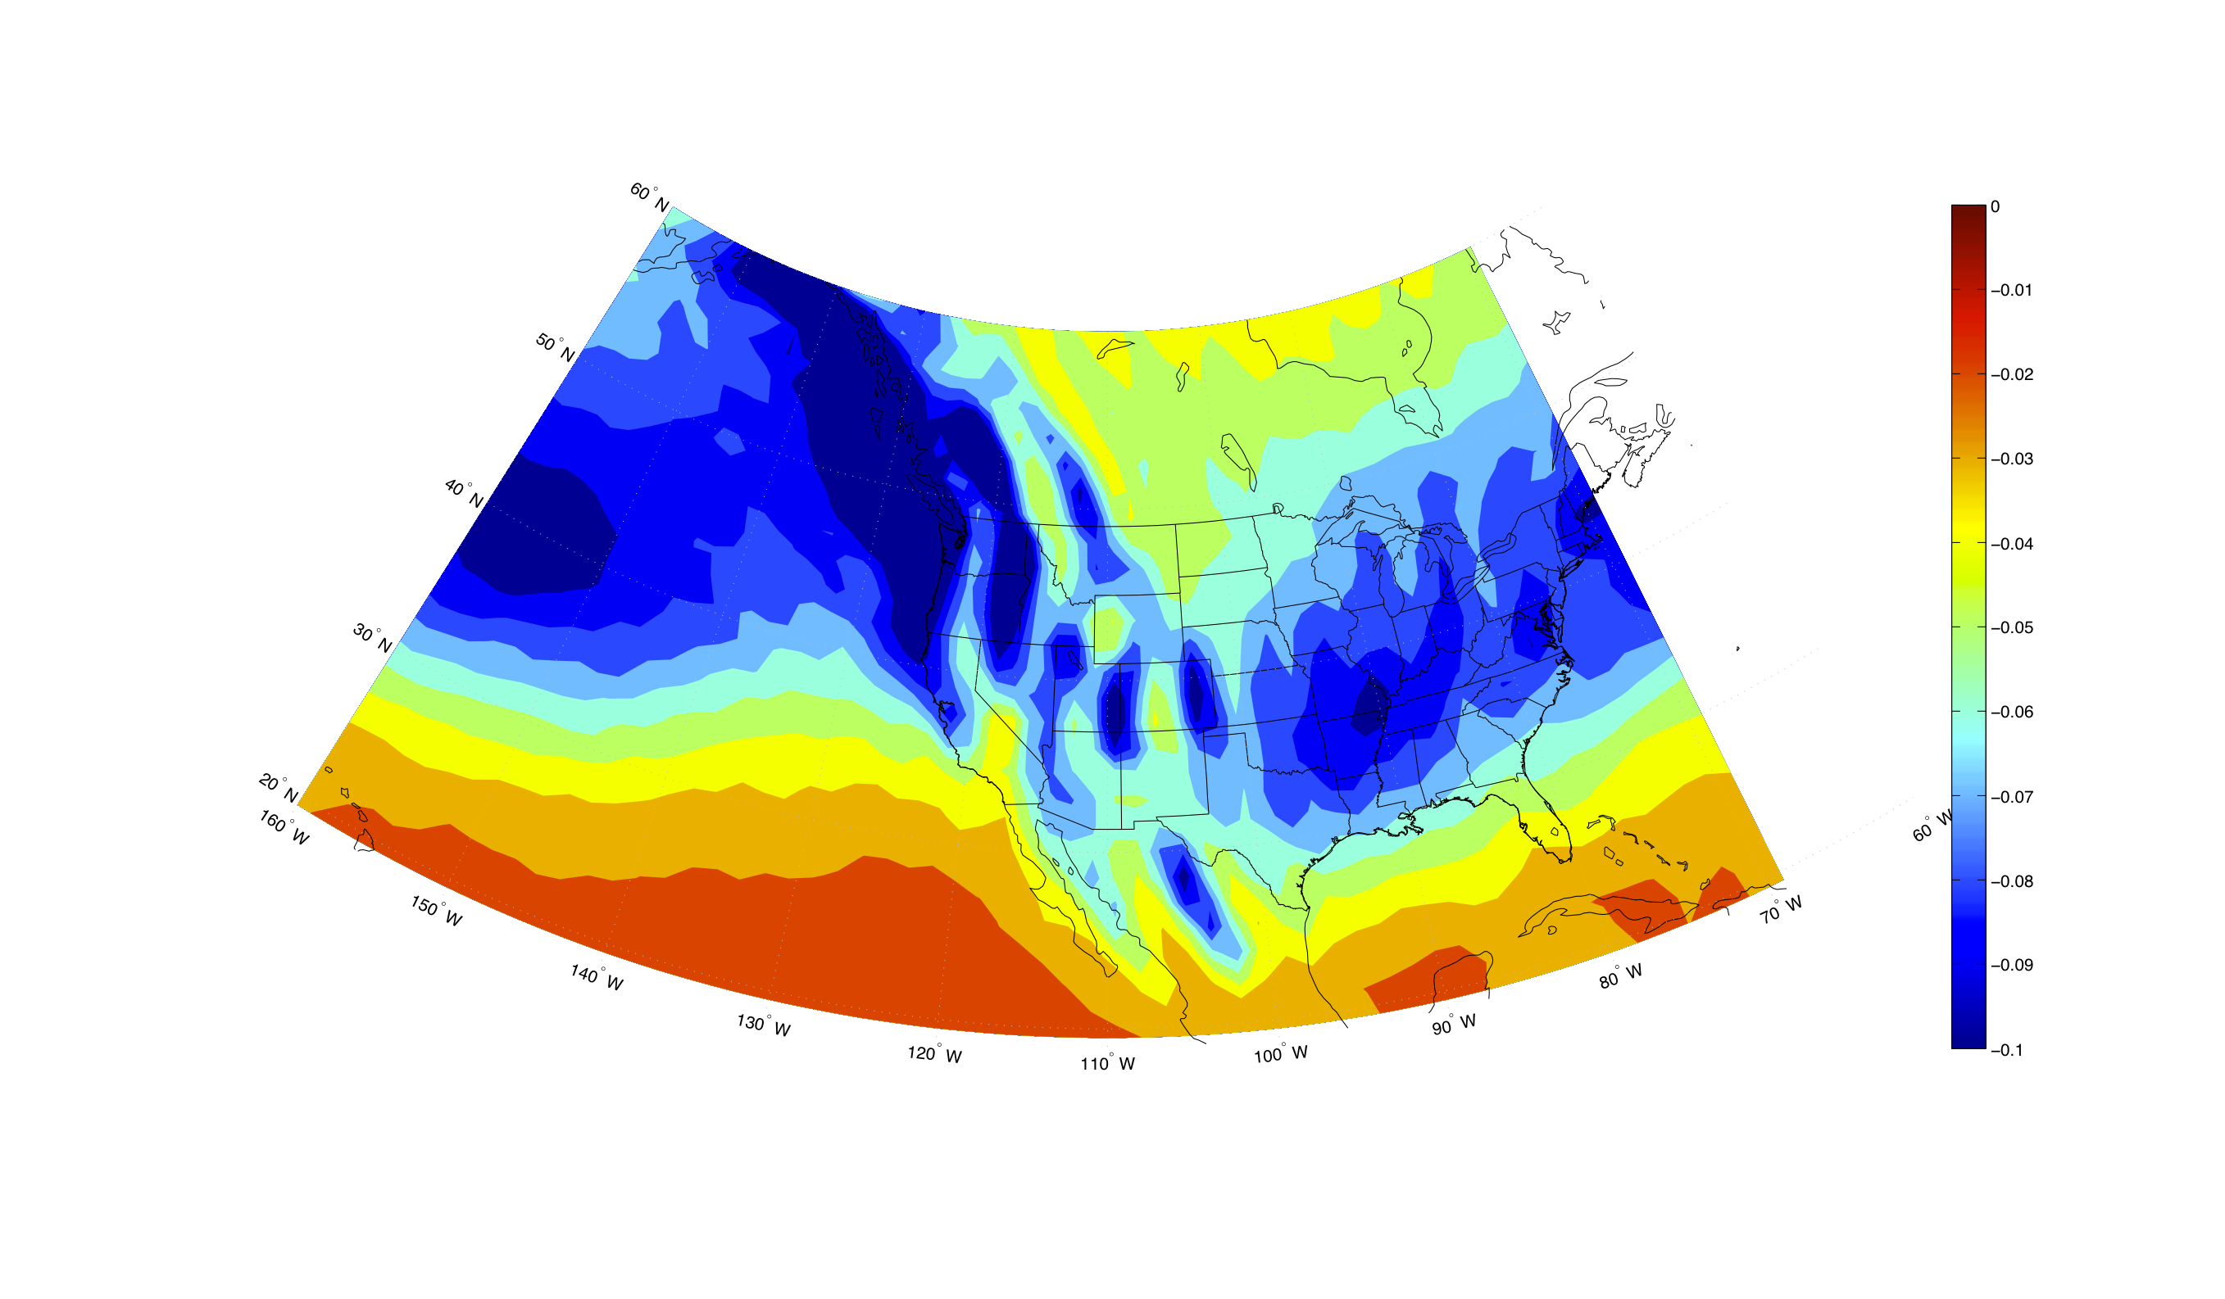
Figure 1 Climatological mean ascent (omega) at 500 hPa from the ERA-interim. Units are Pa s⁻¹.

