Table 1. Summary of WRF setup and parameterizations.
Parameter | Chosen Setup | Reference
Initial/Boundary Conditions | NAM Analysis
Vertical Levels | 41
Domains | 3 one-way nests
Resolution | 12 km, 4 km, 1.33 km
Time Step | 45 s, 15 s, 5 s
Microphysics | Thompson | Thompson et al. (2008)
Shortwave Radiation | RRTMG | Iacono et al. (2008)
Longwave Radiation | RRTMG | Iacono et al. (2008)
Boundary Layer | Mellor-Yamada-Janjic (MYJ) | Janjic (1994)
Surface Layer | Eta Similarity
Land Surface | Noah | Chen and Dudhia (2001)
Cumulus | Kain-Fritsch (12 km domain only) | Kain (2004)
Diffusion | 2nd order on coordinate surfaces

Table 2. Overview of WRF simulations.
Simulation Name | Prescribed Snow Cover | Cloud Ice Sedimentation | Cloud Ice Auto-conversion to Snow
BASE | Full Snow in basin | ON | ON
FULL | Full Snow in basin | OFF | OFF
NONE | No Snow below 2000 m  in basin | OFF | OFF
Table 3. 2-m temperature errors from WRF simulations. Mean errors calculated from the six surface stations in Fig. 1.5b during the 1-6 February 2013 period.
Simulation | Bias (C) | Mean Abs Error (C) | RMSE (C)
BASE | 1.65 | 3.25 | 3.97
FULL | 0.11 | 2.44 | 2.98
NONE | 7.71 | 7.74 | 8.29
Table 4. Ozone concentration statistics from CMAQ model forced by FULL and NONE simulations during the 1-6 February 2013 period.
 | FULL | NONE
Highest mean O₃ - Afternoon (ppb) | 97.2 | 81.2
Highest mean O₃ - Non afternoon (ppb) | 61.9 | 51.0
Maximum Hourly O₃ (ppb) | 134.4 | 118.0
Area of mean afternoon O₃ > 75 ppb (km²) | 896 | 144
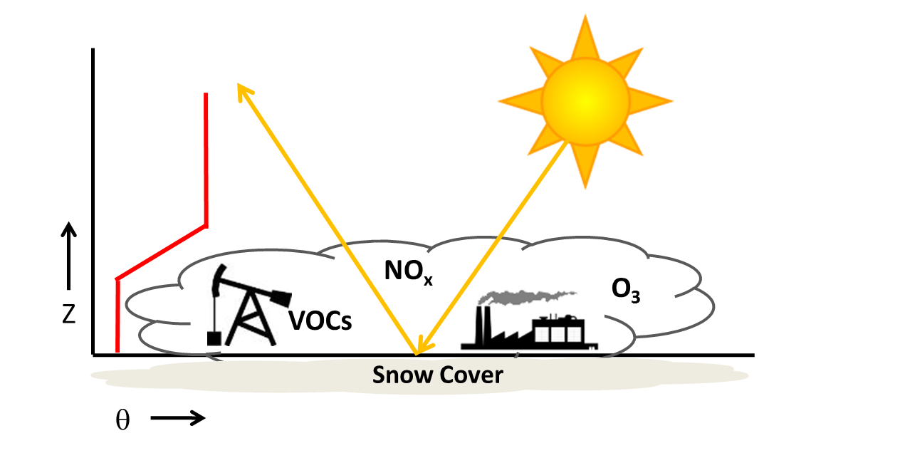
Figure 1. Schematic of factors contributing to high ozone concentrations. Potential temperature profile (red line) with stable layer trapping ozone precursors (NOx and VOCs) within the cold-air pool. Snow cover reflects solar radiation, increases photolysis rates, and leads to enhanced ozone (O3) concentrations near the surface. Ice fogs are common in the cold-air pool.
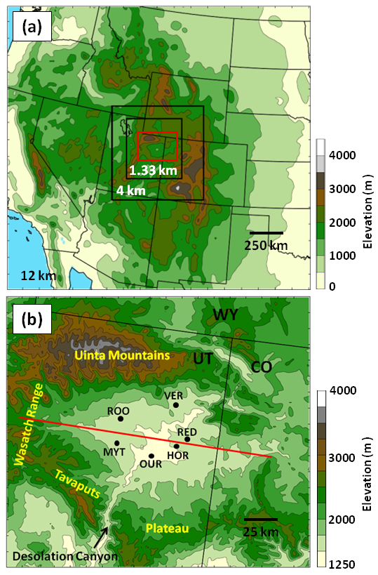
Figure 2. (a) WRF 12-, 4-, and 1.33-km domains with terrain contoured every 500 m. (b) Uintah Basin subdomain with terrain contoured every 250 m and major geographic features labelled. Black dots indicate locations of surface stations used for verification: Horsepool (HOR), Myton (MYT), Ouray (OUR), Red Wash (RED), Roosevelt (ROO), and Vernal(VER). Red box in (a) indicates close-up region shown in (b) and the red line in (b) indicates position of vertical cross sections shown later.
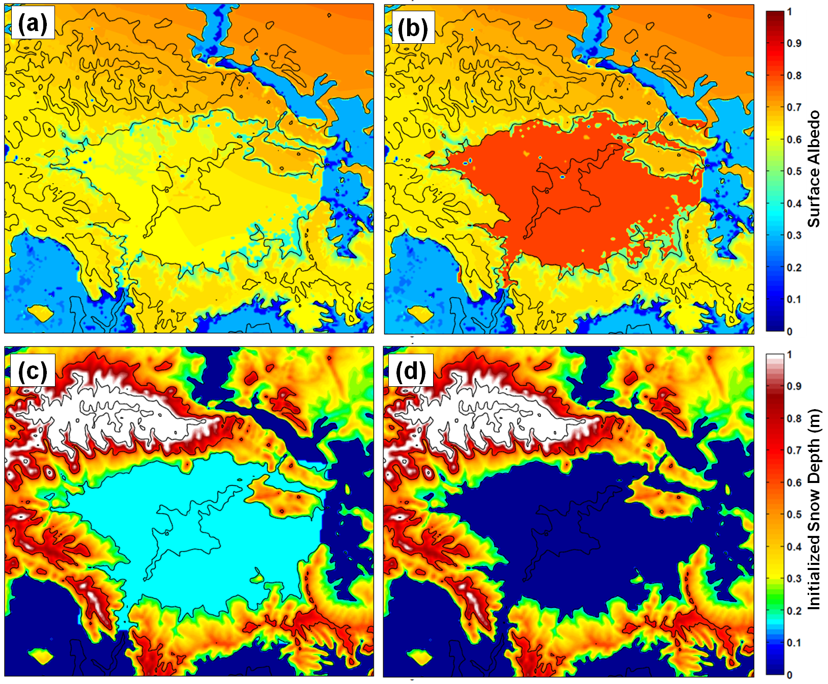
Figure 3. WRF surface albedo (top) at 18:00MST 31 January 2013 for (a) before and (b) after modifications to WRF snow albedo and vegetation parameter table. Initialized snow depth (bottom, in m) at 17:00MST 31 January 2013 for (c) “Full Snow” cases (BASE/FULL) and (d) “No Snow” case (NONE). Terrain contoured every 500 m in black.

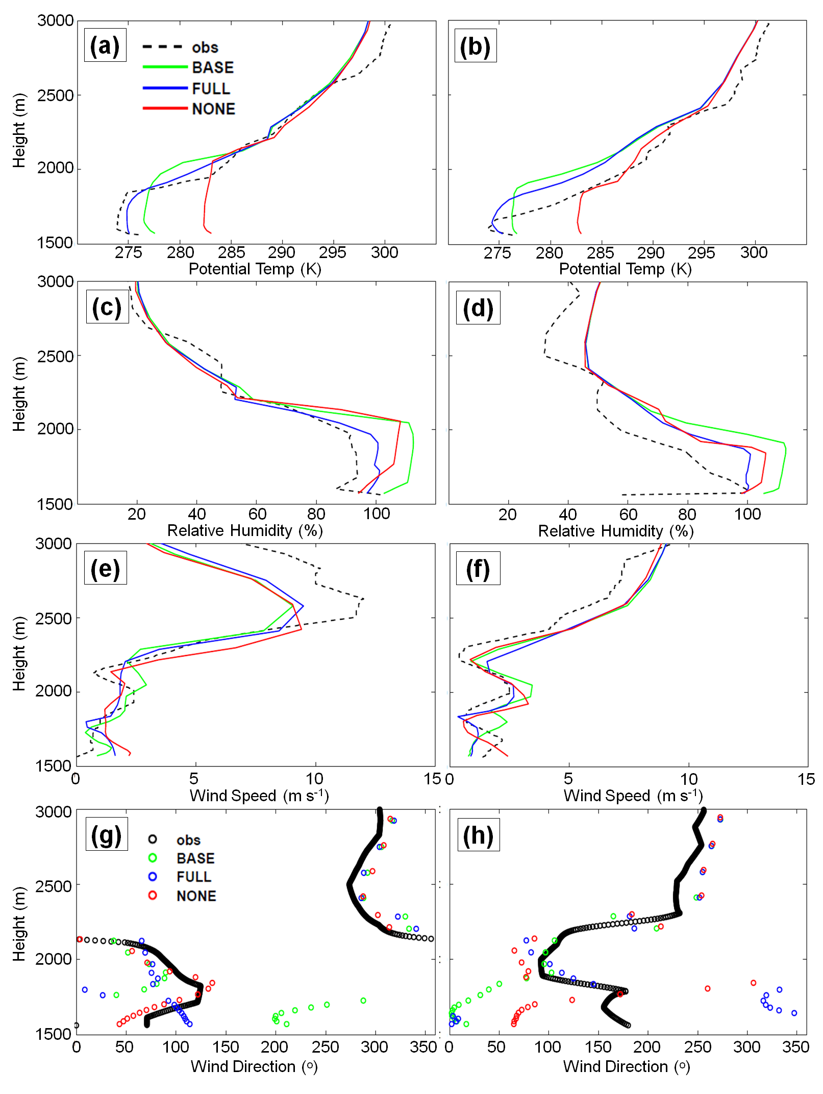
Figure 4. Observed and simulated vertical profiles at Roosevelt of (a, b) potential temperature, (c, d) relative humidity with respect to ice, (e, f) wind speed, and (g, h) wind direction for 11:00 MST 4 February 2013 (left) and 11:00 MST 5 February 2013 (right).
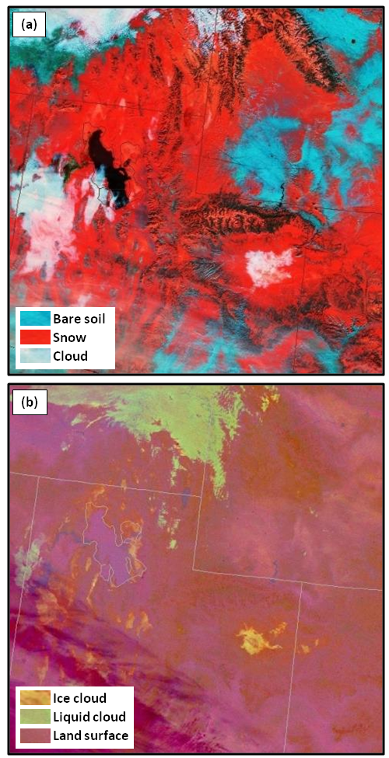
Figure 5. SPoRT-derived VIIRS satellite images: (a) Snow-Cloud product at 1115 MST 2 February 2013 and (b) Nighttime Microphysics RGB product at 0331 MST 2 February 2013.
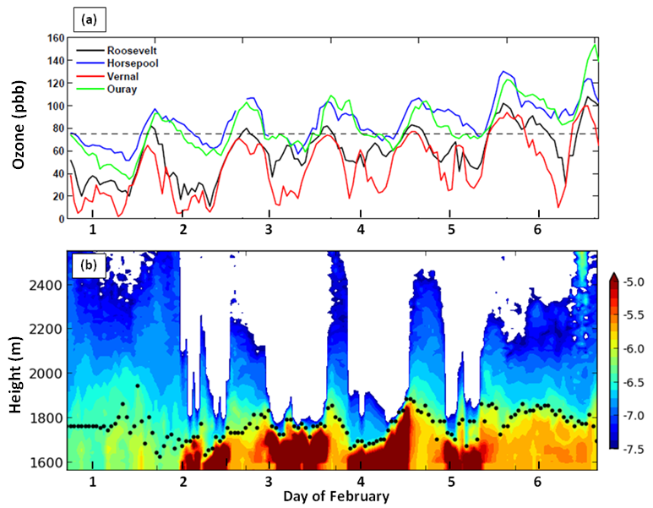
Figure 6. (a) Hourly ozone concentrations from 31 January-6 February 2013 (thick black tick marks denote 00:00 MST) for Roosevelt (black), Horsepool (blue), Vernal (red), and Ouray (green) with the 75 ppb (8-hour mean) NAAQS denoted by the dashed line. (b) Ceilometer backscatter (shaded) and estimated aerosol depth (black dots) as a function of height (m) at Roosevelt from 31 January-6 February 2013. Red, yellow, blue, and white shading denote fog and stratus clouds, high aerosol concentrations; low aerosol concentrations, and beam attenuation, respectively.
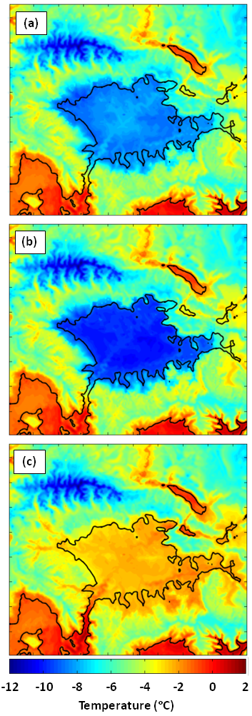
Figure 7. Average 2-m temperature (in °C according to the scale below) between 17:00 MST 31 January and 17:00 MST 6 February 2013 from (a) BASE, (b) FULL, and (c) NONE simulations.
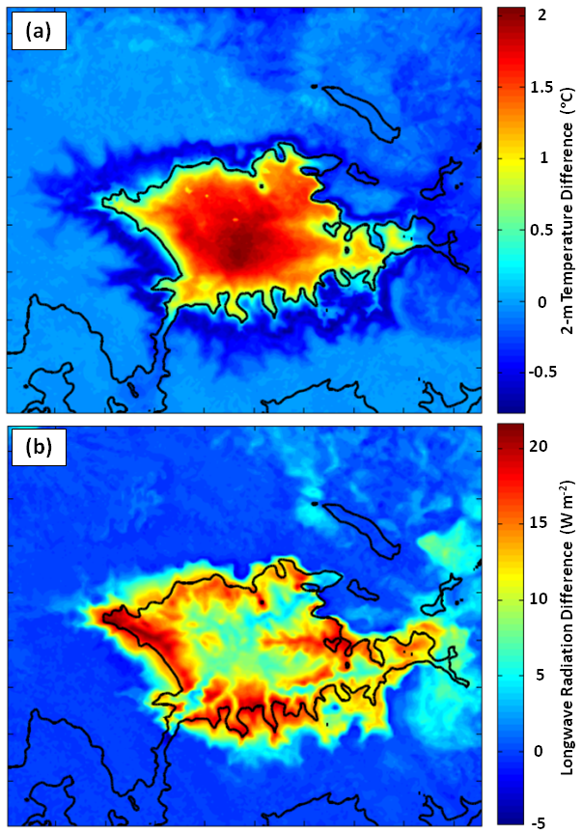
Figure 8. Average difference (BASE – FULL) for period 17:00 MST 31 January to 17:00 MST 6 February 2013 in: (a) 2-m temperature (in °C according to the scale to the right) and (b) downwelling longwave radiation (in W m-2 according to the scale on the right).
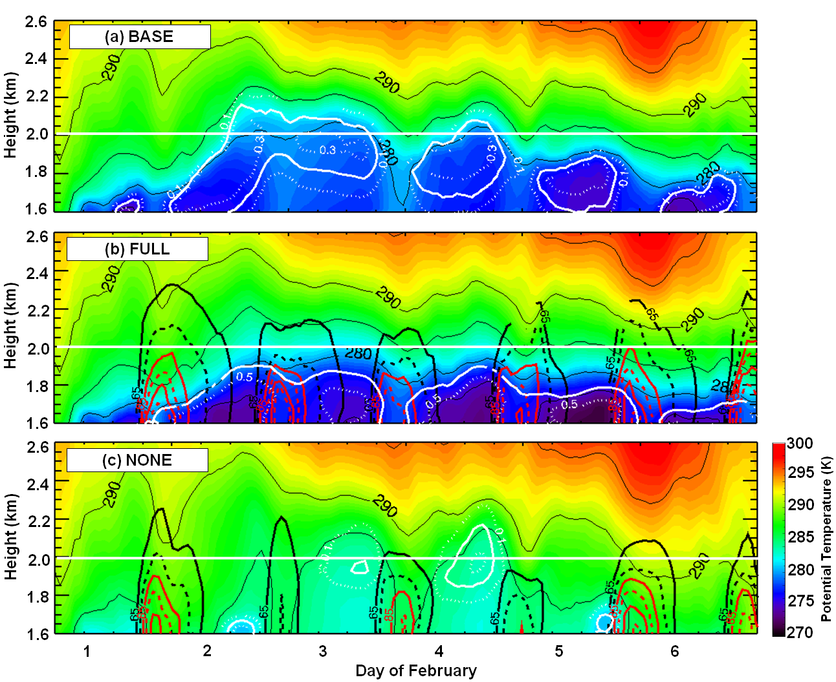
Figure 9. Time-height plot of potential temperature (in K according to the scale on the right) at Horsepool from 17:00 MST 31 January to 17:00 MST 6 February 2013 (dates are labelled at 00:00 MST) from (a) BASE, (b) FULL, and (c) NONE simulations. Ozone concentrations are contoured every 10 ppb, starting at 65 ppb and alternate between solid and dashed every 10 ppb. Ozone concentrations above (below) 85 ppb are contoured in red(black). Plotted ozone concentrations represent the maximum value for each hour in a 40 by 40 km region encompassing Ouray and Horsepool. Cloud water amount (g kg⁻¹) in (a) and (c) are labelled at 0.1 (dashed white line), 0.2 (solid white line) and 0.3 (dashed white line). Cloud ice amount (g kg⁻¹) in (b) is labelled at 0.3 (solid white line) and 0.5 (dashed white line).

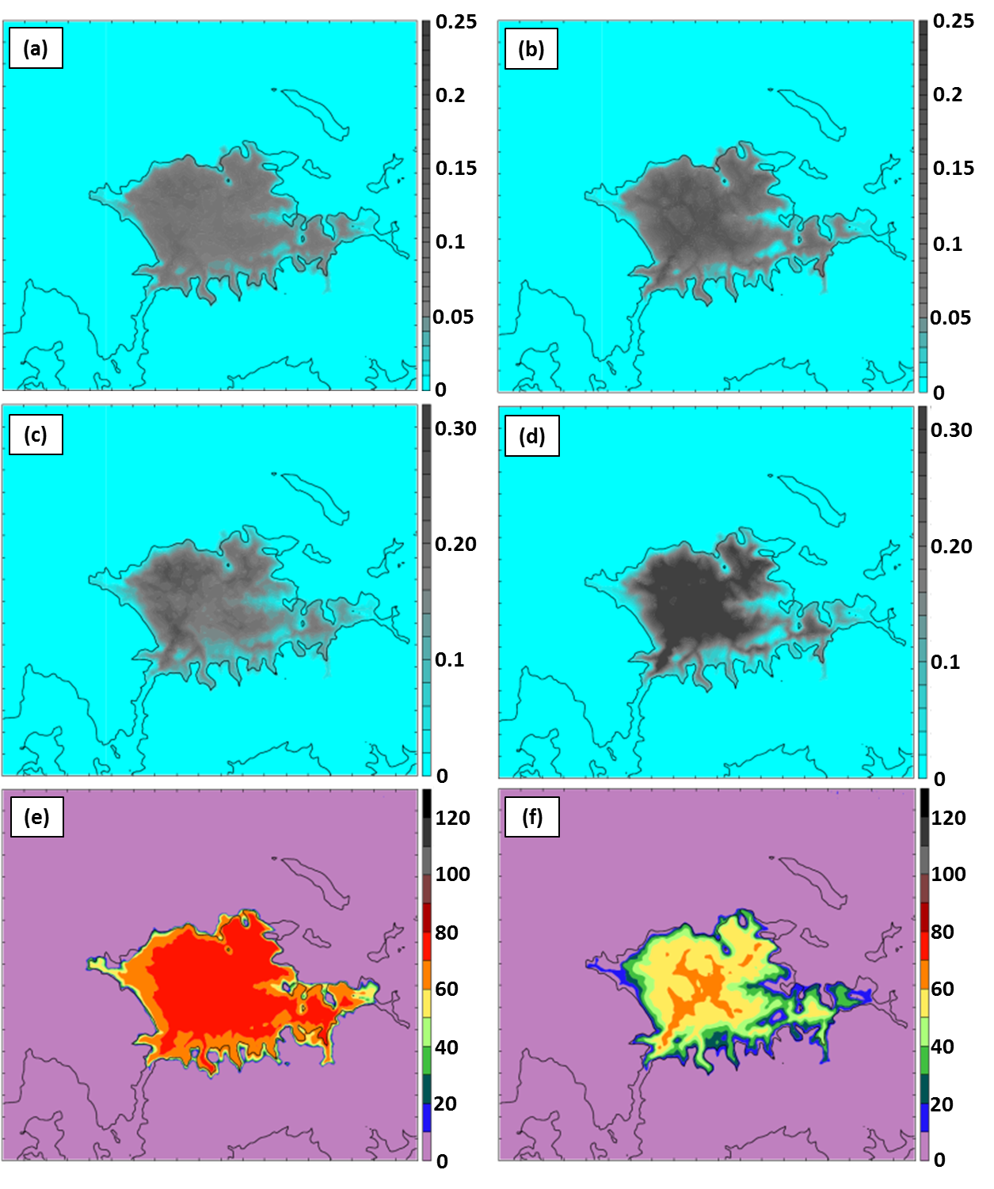
Figure 10. Cloud characteristics from BASE (a, c, e) and FULL (b, d, f) simulations at 23:00 MST 4 February 2013. (a, b) Integrated cloud amount (in mm according to the scale on the right), (c) mean cloud water in bottom 15 model levels (in g kg-1 according to the scale on the right), (d) mean cloud ice in bottom 15 model levels (in g kg-1 according to the scale on the right), (e, f) net downwelling longwave radiation from clouds (in W m-2 according to the scale on the right).
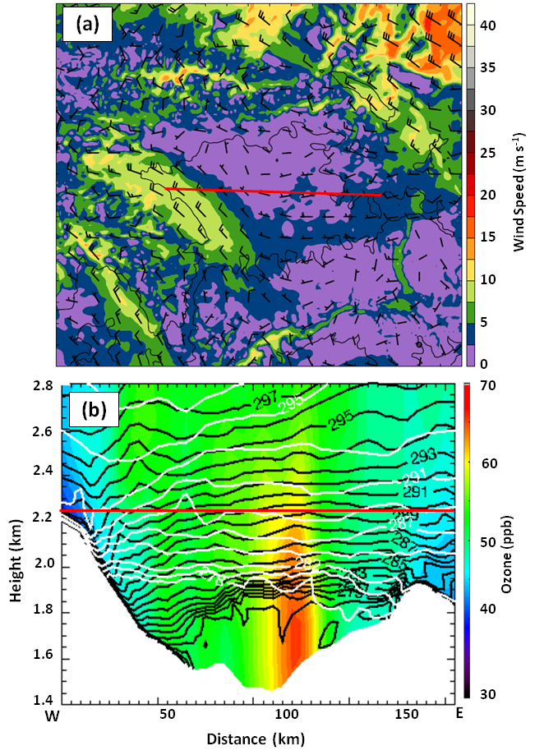
Figure 11. FULL simulation at 23:00 MST 3 February 2013 for (a) 2.3 km MSL wind speed (in m s-1 according to the scale on the right) and barbs (full barb 5 m s-1). (b) Vertical cross section of potential temperature at 23:00 MST 3 February (in K according to the labelled black contours) and at 05:00 MST 4 February (in K according to labelled white contours) and ozone in ppb (according to color scale) along red line in (a).
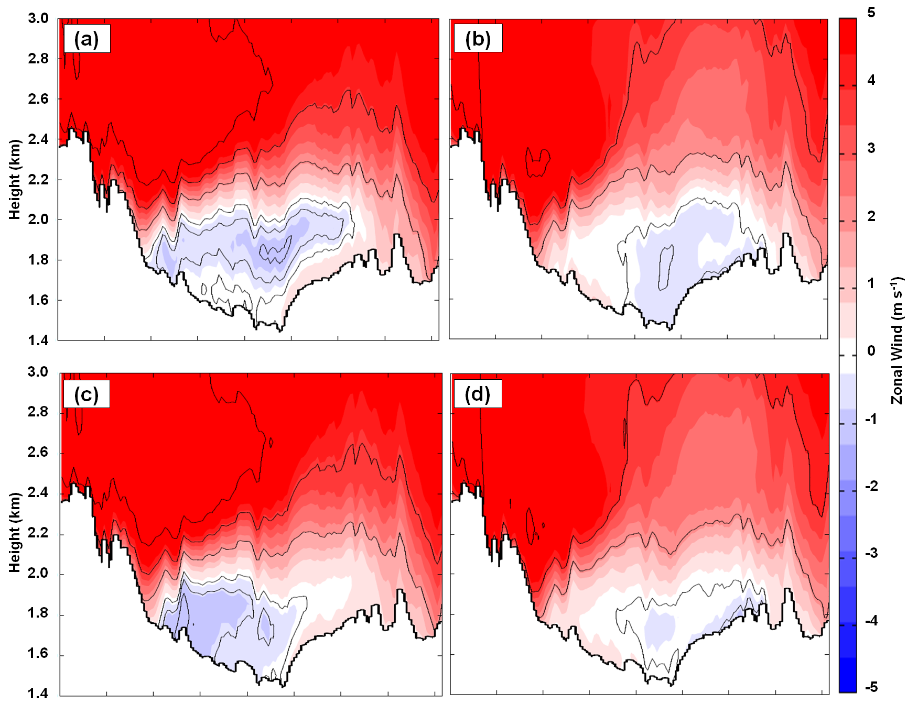
Figure 12. Average zonal wind in the vicinity of the cross-section in Fig. 2b for 17:00 MST 31 January to 17:00 MST 6 February 2013 period. The FULL simulation (top) and NONE simulation (bottom) results for (a, c) daytime hours (0800 to 17:00 MST) and (b, d) nighttime hours (1800 to 07:00 MST). Westerly (easterly) winds shaded in m s-1 according to the scale on the right in red (blue) with westerly (easterly) winds contoured every 2 m s-1 ( -0.5, -1, and -2 m s-1 only). Values are averaged over a 26-km wide swath perpendicular to the cross section.
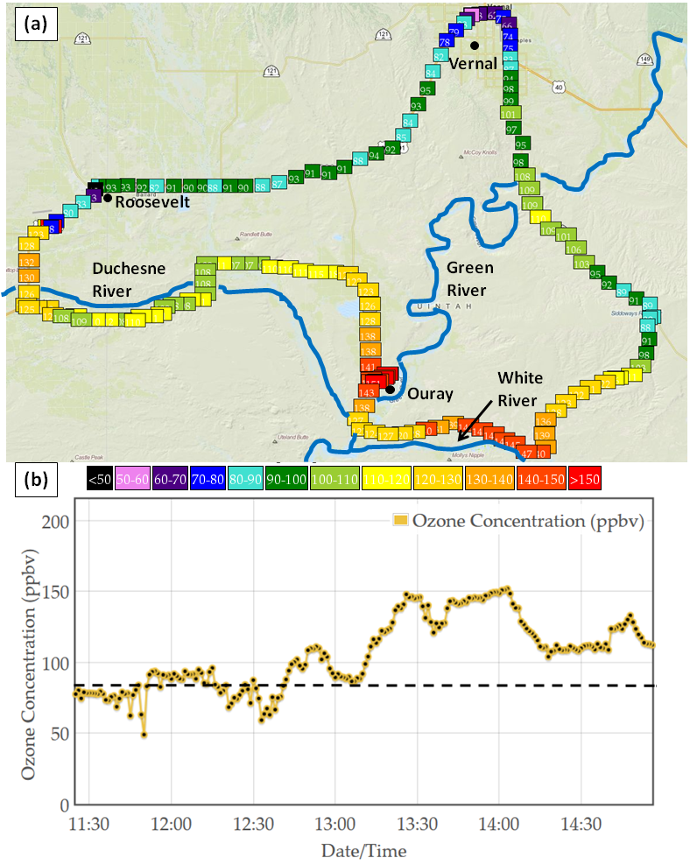
Figure 13. University of Utah Mobile transect of ozone concentration from 1130 to 15:00 MST 6 February 2013 as a function of (a) geographic location and (b) time. Dashed black line represents NAAQS for ozone (75 ppb). Ozone concentrations in (a) are according to color scale. Ozone data and plots available at: http://home.chpc.utah.edu/~u0198116/ubos/obs.html
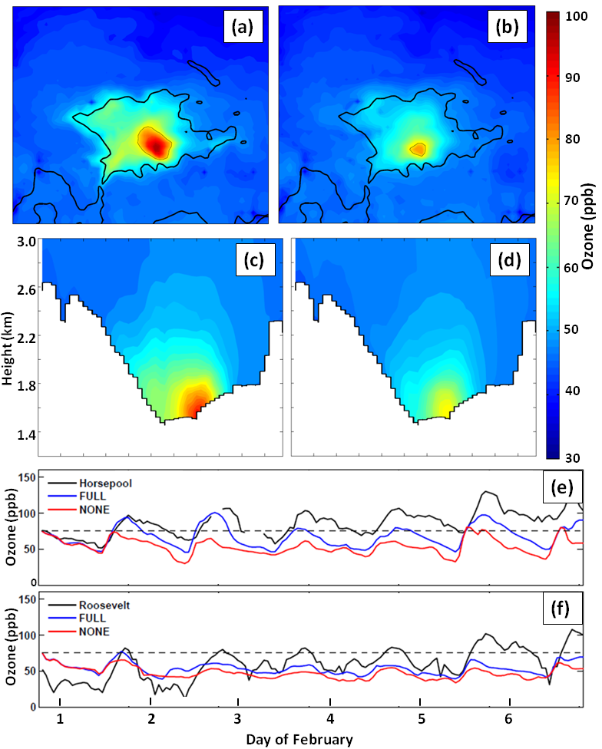
Figure 14. (top) Average ozone concentration (in ppb according to scale on the right) during 1100-17:00 MST 1–6 February 2013 on the lowest CMAQ model level (~17.5 m) from (a) FULL and (b) NONE simulations. The thin black line outlines regions where the ozone concentration exceeds 75 ppb while the reference terrain elevation of 1800 m is shown by the heavy black line. (bottom) Average ozone concentration during 1100-17:00 MST 1–6 February 2013 from (c) FULL and (d) NONE simulations along cross section approximately 25 km south of the red line in Fig. 2b. Values averaged over 24-km wide swath perpendicular to the cross section. Time Series of ozone concentrations from (e) Horsepool, and (f) Roosevelt. Observations, CMAQ output from FULL and NONE simulations in blue, red, and black respectively (thick black tick marks denote 00:00 MST). The NAAQS of 75 ppb is denoted by the thin black dashed line.

