**Neurology Consult Template**

**ID:**  Age, Sex, Handedness (RHD vs. LHD)

**RFC:**

**PMHx/PSHx:**

**FamHx:**

**Rx at-home:**

**Rx in-hospital:**

**Supplements/OTC:**

**Allergies:**

**Habits:**

**Social:**

**HPI:**

**On exam:**

Vital signs on arrival  
Most recent VS:

General appearance:

**Neuro:**

Mental status: Awake, alert, appropriate, and oriented to time, place and self. Attention intact.

Language: Fluency and comprehension intact. Comment if any aphasia.

Speech: No dysarthria.

CNs:

I deferred

II: Pupils equal, round, reactive to light direct and consensual bilaterally. No RAPD (test if suspicion for optic neuritis). Visual fields full. Normal fundoscopy (if visual complaints).

III-IV-VI: EOMs full. Smooth pursuits, no nystagmus, no diplopia. Saccades normal.

V: Facial sensation grossly intact to light touch bilaterally V1-V3. Masseter muscles intact.

VII: No facial droop, facial muscles intact bilaterally.

VIII: Hearing grossly normal bilaterally.

IX-X: Palate elevation symmetrical, no uvula deviation.

XI: SCM and trap strength 5/5 bilaterally.

XII: Tongue midline, no atrophy, no fasciculations.

Motor:

Normal bulk. No tremor or abnormal movements. No fasciculations.

No pronator or barre drift. Normal fine finger movements. No satelliting. Toe tapping normal.

Tone: No spasticity/rigidity on elbow extension, supination, wrist flexion/extension, knee flexion, foot dorsiflexion. No clonus.

Segmental strength (0-5/5):

| UE | SA | EE | EF | WF | WE | FF | FE | FA |
| --- | --- | --- | --- | --- | --- | --- | --- | --- |
| Right | 5 | 5 | 5 | 5 | 5 | 5 | 5 | 5 |
| Left | 5 | 5 | 5 | 5 | 5 | 5 | 5 | 5 |

| LE | HF | HE | KF | KE | DF | PF | TE | TF |
| --- | --- | --- | --- | --- | --- | --- | --- | --- |
| Right | 5 | 5 | 5 | 5 | 5 | 5 | 5 | 5 |
| Left | 5 | 5 | 5 | 5 | 5 | 5 | 5 | 5 |

Reflexes (0-4+):

|  | Biceps | Brachioradialis | Triceps | Patellar | Achilles | Plantar response |
| --- | --- | --- | --- | --- | --- | --- |
| Right | 2+ | 2+ | 2+ | 2+ | 2+ | downgoing |
| Left | 2+ | 2+ | 2+ | 2+ | 2+ | downgoing |

Sensation: Grossly intact to light touch, temperature, pinprick and proprioception UE and LE bilat *(done only if sensory complaint*). Vibration intact (approx #s bilat; *should be done in all patients with complaints of poor balance and patients with diabetes*). Romberg negative.

Coordination: Normal finger-to-nose (comment if dysmetria). Normal rapid alternating hand movements (comment if dysdiadochokinesia). Normal heel-to-shin (comment if dysmetria).

Gait: Normal gait, heel walking, toe walking, tandem gait.

**Labs:**

**Imaging:**

**Impression/Plan:**

*When formulating an impression in neurology you want to answer 3 main questions:*

1. *Is there a problem in the nervous system?*
2. *Where does the problem localize? (UMN vs. LMN, exact location)*
3. *What is the most likely diagnosis and differential?*

Appendix:

1. Tests for motor function

Teitelbaum JS, Eliasziw M, Garner M. Tests of Motor Function in Patients Suspected of Having Mild Unilateral Cerebral Lesions. Canadian Journal of Neurological Sciences. 2002;29(4):337-344. doi:10.1017/S0317167100002201

1. UMN vs. LMN

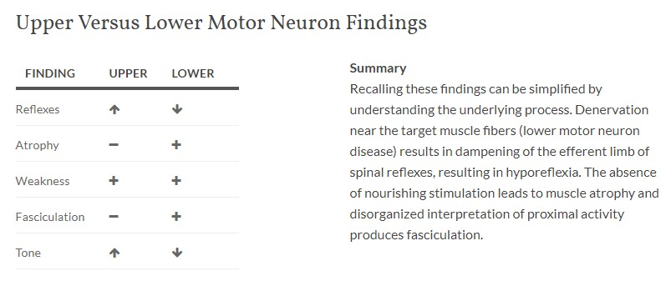

https://www.grepmed.com/images/4756/diagnosis-lower-versus-findings-motorneuron